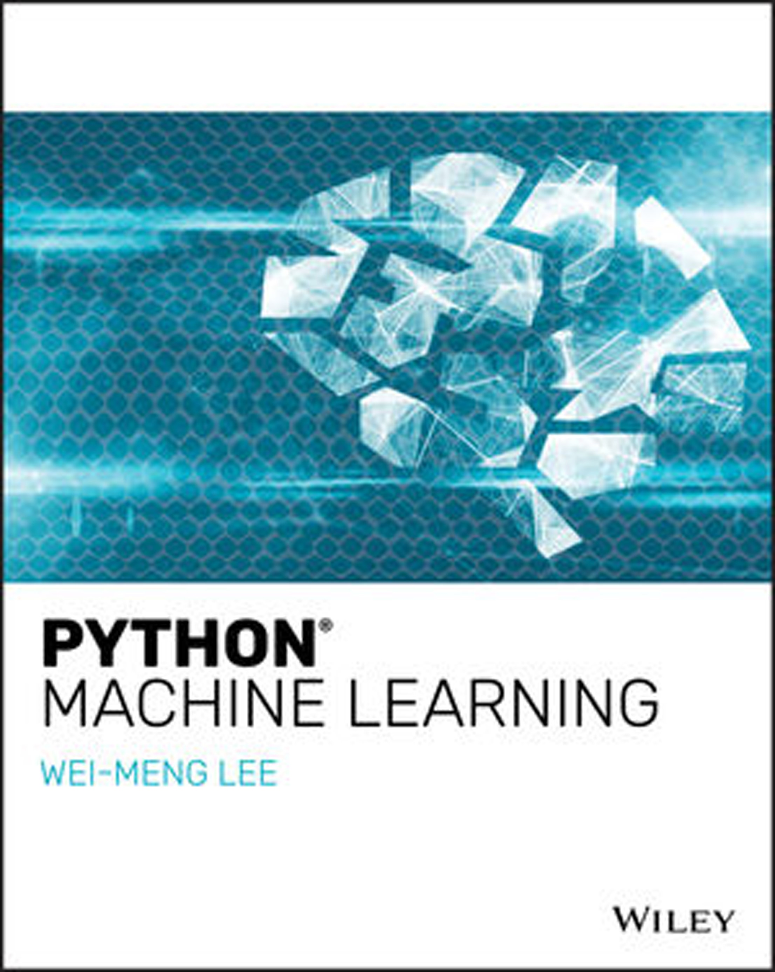

**Python® Machine Learning**



**Python® Machine**

**Learning**

Wei-Meng Lee

**Python® Machine Learning**

Published by

John Wiley & Sons, Inc.

10475 Crosspoint Boulevard Indianapolis, IN 46256

**www.wiley.com**

Copyright © 2019 by John Wiley & Sons, Inc., Indianapolis, Indiana Published simultaneously in Canada

ISBN: 978-1-119-54563-7

ISBN: 978-1-119-54569-9 (ebk)

ISBN: 978-1-119-54567-5 (ebk)

Manufactured in the United States of America

10 9 8 7 6 5 4 3 2 1

No part of this publication may be reproduced, stored in a retrieval system or transmitted in any form or by any means, electronic, mechanical, photocopying, recording, scanning or otherwise, except as permitted under Sections 107 or 108 of the 1976 United States Copyright Act, without either the prior written permission of the Publisher, or authorization through payment of the appropriate per-copy fee to the Copyright Clearance Center, 222 Rosewood Drive, Danvers, MA 01923, (978) 750-8400, fax (978) 646-8600. Requests to the Publisher for permission should be addressed to the Permissions Department, John Wiley & Sons, Inc., 111 River Street, Hoboken, NJ 07030, (201) 748-6011, fax (201) 748-6008, or online at **http://www.wiley.com/go/permissions**.

**Limit of Liability/Disclaimer of Warranty:** The publisher and the author make no representations or warranties with respect to the accuracy or completeness of the contents of this work and specifically disclaim all warranties, including without limitation warranties of fitness for a particular purpose. No warranty may be created or extended by sales or promotional materials. The advice and strategies contained herein may not be suitable for every situation. This work is sold with the understanding that the publisher is not engaged in rendering legal, accounting, or other professional services. If professional assistance is required, the services of a competent professional person should be sought. Neither the publisher nor the author shall be liable for damages arising herefrom. The fact that an organization or Web site is referred to in this work as a citation and/or a potential source of further information does not mean that the author or the publisher endorses the information the organization or website may provide or recommendations it may make. Further, readers should be aware that Internet websites listed in this work may have changed or disappeared between when this work was written and when it is read.

For general information on our other products and services please contact our Customer Care Department within the United States at (877) 762-2974, outside the United States at (317) 572-3993 or fax (317) 572-4002.

Wiley publishes in a variety of print and electronic formats and by print-on-demand. Some material included with standard print versions of this book may not be included in e-books or in print-on-demand. If this book refers to media such as a CD or DVD that is not included in the version you purchased, you may download this material at **http:// booksupport.wiley.com**. For more information about Wiley products, visit **www.wiley.com**.

**Library of Congress Control Number: 2019931301**

**Trademarks:** Wiley and the Wiley logo are trademarks or registered trademarks of John Wiley & Sons, Inc. and/or its affiliates, in the United States and other countries, and may not be used without written permission. Python is a registered trademark of Python Software Foundation. All other trademarks are the property of their respective owners. John Wiley & Sons, Inc. is not associated with any product or vendor mentioned in this book.

*I dedicate this book with love to my dearest wife (Sze Wa) and girl (Chloe), who have to endure my irregular work schedule and for their companionship when I am trying to meet writing deadlines!*

**About the Author**

**Wei-Meng Lee** is a technologist and founder of Developer Learning Solutions

(**http://www.learn2develop.net**), a company specializing in hands-on training on the latest technologies.

Wei-Meng has many years of training experience, and his training courses place special emphasis on the learning-by-doing approach. His hands-on approach to learning programming makes understanding the subject much easier than just reading books, tutorials, and documentations.

Wei-Meng’s name regularly appears in online and print publications such as **DevX.com**, **MobiForge.com**, and CoDe Magazine. You can contact Wei-Meng at: **weimenglee@learn2develop.net**.

**vii**

**About the Technical Editor**

**Doug Mahugh** is a software developer who began his career in 1978 as a Fortran programmer for Boeing. Doug has worked for Microsoft since 2005 in a variety of roles including developer advocacy, standards engagement, and content development. Since learning Python in 2008, Doug has written samples and tutorials on topics ranging from caching and continuous integration to Azure Active Directory authentication and Microsoft Graph. Doug has spoken at industry events in over 20 countries, and he has been Microsoft’s technical representative to standards bodies including ISO/IEC, Ecma International, OASIS, CalConnect, and others.

Doug currently lives in Seattle with his wife Megan and two Samoyeds named Jamie and Alice.

**ix**

**Credits**

|  |  |
| --- | --- |
| **Acquisitions Editor** Devon Lewis  **Associate Publisher** Jim Minatel  **Editorial Manager** Pete Gaughan  **Production Manager**  Katie Wisor  **Project Editor**  Gary Schwartz  **Production Editor**  Barath Kumar Rajasekaran  **Technical Editor** Doug Mahugh | **Copy Editor** Kim Cofer  **Proofreader** Nancy Bell  **Indexer**  Potomac Indexing, LLC  **Cover Designer** Wiley  **Cover Image**  ©Lidiia Moor/iStockphoto- background texture  © Rick_Jo/iStockphoto-digital robotic brain |

**xi**

**Acknowledgments**

Writing a book is always exciting, but along with it come long hours of hard work, straining to get things done accurately and correctly. To make a book possible, a lot of unsung heroes work tirelessly behind the scenes. For this, I would like to take this opportunity to thank a number of special people who made this book possible.

First, I want to thank my acquisitions editor Devon Lewis, who was my first point of contact for this book. Thank you, Devon, for giving me this opportunity and for your trust in me!

Next, a huge thanks to Gary Schwartz, my project editor, who was always a pleasure to work with. Gary is always contactable, even when he is at the airport! Gary has been very patient with me, even though I have missed several of my deadlines for the book. I know it threw a spanner into his plan, but he is always accommodating. Working with him, I know my book is in good hands. Thank you very much, Gary!

Equally important is my technical editor—Doug Mahugh. Doug has been very eager-eyed editing and testing my code, and never fails to let me know if things do not work the way I intended. Thanks for catching my errors and making the book a better read, Doug! I would also like to take this opportunity to thank my production editor—Barath Kumar Rajasekaran. Without his hard work, this book would not be even possible. Thanks, Barath!

Last, but not least, I want to thank my parents and my wife, Sze Wa, for all the support they have given me. They have selflessly adjusted their schedules to accommodate my busy schedule when I was working on this book. I love you all!

**xiii**

**Contents at a glance**

**Introduction xxiii**

**Chapter 1 Introduction to Machine Learning 1**

**Chapter 2 Extending Python Using NumPy 19**

**Chapter 3 Manipulating Tabular Data Using Pandas 39**

**Chapter 4 Data Visualization Using matplotlib 67**

**Chapter 5 Getting Started with Scikit-learn for Machine Learning 93**

**Chapter 6 Supervised Learning—Linear Regression 119**

**Chapter 7 S upervised Learning—Classification Using**

**Logistic Regression 151**

**Chapter 8 Supervised Learning—Classification Using Support**

**Vector Machines 177**

**Chapter 9 Supervised Learning—Classification Using K-Nearest**

**Neighbors (KNN) 205**

**Chapter 10 Unsupervised Learning—Clustering Using K-Means 221**

**Chapter 11 Using Azure Machine Learning Studio 243**

**Chapter 12 Deploying Machine Learning Models 269**

**Index 285**

**xv**

**Contents**

**Introduction xxiii**

**Chapter 1 Introduction to Machine Learning 1**

What Is Machine Learning? 2

What Problems Will Machine Learning Be Solving in This Book? 3

Classification 4

Regression 4

Clustering 5

Types of Machine Learning Algorithms 5

Supervised Learning 5

Unsupervised Learning 7

Getting the Tools 8

Obtaining Anaconda 8

Installing Anaconda 9

Running Jupyter Notebook for Mac 9

Running Jupyter Notebook for Windows 10

Creating a New Notebook 11

Naming the Notebook 12

Adding and Removing Cells 13

Running a Cell 14

Restarting the Kernel 16

Exporting Your Notebook 16

Getting Help 17

**Chapter 2 Extending Python Using NumPy 19**

What Is NumPy? 19

Creating NumPy Arrays 20

Array Indexing 22

**xvii**

Boolean Indexing 22

Slicing Arrays 23

NumPy Slice Is a Reference 25

Reshaping Arrays 26

Array Math 27

Dot Product 29

Matrix 30

Cumulative Sum 31

NumPy Sorting 32

Array Assignment 34

Copying by Reference 34

Copying by View (Shallow Copy) 36

Copying by Value (Deep Copy) 37

**Chapter 3 Manipulating Tabular Data Using Pandas 39**

What Is Pandas? 39

Pandas Series 40

Creating a Series Using a Specified Index 41

Accessing Elements in a Series 41

Specifying a Datetime Range as the Index of a Series 42

Date Ranges 43

Pandas DataFrame 45

Creating a DataFrame 45

Specifying the Index in a DataFrame 46

Generating Descriptive Statistics on the DataFrame 47

Extracting from DataFrames 49

Selecting the First and Last Five Rows 49

Selecting a Specific Column in a DataFrame 50

Slicing Based on Row Number 50

Slicing Based on Row and Column Numbers 51

Slicing Based on Labels 52

Selecting a Single Cell in a DataFrame 54

Selecting Based on Cell Value 54

Transforming DataFrames 54

Checking to See If a Result Is a DataFrame or Series 55

Sorting Data in a DataFrame 55

Sorting by Index 55

Sorting by Value 56

Applying Functions to a DataFrame 57

Adding and Removing Rows and Columns in a DataFrame 60

Adding a Column 61

Removing Rows 61

Removing Columns 62

Generating a Crosstab 63

**Chapter 4 Data Visualization Using matplotlib 67**

What Is matplotlib? 67

Plotting Line Charts 68

**Contents xix**

Adding Title and Labels 69

Styling 69

Plotting Multiple Lines in the Same Chart 71

Adding a Legend 72

Plotting Bar Charts 73

Adding Another Bar to the Chart 74

Changing the Tick Marks 75

Plotting Pie Charts 77

Exploding the Slices 78

Displaying Custom Colors 79

Rotating the Pie Chart 80

Displaying a Legend 81

Saving the Chart 82

Plotting Scatter Plots 83

Combining Plots 83

Subplots 84

Plotting Using Seaborn 85

Displaying Categorical Plots 86

Displaying Lmplots 88

Displaying Swarmplots 90

**Chapter 5 Getting Started with Scikit-learn for Machine Learning 93**

Introduction to Scikit-learn 93

Getting Datasets 94

Using the Scikit-learn Dataset 94

Using the Kaggle Dataset 97

Using the UCI (University of California, Irvine)

Machine Learning Repository 97

Generating Your Own Dataset 98

Linearly Distributed Dataset 98

Clustered Dataset 98

Clustered Dataset Distributed in Circular Fashion 100

Getting Started with Scikit-learn 100

Using the LinearRegression Class for Fitting the Model 101

Making Predictions 102

Plotting the Linear Regression Line 102

Getting the Gradient and Intercept of the Linear

Regression Line 103

Examining the Performance of the Model by Calculating the

Residual Sum of Squares 104

Evaluating the Model Using a Test Dataset 105

Persisting the Model 106

Data Cleansing 107

Cleaning Rows with NaNs 108

Replacing NaN with the Mean of the Column 109

Removing Rows 109

Removing Duplicate Rows 110

Normalizing Columns 112

Removing Outliers 113

Tukey Fences 113

Z-Score 116

**Chapter 6 Supervised Learning—Linear Regression 119**

Types of Linear Regression 119

Linear Regression 120

Using the Boston Dataset 120

Data Cleansing 125

Feature Selection 126

Multiple Regression 128

Training the Model 131

Getting the Intercept and Coefficients 133

Plotting the 3D Hyperplane 133

Polynomial Regression 135

Formula for Polynomial Regression 138

Polynomial Regression in Scikit-learn 138

Understanding Bias and Variance 141

Using Polynomial Multiple Regression on the Boston Dataset 144

Plotting the 3D Hyperplane 146

**Chapter 7 Supervised Learning—Classification Using**

**Logistic Regression 151**

What Is Logistic Regression? 151

Understanding Odds 153

Logit Function 153

Sigmoid Curve 154

Using the Breast Cancer Wisconsin (Diagnostic) Data Set 156

Examining the Relationship Between Features 156

Plotting the Features in 2D 157

Plotting in 3D 158

Training Using One Feature 161

Finding the Intercept and Coefficient 162

Plotting the Sigmoid Curve 162

Making Predictions 163

Training the Model Using All Features 164

Testing the Model 166

Getting the Confusion Matrix 166

Computing Accuracy, Recall, Precision, and Other Metrics 168

Receiver Operating Characteristic (ROC) Curve 171

Plotting the ROC and Finding the Area Under the

Curve (AUC) 174

**Chapter 8 Supervised Learning—Classification Using Support**

**Vector Machines 177**

What Is a Support Vector Machine? 177

Maximum Separability 178

Support Vectors 179

**Contents xxi**

Formula for the Hyperplane 180

Using Scikit-learn for SVM 181

Plotting the Hyperplane and the Margins 184

Making Predictions 185

Kernel Trick 186

Adding a Third Dimension 187

Plotting the 3D Hyperplane 189

Types of Kernels 191

C 194

Radial Basis Function (RBF) Kernel 196

Gamma 197

Polynomial Kernel 199

Using SVM for Real-Life Problems 200

**Chapter 9 Supervised Learning—Classification Using K-Nearest**

**Neighbors (KNN) 205**

What Is K-Nearest Neighbors? 205

Implementing KNN in Python 206

Plotting the Points 206

Calculating the Distance Between the Points 207

Implementing KNN 208

Making Predictions 209

Visualizing Different Values of K 209

Using Scikit-Learn’s KNeighborsClassifier Class for KNN 211

Exploring Different Values of K 213

Cross-Validation 216

Parameter-Tuning K 217

Finding the Optimal K 218

**Chapter 10 Unsupervised Learning—Clustering Using K-Means 221**

What Is Unsupervised Learning? 221

Unsupervised Learning Using K-Means 222

How Clustering in K-Means Works 222

Implementing K-Means in Python 225

Using K-Means in Scikit-learn 230

Evaluating Cluster Size Using the Silhouette Coefficient 232

Calculating the Silhouette Coefficient 233

Finding the Optimal K 234

Using K-Means to Solve Real-Life Problems 236

Importing the Data 237

Cleaning the Data 237

Plotting the Scatter Plot 238

Clustering Using K-Means 239

Finding the Optimal Size Classes 240

**Chapter 11 Using Azure Machine Learning Studio 243**

What Is Microsoft Azure Machine Learning Studio? 243

An Example Using the Titanic Experiment 244

Using Microsoft Azure Machine Learning Studio 246

Uploading Your Dataset 247

Creating an Experiment 248

Filtering the Data and Making Fields Categorical 252

Removing the Missing Data 254

Splitting the Data for Training and Testing 254

Training a Model 256

Comparing Against Other Algorithms 258

Evaluating Machine Learning Algorithms 260

Publishing the Learning Model as a Web Service 261

Publishing the Experiment 261

Testing the Web Service 263

Programmatically Accessing the Web Service 263

**Chapter 12 Deploying Machine Learning Models 269**

Deploying ML 269

Case Study 270

Loading the Data 271

Cleaning the Data 271

Examining the Correlation Between the Features 273

Plotting the Correlation Between Features 274

Evaluating the Algorithms 277

Logistic Regression 277

K-Nearest Neighbors 277

Support Vector Machines 278

Selecting the Best Performing Algorithm 279

Training and Saving the Model 279

Deploying the Model 280

Testing the Model 282

Creating the Client Application to Use the Model 283

**Index 285**

**Introduction**

This book covers machine learning, one of the hottest topics in more recent years. With computing power increasing exponentially and prices decreasing simultaneously, there is no better time for machine learning. With machine learning, tasks that usually require huge processing power are now possible on desktop machines. Nevertheless, machine learning is not for the faint of heart—it requires a good foundation in statistics, as well as programming knowledge. Most books on the market either are too superficial or go into too much depth that often leaves beginning readers gasping for air.

This book will take a gentle approach to this topic. First, it will cover some of the fundamental libraries used in Python that make machine learning possible. In particular, you will learn how to manipulate arrays of numbers using the NumPy library, followed by using the Pandas library to deal with tabular data. Once that is done, you will learn how to visualize data using the matplotlib library, which allows you to plot different types of charts and graphs so that you can visualize your data easily.

Once you have a firm foundation in the basics, I will discuss machine learning using Python and the Scikit-Learn libraries. This will give you a solid understanding of how the various machine learning algorithms work behind the scenes.

For this book, I will cover the common machine learning algorithms, such as regression, clustering, and classification.

This book also contains a chapter where you will learn how to perform machine learning using the Microsoft Azure Machine Learning Studio, which allows developers to start building machine learning models using drag-and-drop without needing to code. And most importantly, without requiring a deep knowledge of machine learning.

**xxiii**

**Introduction**

Finally, I will discuss how you can deploy the models that you have built, so that they can be used by client applications running on mobile and desktop devices.

It is my key intention to make this book accessible to as many developers as possible. To get the most out of this book, you should have some basic knowledge of Python programming, and some foundational understanding of basic statistics. And just like you will never be able to learn how to swim just by reading a book, I strongly suggest that you try out the sample code while you are going through the chapters. Go ahead and modify the code and see how the output varies, and very often you would be surprised by what you can do.

All the sample code in this book are available as Jupyter Notebooks (available for download from Wiley’s support page for this book, **www.wiley.com/go/ leepythonmachinelearning**). So you could just download them and try them out immediately.

Without further delay, welcome to *Python Machine Learning*!

|  |
| --- |
| **CHAPTER** |
| **1** |

**Introduction to Machine Learning**

Welcome to *Python Machine Learning*! The fact that you are reading this book is a clear indication of your interest in this very interesting and exciting topic.

This book covers *machine learning*, one of the hottest programming topics in more recent years. *Machine learning (ML)* is a collection of algorithms and techniques used to design systems that learn from data. These systems are then able to perform predictions or deduce patterns from the supplied data.

With computing power increasing exponentially and prices decreasing simultaneously, there is no better time for machine learning. Machine learning tasks that usually require huge processing power are now possible on desktop machines. Nevertheless, machine learning is not for the faint of heart—it requires a good foundation in mathematics, statistics, as well as programming knowledge. The majority of the books in the market on machine learning go into too much detail, which often leaves beginning readers gasping for air. Most of the discussion on machine learning revolves heavily around statistical theories and algorithms, so unless you are a mathematician or a PhD candidate, you will likely find them difficult to digest. For most people, developers in particular, what they want is to have a foundational understanding of how machine learning works, and most importantly, how to apply machine learning in their applications. It is with this motive in mind that I set out to write this book.

Python® Machine Learning, First Edition. Wei-Meng Lee. **1**

© 2019 John Wiley & Sons, Inc. Published 2019 by John Wiley & Sons, Inc.

This book will take a *gentle* approach to machine learning. I will attempt to do the following:

|  |  |
| --- | --- |
| **➤** | Cover the libraries in Python that lay the foundation for machine learning, namely NumPy, Pandas, and matplotlib. |
| **➤** | Discuss machine learning using Python and the Scikit-learn libraries. Where possible, I will manually implement the relevant machine learning algorithm using Python. This will allow you to understand how the various machine learning algorithms work behind the scenes. Once this is done, I will show how to use the Scikit-learn libraries, which make it really easy to integrate machine learning into your own apps. |
| **➤** | Cover the common machine learning algorithms—regressions, clustering, and classifications. |

**TIP It is not the intention of this book to go into a deep discussion of machine learning algorithms. Although there are chapters that discuss some of the mathematical concepts behind the algorithms, it is my intention to make the subject easy to understand and hopefully motivate you to learn further.**

Machine learning is indeed a very complex topic. But instead of discussing the complex mathematical theories behind it, I will cover it using easy-to-understand examples and walk you through numerous code samples. This code-intensive book encourages readers to try out the numerous examples in the various chapters, which are designed to be independent, compact, and easy to follow and understand.

**What Is Machine Learning?**

If you have ever written a program, you will be familiar with the diagram shown in Figure 1.1. You write a program, feed some data into it, and get your output. For example, you might write a program to perform some accounting tasks for your business. In this case, the data collected would include your sales records, your inventory lists, and so on. The program would then take in the data and calculate your profits or loss based on your sales records. You may also perhaps churn out some nice and fanciful charts showing your sales performance. In this case, the output is the profit/loss statement, as well as other charts.

**Traditional Programming**

Data



**Computer**

Output

Program

**Figure 1.1:** In traditional programming, the data and the program produce the output

For many years, traditional desktop and web programming have dominated the landscape, and many algorithms and methodologies have evolved to make programs run more efficiently. In more recent years, however, machine learning has taken over the programming world. Machine learning has transformed the paradigm in Figure 1.1 to a new paradigm, which is shown in Figure 1.2. Instead of feeding the data to the program, you now use the data and the output that you have collected to derive your program (also known as the *model*). Using the same accounting example, with the machine learning paradigm, you would take the detailed sales records (which are collectively both the data and output) and use them to derive a set of rules to make predictions. You may use this model to predict the most popular items that will sell next year, or which items will be less popular going forward.

**Machine Learning**

Data



**Computer**

Program

Output

**Figure 1.2:** In machine learning, the data and the output produce the program

**TIP Machine learning is about finding** *patterns* **in data.**

**What Problems Will Machine Learning Be Solving in This Book?**

So, what exactly is machine learning? Machine learning (ML) is a collection of algorithms and techniques used to design systems that learn from data. ML algorithms have a strong mathematical and statistical basis, but they do not take into account domain knowledge. ML consists of the following disciplines:

**■**Scientific computing

**■**Mathematics

**■**Statistics

A good application of machine learning is trying to determine if a particular credit card transaction is fraudulent. Given past transaction records, the data scientist’s job is to clean up and transform the data based on domain knowledge so that the right ML algorithm can be applied in order to solve the problem (in this case determine if a transaction is fraudulent). A data scientist needs to know about which method of machine learning will best help in completing this task and how to apply it. The data scientist does not necessarily need to know how that method works, although knowing this will always help in building a more accurate learning model.

In this book, there are three main types of problems that we want to solve using machine learning. These problem types are as follows:

**Classification:** Is this A or B?

**Regression:** How much or how many? **Clustering:** How is this organized?

***Classification***

In machine learning, *classification* is identifying to which set of categories a new observation belongs based on the set of training data containing in the observed categories. Here are some examples of classification problems:

**■**Predicting the winner for the U.S. 2020 Presidential Election

**■**Predicting if a tumor is cancerous

**■**Classifying the different types of flowers

A classification problem with two classes is known as a *two-class classification* problem. Those with more than two classes are known as *multi-class classification*

problems.

The outcome of a classification problem is a discrete value indicating the predicted class in which an observation lies. The outcome of a classification problem can also be a continuous value, indicating the likelihood of an observation belonging to a particular class. For example, candidate A is predicted to win the election with a probability of 0.65 (or 65 percent). Here, 0.65 is the continuous value indicating the confidence of the prediction, and it can be converted to a class value (“win” in this case) by selecting the prediction with the highest probability.

Chapter 7 through Chapter 9 will discuss classifications in more detail.

***Regression***

*Regression* helps in forecasting the future by estimating the relationship between variables. Unlike classification (which predicts the class to which an observation belongs), regression returns a continuous output variable. Here are some examples of regression problems:

**■**Predicting the sales number for a particular item for the next quarter

**■**Predicting the temperatures for next week

**■**Predicting the lifespan of a particular model of tire

Chapter 5 and Chapter 6 will discuss regressions in more detail.

***Clustering***

*Clustering* helps in grouping similar data points into intuitive groups. Given a set of data, clustering helps you discover how they are organized by grouping them into natural clumps.

Examples of clustering problems are as follows:

**■**Which viewers like the same genre of movies

**■**Which models of hard drives fail in the same way

Clustering is very useful when you want to discover a specific pattern in the data. Chapter 10 will discuss clustering in more detail.

**Types of Machine Learning Algorithms**

Machine learning algorithms fall into two broad categories:

**■***Supervised learning algorithms* are trained with labeled data. In other words, data composed of examples of the desired answers. For instance, a model that identifies fraudulent credit card use would be trained from a dataset with labeled data points of known fraudulent and valid charges. Most machine learning is supervised.

**■***Unsupervised learning algorithms* are used on data with no labels, and the goal is to find relationships in the data. For instance, you might want to find groupings of customer demographics with similar buying habits.

***Supervised Learning***

In supervised learning, a labeled dataset is used. A *labeled dataset* means that a group of data has been tagged with a label. This label provides informative meaning to the data. Using the label, unlabeled data can be predicted to obtain a new label. For example, a dataset may contain a series of records containing the following fields, which record the size of the various houses and the prices for which they were sold:

*House Size, Price Sold*

In this very simple example, *Price Sold* is the label. When plotted on a chart (see Figure 1.3), this dataset can help you predict the price of a house that is yet to be sold. Predicting a price for the house is a *regression* problem.



500

400

300

Predict prices

**Regression**

200

100

500

1000

1500

2000

**Size in square feet**

2500

**Price in Ks**

**x**

**x**

**x**

**x**

**x**

**x**

**x**

**Figure 1.3:** Using regression to predict the expected selling price of a house

Using another example, suppose that you have a dataset containing the following:

*Tumor Size, Age, Malignant*

The *Malignant* field is a label indicating if a tumor is cancerous. When you plot the dataset on a chart (see Figure 1.4), you will be able to classify it into two distinct groups, with one group containing the cancerous tumors and the other containing the benign tumors. Using this grouping, you can now predict if a new tumor is cancerous or not. This type of problem is known as a *classification* problem.



Predict discrete value

**Classification**

**Tumor Size**

**Age**

**x**

**x**

**x**

**x**

**x**

**x**

**x**

**O**

**O**

**O**

**O**

**O**

**O**

**O**

**O**

**x**

**Figure 1.4:** Using classification to categorize data into distinct classes

**TIP Chapter 6 through Chapter 9 will discuss supervised learning algorithms in more detail.**

***Unsupervised Learning***

In unsupervised learning, the dataset used is not labeled. An easy way to visualize unlabeled data is to consider the dataset containing the waist size and leg length of a group of people:

*Waist Size, Leg Length*

Using unsupervised learning, your job is to try to predict a pattern in the dataset. You may plot the dataset in a chart, as shown in Figure 1.5.



**Leg Length**

**Waist Size**

**O**

**O**

**O**

**O**

**O**

**O**

**O**

**O**

**O**

**O**

**O**

**O**

**O**

**O**

**O**

**O**

**O**

**O**

**O**

**O**

**O**

**O**

**O**

**O**

**O**

**O**

**Figure 1.5:** Plotting the unlabeled data

You can then use some clustering algorithms to find the patterns in the dataset. The end result might be the discovery of three distinct groups of clusters in the data, as shown in Figure 1.6.



**Leg Length**

**Waist Size**

**O**

**O**

**O**

**O**

**O**

**O**

**O**

**OO**

**O**

**O**

**O**

**O**

**O**

**O**

**O**

**O**

**O**

**O**

**O**

**O**

**O**

**O**

**O**

**O**

**O**

**Figure 1.6:** Clustering the points into distinct groups

**TIP Chapter 10 will discuss unsupervised learning algorithms in more detail.**

**Getting the Tools**

For this book, all of the examples are tested using Python 3 and the Scikit-learn library, a Python library that implements the various types of machine learning algorithms, such as classification, regression, clustering, decision tree, and more. Besides Scikit-learn, you will also be using some complementary Python libraries—NumPy, Pandas, and matplotlib.

While you can install the Python interpreter and the other libraries individually on your computer, the trouble-free way to install all of these libraries is to install the Anaconda package. *Anaconda* is a free Python distribution that comes with all of the necessary libraries that you need to create data science and machine learning projects.

Anaconda includes the following:

**■**The core Python language

**■**The various Python packages (libraries)

**■***conda*, Anaconda’s own package manager for updating Anaconda and

packages

**■**Jupyter Notebook (formerly known as *iPython Notebook*), a web-based editor for working with Python projects

With Anaconda, you have the flexibility to install different languages (R, JavaScript, Julia, and so on) to work in Jupyter Notebook.

**Obtaining Anaconda**

To download Anaconda, go to **https://www.anaconda.com/download/**. You will be able to download Anaconda for these operating systems (see Figure 1.7):

**■**Windows

**■**macOS

**■** Linux

Download the Python 3 for the platform you are using.

**NOTE At the time of this writing, Python is in version 3.7.**

**TIP For this book, we will be using Python 3. So be sure to download the correct version of Anaconda containing Python 3.**



**Figure 1.7:** Downloading Anaconda for Python 3

**Installing Anaconda**

Installing Anaconda is mostly a non-event process. Double-click the file that you have downloaded, and follow the instructions displayed on the screen. In particular, Anaconda for Windows has the option to be installed only for the local user. This option does not require administrator rights, and hence it is very useful for users who are installing Anaconda on company-issued computers, which are usually locked down with limited user privileges.

Once Anaconda is installed, you will want to launch Jupyter Notebook. Jupyter Notebook is an open source web application, which allows you to create and share documents that contain documentation, code, and more.

***Running Jupyter Notebook for Mac***

To launch Jupyter from macOS, launch *Terminal* and type the following command:

**$ jupyter notebook**

You will see the following:

**$ jupyter notebook**

**[I 18:57:03.642 NotebookApp] JupyterLab extension loaded from**

**/Users/weimenglee/anaconda3/lib/python3.7/site-packages/jupyterlab [I 18:57:03.643 NotebookApp] JupyterLab application directory is**

**/Users/weimenglee/anaconda3/share/jupyter/lab**

**[I 18:57:03.648 NotebookApp] Serving notebooks from local directory:**

**/Users/weimenglee/Python Machine Learning [I 18:57:03.648 NotebookApp] The Jupyter Notebook is running at: [I 18:57:03.648 NotebookApp]**

**http://localhost:8888/?token=3700cfe13b65982612c0e1975ce3a68107399b07f89 b85fa [I 18:57:03.648 NotebookApp] Use Control-C to stop this server and shut down all kernels (twice to skip confirmation).**

**[C 18:57:03.649 NotebookApp]**

**Copy/paste this URL into your browser when you connect for the first time, to login with a token:**

**http://localhost:8888/?token=3700cfe13b65982612c0e1975ce3a681073**

**99b07f89b85fa**

**[I 18:57:04.133 NotebookApp] Accepting one-time-token-authenticated connection from ::1**

Essentially, Jupyter Notebook starts a web server listening at port 8888. After a while, a web browser will launch (see Figure 1.8).

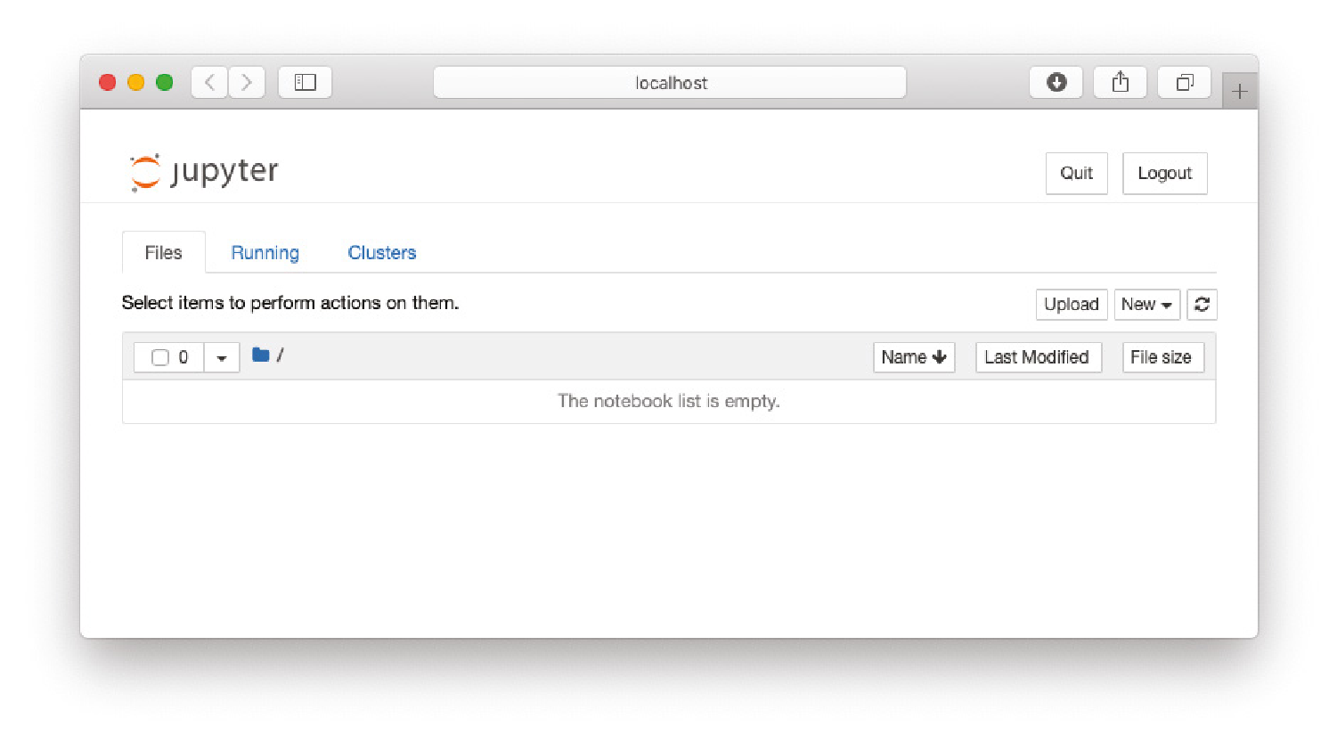

**Figure 1.8:** The Jupyter Notebook Home page

**TIP The Home page of Jupyter Notebook shows the content of the directory from where it is launched. Hence, it is always useful to change to the directory that contains your source code first, prior to launching Jupyter Notebook.**

***Running Jupyter Notebook for Windows***

The best way to launch Jupyter Notebook in Windows is to launch it from the *Anaconda Prompt*. The Anaconda Prompt automatically runs the batch file located at **C:\Anaconda3\Scripts\activate.bat** with the following argument:

**C:\Anaconda3\Scripts\activate.bat C:\Anaconda3**

**TIP Note that the exact location of the Anaconda3 folder can vary. For example, by default Windows 10 will install Anaconda in C:\Users\<username>\AppData\ Local\Continuum\anaconda3 instead of C:\Anaconda3.**

This sets up the necessary paths for accessing Anaconda and its libraries.

To launch the Anaconda Prompt, type **Anaconda Prompt** in the Windows Run textbox. To launch Jupyter Notebook from the Anaconda Prompt, type the following:

**(base) C:\Users\Wei-Meng Lee\Python Machine Learning>jupyter notebook** You will then see this:

**[I 21:30:48.048 NotebookApp] JupyterLab beta preview extension loaded from**

**C:\Anaconda3\lib\site-packages\jupyterlab**

**[I 21:30:48.048 NotebookApp] JupyterLab application directory is**

**C:\Anaconda3\share\jupyter\lab**

**[I 21:30:49.315 NotebookApp] Serving notebooks from local directory:**

**C:\Users\Wei-Meng Lee\Python Machine Learning**

**[I 21:30:49.315 NotebookApp] 0 active kernels [I 21:30:49.322 NotebookApp] The Jupyter Notebook is running at:**

**[I 21:30:49.323 NotebookApp]**

**http://localhost:8888/?token=482bfe023bd77731dc132b5340f335b9e450ce5e1c4 d7b2f [I 21:30:49.324 NotebookApp] Use Control-C to stop this server and shut down all kernels (twice to skip confirmation).**

**[C 21:30:49.336 NotebookApp]**

**Copy/paste this URL into your browser when you connect for the first time, to login with a token:**

**http://localhost:8888/?token=482bfe023bd77731dc132b5340f335b9e45**

**0ce5e1c4d7b2f**

**[I 21:30:49.470 NotebookApp] Accepting one-time-token-authenticated connection from ::1**

Essentially, Jupyter Notebook starts a web server listening at port 8888. It then launches your web browser showing you the page in Figure 1.9.

***Creating a New Notebook***

To create a new notebook, locate the New button on the right side of the screen and click it. You should be able to see Python 3 in the dropdown (see Figure 1.10).

Click this option.

Your new notebook will now appear (see Figure 1.11).

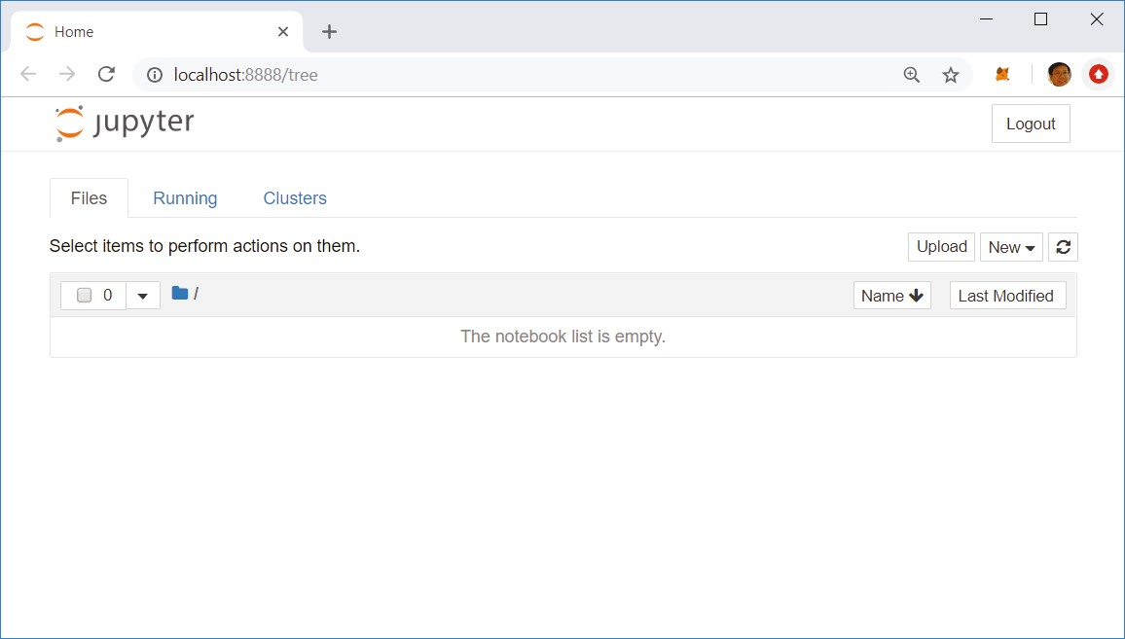

**Figure 1.9:** Jupyter Notebook showing the Home page

***Naming the Notebook***

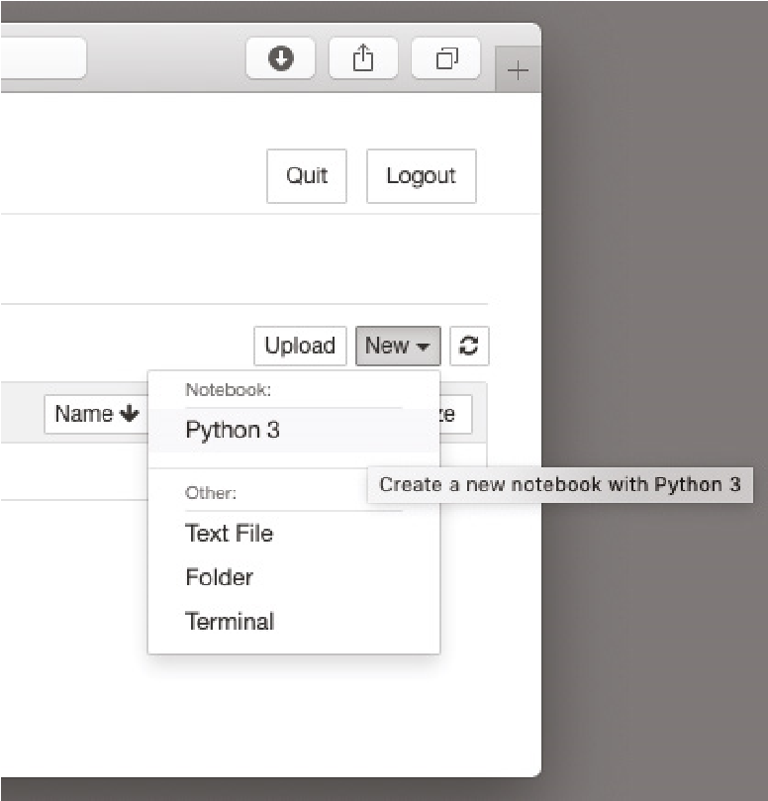

**Figure 1.10:**

Creating a new Python 3 notebook

By default, your notebook will be named “Untitled”. To give it a suitable name, click “Untitled” and type in a new name. Your notebook will be saved in the directory from which you have launched Jupyter Notebook. The notebook will be saved with a filename that you have given it, together with the **.ipynb** extension.

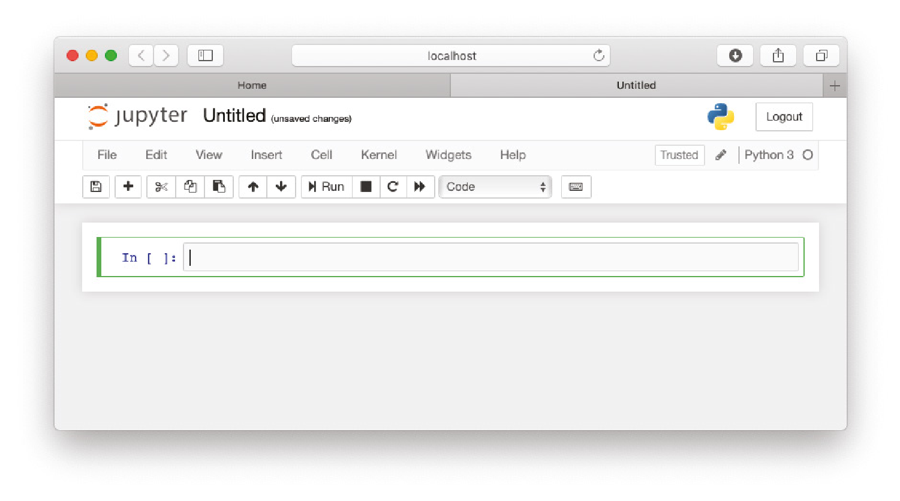

**Figure 1.11:** The Python 3 notebook created in Jupyter Notebook

**TIP Jupyter Notebook was previously known as** *iPython Notebook***; hence the .ipynb extension.**

***Adding and Removing Cells***

A notebook contains one or more cells. You can type Python statements in each cell. Using Jupyter Notebook, you can divide your code into multiple snippets and put them into cells so that they can be run individually.

To add more cells to your notebook, click the **+** button. You can also use the Insert menu item and select the option Insert Cell Above to add a new cell above the current cell, or select the Insert Cell Below option to add a new cell below the current cell.

Figure 1.12 shows the notebook containing two cells.

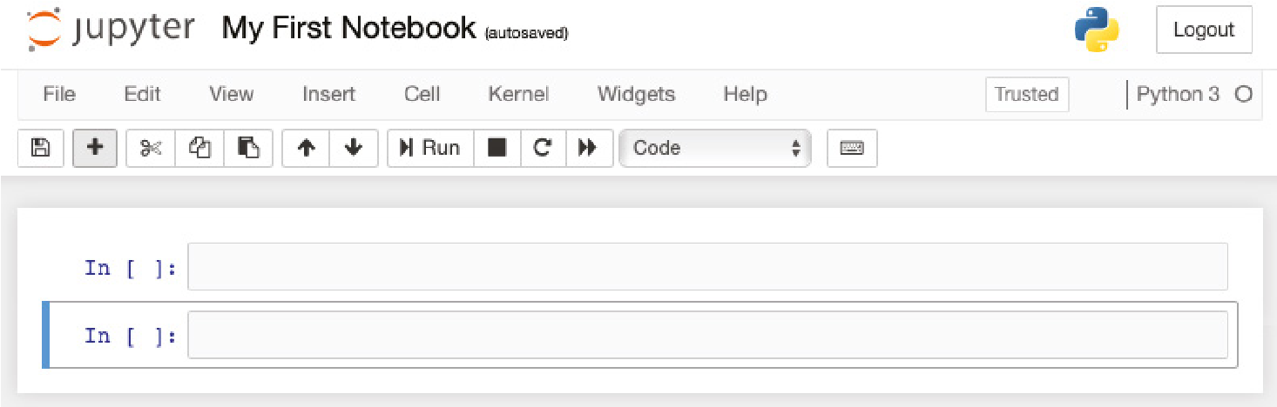

**Figure 1.12:** The notebook with two cells

***Running a Cell***

Each cell in a Jupyter Notebook can be run independently. To execute (run) the code in a cell, press Ctrl+Enter, or click the arrow icon displayed to the left of the cell when you hover your mouse over it (see Figure 1.13).

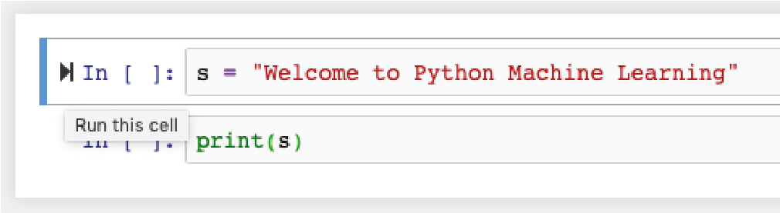

**Figure 1.13:** Running (executing) the code in the cell

When cells are run, the order in which they were executed is displayed as a running number. Figure 1.14 shows two cells executed in the order shown. The number 1 in the first cell indicates that this cell was executed first, followed by number 2 in the second cell. The output of the cell is displayed immediately after the cell. If you go back to the first cell and run it, the number will then change to 3.

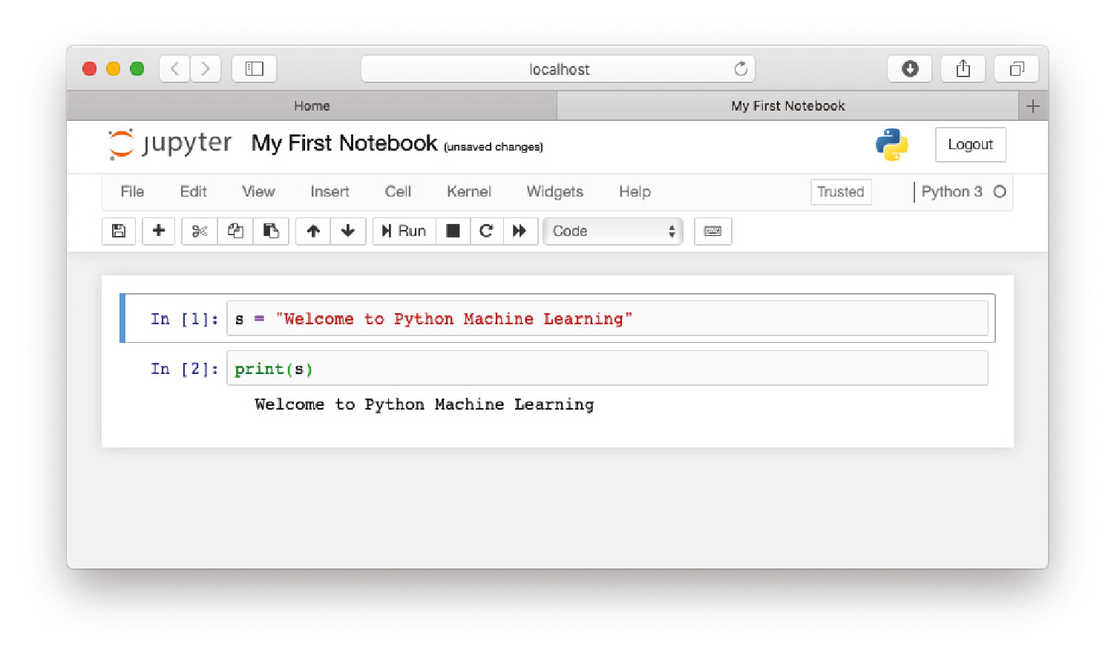

**Figure 1.14:** The number displayed next to the cell indicates the order in which it was run

As you can see, code that was executed previously in another cell retains its value in memory when you execute the current cell. However, you need to be careful when you are executing cells in various orders. Consider the example in Figure 1.15. Here, we have three cells. In the first cell, we initialize the value of **s** to a string and print its value in the second cell. In the third cell, we change the value of **s** to another string.

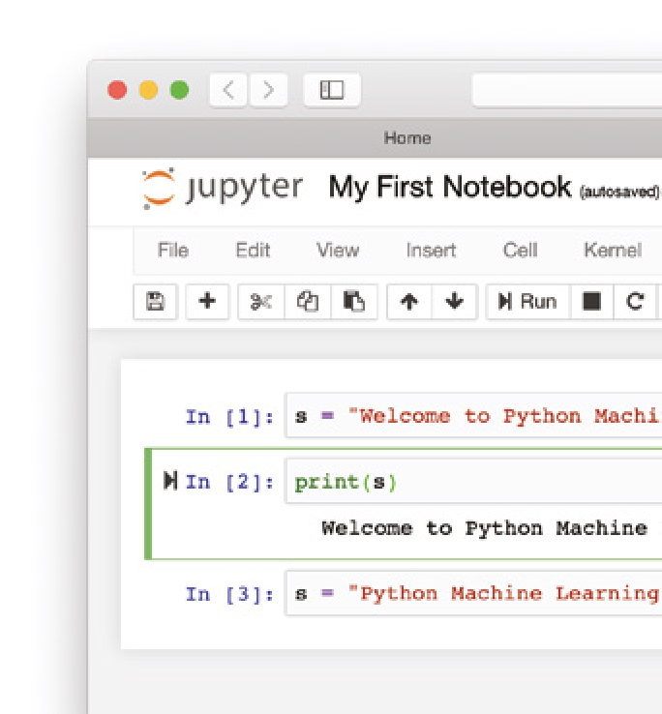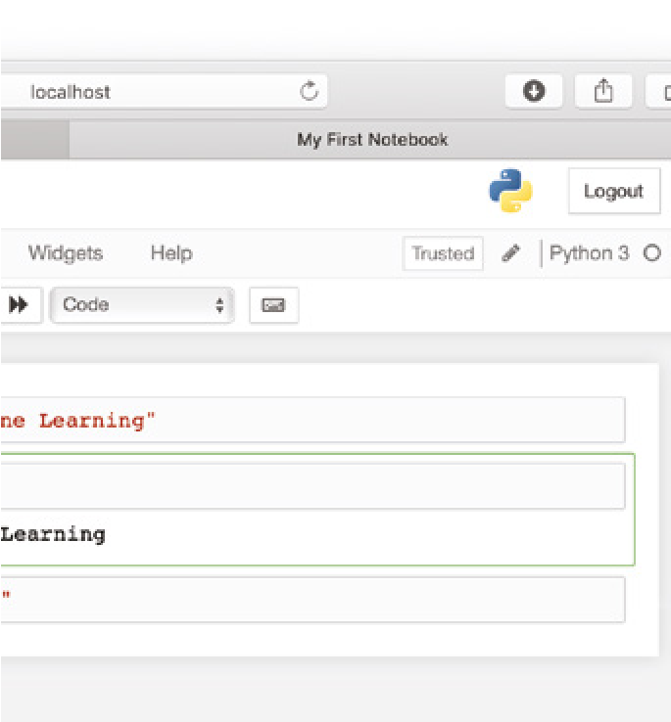

**Figure 1.15:**

The notebook with three cells

Very often, in the midst of testing your code, it is very common that you may make modifications in one cell and go back to an earlier cell to retest the code. In this example, suppose that you go back and rerun the second cell. In this case, you would now print out the new value of **s** (see Figure 1.16). At first glance, you may be expecting to see the string “Welcome to Python Machine Learning,” but since the second cell was rerun after the third cell, the value of **s** will take on the “Python Machine Learning” string.

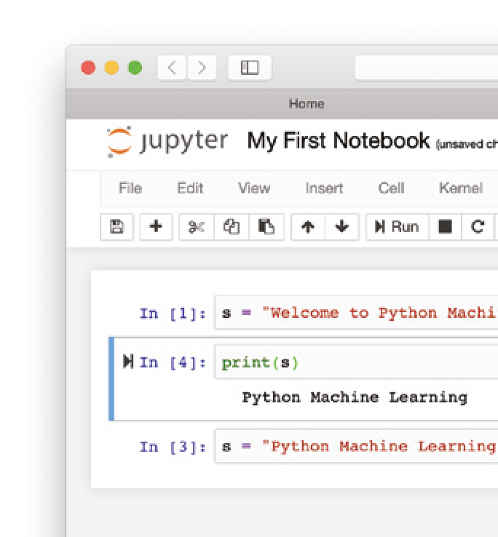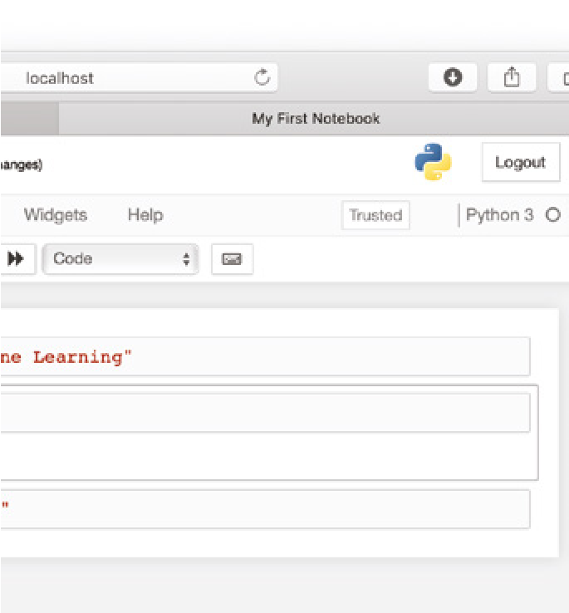

**Figure 1.16:** Executing the cells in non-linear order

To restart the execution from the first cell, you need to restart the kernel, or select Cell ⇨ Run All.

***Restarting the Kernel***

As you can run any cell in your notebook in any order, after a while things may get a little messy. You may want to restart the execution and start all over again. This is where restarting the kernel is necessary (see Figure 1.17).

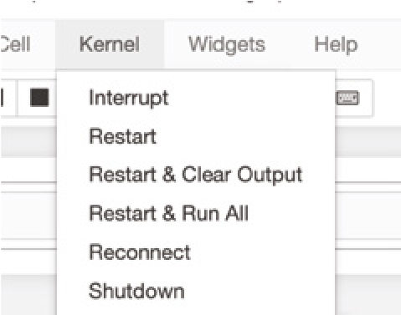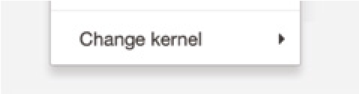

**Figure 1.17:** Restarting the kernel

**TIP When your code goes into an infinite loop, you need to restart the kernel.**

**There are two common scenarios for restarting the kernel:**

**Restart & Clear Output Restart the kernel and clear all of the outputs. You can now run any of the cells in any order you like.**

**Restart & Run All Restart the kernel and run all of the cells from the first to the last. This is very useful if you are satisfied with your code and want to test it in its entirety.**

***Exporting Your Notebook***

Once you are done with your testing in Jupyter Notebook, you can now export code from your notebook to a Python file. To do so, select File ⇨ Download as ⇨ python (.py). (See Figure 1.18.)

A file with the same name as your notebook, but now with the **.py** extension, will be downloaded to your computer.

**TIP Make sure that you select the python (.py) option and not the Python (.py) option. The latter option saves the file with an .html extension.**

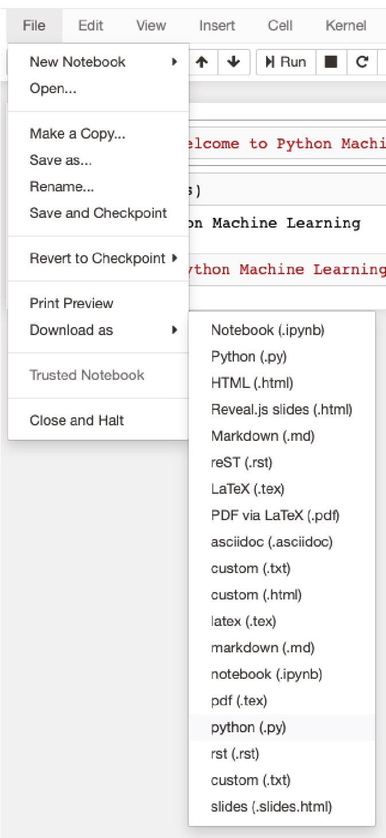

**Figure 1.18:** Exporting your notebook to a Python file

***Getting Help***

You can get help in Jupyter Notebook quite easily. To get help on a function in Python, position your cursor on the function name and press Shift+Tab. This will display a pop-up known as the *tooltip* (see Figure 1.19).

To expand the tooltip (see Figure 1.20), click the **+** button on the upper-right corner of the tooltip. You can also get the expanded version of the tooltip when you press Shift+Tab+Tab.

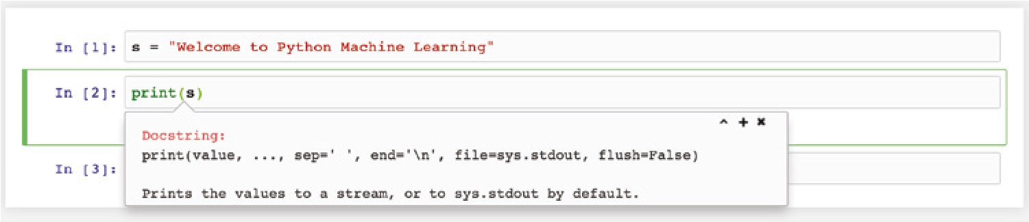

**Figure 1.19:** The tooltip displays help information

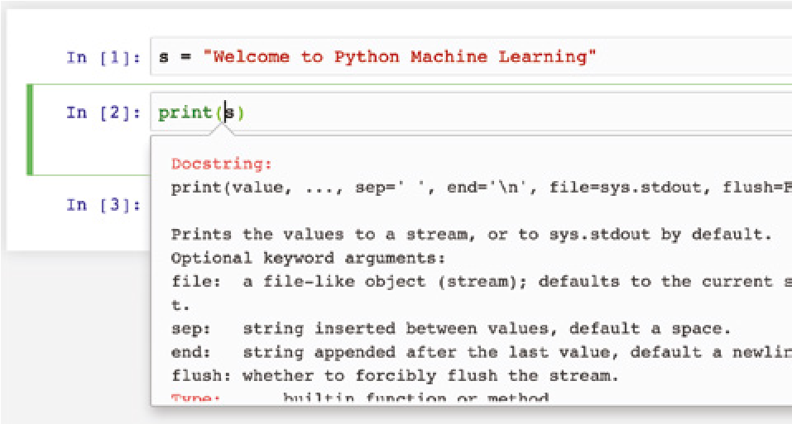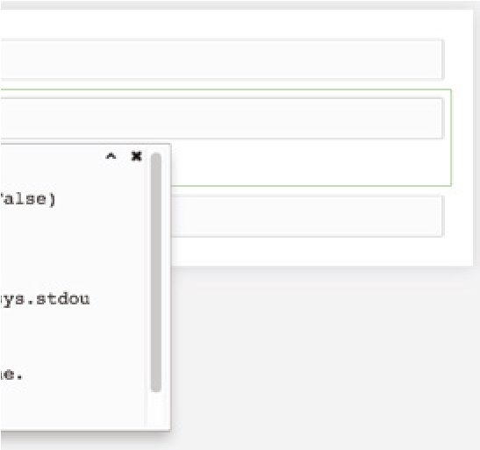

**Figure 1.20:** Expanding the tooltip to show more detail

**Summary**

In this chapter, you learned about machine learning and the types of problems that it can solve. You also studied the main difference between supervised and unsupervised learning. For developers who are new to Python programming, I strongly advise you to install Anaconda, which will provide all of the libraries and packages you’ll need to follow the examples in this book. I know that you are all eager to start learning, so let’s move onward to Chapter 2!

|  |
| --- |
| **CHAPTER** |
| **2** |

**Extending Python Using NumPy**

**What Is NumPy?**

In Python, you usually use the **list** data type to store a collection of items. The Python list is similar to the concept of arrays in languages like Java, C#, and JavaScript. The following code snippet shows a Python list: **list1 = [1,2,3,4,5]**

Unlike arrays, a Python list does not need to contain elements of the same type. The following example is a perfectly legal list in Python: **list2 = [1,"Hello",3.14,True,5]**

While this unique feature in Python provides flexibility when handling multiple types in a list, it has its disadvantages when processing large amounts of data (as is typical in machine learning and data science projects). The key problem with Python’s **list** data type is its efficiency. To allow a list to have non-uniform type items, each item in the list is stored in a memory location, with the list containing an “array” of pointers to each of these locations. A Python list requires the following:

**■**At least 4 bytes per pointer.

**■**At least 16 bytes for the smallest Python object—4 bytes for a pointer, 4 bytes for the reference count, 4 bytes for the value. All of these together round up to 16 bytes.

Python® Machine Learning, First Edition. Wei-Meng Lee. **19**

© 2019 John Wiley & Sons, Inc. Published 2019 by John Wiley & Sons, Inc.

Due to the way that a Python list is implemented, accessing items in a large list is computationally expensive. To solve this limitation with Python’s list feature, Python programmers turn to *NumPy*, an extension to the Python programming language that adds support for large, multidimensional arrays and matrices, along with a large library of high-level mathematical functions to operate on these arrays.

In NumPy, an array is of type **ndarray** (n-dimensional array), and all elements must be of the same type. An **ndarray** object represents a multidimensional, homogeneous array of fixed-size items, and it is much more efficient than Python’s list. The **ndarray** object also provides functions that operate on an entire array at once.

**Creating NumPy Arrays**

Before using NumPy, you first need to import the NumPy package (you may use its conventional alias ***np*** if you prefer): **import numpy as np**

The first way to make NumPy arrays is to create them intrinsically, using the functions built right into NumPy. First, you can use the **arange()** function to create an evenly spaced array with a given interval:

**a1 = np.arange(10) # creates a range from 0 to 9 print(a1) # [0 1 2 3 4 5 6 7 8 9] print(a1.shape) # (10,)**

The preceding statement creates a rank 1 array (one-dimensional) of ten elements. To get the shape of the array, use the **shape** property. Think of ***a1*** as a 10×1 matrix.

You can also specify a step in the **arange()** function. The following code snippet inserts a step value of 2:

**a2 = np.arange(0,10,2) # creates a range from 0 to 9, step 2 print(a2) # [0 2 4 6 8]**

To create an array of a specific size filled with 0s, use the **zeros()** function:

**a3 = np.zeros(5) # create an array with all 0s print(a3) # [ 0. 0. 0. 0. 0.] print(a3.shape) # (5,)**

You can also create two-dimensional arrays using the **zeros()** function:

**a4 = np.zeros((2,3)) # array of rank 2 with all 0s; 2 rows and 3**

**# columns print(a4.shape) # (2,3) print(a4)**

**'''**

**[[ 0. 0. 0.]**

**[ 0. 0. 0.]]**

**'''**

If you want an array filled with a specific number instead of 0, use the **full()**

function:

**a5 = np.full((2,3), 8) # array of rank 2 with all 8s print(a5)**

**'''**

**[[8 8 8]**

**[8 8 8]]**

**'''**

Sometimes, you need to create an array that mirrors an identity matrix. In NumPy, you can do so using the **eye()** function:

**a6 = np.eye(4) # 4x4 identity matrix print(a6)**

**'''**

**[[ 1. 0. 0. 0.]**

**[ 0. 1. 0. 0.]**

**[ 0. 0. 1. 0.]**

**[ 0. 0. 0. 1.]]**

**'''**

The **eye()** function returns a 2-D array with ones on the diagonal and zeros

elsewhere.

To create an array filled with random numbers, you can use the **random()** function from the **numpy.random** module:

**a7 = np.random.random((2,4)) # rank 2 array (2 rows 4 columns) with**

**# random values**

**# in the half-open interval [0.0, 1.0)**

**print(a7)**

**'''**

**[[ 0.48255806 0.23928884 0.99861279 0.4624779 ]**

**[ 0.18721584 0.71287041 0.84619432 0.65990083]]**

**'''**

Another way to create a NumPy array is to create it from a Python list as follows:

**list1 = [1,2,3,4,5] # list1 is a list in Python r1 = np.array(list1) # rank 1 array print(r1) # [1 2 3 4 5]**

The array created in this example is a rank 1 array.

**Array Indexing**

Accessing elements in the array is similar to accessing elements in a Python list:

**print(r1[0]) # 1 print(r1[1]) # 2**

The following code snippet creates another array named ***r2***, which is two-dimensional:

**list2 = [6,7,8,9,0]**

**r2 = np.array([list1,list2]) # rank 2 array**

**print(r2)**

**'''**

**[[1 2 3 4 5]**

**[6 7 8 9 0]]**

**'''**

**print(r2.shape) # (2,5) - 2 rows and 5 columns print(r2[0,0]) # 1 print(r2[0,1]) # 2 print(r2[1,0]) # 6**

Here, ***r2*** is a rank 2 array, with two rows and five columns.

Besides using an index to access elements in an array, you can also use a list as the index as follows:

**list1 = [1,2,3,4,5] r1 = np.array(list1) print(r1[[2,4]]) # [3 5]**

**Boolean Indexing**

In addition to using indexing to access elements in an array, there is another very cool way to access elements in a NumPy array. Consider the following: **print(r1>2) # [False False True True True]**

This statement prints out a list containing Boolean values. What it actually does is to go through each element in ***r1*** and check if each element is more than two. The result is a Boolean value, and a list of Boolean values is created at the end of the process. You can feed the list results back into the array as the index:

**print(r1[r1>2]) # [3 4 5]**

This method of accessing elements in an array is known as *Boolean Indexing*.

This method is very useful. Consider the following example:

**nums = np.arange(20)**

**print(nums) # [ 0 1 2 3 4 5 6 7 8 9 10 11 12 13 14 15 16 17 18 19]**

If you want to retrieve all of the odd numbers from the list, you could simply use Boolean Indexing as follows:

**odd_num = nums[nums % 2 == 1] print(odd_num) # [ 1 3 5 7 9 11 13 15 17 19]**

**Slicing Arrays**

Slicing in NumPy arrays is similar to how it works with a Python list. Consider the following example:

**a = np.array([[1,2,3,4,5], [4,5,6,7,8],**

**[9,8,7,6,5]]) # rank 2 array print(a)**

**'''**

**[[1 2 3 4 5]**

**[4 5 6 7 8]**

**[9 8 7 6 5]]**

**'''**

To extract the last two rows and first two columns, you can use slicing:

**b1 = a[1:3, :3] # row 1 to 3 (not inclusive) and first 3 columns**

**print(b1)**

The preceding code snippet will print out the following:

**[[4 5 6]**

**[9 8 7]]**

Let’s dissect this code. Slicing has the following syntax: **[start:stop]**. For two-dimensional arrays, the slicing syntax becomes **[start:stop, start:stop]**. The **start:stop** before the comma (**,**) refers to the rows, and the **start:stop** after the comma (**,**) refers to the columns. Hence for **[1:3, :3]**, this means that you want to extract the rows with index 1 right up to 3 (but not including 3), and columns starting from the first column right up to index 3 (but not including 3). The general confusion regarding slicing is the end index. You need to remember that the end index is not included in the answer. A better way to visualize slicing is to write the index of each row and column between the numbers, instead of at the center of the number, as shown in Figure 2.1.

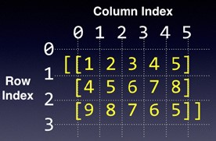

**Figure 2.1:** Writing the index for row and column in between the numbers

Using this approach, it is now much easier to visualize how slicing works (see Figure 2.2).

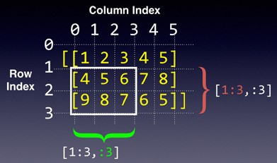

**Figure 2.2:** Performing slicing using the new approach

What about negative indices? For example, consider the following:

**b2 = a[-2:,-2:] print(b2)**

Using the method just described, you can now write the negative row and column indices, as shown in Figure 2.3.

You should now be able to derive the answer quite easily, which is as follows:

**[[7 8]**

1. **5]]**

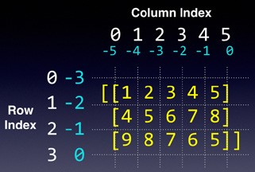

**Figure 2.3:** Writing the negative indices for rows and columns

**NumPy Slice Is a Reference**

It is noteworthy that the result of a NumPy slice is a reference and not a copy of the original array. Consider the following:

**b3 = a[1:, 2:] # row 1 onwards and column 2 onwards # b3 is now pointing to a subset of a print(b3)**

The result is as follows:

**[[6 7 8]**

1. **6 5]]**

Here, ***b3*** is actually a reference to the original array ***a*** (see Figure 2.4).

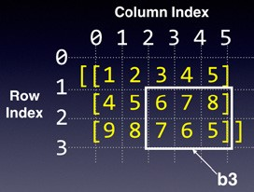

**Figure 2.4:** Slicing returns a reference to the original array and not a copy

Hence, if you were to change one of the elements in ***b3*** as follows:

**b3[0,2] = 88 # b3[0,2] is pointing to a[1,4]; modifying it will**

**# modify the original array print(a)**

The result will affect the content of ***a*** like this:

**[[ 1 2 3 4 5] [ 4 5 6 7 88]**

**[ 9 8 7 6 5]]**

Another salient point to note is that the result of the slicing is dependent on how you slice it. Here is an example:

**b4 = a[2:, :] # row 2 onwards and all columns print(b4) print(b4.shape)**

In the preceding statement, you are getting rows with index 2 and above and all of the columns. The result is a rank 2 array, like this:

**[[9 8 7 6 5]]**

**(1,5)**

If you have the following instead . . .

**b5 = a[2, :] # row 2 and all columns print(b5) # b5 is rank 1**

. . . then the result would be a rank 1 array:

**[9 8 7 6 5]**

Printing the shape of the array confirms this:

**print(b5.shape) # (5,)**

**Reshaping Arrays**

You can reshape an array to another dimension using the **reshape()** function. Using the ***b5*** (which is a rank 1 array) example, you can reshape it to a rank 2 array as follows:

**b5 = b5.reshape(1,-1) print(b5)**

**'''**

**[[9 8 7 6 5]]**

**'''**

In this example, you call the **reshape()** function with two arguments. The first **1** indicates that you want to convert it into rank 2 array with 1 row, and the **-1** indicates that you will leave it to the **reshape()** function to create the correct number of columns. Of course, in this example, it is clear that after reshaping there will be five columns, so you can call the **reshape()** function as **reshape(1,5)**. In more complex cases, however, it is always convenient to be able to use **-1** to let the function decide on the number of rows or columns to create.

Here is another example of how to reshape ***b4*** (which is a rank 2 array) to rank 1:

**b4.reshape(-1,)**

**'''**

**[9 8 7 6 5]**

**'''**

The **-1** indicates that you let the function decide how many rows to create as long as the end result is a rank 1 array.

**TIP To convert a rank 2 array to a rank 1 array, you can also use the flatten() or ravel() functions. The flatten() function always returns a copy of the array, while the ravel() and reshape() functions return a view (reference) of the original array.**

**Array Math**

You can perform array math very easily on NumPy arrays. Consider the following two rank 2 arrays:

**x1 = np.array([[1,2,3],[4,5,6]]) y1 = np.array([[7,8,9],[2,3,4]])**

To add these two arrays together, you use the **+** operator as follows: **print(x1 + y1)**

The result is the addition of each individual element in the two arrays:

**[[ 8 10 12]**

**[ 6 8 10]]**

Array math is important, as it can be used to perform vector calculations.

A good example is as follows:

**x = np.array([2,3]) y = np.array([4,2]) z = x + y**

**'''**

**[6 5]**

**'''**

Figure 2.5 shows the use of arrays to represent vectors and uses array addition to perform vector addition.

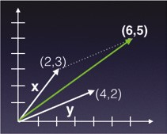

**Figure 2.5:** Using array addition for vector addition

Besides using the **+** operator, you can also use the **np.add()** function to add two arrays: **np.add(x1,y1)**

Apart from addition, you can also perform subtraction, multiplication, as well as division with NumPy arrays:

**print(x1 - y1) # same as np.subtract(x1,y1)**

**'''**

**[[-6 -6 -6]**

**[ 2 2 2]]**

**'''**

**print(x1 * y1) # same as np.multiply(x1,y1)**

**'''**

**[[ 7 16 27]**

**[ 8 15 24]]**

**'''**

**print(x1 / y1) # same as np.divide(x1,y1)**

**'''**

**[[ 0.14285714 0.25 0.33333333]**

**[ 2. 1.66666667 1.5 ]]**

**'''**

What’s a practical use of the ability to multiply or divide two arrays? As an example, suppose you have three arrays: one containing the names of a group of people, another the corresponding heights of these individuals, and the last one the corresponding weights of the individuals in the group:

**names = np.array(['Ann','Joe','Mark']) heights = np.array([1.5, 1.78, 1.6]) weights = np.array([65, 46, 59])**

Now say that you want to calculate the Body Mass Index (BMI) of this group of people. The formula to calculate BMI is as follows:

**■**Divide the weight in kilograms (kg) by the height in meters (m)

**■**Divide the answer by the height again

Using the BMI, you can classify a person as healthy, overweight, or underweight using the following categories:

**■**Underweight if BMI < 18.5

**■**Overweight if BMI > 25

**■**Normal weight if 18.5 <= BMI <= 25

Using array division, you could simply calculate BMI using the following statement:

**bmi = weights/heights **2 # calculate the BMI print(bmi) # [ 28.88888889 14.51836889 23.046875 ]**

Finding out who is overweight, underweight, or otherwise is now very easy:

**print("Overweight: " , names[bmi>25])**

**# Overweight: ['Ann']**

**print("Underweight: " , names[bmi<18.5])**

**# Underweight: ['Joe']**

**print("Healthy: " , names[(bmi>=18.5) & (bmi<=25)]) # Healthy: ['Mark']**

**Dot Product**

Note that when you multiply two arrays, you are actually multiplying each of the corresponding elements in the two arrays. Very often, you want to perform a scalar product (also commonly known as *dot product*). The dot product is an algebraic operation that takes two coordinate vectors of equal size and returns a single number. The dot product of two vectors is calculated by multiplying corresponding entries in each vector and adding up all of those products. For example, given two vectors—a = [a1, a2, . . ., an] and b = [b1, b2, . . ., bn]—the dot product of these two vectors is a1b1 + a2b2 + . . . + anbn.

In NumPy, dot product is accomplished using the **dot()** function:

**x = np.array([2,3]) y = np.array([4,2]) np.dot(x,y) # 2x4 + 3x2 = 14**

Dot products also work on rank 2 arrays. If you perform a dot product of two rank 2 arrays, it is equivalent to the following *matrix multiplication*:

**x2 = np.array([[1,2,3],[4,5,6]]) y2 = np.array([[7,8],[9,10], [11,12]])**

**print(np.dot(x2,y2)) # matrix multiplication**

**'''**

**[[ 58 64]**

**[139 154]]**

**'''**

Figure 2.6 shows how matrix multiplication works. The first result, 58, is derived from the dot product of the first row of the first array and the first column of the second array—1 × 7 + 2 × 9 + 3 × 11 = 58. The second result of 64 is obtained by the dot product of the first row of the first array and the second column of the second array—1 × 8 + 2 × 10 + 3 × 12 = 64. And so on.

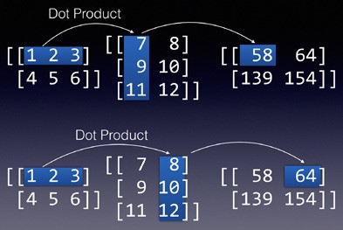

**Figure 2.6:** Performing matrix multiplication on two arrays

**Matrix**

NumPy provides another class in addition to arrays (**ndarray**): **matrix**. The *matrix* class is a subclass of the **ndarray**, and it is basically identical to the **ndarray** with one notable exception—a matrix is strictly two-dimensional, while an **ndarray** can be multidimensional. Creating a matrix object is similar to creating a NumPy array:

**x2 = np.matrix([[1,2],[4,5]]) y2 = np.matrix([[7,8],[2,3]])**

You can also convert a NumPy array to a matrix using the **asmatrix()** function:

**x1 = np.array([[1,2],[4,5]]) y1 = np.array([[7,8],[2,3]]) x1 = np.asmatrix(x1) y1 = np.asmatrix(y1)**

Another important difference between an **ndarray** and a matrix occurs when you perform multiplications on them. When multiplying two **ndarray** objects, the result is the element-by-element multiplication that we have seen earlier. On the other hand, when multiplying two matrix objects, the result is the dot product (equivalent to the **np.dot()** function):

**x1 = np.array([[1,2],[4,5]]) y1 = np.array([[7,8],[2,3]])**

**print(x1 * y1) # element-by-element multiplication**

**'''**

**[[ 7 16]**

**[ 8 15]]**

**'''**

**x2 = np.matrix([[1,2],[4,5]]) y2 = np.matrix([[7,8],[2,3]])**

**print(x2 * y2) # dot product; same as np.dot()**

**'''**

**[[11 14]**

**[38 47]]**

**'''**

**Cumulative Sum**

Very often, when dealing with numerical data, there is a need to find the cumulative sum of numbers in a NumPy array. Consider the following array:

**a = np.array([(1,2,3),(4,5,6), (7,8,9)]) print(a)**

**'''**

**[[1 2 3]**

**[4 5 6]**

**[7 8 9]]**

**'''**

You can call the **cumsum()** function to get the cumulative sum of the elements:

**print(a.cumsum()) # prints the cumulative sum of all the**

**# elements in the array**

**# [ 1 3 6 10 15 21 28 36 45]**

In this case, the **cumsum()** function returns a rank 1 array containing the cumulative sum of all of the elements in the ***a*** array. The **cumsum()** function also takes in an optional argument—**axis**. Specifying an **axis** of **0** indicates that you want to get the cumulative sum of each column:

**print(a.cumsum(axis=0)) # sum over rows for each of the 3 columns**

**'''**

**[[ 1 2 3]**

**[ 5 7 9]**

**[12 15 18]]**

**'''**

Specifying an axis of **1** indicates that you want to get the cumulative sum of each row:

**print(a.cumsum(axis=1)) # sum over columns for each of the 3 rows**

**'''**

**[[ 1 3 6]**

**[ 4 9 15]**

**[ 7 15 24]]**

**'''**

Figure 2.7 makes it easy to understand how the **axis** parameter affects the way that cumulative sums are derived.

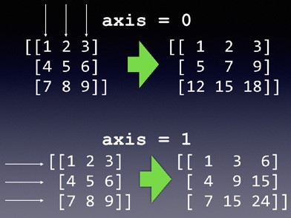

**Figure 2.7:** Performing cumulative sums on columns and rows

**NumPy Sorting**

NumPy provides a number of efficient sorting functions that make it very easy to sort an array. The first function for sorting is **sort()**, which takes in an array and returns a sorted array. Consider the following:

**ages = np.array([34,12,37,5,13])**

**sorted_ages = np.sort(ages) # does not modify the original array print(sorted_ages) # [ 5 12 13 34 37] print(ages) # [34 12 37 5 13]**

As you can see from the output, the **sort()** function does not modify the original array. Instead it returns a sorted array. If you want to sort the original array, call the **sort()** function on the array itself as follows:

**ages.sort() # modifies the array print(ages) # [ 5 12 13 34 37]**

There is another function used for sorting—**argsort()**. To understand how it works, it is useful to examine the following code example:

**ages = np.array([34,12,37,5,13]) print(ages.argsort()) # [3 1 4 0 2]**

The **argsort()** function returns the indices that will sort an array. In the preceding example, the first element (**3**) in the result of the **argsort()** function means that the smallest element after the sort is in index 3 of the original array, which is the number 5. The next number is in index **1**, which is the number 12, and so on. Figure 2.8 shows the meaning of the sort indices.

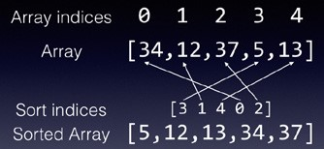

**Figure 2.8:** Understanding the meaning of the result of the **argsort()** function

To print the sorted ***ages*** array, use the result of **argsort()** as the index to the ***ages*** array: **print(ages[ages.argsort()]) # [ 5 12 13 34 37]**

What is the real use of **argsort()**? Imagine that you have three arrays representing a list of people, along with their ages and heights:

**persons = np.array(['Johnny','Mary','Peter','Will','Joe']) ages = np.array([34,12,37,5,13]) heights = np.array([1.76,1.2,1.68,0.5,1.25])**

Suppose that you want to sort this group of people by age. If you simply sort the ***ages*** array by itself, the other two arrays would not be sorted correctly based on age. This is where **argsort()** comes in really handy:

**sort_indices = np.argsort(ages) # performs a sort based on ages # and returns an array of indices**

**# indicating the sort order**

Once the sort indices are obtained, simply feed them into the three arrays:

**print(persons[sort_indices]) # ['Will' 'Mary' 'Joe' 'Johnny'**

**'Peter']**

**print(ages[sort_indices]) # [ 5 12 13 34 37] print(heights[sort_indices]) # [ 0.5 1.2 1.25 1.76 1.68]**

They would now be sorted based on age. As you can see, Will is the youngest, followed by Mary, and so on. The corresponding height for each person would also be in the correct order.

If you wish to sort based on name, then simply use **argsort()** on the ***persons*** array and feed the resulting indices into the three arrays:

**sort_indices = np.argsort(persons) # sort based on names**

**print(persons[sort_indices]) # ['Joe' 'Johnny' 'Mary' 'Peter'**

**'Will']**

**print(ages[sort_indices]) # [13 34 12 37 5] print(heights[sort_indices]) # [ 1.25 1.76 1.2 1.68 0.5 ]**

To reverse the order of the names and display them in descending order, use the Python**[::-1]** notation:

**reverse_sort_indices = np.argsort(persons)[::-1] # reverse the order of a list print(persons[reverse_sort_indices]) # ['Will' 'Peter' 'Mary' # 'Johnny' 'Joe'] print(ages[reverse_sort_indices]) # [ 5 37 12 34 13] print(heights[reverse_sort_indices]) # [ 0.5 1.68 1.2 1.76 # 1.25]**

**Array Assignment**

When assigning NumPy arrays, you have to take note of how arrays are assigned. Following are a number of examples to illustrate this.

**Copying by Reference**

Consider an array named ***a1***:

**list1 = [[1,2,3,4], [5,6,7,8]] a1 = np.array(list1) print(a1)**

**'''**

**[[1 2 3 4]**

**[5 6 7 8]]**

**'''**

When you try to assign ***a1*** to another variable, ***a2***, a copy of the array is created:

**a2 = a1 # creates a copy by reference print(a1)**

**'''**

**[[1 2 3 4]**

**[5 6 7 8]]**

**'''**

**print(a2)**

**'''**

**[[1 2 3 4]**

**[5 6 7 8]]**

**'''**

However, ***a2*** is actually pointing to the original ***a1***. So, any changes made to either array will affect the other as follows:

**a2[0][0] = 11 # make some changes to a2 print(a1) # affects a1**

**'''**

**[[11 2 3 4]**

**[ 5 6 7 8]]**

**'''**

**print(a2)**

**'''**

**[[11 2 3 4]**

**[ 5 6 7 8]]**

**'''**

**TIP In the “Reshaping Arrays” section earlier in this chapter, you saw how to change the shape of an ndarray using the reshape() function. In addition to using the reshape() function, you can also use the shape property of the ndarray to change its dimension.**

If ***a1*** now changes shape, ***a2*** will also be affected as follows:

**a1.shape = 1,-1 # reshape a1 print(a1)**

**'''**

**[[11 2 3 4 5 6 7 8]]**

**'''**

**print(a2) # a2 also changes shape**

**'''**

**[[11 2 3 4 5 6 7 8]]**

**'''**

**Copying by View (Shallow Copy)**

NumPy has a **view()** function that allows you to create a copy of an array by reference, while at the same time ensuring that changing the shape of the original array does not affect the shape of the copy. This is known as a *shallow copy*. Let’s take a look at an example to understand how this works:

**a2 = a1.view() # creates a copy of a1 by reference; but changes**

**# in dimension in a1 will not affect a2 print(a1)**

**'''**

**[[1 2 3 4]**

**[5 6 7 8]]**

**'''**

**print(a2)**

**'''**

**[[1 2 3 4]**

**[5 6 7 8]]**

**'''**

As usual, modify a value in ***a1*** and you will see the changes in ***a2***:

**a1[0][0] = 11 # make some changes in a1 print(a1)**

**'''**

**[[11 2 3 4]**

**[ 5 6 7 8]]**

**'''**

**print(a2) # changes is also seen in a2**

**'''**

**[[11 2 3 4]**

**[ 5 6 7 8]]**

**'''**

Up until now, the shallow copy is identical to the copying performed in the previous section. But with shallow copying, when you change the shape of ***a1***, ***a2*** is unaffected:

**a1.shape = 1,-1 # change the shape of a1 print(a1)**

**'''**

**[[11 2 3 4 5 6 7 8]]**

**'''**

**print(a2) # a2 does not change shape**

**'''**

**[[11 2 3 4]**

**[ 5 6 7 8]]**

**'''**

**Copying by Value (Deep Copy)**

If you want to copy an array by value, use the **copy()** function, as in the following example:

**list1 = [[1,2,3,4], [5,6,7,8]] a1 = np.array(list1) a2 = a1.copy() # create a copy of a1 by value (deep copy)**

The **copy()** function creates a deep copy of the array—it creates a complete copy of the array and its data. When you assign the copy of the array to another variable, any changes made to the shape of the original array will not affect its copy. Here’s the proof:

**a1[0][0] = 11 # make some changes in a1 print(a1)**

**'''**

**[[11 2 3 4]**

**[ 5 6 7 8]]**

**'''**

**print(a2) # changes is not seen in a2**

**'''**

**[[1 2 3 4]**

**[5 6 7 8]]**

**'''**

**a1.shape = 1,-1 # change the shape of a1 print(a1)**

**'''**

**[[11 2 3 4 5 6 7 8]]**

**'''**

**print(a2) # a2 does not change shape**

**'''**

**[[1 2 3 4]**

**[5 6 7 8]]**

**'''**

**Summary**

In this chapter, you learned about the use of NumPy as a way to represent data of the same type. You also learned how to create arrays of different dimensions, as well as how to access data stored within the arrays. An important feature of NumPy arrays is their ability to perform array math very easily and efficiently, without requiring you to write lots of code.

In the next chapter, you will learn about another important library that makes dealing with tabular data easy—Pandas.

|  |
| --- |
| **CHAPTER** |
| **3**  **Pandas** |

**Manipulating Tabular Data Using**

**What Is Pandas?**

While NumPy arrays are a much-improved N-dimensional array object ver-

sion over Python’s list, it is insufficient to meet the needs of data science. In the real world, data are often presented in table formats. For example, consider the content of the CSV file shown here:

**,DateTime,mmol/L**

**0,2016-06-01 08:00:00,6.1**

**1,2016-06-01 12:00:00,6.5**

**2,2016-06-01 18:00:00,6.7**

**3,2016-06-02 08:00:00,5.0**

**4,2016-06-02 12:00:00,4.9**

**5,2016-06-02 18:00:00,5.5**

**6,2016-06-03 08:00:00,5.6**

**7,2016-06-03 12:00:00,7.1**

**8,2016-06-03 18:00:00,5.9**

**9,2016-06-04 09:00:00,6.6**

**10,2016-06-04 11:00:00,4.1**

**11,2016-06-04 17:00:00,5.9**

**12,2016-06-05 08:00:00,7.6**

**13,2016-06-05 12:00:00,5.1**

**14,2016-06-05 18:00:00,6.9**

**15,2016-06-06 08:00:00,5.0**

Python® Machine Learning, First Edition. Wei-Meng Lee. **39**

© 2019 John Wiley & Sons, Inc. Published 2019 by John Wiley & Sons, Inc.

**16,2016-06-06 12:00:00,6.1**

**17,2016-06-06 18:00:00,4.9**

**18,2016-06-07 08:00:00,6.6**

**19,2016-06-07 12:00:00,4.1**

**20,2016-06-07 18:00:00,6.9**

**21,2016-06-08 08:00:00,5.6**

**22,2016-06-08 12:00:00,8.1**

**23,2016-06-08 18:00:00,10.9**

**24,2016-06-09 08:00:00,5.2**

**25,2016-06-09 12:00:00,7.1**

**26,2016-06-09 18:00:00,4.9**

The CSV file contains rows of data that are divided into three columns— index, date and time of recording, and blood glucose readings in mmol/L. To be able to deal with data stored as tables, you need a new data type that is more suited to deal with it—*Pandas*. While Python supports lists and dictionaries for manipulating structured data, it is not well suited for manipulating numerical tables, such as the one stored in the CSV file. *Pandas* is a Python package providing fast, flexible, and expressive data structures designed to make working with “relational” or “labeled” data both easy and intuitive.

**NOTE Pandas stands for *Panel Data Analysis*.**

Pandas supports two key data structures: Series and DataFrame. In this chapter, you will learn how to work with Series and DataFrames in Pandas.

**Pandas Series**

A *Pandas Series* is a one-dimensional NumPy-like array, with each element having an index (0, 1, 2, . . . by default); a Series behaves very much like a dictionary that includes an index. Figure 3.1 shows the structure of a Series in Pandas.

**SERIES**



0

**1**

index

element

1

**2**

2

**3**

3

**4**

4

**5**

**Figure 3.1:** A Pandas Series

To create a Series, you first need to import the **pandas** library (the convention is to use **pd** as the alias) and then use the **Series** class:

**import pandas as pd series = pd.Series([1,2,3,4,5])**

**print(series)**

The preceding code snippet will print the following output:

# 0 1

1. **2**
2. **3**
3. **4 4 5**

**dtype: int64**

By default, the index of a Series starts from 0.

**Creating a Series Using a Specified Index**

You can specify an optional index for a Series using the **index** parameter:

**series = pd.Series([1,2,3,4,5], index=['a','b','c','d','c']) print(series)**

The preceding code snippet prints out the following:

**a 1 b 2 c 3 d 4 c 5**

**dtype: int64**

It is worth noting that the index of a Series need not be unique, as the preceding output shows.

**Accessing Elements in a Series**

Accessing an element in a Series is similar to accessing an element in an array. You can use the position of the element as follows:

**print(series[2]) # 3**

**# same as print(series.iloc[2]) # 3 - based on the position of the index** The **iloc** indexer allows you to specify an element via its position.

Alternatively, you can also specify the value of the index of the element you wish to access like this:

**print(series['d']) # 4**

**# same as print(series.loc['d']) # 4 - based on the label in the index**

The **loc** indexer allows you to specify the *label* (value) of an index.

Note that in the preceding two examples, the result is an integer (which is the type of this Series). What happens if we do the following? **print(series['c']) # more than 1 row has the index 'c'** In this case, the result would be another Series:

**c 3 c 5 dtype: int64**

You can also perform slicing on a Series:

**print(series[2:]) # returns a Series print(series.iloc[2:]) # returns a Series**

The preceding code snippet generates the following output:

**c 3 d 4 c 5**

**dtype: int64**

**Specifying a Datetime Range as the Index of a Series**

Often, you want to create a timeseries, such as a running sequence of dates in a month. You could use the **date_range()** function for this purpose:

**dates1 = pd.date_range('20190525', periods=12) print(dates1)**

The preceding code snippet will display the following:

**DatetimeIndex(['2019-05-25', '2019-05-26', '2019-05-27', '2019-05-28',**

**'2019-05-29', '2019-05-30', '2019-05-31', '2019-06-01',**

**'2019-06-02', '2019-06-03', '2019-06-04', '2019-06-05'], dtype='datetime64[ns]', freq='D')**

To assign the range of dates as the index of a Series, use the **index** property of the Series like this:

**series = pd.Series([1,2,3,4,5,6,7,8,9,10,11,12]) series.index = dates1 print(series)**

You should see the following output:

**2019-05-25 1**

**2019-05-26 2**

**2019-05-27 3**

**2019-05-28 4**

**2019-05-29 5**

**2019-05-30 6**

**2019-05-31 7**

**2019-06-01 8**

**2019-06-02 9**

**2019-06-03 10**

**2019-06-04 11**

**2019-06-05 12**

**Freq: D, dtype: int64**

**Date Ranges**

In the previous section, you saw how to create date ranges using the **date_ range()** function. The **periods** parameter specifies how many dates you want to create, and the default frequency is **D** (for Daily). If you want to change the frequency to month, use the **freq** parameter and set it to **M**:

**dates2 = pd.date_range('2019-05-01', periods=12, freq='M') print(dates2)**

This will print out the following dates:

**DatetimeIndex(['2019-05-31', '2019-06-30', '2019-07-31', '2019-08-31',**

**'2019-09-30', '2019-10-31', '2019-11-30', '2019-12-31',**

**'2020-01-31', '2020-02-29', '2020-03-31', '2020-04-30'], dtype='datetime64[ns]', freq='M')**

Notice that when the frequency is set to month, the day of each date will be the last day of the month. If you want the date to start with the first day of the month, set the **freq** parameter to **MS**:

**dates2 = pd.date_range('2019-05-01', periods=12, freq='MS') print(dates2)**

You should now see that each of the dates starts with the first day of every month:

**DatetimeIndex(['2019-05-01', '2019-06-01', '2019-07-01', '2019-08-01',**

**'2019-09-01', '2019-10-01', '2019-11-01', '2019-12-01',**

**'2020-01-01', '2020-02-01', '2020-03-01', '2020-04-01'], dtype='datetime64[ns]', freq='MS')**

**TIP For other date frequencies, check out the *Offset Aliases* section of the documentation at:**

**http://pandas.pydata.org/pandas-docs/stable/timeseries**

**.html#offset-aliases**

Notice that Pandas automatically interprets the date you specified. In this case, *2019-05-01* is interpreted as 1st May, 2019. In some regions, developers will specify the date in the *dd-mm-yyyy* format. Thus to represent 5th January, 2019, you would specify it as follows:

**dates2 = pd.date_range('05-01-2019', periods=12, freq='MS') print(dates2)**

Note however that in this case, Pandas will interpret 05 as the month, 01 as the day, and 2019 as the year, as the following output proves:

**DatetimeIndex(['2019-05-01', '2019-06-01', '2019-07-01', '2019-08-01',**

**'2019-09-01', '2019-10-01', '2019-11-01', '2019-12-01',**

**'2020-01-01', '2020-02-01', '2020-03-01', '2020-04-01'], dtype='datetime64[ns]', freq='MS')** In addition to setting dates, you can also set the time:

**dates3 = pd.date_range('2019/05/17 09:00:00', periods=8, freq='H') print(dates3)**

You should see the following output:

**DatetimeIndex(['2019-05-17 09:00:00', '2019-05-17 10:00:00',**

**'2019-05-17 11:00:00', '2019-05-17 12:00:00',**

**'2019-05-17 13:00:00', '2019-05-17 14:00:00',**

**'2019-05-17 15:00:00', '2019-05-17 16:00:00'], dtype='datetime64[ns]', freq='H')**

**TIP If you review each of the code snippets that you have seen in this section, you will see that Pandas allows you to specify the date in different formats, such as *mmdd-yyyy*, *yyyy-mm-dd*, and *yyyy/mm/dd*, and it will automatically try to make sense of the dates specified. When in doubt, it is always useful to print out the range of dates to confirm.**

**Pandas DataFrame**

A *Pandas DataFrame* is a two-dimensional NumPy-like array. You can think of it as a table. Figure 3.2 shows the structure of a DataFrame in Pandas. It also shows you that an individual column in a DataFrame (together with the index) is a Series.

**DataFrame**

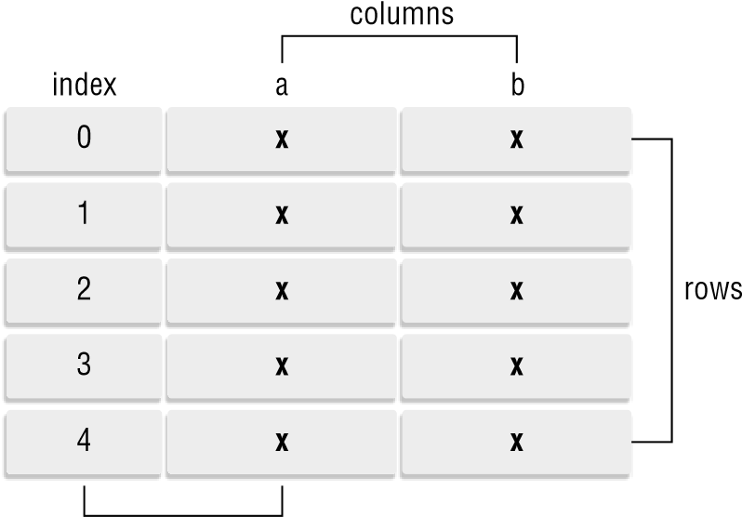

**Series**

**Figure 3.2:** A Pandas DataFrame

A DataFrame is very useful in the world of data science and machine learning, as it closely mirrors how data are stored in real-life. Imagine the data stored in a spreadsheet, and you would have a very good visual impression of a DataFrame. A Pandas DataFrame is often used when representing data in machine learning. Hence, for the remaining sections in this chapter, we are going to invest significant time and effort in understanding how it works.

**Creating a DataFrame**

You can create a Pandas DataFrame using the **DataFrame()** class:

**import pandas as pd import numpy as np**

**df = pd.DataFrame(np.random.randn(10,4), columns=list('ABCD')) print(df)**

In the preceding code snippet, a DataFrame of 10 rows and 4 columns was created, and each cell is filled with a random number using the **randn()** function. Each column has a label: “A”, “B”, “C”, and “D”:

**A B C D**

1. **0.187497 1.122150 -0.988277 -1.985934**
2. **0.360803 -0.562243 -0.340693 -0.986988**
3. **-0.040627 0.067333 -0.452978 0.686223**
4. **-0.279572 -0.702492 0.252265 0.958977**
5. **0.537438 -1.737568 0.714727 -0.939288**
6. **0.070011 -0.516443 -1.655689 0.246721**
7. **0.001268 0.951517 2.107360 -0.108726**
8. **-0.185258 0.856520 -0.686285 1.104195**
9. **0.387023 1.706336 -2.452653 0.260466**
10. **-1.054974 0.556775 -0.945219 -0.030295**

**NOTE Obviously, you will see a different set of numbers in your own DataFrame, as the numbers are generated randomly.**

More often than not, a DataFrame is usually loaded from a text file, such as a CSV file. Suppose that you have a CSV file named **data.csv** with the following content:

**A,B,C,D**

**0.187497,1.122150,-0.988277,-1.985934 0.360803,-0.562243,-0.340693,-0.986988 -0.040627,0.067333,-0.452978,0.686223**

**-0.279572,-0.702492,0.252265,0.958977**

**0.537438,-1.737568,0.714727,-0.939288**

**0.070011,-0.516443,-1.655689,0.246721 0.001268,0.951517,2.107360,-0.108726 -0.185258,0.856520,-0.686285,1.104195**

**0.387023,1.706336,-2.452653,0.260466 -1.054974,0.556775,-0.945219,-0.030295**

You can load the content of the CSV file into a DataFrame using the **read_ csv()** function: **df = pd.read_csv('data.csv')**

**Specifying the Index in a DataFrame**

Notice that the DataFrame printed in the previous section has an index starting from 0. This is similar to that of a Series. Like a Series, you can also set the index for the DataFrame using the **index** property, as in the following code snippet:

**df = pd.read_csv('data.csv')**

**days = pd.date_range('20190525', periods=10) df.index = days print(df)**

You should see the following output:

**A B C D**

**2019-05-25 0.187497 1.122150 -0.988277 -1.985934**

**2019-05-26 0.360803 -0.562243 -0.340693 -0.986988**

**2019-05-27 -0.040627 0.067333 -0.452978 0.686223**

**2019-05-28 -0.279572 -0.702492 0.252265 0.958977**

**2019-05-29 0.537438 -1.737568 0.714727 -0.939288**

**2019-05-30 0.070011 -0.516443 -1.655689 0.246721**

**2019-05-31 0.001268 0.951517 2.107360 -0.108726**

**2019-06-01 -0.185258 0.856520 -0.686285 1.104195**

**2019-06-02 0.387023 1.706336 -2.452653 0.260466**

**2019-06-03 -1.054974 0.556775 -0.945219 -0.030295**

To get the index of the DataFrame, use the **index** property as follows: **print(df.index)**

You will see the following output:

**DatetimeIndex(['2019-05-25', '2019-05-26', '2019-05-27', '2019-05-28',**

**'2019-05-29', '2019-05-30', '2019-05-31', '2019-06-01',**

**'2019-06-02', '2019-06-03'], dtype='datetime64[ns]', freq='D')**

If you want to get the values of the entire DataFrame as a two-dimensional **ndarray**, use the **values** property: **print(df.values)**

You should see the following output:

**[[ 1.874970e-01 1.122150e+00 -9.882770e-01 -1.985934e+00]**

**[ 3.608030e-01 -5.622430e-01 -3.406930e-01 -9.869880e-01]**

**[-4.062700e-02 6.733300e-02 -4.529780e-01 6.862230e-01]**

**[-2.795720e-01 -7.024920e-01 2.522650e-01 9.589770e-01]**

**[ 5.374380e-01 -1.737568e+00 7.147270e-01 -9.392880e-01]**

**[ 7.001100e-02 -5.164430e-01 -1.655689e+00 2.467210e-01]**

**[ 1.268000e-03 9.515170e-01 2.107360e+00 -1.087260e-01]**

**[-1.852580e-01 8.565200e-01 -6.862850e-01 1.104195e+00]**

**[ 3.870230e-01 1.706336e+00 -2.452653e+00 2.604660e-01]**

**[-1.054974e+00 5.567750e-01 -9.452190e-01 -3.029500e-02]]**

**Generating Descriptive Statistics on the DataFrame**

The Pandas DataFrame comes with a few useful functions to provide you with some detailed statistics about the values in the DataFrame. For example, you can use the **describe()** function to get values such as count, mean, standard deviation, minimum and maximum, as well as the various quartiles: **print(df.describe())**

Using the DataFrame that you have used in the previous section, you should see the following values:

**A B C D count 10.000000 10.000000 10.000000 10.000000 mean -0.001639 0.174188 -0.444744 -0.079465 std 0.451656 1.049677 1.267397 0.971164 min -1.054974 -1.737568 -2.452653 -1.985934 25% -0.149100 -0.550793 -0.977513 -0.731647**

**50% 0.035640 0.312054 -0.569632 0.108213 75% 0.317477 0.927768 0.104026 0.579784 max 0.537438 1.706336 2.107360 1.104195**

If you simply want to compute the mean in the DataFrame, you can use the **mean()** function, indicating the axis: **print(df.mean(0)) # 0 means compute the mean for each columns** You should get the following output:

1. **-0.001639**
2. **0.174188**
3. **-0.444744D -0.079465 dtype: float64**

If you want to get the mean for each row, set the axis to 1: **print(df.mean(1)) # 1 means compute the mean for each row** You should get the following output:

**2019-05-25 -0.416141**

**2019-05-26 -0.382280**

**2019-05-27 0.064988**

**2019-05-28 0.057294**

**2019-05-29 -0.356173**

**2019-05-30 -0.463850**

**2019-05-31 0.737855**

**2019-06-01 0.272293**

**2019-06-02 -0.024707**

**2019-06-03 -0.368428**

**Freq: D, dtype: float64**

**Extracting from DataFrames**

In Chapter 2, “Extending Python Using NumPy,” you learned about NumPy and how slicing allows you to extract part of a NumPy array. Likewise, in Pandas, slicing applies to both Series and DataFrames.

Because extracting rows and columns in DataFrames is one of the most common tasks that you will perform with DataFrames (and potentially can be confusing), let’s walk through the various methods one step at a time so that you have time to digest how they work.

***Selecting the First and Last Five Rows***

Sometimes, the DataFrame might be too lengthy, and you just want to take a glimpse of the first few rows in the DataFrame. For this purpose, you can use the **head()** function: **print(df.head())**

The **head()** function prints out the first five rows in the DataFrame:

**A B C D**

**2019-05-25 0.187497 1.122150 -0.988277 -1.985934**

**2019-05-26 0.360803 -0.562243 -0.340693 -0.986988**

**2019-05-27 -0.040627 0.067333 -0.452978 0.686223**

**2019-05-28 -0.279572 -0.702492 0.252265 0.958977**

**2019-05-29 0.537438 -1.737568 0.714727 -0.939288**

If you want more than five rows (or less than five), you can indicate the number of rows that you want in the **head()** function as follows: **print(df.head(8)) # prints out the first 8 rows** There is also a **tail()** function: **print(df.tail())**

The **tail()** function prints the last five rows:

**A B C D**

**2019-05-30 0.070011 -0.516443 -1.655689 0.246721**

**2019-05-31 0.001268 0.951517 2.107360 -0.108726**

**2019-06-01 -0.185258 0.856520 -0.686285 1.104195**

**2019-06-02 0.387023 1.706336 -2.452653 0.260466**

**2019-06-03 -1.054974 0.556775 -0.945219 -0.030295**

Like the **head()** function, the **tail()** function allows you to specify the number of rows to print:

**print(df.tail(8)) # prints out the last 8 rows**

***Selecting a Specific Column in a DataFrame***

To obtain one or more columns in a DataFrame, you can specify the column label as follows:

**print(df['A'])**

**# same as print(df.A)**

This will print out the “A” column together with its index:

**2019-05-25 0.187497**

**2019-05-26 0.360803**

**2019-05-27 -0.040627**

**2019-05-28 -0.279572**

**2019-05-29 0.537438**

**2019-05-30 0.070011**

**2019-05-31 0.001268**

**2019-06-01 -0.185258**

**2019-06-02 0.387023**

**2019-06-03 -1.054974**

**Freq: D, Name: A, dtype: float64**

Essentially, what you get in return is a Series. If you want to retrieve more than one column, pass in a list containing the column labels: **print(df[['A', 'B']])**

You should see the following output:

**A B**

**2019-05-25 0.187497 1.122150**

**2019-05-26 0.360803 -0.562243**

**2019-05-27 -0.040627 0.067333**

**2019-05-28 -0.279572 -0.702492**

**2019-05-29 0.537438 -1.737568**

**2019-05-30 0.070011 -0.516443**

**2019-05-31 0.001268 0.951517**

**2019-06-01 -0.185258 0.856520**

**2019-06-02 0.387023 1.706336**

**2019-06-03 -1.054974 0.556775**

In this case, instead of a Series, you are now getting a DataFrame.

***Slicing Based on Row Number***

First, let’s extract a range of rows in the DataFrame: **print(df[2:4])**

This extracts row numbers 2 through 4 (not including row 4) from the DataFrame, and you should see the following output:

**A B C D**

**2019-05-27 -0.040627 0.067333 -0.452978 0.686223**

**2019-05-28 -0.279572 -0.702492 0.252265 0.958977**

You can also use the **iloc** indexer for extracting rows based on row number: **print(df.iloc[2:4])**

This will produce the same output as the preceding code snippet.

Note that if you wish to extract specific rows (and not a range of rows) using row numbers, you need to use the **iloc** indexer like this: **print(df.iloc[[2,4]])**

This will print the following output:

**A B C D**

**2019-05-27 -0.040627 0.067333 -0.452978 0.686223**

**2019-05-29 0.537438 -1.737568 0.714727 -0.939288** Without using the **iloc** indexer, the following will not work: **print(df[[2,4]]) # error; need to use the iloc indexer**

The same applies when extracting a single row using a row number; you need to use **iloc**:

**print(df.iloc[2]) # prints out row number 2**

***Slicing Based on Row and Column Numbers***

If you wish to extract specific rows and columns in a DataFrame, you need to use the **iloc** indexer. The following code snippet extracts row numbers 2 to 3, and column numbers 1 to 3: **print(df.iloc[2:4, 1:4])**

You should get the following output:

**B C D**

**2019-05-27 0.067333 -0.452978 0.686223**

**2019-05-28 -0.702492 0.252265 0.958977**

You can also extract specific rows and columns using a list as follows: **print(df.iloc[[2,4], [1,3]])**

The preceding statement prints out row numbers 2 and 4, and column numbers 1 and 3:

**B D**

**2019-05-27 0.067333 0.686223**

**2019-05-29 -1.737568 -0.939288**

**TIP To summarize, if you want to extract a range of rows using slicing, you can simply use the following syntax: df[*start_row*:*end_row*]. If you want to extract specific rows or columns, use the iloc indexer: df.iloc[[*row_1*,*row_2*,...,*row _n*],[*column_1*,*column_2*,...,*column_n*]].**

***Slicing Based on Labels***

Besides extracting rows and columns using their row and column numbers, you can also extract them by label (value). For example, the following code snippet extracts a range of *rows* using their index values (which is of **DatetimeIndex** type): **print(df['20190601':'20190603'])**

This will print out the following output:

**A B C D**

**2019-06-01 -0.185258 0.856520 -0.686285 1.104195**

**2019-06-02 0.387023 1.706336 -2.452653 0.260466**

**2019-06-03 -1.054974 0.556775 -0.945219 -0.030295** You can also use the **loc** indexer as follows: **print(df.loc['20190601':'20190603'])**

Using the **loc** indexer is mandatory if you want to extract the *columns* using their values, as the following example shows: **print(df.loc['20190601':'20190603', 'A':'C'])**

The preceding statement prints out the following:

**A B C**

**2019-06-01 -0.185258 0.856520 -0.686285**

**2019-06-02 0.387023 1.706336 -2.452653**

**2019-06-03 -1.054974 0.556775 -0.945219**

**TIP Unlike slicing by number, where *start*:*end* means extracting row *start* through row *end* but not including *end*, slicing by value will include the *end* row.**

You can also extract specific columns: **print(df.loc['20190601':'20190603', ['A','C']])** The preceding statement prints out the following:

**A C**

**2019-06-01 -0.185258 -0.686285**

**2019-06-02 0.387023 -2.452653**

**2019-06-03 -1.054974 -0.945219**

If you want to extract a specific row, use the **loc** indexer as follows: **print(df.loc['20190601'])**

It will print out the following:

1. **-0.185258**
2. **0.856520**
3. **-0.686285**
4. **1.104195**

**Name: 2019-06-01 00:00:00, dtype: float64**

Oddly, if you want to extract specific rows with **datetime** as the index, you cannot simply pass the date value to the **loc** indexer as follows: **print(df.loc[['20190601','20190603']]) # KeyError** First, you need to convert the date into a **datetime** format:

**from datetime import datetime date1 = datetime(2019, 6, 1, 0, 0, 0) date2 = datetime(2019, 6, 3, 0, 0, 0) print(df.loc[[date1,date2]])** You will now see the output like this:

**A B C D**

**2019-06-01 -0.185258 0.856520 -0.686285 1.104195**

**2019-06-03 -1.054974 0.556775 -0.945219 -0.030295**

If you want a specific row and specific columns, you can extract them as follows: **print(df.loc[date1, ['A','C']])**

And the output will look like this:

**A -0.185258**

**C -0.686285**

**Name: 2019-06-01 00:00:00, dtype: float64**

In the preceding example, because there is only a single specified date, the result is a Series.

**TIP To summarize, if you want to extract a range of rows using their labels, you can simply use the following syntax: df[*start_label*:*end_label*]. If you want to extract specific rows or columns, use the loc indexer with the following syntax: df**

**.loc[[*row_1_label*,*row_2_label*,...,row_n_label],[*column_1_ label*,*column_2_label*,...,*column_n_label*]].**

**Selecting a Single Cell in a DataFrame**

If you simply wish to access a single cell in a DataFrame, there is a function that does just that: **at()**. Using the same example as in the previous section, if you want to get the value of a specific cell, you can use the following code snippet:

**from datetime import datetime d = datetime(2019, 6, 3, 0, 0, 0) print(df.at[d,'B'])**

You should see the following output:

**0.556775**

**Selecting Based on Cell Value**

If you want to select a subset of the DataFrame based on certain values in the cells, you can use the Boolean Indexing method, as described in Chapter 2. The following code snippet prints out all of the rows that have positive values in the A and B columns: **print(df[(df.A > 0) & (df.B>0)])**

You should see the following output:

**A B C D**

**2019-05-25 0.187497 1.122150 -0.988277 -1.985934**

**2019-05-31 0.001268 0.951517 2.107360 -0.108726**

**2019-06-02 0.387023 1.706336 -2.452653 0.260466**

**Transforming DataFrames**

If you need to reflect the DataFrame over its main diagonal (converting columns to rows and rows to columns), you can use the **transpose()** function: **print(df.transpose())**

Alternatively, you can just use the **T** property, which is an accessor to the **transpose()** function: **print(df.T)**

In either case, you will see the following output:

**2019-05-25 2019-05-26 2019-05-27 2019-05-28 2019-05-29 2019-05-30 \**

1. **0.187497 0.360803 -0.040627 -0.279572 0.537438 0.070011**
2. **1.122150 -0.562243 0.067333 -0.702492 -1.737568 -0.516443**
3. **-0.988277 -0.340693 -0.452978 0.252265 0.714727 -1.655689D -1.985934 -0.986988 0.686223 0.958977 -0.939288 0.246721**

**2019-05-31 2019-06-01 2019-06-02 2019-06-03**

1. **0.001268 -0.185258 0.387023 -1.054974**
2. **0.951517 0.856520 1.706336 0.556775**
3. **2.107360 -0.686285 -2.452653 -0.945219**
4. **-0.108726 1.104195 0.260466 -0.030295**

**Checking to See If a Result Is a DataFrame or Series**

One of the common problems that you will face with Pandas is knowing if the result that you have obtained is a Series or a DataFrame. To solve this mystery, here is a function that can make your life easier:

**def checkSeriesOrDataframe(var): if isinstance(var, pd.DataFrame):**

**return 'Dataframe' if isinstance(var, pd.Series): return 'Series'**

**Sorting Data in a DataFrame**

There are two ways that you can sort the data in a DataFrame:

1. Sort by labels (axis) using the **sort_index()** function
2. Sort by value using the **sort_values()** function

***Sorting by Index***

To sort using the axis, you need to specify if you want to sort by index or column. Setting the **axis** parameter to **0** indicates that you want to sort by index:

**print(df.sort_index(axis=0, ascending=False)) # axis = 0 means sort by # index**

Based on the preceding statement, the DataFrame is now sorted according to the index in descending order:

**A B C D**

**2019-06-03 -1.054974 0.556775 -0.945219 -0.030295**

**2019-06-02 0.387023 1.706336 -2.452653 0.260466**

**2019-06-01 -0.185258 0.856520 -0.686285 1.104195**

**2019-05-31 0.001268 0.951517 2.107360 -0.108726**

**2019-05-30 0.070011 -0.516443 -1.655689 0.246721**

**2019-05-29 0.537438 -1.737568 0.714727 -0.939288**

**2019-05-28 -0.279572 -0.702492 0.252265 0.958977**

**2019-05-27 -0.040627 0.067333 -0.452978 0.686223**

**2019-05-26 0.360803 -0.562243 -0.340693 -0.986988**

**2019-05-25 0.187497 1.122150 -0.988277 -1.985934**

**TIP Note that the sort_index() function returns the sorted DataFrame. The original DataFrame is not affected. If you want the original DataFrame to be sorted, use the inplace parameter and set it to True. In general, most operations involving DataFrames do not alter the original DataFrame. So inplace is by default set to False. When inplace is set to True, the function returns None as the result.**

Setting the **axis** parameter to **1** indicates that you want to sort by column labels:

**print(df.sort_index(axis=1, ascending=False)) # axis = 1 means sort by # column**

The DataFrame is now sorted based on the column labels (in descending order):

**D C B A**

**2019-05-25 -1.985934 -0.988277 1.122150 0.187497**

**2019-05-26 -0.986988 -0.340693 -0.562243 0.360803**

**2019-05-27 0.686223 -0.452978 0.067333 -0.040627**

**2019-05-28 0.958977 0.252265 -0.702492 -0.279572**

**2019-05-29 -0.939288 0.714727 -1.737568 0.537438**

**2019-05-30 0.246721 -1.655689 -0.516443 0.070011**

**2019-05-31 -0.108726 2.107360 0.951517 0.001268**

**2019-06-01 1.104195 -0.686285 0.856520 -0.185258**

**2019-06-02 0.260466 -2.452653 1.706336 0.387023**

**2019-06-03 -0.030295 -0.945219 0.556775 -1.054974**

***Sorting by Value***

To sort by value, use the **sort_values()** function. The following statement sorts the DataFrame based on the values in column “A”: **print(df.sort_values('A', axis=0))**

The output now is now sorted (in ascending order) based on the value of column “A” (the values are highlighted). Notice that the index is now jumbled up:

**A B C D**

**2019-06-03 -1.054974 0.556775 -0.945219 -0.030295**

**2019-05-28 -0.279572 -0.702492 0.252265 0.958977**

**2019-06-01 -0.185258 0.856520 -0.686285 1.104195**

**2019-05-27 -0.040627 0.067333 -0.452978 0.686223**

**2019-05-31 0.001268 0.951517 2.107360 -0.108726**

**2019-05-30 0.070011 -0.516443 -1.655689 0.246721**

**2019-05-25 0.187497 1.122150 -0.988277 -1.985934**

**2019-05-26 0.360803 -0.562243 -0.340693 -0.986988**

**2019-06-02 0.387023 1.706336 -2.452653 0.260466**

**2019-05-29 0.537438 -1.737568 0.714727 -0.939288**

To sort based on a particular index, set the **axis** parameter to **1**: **print(df.sort_values('20190601', axis=1))**

You can see that the DataFrame is now sorted (in ascending order) based on the row whose index is **2019-06-01** (the values are highlighted):

**C A B D**

**2019-05-25 -0.988277 0.187497 1.122150 -1.985934**

**2019-05-26 -0.340693 0.360803 -0.562243 -0.986988**

**2019-05-27 -0.452978 -0.040627 0.067333 0.686223**

**2019-05-28 0.252265 -0.279572 -0.702492 0.958977**

**2019-05-29 0.714727 0.537438 -1.737568 -0.939288**

**2019-05-30 -1.655689 0.070011 -0.516443 0.246721**

**2019-05-31 2.107360 0.001268 0.951517 -0.108726**

**2019-06-01 -0.686285 -0.185258 0.856520 1.104195**

**2019-06-02 -2.452653 0.387023 1.706336 0.260466**

**2019-06-03 -0.945219 -1.054974 0.556775 -0.030295**

**Applying Functions to a DataFrame**

You can also apply functions to values in a DataFrame using the **apply()** function. First, let’s define two lambda functions as follows:

**import math**

**sq_root = lambda x: math.sqrt(x) if x > 0 else x sq = lambda x: x**2**

The first function, **sq_root()**, takes the square root of the value **x** if it is a positive number. The second function, **sq()**, takes the square of the value **x**.

It is important to note that objects passed to the **apply()** function are Series objects whose index is either the DataFrame’s index (**axis=0**) or the DataFrame’s columns (**axis=1**).

We can now apply the functions to the DataFrame. First, apply the **sq_root()** function to column “B”: **print(df.B.apply(sq_root))**

Since the result of **df.B** is a Series, we can apply the **sq_root()** function to it and it will return the following results:

**2019-05-25 1.029231**

**2019-05-26 -0.562243**

**2019-05-27 0.509398**

**2019-05-28 -0.702492**

**2019-05-29 -1.737568**

**2019-05-30 -0.516443**

**2019-05-31 0.987652**

**2019-06-01 0.962021**

**2019-06-02 1.142921**

**2019-06-03 0.863813**

**Freq: D, Name: B, dtype: float64**

You can also apply the **sq()** function to **df.B**: **print(df.B.apply(sq))**

You should see the following results:

**2019-05-25 1.122150**

**2019-05-26 0.316117**

**2019-05-27 0.067333**

**2019-05-28 0.493495**

**2019-05-29 3.019143**

**2019-05-30 0.266713**

**2019-05-31 0.951517**

**2019-06-01 0.856520**

**2019-06-02 1.706336**

**2019-06-03 0.556775**

**Freq: D, Name: B, dtype: float64**

If you apply the **sq_root()** function to the DataFrame as shown here,

**df.apply(sq_root) # ValueError**

you will get the following error:

**ValueError: ('The truth value of a Series is ambiguous. Use a.empty,**

**a.bool(), a.item(), a.any() or a.all().', 'occurred at index A')**

This is because the object passed into the **apply()** function in this case is a DataFrame, not a Series. Interestingly, you can apply the **sq()** function to the DataFrame: **df.apply(sq)**

This will print out the following:

**A B C D**

**2019-05-25 0.035155 1.259221 0.976691 3.943934**

**2019-05-26 0.130179 0.316117 0.116072 0.974145**

**2019-05-27 0.001651 0.004534 0.205189 0.470902**

**2019-05-28 0.078161 0.493495 0.063638 0.919637**

**2019-05-29 0.288840 3.019143 0.510835 0.882262**

**2019-05-30 0.004902 0.266713 2.741306 0.060871**

**2019-05-31 0.000002 0.905385 4.440966 0.011821**

**2019-06-01 0.034321 0.733627 0.470987 1.219247**

**2019-06-02 0.149787 2.911583 6.015507 0.067843**

**2019-06-03 1.112970 0.309998 0.893439 0.000918**

If you want to apply the **sq_root()** function to the entire DataFrame, you can iterate through the columns and apply the function to each column:

**for column in df:**

**df[column] = df[column].apply(sq_root) print(df)**

The result will now look like this:

**A B C D**

**2019-05-25 0.433009 1.059316 -0.988277 -1.985934**

**2019-05-26 0.600669 -0.562243 -0.340693 -0.986988**

**2019-05-27 -0.040627 0.259486 -0.452978 0.828386**

**2019-05-28 -0.279572 -0.702492 0.502260 0.979274**

**2019-05-29 0.733102 -1.737568 0.845415 -0.939288**

**2019-05-30 0.264596 -0.516443 -1.655689 0.496710**

**2019-05-31 0.035609 0.975457 1.451675 -0.108726**

**2019-06-01 -0.185258 0.925484 -0.686285 1.050807**

**2019-06-02 0.622112 1.306268 -2.452653 0.510359**

**2019-06-03 -1.054974 0.746174 -0.945219 -0.030295**

The **apply()** function can be applied on either axis: *index* (0; apply function to each column) or *column* (1; apply function to each row). For the two particular lambda functions that we have seen thus far, it does not matter which axis you apply it to, and the result would be the same. However, for some functions, the axis that you apply it to does matter. For example, the following statement uses the **sum()** function from NumPy and applies it to the rows of the DataFrame: **print(df.apply(np.sum, axis=0))**

Essentially, you are summing up all of the values in each column. You should see the following:

1. **1.128665**
2. **1.753438**
3. **-4.722444D -0.185696 dtype: float64**

If you set **axis** to **1** as follows,

**print(df.apply(np.sum, axis=1))**

you will see the summation applied across each row:

**2019-05-25 -1.481886**

**2019-05-26 -1.289255**

**2019-05-27 0.594267**

**2019-05-28 0.499470**

**2019-05-29 -1.098339**

**2019-05-30 -1.410826**

**2019-05-31 2.354015**

**2019-06-01 1.104747**

**2019-06-02 -0.013915**

**2019-06-03 -1.284314**

**Freq: D, dtype: float64**

**Adding and Removing Rows and Columns in a DataFrame**

So far, all of the previous sections have involved extracting rows and columns from DataFrames, as well as how to sort DataFrames. In this section, we will focus on how to add and remove columns in DataFrames.

Consider the following code snippet, where a DataFrame is created from a dictionary:

**import pandas as pd**

**data = {'name': ['Janet', 'Nad', 'Timothy', 'June', 'Amy'],**

**'year': [2012, 2012, 2013, 2014, 2014],**

**'reports': [6, 13, 14, 1, 7]}**

**df = pd.DataFrame(data, index =**

**['Singapore', 'China', 'Japan', 'Sweden', 'Norway']) print(df)**

The DataFrame looks like this:

**name reports year Singapore Janet 6 2012**

**China Nad 13 2012**

**Japan Timothy 14 2013**

**Sweden June 1 2014**

**Norway Amy 7 2014**

***Adding a Column***

The following code snippet shows you how to add a new column named “school” to the DataFrame:

**import numpy as np**

**schools = np.array(["Cambridge","Oxford","Oxford","Cambridge","Oxford"]) df["school"] = schools print(df)**

Printing the DataFrame will look like this:

**name reports year school**

**Singapore Janet 6 2012 Cambridge**

**China Nad 13 2012 Oxford**

**Japan Timothy 14 2013 Oxford**

**Sweden June 1 2014 Cambridge**

**Norway Amy 7 2014 Oxford**

***Removing Rows***

To remove one or more rows, use the **drop()** function. The following code snippet removes the two rows whose index value is “China” and “Japan”: **print(df.drop(['China', 'Japan'])) # drop rows based on value of index** The following output proves that the two rows are removed:

**name reports year school**

**Singapore Janet 6 2012 Cambridge**

**Sweden June 1 2014 Cambridge**

**Norway Amy 7 2014 Oxford**

**TIP Like the sort_index() function, by default the drop() function does not affect the original DataFrame. Use the inplace parameter if you want to modify the original DataFrame.**

If you want to drop a row based on a particular column value, specify the column name and the condition like this: **print(df[df.name != 'Nad']) # drop row based on column value** The preceding statement drops the row whose name is “**Nad**”:

**name reports year school Singapore Janet 6 2012 Cambridge Japan Timothy 14 2013 Oxford**

**Sweden June 1 2014 Cambridge**

**Norway Amy 7 2014 Oxford** You can also remove rows based on row number: **print(df.drop(df.index[1]))**

The preceding statement drops row number 1 (the second row):

**name reports year school Singapore Janet 6 2012 Cambridge**

**Japan Timothy 14 2013 Oxford**

**Sweden June 1 2014 Cambridge**

**Norway Amy 7 2014 Oxford**

Since **df.index[1]** returns “China”, the preceding statement is equivalent to **df.drop['China']**.

If you want to drop multiple rows, specify the row numbers represented as a list:

**print(df.drop(df.index[[1,2]])) # remove the second and third row**

The preceding statement removes row numbers 1 and 2 (the second and the third row):

**name reports year school Singapore Janet 6 2012 Cambridge**

**Sweden June 1 2014 Cambridge**

**Norway Amy 7 2014 Oxford** The following removes the second to last row: **print(df.drop(df.index[-2])) # remove second last row** You should see the following output:

**name reports year school Singapore Janet 6 2012 Cambridge**

**China Nad 13 2012 Oxford**

**Japan Timothy 14 2013 Oxford**

**Norway Amy 7 2014 Oxford**

***Removing Columns***

The **drop()** function drops rows by default, but if you want to drop columns instead, set the **axis** parameter to **1** like this:

**print(df.drop('reports', axis=1)) # drop column**

The preceding code snippet drops the **reports** column:

**name year school Singapore Janet 2012 Cambridge**

**China Nad 2012 Oxford**

**Japan Timothy 2013 Oxford**

**Sweden June 2014 Cambridge**

**Norway Amy 2014 Oxford**

If you want to drop by column number, specify the column number using the **columns** indexer: **print(df.drop(df.columns[1], axis=1)) # drop using columns number** This will drop the second column (“**reports**”):

**name year school Singapore Janet 2012 Cambridge**

**China Nad 2012 Oxford**

**Japan Timothy 2013 Oxford**

**Sweden June 2014 Cambridge**

**Norway Amy 2014 Oxford** You can also drop multiple columns: **print(df.drop(df.columns[[1,3]], axis=1)) # drop multiple columns** This will drop the second and fourth columns (“**reports**” and “**school**”):

**name year Singapore Janet 2012**

**China Nad 2012**

**Japan Timothy 2013**

**Sweden June 2014**

**Norway Amy 2014**

**Generating a Crosstab**

In statistics, a *crosstab* is used to aggregate and jointly display the distribution of two or more variables. It shows the relationships between these variables. Consider the following example:

**df = pd.DataFrame(**

**{**

**"Gender": ['Male','Male','Female','Female','Female'],**

**"Team" : [1,2,3,3,1]**

**}) print(df)**

Here you are creating a DataFrame using a dictionary. When the DataFrame is printed out, you will see the following:

**Gender Team**

1. **Male 1**
2. **Male 2**
3. **Female 3**
4. **Female 3**
5. **Female 1**

This DataFrame shows the gender of each person and the team to which the person belongs. Using a crosstab, you would be able to summarize the data and generate a table to show the distribution of each gender for each team. To do that, you use the **crosstab()** function:

**print("Displaying the distribution of genders in each team") print(pd.crosstab(df.Gender, df.Team))**

You will see the following output:

**Displaying the distribution of genders in each team**

**Team 1 2 3**

**Gender**

**Female 1 0 2**

**Male 1 1 0**

If you want to see the distribution of each team for each gender, you simply reverse the argument: **print(pd.crosstab(df.Team, df.Gender))** You will see the following output:

**Gender Female Male**

**Team**

1. **1 1**
2. **0 1**
3. **2 0**

**Summary**

In this chapter, you witnessed the use of Pandas to represent tabular data. You learned about the two main Pandas data structures: Series and DataFrame. I attempted to keep things simple and to show you some of the most common operations that you would perform on these data structures. As extracting rows and columns from DataFrames is so common, I have summarized some of these operations in Table 3.1.

**Table 3.1:** Common DataFrame Operations

|  |  |
| --- | --- |
| **DESCRIPTION** | **CODE EXAMPLES** |
| Extract a range of rows using row numbers | **df[2:4] df.iloc[2:4]** |
| Extract a single row using row number | **df.iloc[2]** |
| Extract a range of rows and range of columns | **df.iloc[2:4, 1:4]** |
| Extract a range of rows and specific columns using positional values | **df.iloc[2:4, [1,3]]** |
| Extract specific row(s) and column(s) | **df.iloc[[2,4], [1,3]]** |
| Extract a range of rows using labels | **df['20190601':'20190603']** |
| Extract a single row based on its label | **df.loc['20190601']** |
| Extract specific row(s) using their labels | **df.loc[[date1,date2]]** |
| Extract specific row(s) and column(s) using their labels | **df.loc[[date1,date2], ['A','C']] df.loc[[date1,date2], 'A':'C']** |
| Extract a range of rows and columns using their labels | **df.loc[date1:date2, 'A':'C']** |

|  |
| --- |
| **CHAPTER** |
| **4**  **matplotlib** |

**Data Visualization Using**

**What Is matplotlib?**

As the adage goes, “A picture is worth a thousand words.” This is probably most true in the world of machine learning. No matter how large or how small your dataset, it is often very useful (and many times, essential) that you are able to visualize the data and see the relationships between the various features within it. For example, given a dataset containing a group of students with their family details (such as examination results, family income, educational background of parents, and so forth), you might want to establish a relationship between the students’ results with their family income. The best way to do this would be to plot a chart displaying the related data. Once the chart is plotted, you can then use it to draw your own conclusions and determine whether the results have a positive relationship to family income.

In Python, one of the most commonly used tools for plotting is matplotlib. *Matplotlib* is a Python 2D plotting library that you can use to produce publicationquality charts and figures. Using matplotlib, complex charts and figures can be generated with ease, and its integration with Jupyter Notebook makes it an ideal tool for machine learning.

In this chapter, you will learn the basics of matplotlib. In addition, you will also learn about Seaborn, a complementary data visualization library that is based on matplotlib.

Python® Machine Learning, First Edition. Wei-Meng Lee. **67**

© 2019 John Wiley & Sons, Inc. Published 2019 by John Wiley & Sons, Inc.

**Plotting Line Charts**

To see how easy it is to use matplotlib, let’s plot a line chart using Jupyter Notebook. Here is a code snippet that plots a line chart:

**%matplotlib inline**

**import matplotlib.pyplot as plt**

**plt.plot(**

**[1,2,3,4,5,6,7,8,9,10],**

**[2,4.5,1,2,3.5,2,1,2,3,2]**

**)**

Figure 4.1 shows the line chart plotted.

4.5

4.0

3.5

3.0

2.5

2.0

1.5

1.0

2

4

6

8

10

**Figure 4.1:** A line graph plotted using matplotlib

The first statement tells matplotlib to display the output of the plotting commands in line within front-ends likes Jupyter Notebook. In short, it means display the chart within the same page as your Jupyter Notebook:

**%matplotlib inline**

To use matplotlib, you import the **pyplot** module and name it ***plt*** (its commonly used alias): **import matplotlib.pyplot as plt**

To plot a line chart, you use the **plot()** function from the **pyplot** module, supplying it with two arguments as follows:

1. A list of values representing the x-axis
2. A list of values representing the y-axis

**[1,2,3,4,5,6,7,8,9,10],**

**[2,4.5,1,2,3.5,2,1,2,3,2]**

That’s it. The chart will be shown in your Jupyter Notebook when you run it.

**Adding Title and Labels**

A chart without title and labels does not convey meaningful information. Matplotlib allows you to add a title and labels to the axes using the **title()**, **xlabel()**, and **ylabel()** functions as follows:

**%matplotlib inline**

**import matplotlib.pyplot as plt**

**plt.plot(**

**[1,2,3,4,5,6,7,8,9,10],**

**[2,4.5,1,2,3.5,2,1,2,3,2]**

**)**

**plt.title("Results") # sets the title for the chart plt.xlabel("Semester") # sets the label to use for the x-axis plt.ylabel("Grade") # sets the label to use for the y-axis**

Figure 4.2 shows the chart with the title, as well as the labels for the x- and y-axes.

2

4.5

4.0

3.5

3.0

Grade

2.5

2.0

1.5

1.0

4

Semester

Results

6

8

10

**Figure 4.2:** The line chart with the title and the labels for the x- and y-axes added

**Styling**

Matplotlib lets you adjust every aspect of your plot and create beautiful charts. However, it is very time consuming to create really beautiful charts and plots. To help with this, matplotlib ships with a number of predefined styles. Styles allow you to create professional-looking charts using a predefined look-andfeel without requiring you to customize each element of the chart individually.

The following example uses the **ggplot** style, based on a popular data visualization package for the statistical programming language R:

**TIP The “gg” in ggplot comes from Leland Wilkinson’s landmark 1999 book, *The Grammar of Graphics: Statistics and Computing*, (Springer, 2005).**

**%matplotlib inline**

**import matplotlib.pyplot as plt**

**from matplotlib import style style.use("ggplot")**

**plt.plot(**

**[1,2,3,4,5,6,7,8,9,10],**

**[2,4.5,1,2,3.5,2,1,2,3,2]**

**)**

**plt.title("Results") # sets the title for the chart plt.xlabel("Semester") # sets the label to use for the x-axis plt.ylabel("Grade") # sets the label to use for the y-axis** The chart styled using **ggplot** is shown in Figure 4.3.

4.5

4.0

3.5

3.0

Grade

2.5

2.0

1.5

1.0

Semester

Results

2

4

6

8

10

**Figure 4.3:** The chart with the ggplot style applied to it

Figure 4.4 shows the same chart with the **grayscale** styled applied.

4.5

4.0

3.5

3.0

Grade

2.5

2.0

1.5

1.0

2

4

6

Semester

Results

8

1

0

**Figure 4.4:** The chart with the grayscale style applied to it

You can use the **style.available** property to see the list of styles supported: **print(style.available)**

Here is a sample output:

**['seaborn-dark', 'seaborn-darkgrid', 'seaborn-ticks', 'fivethirtyeight',**

**'seaborn-whitegrid', 'classic', '_classic_test', 'fast', 'seaborn-talk',**

**'seaborn-dark-palette', 'seaborn-bright', 'seaborn-pastel', 'grayscale',**

**'seaborn-notebook', 'ggplot', 'seaborn-colorblind', 'seaborn-muted',**

**'seaborn', 'Solarize_Light2', 'seaborn-paper', 'bmh', 'seaborn-white',**

**'dark_background', 'seaborn-poster', 'seaborn-deep']**

**Plotting Multiple Lines in the Same Chart**

You can plot multiple lines in the same chart by calling the **plot()** function one more time, as the following example shows:

**%matplotlib inline**

**import matplotlib.pyplot as plt**

**from matplotlib import style style.use("ggplot")**

**plt.plot(**

**[1,2,3,4,5,6,7,8,9,10],**

**[2,4.5,1,2,3.5,2,1,2,3,2]**

**) plt.plot(**

**[1,2,3,4,5,6,7,8,9,10],**

**[3,4,2,5,2,4,2.5,4,3.5,3]**

**)**

**plt.title("Results") # sets the title for the chart plt.xlabel("Semester") # sets the label to use for the x-axis plt.ylabel("Grade") # sets the label to use for the y-axis** Figure 4.5 shows the chart now containing two line graphs.

5.0

4.5

Grade

4.0

3.5

3.0

2.5

2.0

1.5

1.0

2

4

Semester

Results

6

8

10

**Figure 4.5:** The chart with two line graphs

**Adding a Legend**

As you add more lines to a chart, it becomes more important to have a way to distinguish between the lines. Here is where a legend is useful. Using the previous example, you can add a label to each line plot and then show a legend using the **legend()** function as follows:

**%matplotlib inline**

**import matplotlib.pyplot as plt**

**from matplotlib import style style.use("ggplot")**

**plt.plot(**

**[1,2,3,4,5,6,7,8,9,10],**

**[2,4.5,1,2,3.5,2,1,2,3,2], label="Jim"**

**) plt.plot(**

**[1,2,3,4,5,6,7,8,9,10],**

**[3,4,2,5,2,4,2.5,4,3.5,3], label="Tom"**

**)**

**plt.title("Results") # sets the title for the chart plt.xlabel("Semester") # sets the label to use for the x-axis plt.ylabel("Grade") # sets the label to use for the y-axis plt.legend()**

Figure 4.6 shows the chart with a legend displayed.

5.0

4.5

Grade

4.0

3.5

3.0

2.5

2.0

1.5

1.0

2

4

Semester

Results

6

8

10

Jim

Tom

**Figure 4.6:** The chart with a legend displayed

**Plotting Bar Charts**

Besides plotting line charts, you can also plot bar charts using matplotlib. *Bar charts* are useful for comparing data. For example, you want to be able to compare the grades of a student over a number of semesters.

Using the same dataset that you used in the previous section, you can plot a bar chart using the **bar()** function as follows:

**%matplotlib inline import matplotlib.pyplot as plt from matplotlib import style**

**style.use("ggplot")**

**plt.bar(**

**[1,2,3,4,5,6,7,8,9,10],**

**[2,4.5,1,2,3.5,2,1,2,3,2], label = "Jim",**

**color = "m", # m for magenta align = "center"**

**)**

**plt.title("Results") plt.xlabel("Semester") plt.ylabel("Grade")**

**plt.legend() plt.grid(True, color="y")**

Figure 4.7 shows the bar chart plotted using the preceding code snippet.

Results

|  |  |  |  |  |  |
| --- | --- | --- | --- | --- | --- |
|  |  |  |  |  | Jim |
|  |  |  |  |  |  |
|  |  |  |  |  |  |
|  |  |  |  |  |  |
|  |  |  |  |  |  |

4

3

2

Grade

1

0

2 4 6 8 10

Semester **Figure 4.7:** Plotting a bar chart

**Adding Another Bar to the Chart**

Just like adding an additional line chart to the chart, you can add another bar graph to an existing chart. The following statements in bold do just that:

**%matplotlib inline import matplotlib.pyplot as plt from matplotlib import style**

**style.use("ggplot")**

**plt.bar(**

**[1,2,3,4,5,6,7,8,9,10],**

**[2,4.5,1,2,3.5,2,1,2,3,2], label = "Jim",**

**color = "m", # for magenta align = "center", alpha = 0.5**

**)**

**plt.bar(**

**[1,2,3,4,5,6,7,8,9,10],**

**[1.2,4.1,0.3,4,5.5,4.7,4.8,5.2,1,1.1], label = "Tim",**

**color = "g", # for green align = "center", alpha = 0.5**

**)**

**plt.title("Results") plt.xlabel("Semester") plt.ylabel("Grade")**

**plt.legend() plt.grid(True, color="y")**

Because the bars might overlap each with other, it is important to be able to distinguish them by setting their alpha to 0.5 (making them translucent). Figure 4.8 shows the two bar graphs in the same chart.

Results

|  |  |  |  |  |  |  |  |  |  |  |  |  |  |  |  |  |  |  |  |  |  |
| --- | --- | --- | --- | --- | --- | --- | --- | --- | --- | --- | --- | --- | --- | --- | --- | --- | --- | --- | --- | --- | --- |
|  | |  | | |  | | | | |  | | | | |  | | | | | Jim | |
|  | |  | | |  | | | | |  | | | | |  | | | | | Tim | |
|  | |  |  |  |  |  | | |  |  |  | | | |
|  |  |  |  |  |  |  | | |  |  |  |  |  |  |  |  | | | |  | |
|  |  |  |  |  |  |  |  |  |  |  |  |  |  |  |  |  |  |  | |  | |
|  |  |  |  |  |  |  |  |  |  |  |  |  |  |  |  |  |  |  |  |  |  |
|  |  |  |  |  |  |  | | |  |  |  | | |  |  |  | | |  |  |  |

5 4

3

Grade

2

1

0

2 4 6 8 10

Semester

**Figure 4.8:** Plotting two overlapping bar charts on the same figure

**Changing the Tick Marks**

So far in our charts, the tick marks on the x-axis always displays the value that was supplied (such as 2, 4, 6, and so on). But what if your x-axis label is in the form of strings like this?

**rainfall = [17,9,16,3,21,7,8,4,6,21,4,1] months = ['Jan','Feb','Mar','Apr','May','Jun', 'Jul','Aug','Sep','Oct','Nov','Dec']**

In this case, you might be tempted to plot the chart directly as follows:

**%matplotlib inline**

**import matplotlib.pyplot as plt**

**rainfall = [17,9,16,3,21,7,8,4,6,21,4,1] months = ['Jan','Feb','Mar','Apr','May','Jun', 'Jul','Aug','Sep','Oct','Nov','Dec']**

**plt.bar(months, rainfall, align='center', color='orange' ) plt.show()**

The preceding code snippet will create the chart shown in Figure 4.9.

20.0

17.5

15.0

12.5

10.0

7.5

5.0

2.5

0.0

Apr

AugDec

Feb

Jan

JunMarMayNov

Oct

Sep

Jul

**Figure 4.9:** The bar chart with the alphabetically arranged x-axis

Look carefully at the x-axis: the labels have been sorted alphabetically, and hence the chart does not show the amount of rainfall from Jan to Dec in the correct order. To fix this, create a **range** object matching the size of the rainfall list, and use it to plot the chart. To ensure that the month labels are displayed correctly on the x-axis, use the **xticks()** function:

**%matplotlib inline**

**import matplotlib.pyplot as plt**

**rainfall = [17,9,16,3,21,7,8,4,6,21,4,1] months = ['Jan','Feb','Mar','Apr','May','Jun', 'Jul','Aug','Sep','Oct','Nov','Dec']**

**plt.bar(range(len(rainfall)), rainfall, align='center', color='orange' ) plt.xticks(range(len(rainfall)), months, rotation='vertical') plt.show()**

The **xticks()** function sets the tick labels on the x-axis, as well the positioning of the ticks. In this case, the labels are displayed vertically, as shown in Figure 4.10.

20.0

17.5

15.0

12.5

10.0

7.5

5.0

2.5

0.0

Jan

Feb

Mar

Apr

Ma

y

Jun

Jul

Aug

Sep

Oct

Nov

Dec

**Figure 4.10:** The bar chart with the correct x-axis

**Plotting Pie Charts**

Another chart that is popular is the pie chart. A *pie chart* is a circular statistical graphic divided into slices to illustrate numerical proportions. A pie chart is useful when showing percentage or proportions of data. Consider the following sets of data representing the various browser market shares:

**labels = ["Chrome", "Internet Explorer", "Firefox", "Edge","Safari","Sogou Explorer","Opera","Others"] marketshare = [61.64, 11.98, 11.02, 4.23, 3.79, 1.63, 1.52, 4.19]**

In this case, it would be really beneficial to be able to represent the total market shares as a complete circle, with each slice representing the percentage held by each browser.

The following code snippet shows how you can plot a pie chart using the data that we have:

**%matplotlib inline**

**import matplotlib.pyplot as plt**

**labels = ["Chrome", "Internet Explorer", "Firefox", "Edge","Safari",**

**"Sogou Explorer","Opera","Others"]**

**marketshare = [61.64, 11.98, 11.02, 4.23, 3.79, 1.63, 1.52, 4.19] explode = (0,0,0,0,0,0,0,0)**

**plt.pie(marketshare,**

**explode = explode, # fraction of the radius with which to**

**# offset each wedge labels = labels,**

**autopct="%.1f%%", # string or function used to label the # wedges with their numeric value shadow=True,**

**startangle=45) # rotates the start of the pie chart by # angle degrees counterclockwise from the # x-axis**

**plt.axis("equal") # turns off the axis lines and labels plt.title("Web Browser Marketshare - 2018") plt.show()**

Figure 4.11 shows the pie chart plotted. Note that matplotlib will decide on the colors to use for each of the slices in the pie chart.

61.6

%

%

11.0

%

4.2

3.8

%

%

1.6

%

4.2%1.5

Others

Chrome

Opera

Sogou Explorer

Safari

Edge

Firefox

Internet Explorer

Web Browser Marketshare - 2018

12.0

%

**Figure 4.11:** Plotting a pie chart

**Exploding the Slices**

The *explode parameter* specifies the fraction of the radius with which to offset each wedge. In the preceding example, we have set the ***explode*** parameter to all zeros: **explode = (0,0,0,0,0,0,0,0)**

Say that we need to highlight the market share of the Firefox and Safari browsers. In that case, we could modify the ***explode*** list as follows: **explode = (0,0,0.5,0,0.8,0,0,0)**

Refreshing the chart, you will see the two slices exploding (separating) from the main pie (see Figure 4.12).

%

61.6

11.0

%

4.2

%

3.8

%

1.6

%

4.2%1.5

%

Others

Chrome

Opera

Sogou Explorer

Safari

Edge

Firefox

Internet Explorer

Web Browser Marketshare - 2018

12.0

%

**Figure 4.12:** The pie chart with two exploded slices

**Displaying Custom Colors**

By default, matplotlib will decide on the colors to use for each of the slices in the pie chart. Sometimes the colors that are selected may not appeal to you.

But you can certainly customize the chart to display using your desired colors.

You can create a list of colors and then pass it to the **colors** parameter:

**%matplotlib inline**

**import matplotlib.pyplot as plt**

**labels = ["Chrome", "Internet Explorer", "Firefox", "Edge","Safari",**

**"Sogou Explorer","Opera","Others"]**

**marketshare = [61.64, 11.98, 11.02, 4.23, 3.79, 1.63, 1.52, 4.19] explode = (0,0,0.5,0,0.8,0,0,0) colors = ['yellowgreen', 'gold', 'lightskyblue', 'lightcoral']**

**plt.pie(marketshare,**

**explode = explode, # fraction of the radius with which to**

**# offset each wedge labels = labels, colors = colors,**

**autopct="%.1f%%", # string or function used to label the # wedges with their numeric value shadow=True,**

**startangle=45) # rotates the start of the pie chart by # angle degrees counterclockwise from the**

**# x-axis**

**plt.axis("equal") # turns off the axis lines and labels plt.title("Web Browser Marketshare - 2018") plt.show()**

Since there are more slices than the colors you specified, the colors will be recycled. Figure 4.13 shows the pie chart with the new colors.

Web Browser Marketshare - 2018

Chrome

%

61.6

12.0

%

11.0

%

%

4.2

4.2

%

Safari

Edge

Firefox

Internet Explorer

%

1.6

%

1.5

Others

Opera

Sogou Explorer

3.8

%

**Figure 4.13:** Displaying the pie chart with custom colors

**Rotating the Pie Chart**

Observe that we have set the **startangle** parameter to 45. This parameter specifies the degrees by which to rotate the start of the pie chart, counterclockwise from the x-axis. Figure 4.14 shows the effect of setting the **startangle** to 0 versus 45. startangle = 0 startangle = 45

Web Browser Marketshare - 2018 Web Browser Marketshare - 2018

Chrome

Chrome

%

61.6

61.6

%

%

12.0

12.0

%

11.0

%

11.0

%

%

4.2

4.2

%

4.2

%

4.2

%

Others

Others

Opera

Opera

Sogou Explorer

Sogou Explorer

Safari

Safari

Edge

Edge

Firefox

Firefox

Internet Explorer

Internet Explorer

3.8

%

%

3.8

1.6

%

%

1.6

%

1.5

%

1.5

45

º

**Figure 4.14:** Setting the start angle for the pie chart

**Displaying a Legend**

Like the line and bar charts, you can also display a legend in your pie charts. But before you can do that, you need to handle the return values from the **pie()** function:

**pie = plt.pie(marketshare,**

**explode = explode, # fraction of the radius with which to**

**# offset each wedge labels = labels, colors = colors,**

**autopct="%.1f%%", # string or function used to label the # wedges with their numeric value shadow=True,**

**startangle=45) # rotates the start of the pie chart by # angle degrees counterclockwise from the**

**# x-axis**

The **pie()** function returns a tuple containing the following values:

**patches**: A list of **matplotlib.patches.Wedge** instances. **texts**: A list of the label **matplotlib.text.Text** instances. **autotexts**: A list of **Text** instances for the numeric labels. This will only be

returned if the parameter **autopct** is not **None**.

To display the legend, use the **legend()** function as follows:

**plt.axis("equal") # turns off the axis lines and labels plt.title("Web Browser Marketshare - 2018") plt.legend(pie[0], labels, loc="best") plt.show()**

Figure 4.15 shows the legend displaying on the pie chart.

Ch

12.0

%

%

11.0

4.2

%

%

4.2

Others

Opera

Sogou Explorer

Safari

Edge

Firefox

Internet Explorer

%

3.8

%

1.6

%

1.5

om

e

6

%

1.6

r

Chrome

Internet Explorer

Firefox

Edge

Safari

Sogou Explorer

Opera

Others

**Figure 4.15:** Displaying the legend on the pie chart

**TIP If the autopct parameter is not set to None, the pie() function returns the tuple (patches, texts, autotexts).**

The positioning of the legend can be modified through the **loc** parameter. It can take in either a string value or an integer value. Table 4.1 shows the various values that you can use for the **loc** parameter.

**Table 4.1:** Location Strings and Corresponding Location Codes

|  |  |
| --- | --- |
| **LOCATION STRING** | **LOCATION CODE** |
| ’best’ | 0 |
| ’upper right’ | 1 |
| ’upper left’ | 2 |
| ’lower left’ | 3 |
| ’lower right’ | 4 |
| ’right’ | 5 |
| ’center left’ | 6 |
| ’center right’ | 7 |
| ’lower center’ | 8 |
| ’upper center’ | 9 |
| ’center’ | 10 |

**Saving the Chart**

So far, you have been displaying the charts in a browser. At times, it is useful to be able to save the image to disk. You can do so using the **savefig()** function as follows:

**%matplotlib inline**

**import matplotlib.pyplot as plt**

**labels = ["Chrome", "Internet Explorer", "Firefox", "Edge","Safari",**

**"Sogou Explorer","Opera","Others"]**

**... plt.axis("equal") # turns off the axis lines and labels plt.title("Web Browser Marketshare - 2018") plt.savefig("Webbrowsers.png", bbox_inches="tight") plt.show()**

Setting the **bbox**_**inches** parameter to **tight** removes all of the extra white space around your figure.

**Plotting Scatter Plots**

A *scatter plot* is a two-dimensional chart that uses dots (or other shapes) to represent the values for two different variables. Scatter plots are often used to show how much the value of one variable is affected by another.

The following code snippet shows a scatter plot with the x-axis containing a list of numbers from 1 to 4, and the y-axis showing the cube of the x-axis values:

**%matplotlib inline**

**import matplotlib.pyplot as plt**

**plt.plot([1,2,3,4], # x-axis [1,8,27,64], # y-axis**

**'bo') # blue circle marker plt.axis([0, 4.5, 0, 70]) # xmin, xmax, ymin, ymax plt.show()**

Figure 4.16 shows the scatter plot.

0.0

70

60

50

40

30

20

10

0

0.5

1.0

1.5

2.0

2.5

3.0

4.0

4.5

3.5

**Figure 4.16:** Plotting a scatter plot

**Combining Plots**

You can combine multiple scatter plots into one chart as follows:

**%matplotlib inline**

**import matplotlib.pyplot as plt**

**import numpy as np**

**a = np.arange(1,4.5,0.1) # 1.0, 1.1, 1.2, 1.3...4.4 plt.plot(a, a**2, 'y^', # yellow triangle_up marker a, a**3, 'bo', # blue circle a, a**4, 'r--',) # red dashed line**

**plt.axis([0, 4.5, 0, 70]) # xmin, xmax, ymin, ymax plt.show()**

Figure 4.17 shows the chart displaying three scatter plots. You can customize the shape of the points to draw on the scatter plot. For example, **y^** indicates a yellow triangle-up marker, **bo** indicates a blue circle, and so on.

70

60

50

40

30

20

10

0

3.5

4.0

4.5

2.0

0.0

0.5

1.0

1.5

2.5

3.0

**Figure 4.17:** Combining multiple scatter plots into a single chart

**Subplots**

You can also plot multiple scatter plots separately and combine them into a single figure:

**%matplotlib inline import matplotlib.pyplot as plt import numpy as np**

**a = np.arange(1,5,0.1)**

**plt.subplot(121) # 1 row, 2 cols, chart 1 plt.plot([1,2,3,4,5],**

**[1,8,27,64,125],**

**'y^')**

**plt.subplot(122) # 1 row, 2 cols, chart 2 plt.plot(a, a**2, 'y^', a, a**3, 'bo', a, a**4, 'r--',)**

**plt.axis([0, 4.5, 0, 70]) # xmin, xmax, ymin, ymax plt.show()**

Figure 4.18 shows two charts displayed in a single figure.

1

0

20

40

60

80

100

120

70

60

50

40

30

20

10

0

2

1

0

4

3

2

4

3

5

**Figure 4.18:** Combining two charts into a single figure

The **subplot()** function adds a subplot to the current figure. One of the arguments it takes in has the following format: *nrow,ncols,index*. In the preceding example, the 121 means “1 row, 2 columns, and chart 1.” Using this format, you can have up to a maximum of nine figures. The **subplot()** function can also be called with the following syntax: **plt.subplot(1,2,1) # 1 row, 2 cols, chart 1**

Using this syntax, you can now have more than 10 charts in a single figure.

**TIP The scatter() function draws points without lines connecting them, whereas the plot() function may or may not plot the lines, depending on the arguments.**

**Plotting Using Seaborn**

While matplotlib allows you to plot a lot of interesting charts, it takes a bit of effort to get the chart that you want. This is especially true if you are dealing with a large amount of data and would like to examine the relationships be tween multiple variables.

Introducing *Seaborn*, a complementary plotting library that is based on the matplotlib data visualization library. Seaborn’s strength lies in its ability to make statistical graphics in Python, and it is closely integrated with the Pandas data structure (covered in Chapter 3). Seaborn provides high-level abstractions to allow you to build complex visualizations for your data easily. In short, you write less code with Seaborn than with matplotlib, while at the same time you get more sophisticated charts.

**Displaying Categorical Plots**

The first example that you will plot is called a categorical plot (formerly known as a factorplot). It is useful in cases when you want to plot the distribution of a certain group of data. Suppose that you have a CSV file named **drivinglicense .csv** containing the following data:

**gender,group,license men,A,1 men,A,0 men,A,1 women,A,1 women,A,0 women,A,0 men,B,0 men,B,0 men,B,0 men,B,1 women,B,1 women,B,1 women,B,1 women,B,1**

This CSV file shows the distribution of men and women in two groups, A and B, with 1 indicating that the person has a driver’s license and a 0 indicating no driver’s license. If you are tasked with plotting a chart to show the proportion of men and women in each group that has a driver’s license, you can use Seaborn’s categorical plot.

First, import the relevant modules:

**import matplotlib.pyplot as plt import seaborn as sns import pandas as pd**

Load the data into a Pandas dataframe:

**#---load data---**

**data = pd.read_csv('drivinglicense.csv')**

Call the **catplot()** function with the following arguments:

**#---plot a factorplot---**

**g = sns.catplot(x="gender", y="license", col="group", data=data, kind="bar", ci=None, aspect=1.0)**

You pass in the dataframe through the **data** parameter, and you specify the ***gender*** as the x-axis. The y-axis will tabulate the proportion of men and women who have a driver’s license, and hence you set **y** to ***license***. You want to separate the chart into two groups based on group, hence you set **col** to ***group***.

Next, you set the labels on the chart:

**#---set the labels---**

**g.set_axis_labels("", "Proportion with Driving license")**

**g.set_xticklabels(["Men", "Women"])**

**g.set_titles("{col_var} {col_name}")**

**#---show plot--plt.show()**

Figure 4.19 shows the categorical plot drawn by Seaborn. As you can see, 2/3 of the men and 1/3 of the women have driver’s licenses in Group A, while in Group B, 1/4 of the men and all the women have driver’s licenses. Neat, isn’t it?

1.0

0.8

0.6

Proportion with Driving licence

0.4

0.2

0.0

Men

Women

group A

1.0

0.8

0.6

0.4

0.2

0.0

Men

Women

group B

**Figure 4.19:** Displaying a factorplot showing the distribution of men and women who have driver’s licenses in each group

Let’s take a look at another example of catplot. Using the Titanic dataset, let’s plot a chart and see what the survival rate of men, women, and children looks like in each of the three classes.

**TIP Seaborn has a built-in dataset that you can load directly using the load_ dataset() function. To see the names of the dataset that you can load, use the sns .get_dataset_names() function. Alternatively, if you want to download the dataset for offline use, check out https://github.com/mwaskom/seaborn-data. Note that you would need to have an Internet connection, as the load_dataset() function loads the specified dataset from the online repository.**

**import matplotlib.pyplot as plt import seaborn as sns**

**titanic = sns.load_dataset("titanic") g = sns.catplot(x="who", y="survived", col="class", data=titanic, kind="bar", ci=None, aspect=1)**

**g.set_axis_labels("", "Survival Rate")**

**g.set_xticklabels(["Men", "Women", "Children"])**

**g.set_titles("{col_name} {col_var}")**

**#---show plot--plt.show()**

Figure 4.20 shows the distribution of the data based on classes. As you can see, both women and children have a higher chance of survival if they are in the first- and second-class cabins.

Men

Women

First class

Second class

Third class

Children

0.0

0.2

0.4

0.6

Survival Rate

0.8

1.0

Women

Men

Children

0.0

0.2

0.4

0.6

0.8

1.0

Children

Men

Women

0.0

0.2

0.4

0.6

0.8

1.0

**Figure 4.20:** A factorplot showing the survival rate of men, women, and children in each of the cabin classes in the Titanic dataset

**Displaying Lmplots**

Another plot that is popular in Seaborn is the lmplot. An *lmplot* is a scatter plot. Using another built-in dataset from Seaborn, you can plot the relationships between the petal width and petal length of an iris plant and use it to determine the type of iris plants: setosa, versicolor, or virginica.

**import seaborn as sns import matplotlib.pyplot as plt**

**#---load the iris dataset--iris = sns.load_dataset("iris")**

**#---plot the lmplot---**

**sns.lmplot('petal_width', 'petal_length', data=iris, hue='species', palette='Set1', fit_reg=False, scatter_kws={"s": 70})**

**#---get the current polar axes on the current figure--ax = plt.gca()**

**ax.set_title("Plotting using the Iris dataset")**

**#---show the plot--plt.show()**

Figure 4.21 shows the scatter plot created using the **lmplot()** function.

Plotting using the Iris dataset

0.0

1

2

3

4

5

6

7

1.5

1.0

0.5

petal_width

species

setosa

versicolor

virginica

petal_length

2.5

2.0

**Figure 4.21:** An lmplot showing the relationship between the petal length and width of the iris dataset

**Displaying Swarmplots**

A *swarmplot* is a categorical scatterplot with nonoverlapping points. It is useful for discovering the distribution of data points in a dataset. Consider the following CSV file named **salary.csv**, which contains the following content:

**gender,salary men,100000 men,120000 men,119000 men,77000 men,83000 men,120000 men,125000 women,30000 women,140000 women,38000 women,45000 women,23000 women,145000 women,170000**

You want to show the distribution of salaries for men and women. In this case, a swarmplot is an ideal fit. The following code snippet does just that:

**import matplotlib.pyplot as plt import seaborn as sns import pandas as pd**

**sns.set_style("whitegrid")**

**#---load data---**

**data = pd.read_csv('salary.csv')**

**#---plot the swarm plot---**

**sns.swarmplot(x="gender", y="salary", data=data)**

**ax = plt.gca()**

**ax.set_title("Salary distribution")**

**#---show plot--plt.show()**

Figure 4.22 shows that, in this group, even though women have the highest salary, it also has the widest income disparity.

Salary distribution

160000

140000

120000

100000

salary

80000

60000

40000

20000

men

women

gender

**Figure 4.22:** A swarmplot showing the distribution of salaries for men and women

**Summary**

In this chapter, you learned how to use matplotlib to plot the different types of charts that are useful for discovering patterns and relationships in a dataset. A complementary plotting library, Seaborn, simplifies plotting more sophisticated charts. While this chapter does not contain an exhaustive list of charts that you can plot with matplotlib and Seaborn, subsequent chapters will provide more samples and uses for them.

|  |
| --- |
| **CHAPTER** |
| **5** |

**Getting Started with Scikit-learn for Machine Learning**

**Introduction to Scikit-learn**

In Chapters 2–4, you learned how to use Python together with libraries such as NumPy and Pandas to perform number crunching, data visualization, and analysis. For machine learning, you can also use these libraries to build your own learning models. However, doing so would require you to have a strong appreciation of the mathematical foundation for the various machine learning algorithms—not a trivial matter.

Instead of implementing the various machine learning algorithms manually by hand, fortunately, someone else has already done the hard work for you. Introducing *Scikit-learn*, a Python library that implements the various types of machine learning algorithms, such as classification, regression, clustering, decision tree, and more. Using Scikit-learn, implementing machine learning is now simply a matter of calling a function with the appropriate data so that you can fit and train the model.

In this chapter, first you will learn the various venues where you can get the sample datasets to learn how to perform machine learning. You will then learn how to use Scikit-learn to perform simple linear regression on a simple dataset. Finally, you will learn how to perform data cleansing.

Python® Machine Learning, First Edition. Wei-Meng Lee. **93**

© 2019 John Wiley & Sons, Inc. Published 2019 by John Wiley & Sons, Inc.

**Getting Datasets**

Often, one of the challenges in machine learning is obtaining sample datasets for experimentation. In machine learning, when you are just getting started with an algorithm, it is often useful to get started with a simple dataset that you can create yourself to test that the algorithm is working correctly according to your understanding. Once you clear this stage, it is time to work with a large dataset, and for this you would need to find the relevant source so that your machine learning model can be as realistic as possible.

Here are some places where you can get the sample dataset to practice your machine learning:

**■**Scikit-learn’s built-in dataset

**■**Kaggle dataset

**■**UCI (University of California, Irvine) Machine Learning Repository Let’s take a look at each of these in the following sections.

**Using the Scikit-learn Dataset**

Scikit-learn comes with a few standard sample datasets, which makes learning machine learning easy. To load the sample datasets, import the datasets module and load the desired dataset. For example, the following code snippets load the *Iris dataset*:

**from sklearn import datasets iris = datasets.load_iris() # raw data of type Bunch**

**TIP The Iris flower dataset or Fisher’s Iris dataset is a multivariate dataset introduced by the British statistician and biologist Ronald Fisher. The dataset consists of 50 samples from each of three species of Iris (Iris setosa, Iris virginica, and Iris versicolor). Four features were measured from each sample: the length and the width of the sepals and petals in centimeters. Based on the combination of these four features, Fisher developed a linear discriminant model to distinguish the species from each other.**

The dataset loaded is represented as a **Bunch** object, a Python dictionary that provides attribute-style access. You can use the **DESCR** property to obtain a description of the dataset: **print(iris.DESCR)**

More importantly, however, you can obtain the features of the dataset using the **data** property: **print(iris.data) # Features** The preceding statement prints the following:

**[[ 5.1 3.5 1.4 0.2]**

**[ 4.9 3. 1.4 0.2] ...**

**[ 6.2 3.4 5.4 2.3]**

**[ 5.9 3. 5.1 1.8]]**

You can also use the **feature**_**names** property to print the names of the features: **print(iris.feature_names) # Feature Names** The preceding statement prints the following:

**['sepal length (cm)', 'sepal width (cm)',**

**'petal length (cm)', 'petal width (cm)']**

This means that the dataset contains four columns—sepal length, sepal width, petal length, and petal width. If you are wondering what a petal and sepal are, Figure 5.1 shows the Tetramerous flower of Ludwigia octovalvis showing petals and sepals (source: **https://en.wikipedia.org/wiki/Sepal**).

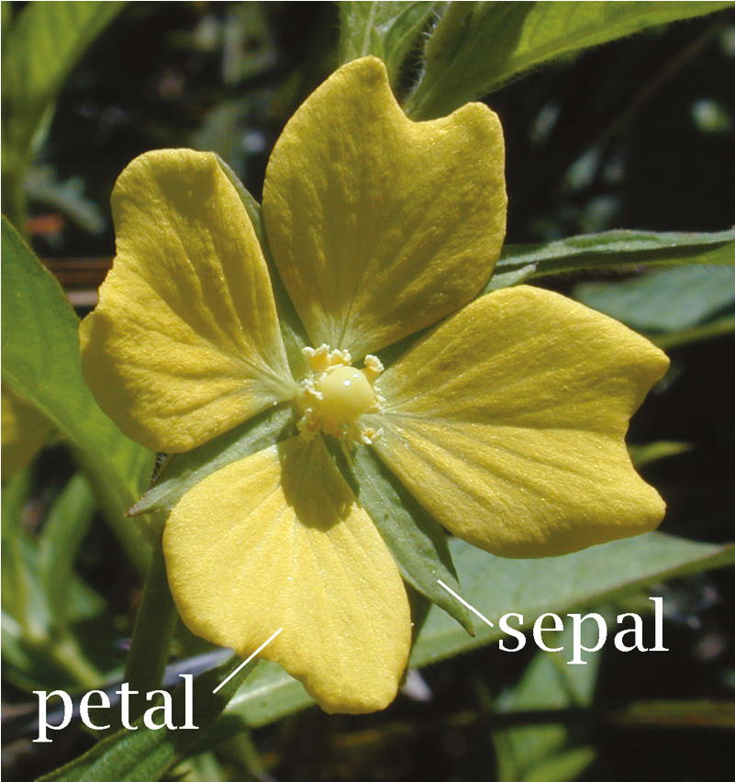

**Figure 5.1:** The petal and sepal of a flower

To print the label of the dataset, use the **target** property. For the label names, use the **target**_**names** property:

**print(iris.target) # Labels print(iris.target_names) # Label names** This prints out the following:

**[0 0 0 0 0 0 0 0 0 0 0 0 0 0 0 0 0 0 0 ... 2 2 2 2 2 2**

**2 2]**

**['setosa' 'versicolor' 'virginica']**

In this case, 0 represents *setosa*, 1 represents *versicolor*, and 2 represents *virginica*.

**TIP Note that not all sample datasets in Scikit-learn support the feature_names and target_names properties.**

Figure 5.2 summarizes what the dataset looks like.

|  |  |  |  |  |
| --- | --- | --- | --- | --- |
| **sepal length** | **sepal width** | **petal length** | **petal width** | **target** |
| 5.1 | 3.5 | 1.4 | 0.2 | *0* |
| 4.9 | 3.0 | 1.4 | 0.2 | *0* |
| ... | ... | ... | ... | ... |
| 5.9 | 3.0 | 5.1 | 1.8 | *2* |

*0 represents setosa, 1 represents versicolor, 2 represents virginica*

**Figure 5.2:** The fields in the Iris dataset and its target

Often, it is useful to convert the data to a Pandas dataframe, so that you can manipulate it easily:

**import pandas as pd**

**df = pd.DataFrame(iris.data) # convert features**

**# to dataframe in Pandas print(df.head())**

These statements print out the following:

**0 1 2 3**

1. **5.1 3.5 1.4 0.2**
2. **4.9 3.0 1.4 0.2**
3. **4.7 3.2 1.3 0.2**
4. **4.6 3.1 1.5 0.2**
5. **5.0 3.6 1.4 0.2**

Besides the Iris dataset, you can also load some interesting datasets in Scikitlearn, such as the following:

**# data on breast cancer**

**breast_cancer = datasets.load_breast_cancer()**

**# data on diabetes**

**diabetes = datasets.load_diabetes()**

**# dataset of 1797 8x8 images of hand-written digits digits = datasets.load_digits()**

For more information on the Scikit-learn dataset, check out the documentation at **http://scikit-learn.org/stable/datasets/index.html**. **Using the Kaggle Dataset**

*Kaggle* is the world’s largest community of data scientists and machine learners. What started off as a platform for offering machine learning competitions, Kaggle now also offers a public data platform, as well as a cloud-based workbench for data scientists. Google acquired Kaggle in March 2017.

For learners of machine learning, you can make use of the sample datasets provided by Kaggle at **https://www.kaggle.com/datasets/**. Some of the interesting datasets include:

**■Women’s Shoe Prices:** A list of 10,000 women’s shoes and the prices at which they are sold (**https://www.kaggle.com/datafiniti/womens- shoes-prices**)

**■Fall Detection Data from China:** Activity of elderly patients along with their medical information (**https://www.kaggle.com/pitasr/falldata**)

**■NYC Property Sales:** A year’s worth of properties sold on the NYC real estate market (**https://www.kaggle.com/new-york-city/nyc-propertysales#nyc-rolling-sales.csv**)

**■US Flight Delay:** Flight Delays for year 2016 (**https://www.kaggle.com/ niranjan0272/us-flight-delay**)

**Using the UCI (University of California, Irvine) Machine**

**Learning Repository**

The UCI Machine Learning Repository (**https://archive.ics.uci.edu/ml/ datasets.html**) is a collection of databases, domain theories, and data generators that are used by the machine learning community for the empirical analysis of machine learning algorithms. Here are some interesting ones from the huge dataset it contains:

**■Auto MPG Data Set:** A collection of data about the fuel efficiency of different types of cars (**https://archive.ics.uci.edu/ml/datasets/Auto+MPG**)

**■Student Performance Data Set:** Predict student performance in secondary education (high school) (**https://archive.ics.uci.edu/ml/datasets/ Student+Performance**)

**■Census Income Data Set:** Predict whether income exceeds $50K/yr. based on census data (**https://archive.ics.uci.edu/ml/datasets/census+income**)

**Generating Your Own Dataset**

If you cannot find a suitable dataset for experimentation, why not generate one yourself? The **sklearn.datasets.samples**_**generator** module from the Scikitlearn library contains a number of functions to let you generate different types of datasets for different types of problems. You can use it to generate datasets of different distributions, such as the following:

**■**Linearly distributed datasets

**■**Clustered datasets

**■**Clustered datasets distributed in circular fashion

***Linearly Distributed Dataset***

The **make**_**regression()** function generates data that is linearly distributed. You can specify the number of features that you want, as well as the standard deviation of the Gaussian noise applied to the output:

**%matplotlib inline**

**from matplotlib import pyplot as plt**

**from sklearn.datasets.samples_generator import make_regression**

**X, y = make_regression(n_samples=100, n_features=1, noise=5.4) plt.scatter(X,y)**

Figure 5.3 shows the scatter plot of the dataset generated.

***Clustered Dataset***

The **make**_**blobs()** function generates *n* number of clusters of random data. This is very useful when performing clustering in unsupervised learning (Chapter 9, “Supervised Learning—Classification using K Nearest Neighbors (KNN)”):

–1.5

–150

–100

–50

0

50

100

150

200

–1.0

–0.5

0.0

0.5

1.0

1.5

2.0

**Figure 5.3:** Scatter plot showing the linearly distributed data points

**%matplotlib inline import matplotlib.pyplot as plt import numpy as np**

**from sklearn.datasets import make_blobs**

**X, y = make_blobs(500, centers=3) # Generate isotropic Gaussian**

**# blobs for clustering**

**rgb = np.array(['r', 'g', 'b'])**

**# plot the blobs using a scatter plot and use color coding plt.scatter(X[:, 0], X[:, 1], color=rgb[y])**

Figure 5.4 shows the scatter plot of the random dataset generated.

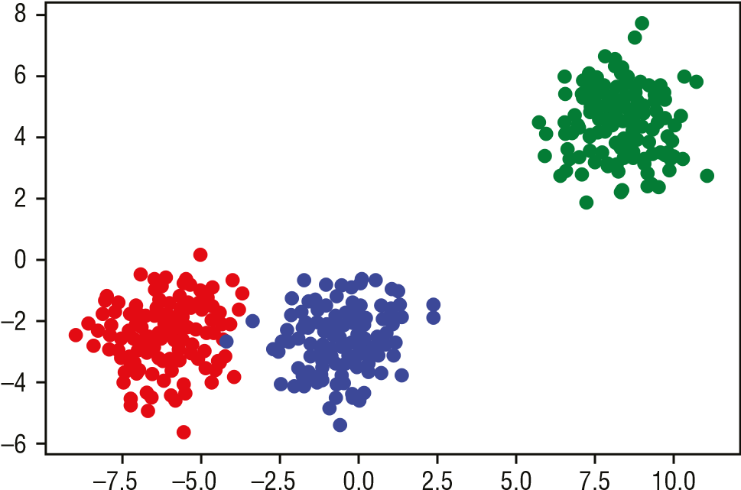

**Figure 5.4:** Scatter plot showing the three clusters of data points generated

***Clustered Dataset Distributed in Circular Fashion***

The **make**_**circles()** function generates a random dataset containing a large circle embedding a smaller circle in two dimensions. This is useful when performing classifications, using algorithms like SVM (Support Vector Machines). SVM will be covered in Chapter 8, “Supervised Learning—Classification using SVM.”

**%matplotlib inline import matplotlib.pyplot as plt import numpy as np**

**from sklearn.datasets import make_circles**

**X, y = make_circles(n_samples=100, noise=0.09)**

**rgb = np.array(['r', 'g', 'b']) plt.scatter(X[:, 0], X[:, 1], color=rgb[y])**

Figure 5.5 shows the scatter plot of the random dataset generated.

–1.0

–1.0

–0.5

0.0

0.5

1.0

–0.5

0.0

0.5

1.0

**Figure 5.5:** Scatter plot showing the two clusters of data points distributed in circular fashion

**Getting Started with Scikit-learn**

The easiest way to get started with machine learning with Scikit-learn is to start with linear regression. *Linear regression* is a linear approach for modeling the relationship between a scalar dependent variable *y* and one or more explanatory variables (or independent variables). For example, imagine that you have a set of data comprising the heights (in meters) of a group of people and their corresponding weights (in kg):

**%matplotlib inline**

**import matplotlib.pyplot as plt**

**# represents the heights of a group of people in meters heights = [[1.6], [1.65], [1.7], [1.73], [1.8]]**

**# represents the weights of a group of people in kgs weights = [[60], [65], [72.3], [75], [80]]**

**plt.title('Weights plotted against heights') plt.xlabel('Heights in meters') plt.ylabel('Weights in kilograms')**

**plt.plot(heights, weights, 'k.')**

**# axis range for x and y plt.axis([1.5, 1.85, 50, 90]) plt.grid(True)**

When you plot a chart of weights against heights, you will see the chart as shown in Figure 5.6.

50

1.50

1.55

1.60

1.65

Heights in meters

Weights plotted against heights

1.70

1.75

1.80

1.85

55

60

65

70

W

eights in kilograms

75

80

85

90

**Figure 5.6:** Plotting the weights against heights for a group of people

From the chart, you can see that there is a positive correlation between the weights and heights for this group of people. You could draw a straight line through the points and use that to predict the weight of another person based on their height.

**Using the LinearRegression Class for Fitting the Model**

So how do we draw the straight line that cuts though all of the points? It turns out that the Scikit-learn library has the **LinearRegression** class that helps you to do just that. All you need to do is to create an instance of this class and use the ***heights*** and ***weights*** lists to create a linear regression model using the **fit()** function, like this:

**from sklearn.linear_model import LinearRegression**

**# Create and fit the model model = LinearRegression() model.fit(X=heights, y=weights)**

**TIP Observe that the *heights* and *weights* are both represented as two-dimensional lists. This is because the fit() function requires both the *X* and *y* arguments to be two-dimensional (of type list or ndarray).**

**Making Predictions**

Once you have fitted (trained) the model, you can start to make predictions using the **predict()** function, like this:

**# make prediction**

**weight = model.predict([[1.75]])[0][0] print(round(weight,2)) # 76.04**

In the preceding example, you want to predict the weight for a person that is

1.75m tall. Based on the model, the weight is predicted to be 76.04kg.

**TIP In Scikit-learn, you typically use the fit() function to train a model. Once the model is trained, you use the predict() function to make a prediction.**

**Plotting the Linear Regression Line**

It would be useful to visualize the linear regression line that has been created by the **LinearRegression** class. Let’s do this by first plotting the original data points and then sending the ***heights*** list to the model to predict the weights. We then plot the series of forecasted weights to obtain the line. The following code snippet shows how this is done:

**import matplotlib.pyplot as plt**

**heights = [[1.6], [1.65], [1.7], [1.73], [1.8]] weights = [[60], [65], [72.3], [75], [80]]**

**plt.title('Weights plotted against heights') plt.xlabel('Heights in meters') plt.ylabel('Weights in kilograms') plt.plot(heights, weights, 'k.')**

**plt.axis([1.5, 1.85, 50, 90]) plt.grid(True)**

**# plot the regression line plt.plot(heights, model.predict(heights), color='r')** Figure 5.7 shows the linear regression line.

50

1.50

1.55

1.60

1.65

Heights in meters

Weights plotted against heights

1.70

1.75

1.80

1.85

55

60

65

70

W

eights in kilograms

75

80

85

90

**Figure 5.7:** Plotting the linear regression line

**Getting the Gradient and Intercept of the Linear**

**Regression Line**

From Figure 5.7, it is not clear at what value the linear regression line intercepts the y-axis. This is because we have adjusted the x-axis to start plotting at 1.5. A better way to visualize this would be to set the x-axis to start from 0 and enlarge the range of the y-axis. You then plot the line by feeding in two extreme values of the height: 0 and 1.8. The following code snippet re-plots the points and the linear regression line:

**plt.title('Weights plotted against heights') plt.xlabel('Heights in meters') plt.ylabel('Weights in kilograms')**

**plt.plot(heights, weights, 'k.')**

**plt.axis([0, 1.85, -200, 200]) plt.grid(True)**

**# plot the regression line extreme_heights = [[0], [1.8]] plt.plot(extreme_heights, model.predict(extreme_heights), color='b')** Figure 5.8 now shows the point where the line cuts the y-axis.

0.00

–200

–150

–100

–50

0

50

100

150

200

0.25

0.50

0.75

Heights in meters

Weights plotted against heights

1.00

1.25

1.50

1.75

W

eights in kilograms

**Figure 5.8:** The linear regression line

While you can get the y-intercept by predicting the weight if the height is 0: **round(model.predict([[0]])[0][0],2) # -104.75**

the ***model*** object provides the answer directly through the **intercept**_ property: **print(round(model.intercept_[0],2)) # -104.75**

Using the ***model*** object, you can also get the gradient of the linear regression line through the **coef**_ property:

**print(round(model.coef_[0][0],2)) # 103.31**

**Examining the Performance of the Model by Calculating the**

**Residual Sum of Squares**

To know if your linear regression line is well fitted to all of the data points, we use the *Residual Sum of Squares (RSS)* method. Figure 5.9 shows how the RSS is calculated.

The following code snippet shows how the RSS is calculated in Python:

**import numpy as np**

**print('Residual sum of squares: %.2f' %**

**np.sum((weights - model.predict(heights)) ** 2))**

**# Residual sum of squares: 5.34**

Errors of prediction (

**E**

)

**Residual Sum of Squares**

**=**

**Sum of E**

**2**

**Figure 5.9:** Calculating the Residual Sum of Squares for linear regression

The RSS should be as small as possible, with 0 indicating that the regression line fits the points exactly (rarely achievable in the real world).

**Evaluating the Model Using a Test Dataset**

Now that our model is trained with our training data, we can put it to the test. Assuming that we have the following test dataset:

**# test data**

**heights_test = [[1.58], [1.62], [1.69], [1.76], [1.82]] weights_test = [[58], [63], [72], [73], [85]]**

we can measure how closely the test data fits the regression line using the *R-Squared method*. The R-Squared method is also known as the *coefficient of determination*, or the *coefficient of multiple determinations for multiple regressions*.

The formula for calculating R-Squared is shown in Figure 5.10.

*R*2 = 1 *RSS*

TSS

*n*

TSS =Σ (*yi – ~~y~~*)2

*i* =1

*n*

*RSS* =Σ(*yi – f* (*xi* ))2

*i* =1

**Figure 5.10:** The formula for calculating R-Squared

Using the formula shown for R-Squared, note the following:

**■**R2 is R-squared

**■**TSS is Total Sum of Squares

**■**RSS is Residual Sum of Squares

You can now calculate it in Python using the following code snippet:

**# Total Sum of Squares (TSS)**

**weights_test_mean = np.mean(np.ravel(weights_test))**

**TSS = np.sum((np.ravel(weights_test) weights_test_mean) ** 2) print("TSS: %.2f" % TSS)**

**# Residual Sum of Squares (RSS)**

**RSS = np.sum((np.ravel(weights_test) -**

**np.ravel(model.predict(heights_test)))**

**\*\* 2) print("RSS: %.2f" % RSS)**

**# R_squared**

**R_squared = 1 - (RSS / TSS) print("R-squared: %.2f" % R_squared)**

**TIP The ravel() function converts the two-dimensional list into a contiguous flattened (one-dimensional) array.**

The preceding code snippet yields the following result:

**TSS: 430.80**

**RSS: 24.62**

**R-squared: 0.94**

Fortunately, you don’t have to calculate the R-Squared manually yourself— Scikit-learn has the **score()** function to calculate the R-Squared automatically for you:

**# using scikit-learn to calculate r-squared print('R-squared: %.4f' % model.score(heights_test, weights_test))**

**# R-squared: 0.9429**

An R-Squared value of 0.9429 (94.29%) indicates a pretty good fit for your test data.

**Persisting the Model**

Once you have trained a model, it is often useful to be able to save it for later use. Rather than retraining the model every time you have new data to test, a saved model allows you to load the trained model and make predictions immediately without the need to train the model again.

There are two ways to save your trained model in Python:

**■**Using the standard **pickle** module in Python to serialize and deserialize objects

**■**Using the **joblib** module in Scikit-learn that is optimized to save and load Python objects that deal with NumPy data

The first example you will see is saving the model using the **pickle** module:

**import pickle**

**# save the model to disk**

**filename = 'HeightsAndWeights_model.sav'**

**# write to the file using write and binary mode pickle.dump(model, open(filename, 'wb'))**

In the preceding code snippet, you first opened a file in "**wb**" mode ("**w**" for write and "**b**" for binary). You then use the **dump()** function from the **pickle** module to save the model into the file.

To load the model from file, use the **load()** function:

**# load the model from disk loaded_model = pickle.load(open(filename, 'rb'))** You can now use the model as usual:

**result = loaded_model.score(heights_test, weights_test)**

Using the **joblib** module is very similar to using the **pickle** module:

**from sklearn.externals import joblib**

**# save the model to disk**

**filename = 'HeightsAndWeights_model2.sav' joblib.dump(model, filename)**

**# load the model from disk loaded_model = joblib.load(filename) result = loaded_model.score(heights_test, weights_test) print(result)**

**Data Cleansing**

In machine learning, one of the first tasks that you need to perform is *data cleansing*. Very seldom would you have a dataset that you can use straightaway to train your model. Instead, you have to examine the data carefully for any missing values and either remove them or replace them with some valid values, or you have to normalize them if there are columns with wildly different values. The following sections show some of the common tasks you need to perform when cleaning your data.

**Cleaning Rows with NaNs**

Consider a CSV file named **NaNDataset.csv** with the following content:

**A,B,C**

**1,2,3**

**4,,6**

**7,,9**

**10,11,12**

**13,14,15**

**16,17,18**

Visually, you can spot that there are a few rows with empty fields. Specifically, the second and third rows have missing values for the second columns. For small sets of data, this is easy to spot. But if you have a large dataset, it becomes almost impossible to detect. An effective way to detect for empty rows is to load the dataset into a Pandas dataframe and then use the **isnull()** function to check for null values in the dataframe:

**import pandas as pd df = pd.read_csv('NaNDataset.csv') df.isnull().sum()**

This code snippet will produce the following output:

1. **0**
2. **2**
3. **0**

**dtype: int64**

You can see that column B has two null values. When Pandas loads a dataset containing empty values, it will use **NaN** to represent those empty fields. The following is the output of the dataframe when you print it out:

**A B C**

**0 1 2.0 3**

# 1 4 NaN 6

1. **7 NaN 9**
2. **10 11.0 12**
3. **13 14.0 15**
4. **16 17.0 18**

***Replacing NaN with the Mean of the Column***

One of the ways to deal with **NaN**s in your dataset is to replace them with the mean of the columns in which they are located. The following code snippet replaces all of the **NaN**s in column B with the average value of column B:

**# replace all the NaNs in column B with the average of column B df.B = df.B.fillna(df.B.mean()) print(df)**

The dataframe now looks like this:

**A B C**

1. **1 2.0 3**
2. **4 11.0 6**
3. **7 11.0 9**
4. **10 11.0 12**
5. **13 14.0 15**
6. **16 17.0 18**

***Removing Rows***

Another way to deal with **NaN**s in your dataset is simply to remove the rows containing them. You can do so using the **dropna()** function, like this:

**df = pd.read_csv('NaNDataset.csv')**

**df = df.dropna() # drop all rows with NaN print(df)**

This code snippet will produce the following output:

**A B C**

**0 1 2.0 3**

1. **10 11.0 12**
2. **13 14.0 15**
3. **16 17.0 18**

Observe that after removing the rows containing **NaN**, the index is no longer in sequential order. If you need to reset the index, use the **reset**_**index()** function:

**df = df.reset_index(drop=True) # reset the index print(df)**

The dataframe with the reset index will now look like this:

**A B C**

1. **1 2.0 3**
2. **10 11.0 12**
3. **13 14.0 15**
4. **16 17.0 18**

**Removing Duplicate Rows**

Consider a CSV file named **DuplicateRows.csv** with the following content:

**A,B,C**

**1,2,3**

**4,5,6**

**4,5,6**

**7,8,9**

**7,18,9**

**10,11,12**

**10,11,12**

**13,14,15**

**16,17,18**

To find all of the duplicated rows, first load the dataset into a dataframe and then use the **duplicated()** function, like this:

**import pandas as pd**

**df = pd.read_csv('DuplicateRows.csv') print(df.duplicated(keep=False))** This will produce the following output:

1. **False**
2. **True**
3. **True**
4. **False**
5. **False**
6. **True**
7. **True**
8. **False8 False dtype: bool**

It shows which rows are duplicated. In this example, rows with index 1, 2, 5, and 6 are duplicates. The **keep** argument allows you to specify how to indicate duplicates:

**■**The default is **'first'**: All duplicates are marked as **True** except for the first occurrence

**■'last'**: All duplicates are marked as **True** except for the last occurrence

**■False**: All duplicates are marked as **True**

So, if you set **keep** to **'first'**, you will see the following output:

1. **False**
2. **False**
3. **True**
4. **False**
5. **False**
6. **False**
7. **True**
8. **False8 False dtype: bool**

Hence, if you want to see all duplicate rows, you can set **keep** to **False** and use the result of the **duplicated()** function as the index into the dataframe: **print(df[df.duplicated(keep=False)])**

The preceding statement will print all of the duplicate rows:

**A B C**

1. **4 5 6**
2. **4 5 6**
3. **10 11 12**
4. **10 11 12**

To drop duplicate rows, you can use the **drop**_**duplicates()** function, like this:

**df.drop_duplicates(keep='first', inplace=True) # remove**

**duplicates and keep the first print(df)**

**TIP By default, the drop_duplicates() function will not modify the original dataframe and will return the dataframe containing the dropped rows. If you want to modify the original dataframe, set the inplace parameter to True, as shown in the preceding code snippet.**

The preceding statements will print the following:

**A B C**

0 1 2 3

1 4 5 6

3 7 8 9

4 7 18 9

5 10 11 127 13 14 15

**8 16 17 18**

**TIP To remove all duplicates, set the keep parameter to False. To keep the last occurrence of duplicate rows, set the keep parameter to 'last'.**

Sometimes, you only want to remove duplicates that are found in certain columns in the dataset. For example, if you look at the dataset that we have been using, observe that for row 3 and row 4, the values of column A and C are identical:

**A B C**

# 3 7 8 9

# 4 7 18 9

You can remove duplicates in certain columns by specifying the **subset** parameter:

**df.drop_duplicates(subset=['A', 'C'], keep='last',**

**inplace=True) # remove all duplicates in # columns A and C and keep**

**# the last print(df)**

This statement will yield the following:

**A B C**

1. **1 2 3**
2. **4 5 6**

**4 7 18 9**

# 5 10 11 12

1. **13 14 15**
2. **16 17 18**

**Normalizing Columns**

Normalization is a technique often applied during the data cleansing process. The aim of *normalization* is to change the values of numeric columns in the dataset to use a common scale, without modifying the differences in the ranges of values.

Normalization is crucial for some algorithms to model the data correctly. For example, one of the columns in your dataset may contain values from 0 to 1, while another column has values ranging from 400,000 to 500,000. The huge disparity in the scale of the numbers could introduce problems when you use the two columns to train your model. Using normalization, you could maintain the ratio of the values in the two columns while keeping them to a limited range. In Pandas, you can use the **MinMaxScaler** class to scale each column to a particular range of values.

Consider a CSV file named **NormalizeColumns.csv** with the following content:

**A,B,C**

**1000,2,3**

**400,5,6**

**700,6,9**

**100,11,12**

**1300,14,15**

**1600,17,18**

The following code snippet will scale all the columns’ values to the (0,1) range:

**import pandas as pd**

**from sklearn import preprocessing**

**df = pd.read_csv('NormalizeColumns.csv') x = df.values.astype(float)**

**min_max_scaler = preprocessing.MinMaxScaler() x_scaled = min_max_scaler.fit_transform(x) df = pd.DataFrame(x_scaled, columns=df.columns) print(df)**

You should see the following output:

**A B C**

1. **0.6 0.000000 0.0**
2. **0.2 0.200000 0.2**
3. **0.4 0.266667 0.4**
4. **0.0 0.600000 0.6**
5. **0.8 0.800000 0.8**
6. **1.0 1.000000 1.0**

**Removing Outliers**

In statistics, an *outlier* is a point that is distant from other observed points. For example, given a set of values—234, 267, 1, 200, 245, 300, 199, 250, 8999, and 245—it is quite obvious that 1 and 8999 are outliers. They distinctly stand out from the rest of the values, and they “lie outside” most of the other values in the dataset; hence the word *outlier*. Outliers occur mainly due to errors in recording or experimental error, and in machine learning it is important to remove them prior to training your model as it may potentially distort your model if you don’t.

There are a number of techniques to remove outliers, and in this chapter we discuss two of them:

**■**Tukey Fences

**■**Z-Score

***Tukey Fences***

Tukey Fences is based on *Interquartile Range (IQR)*. IQR is the difference between the first and third quartiles of a set of values. The first quartile, denoted Q1, is the value in the dataset that holds 25% of the values below it. The third quartile, denoted Q3, is the value in the dataset that holds 25% of the values above it. Hence, by definition, IQR = Q3 – Q1.

Figure 5.11 shows an example of how IQR is obtained for datasets with even and odd numbers of values.

|  |
| --- |
| **Number of Items: 10**  1 3 4 5 6 7 10 11 12 14  **Median is 6.5**  **First Quartile is 4 Third Quartile is 11**  **Interquartile Range (IQR) is 11 – 4 = 7** |
| **Number of Items: 11**  1 3 4 5 6 7 10 11 12 14  **Median is 7**  **First Quartile is 4 Third Quartile is 12**  **Interquartile Range (IQR) is 12 – 4 = 8** |

**Figure 5.11:** Examples of finding the Interquartile Range (IQR)

In Tukey Fences, outliers are values that are as follows:

**■**Less than Q1 – (1.5 × IQR), or

**■**More than Q3 + (1.5 × IQR)

The following code snippet shows the implementation of Tukey Fences using Python:

**import numpy as np def outliers_iqr(data):**

**q1, q3 = np.percentile(data, [25, 75]) iqr = q3 - q1**

**lower_bound = q1 - (iqr * 1.5) upper_bound = q3 + (iqr * 1.5) return np.where((data > upper_bound) | (data < lower_bound))**

**TIP The np.where() function returns the location of items satisfying the conditions.**

The **outliers**_**iqr()** function returns a tuple of which the first element is an array of indices of those rows that have outlier values.

To test the Tukey Fences, let’s use the famous Galton dataset on the heights of parents and their children. The dataset contains data based on the famous 1885 study of Francis Galton exploring the relationship between the heights of adult children and the heights of their parents. Each case is an adult child, and the variables are as follows:

**Family:** The family that the child belongs to, labeled by the numbers from 1 to 204 and 136A

**Father:** The father’s height, in inches

**Mother:** The mother’s height, in inches

**Gender:** The gender of the child, male (M) or female (F)

**Height:** The height of the child, in inches **Kids:** The number of kids in the family of the child

The dataset has 898 cases. First, import the data:

**import pandas as pd**

**df = pd.read_csv("http://www.mosaic-web.org/go/datasets/galton.csv") print(df.head())**

You should see the following:

**family father mother sex height nkids 0 1 78.5 67.0 M 73.2 4**

1. **1 78.5 67.0 F 69.2 4**
2. **1 78.5 67.0 F 69.0 4**
3. **1 78.5 67.0 F 69.0 4**
4. **2 75.5 66.5 M 73.5 4**

If you want to find the outliers in the **height** column, you can call the **outliers**_**iqr()** function as follows:

**print("Outliers using outliers_iqr()") print("=============================") for i in outliers_iqr(df.height)[0]:**

**print(df[i:i+1])**

You should see the following output:

**Outliers using outliers_iqr() =============================**

**family father mother sex height nkids 288 72 70.0 65.0 M 79.0 7**

Using the Tukey Fences method, you can see that the **height** column has a single outlier.

***Z-Score***

The second method for determining outliers is to use the *Z-score* method. A Z-score indicates how many standard deviations a data point is from the mean. The Z-score has the following formula:

**Z**

**x**

**i**

/

where xi is the data point, μ is the mean of the dataset, and σ is the standard deviation.

This is how you interpret the Z-score:

**■**A negative Z-score indicates that the data point is less than the mean, and a positive Z-score indicates the data point in question is larger than the mean

**■**A Z-score of 0 tells you that the data point is right in the middle (mean), and a Z-score of 1 tells you that your data point is 1 standard deviation above the mean, and so on

**■**Any Z-score greater than 3 or less than –3 is considered to be an outlier

The following code snippet shows the implementation of the Z-score using Python:

**def outliers_z_score(data): threshold = 3 mean = np.mean(data) std = np.std(data)**

**z_scores = [(y - mean) / std for y in data] return np.where(np.abs(z_scores) > threshold)**

Using the same Galton dataset that you used earlier, you can now find the outliers for the **height** column using the **outliers**_**z**_**score()** function:

**print("Outliers using outliers_z_score()") print("=================================") for i in outliers_z_score(df.height)[0]:**

**print(df[i:i+1]) print()**

You should see the following output:

**Outliers using outliers_z_score() ================================= family father mother sex height nkids 125 35 71.0 69.0 M 78.0 5 family father mother sex height nkids 288 72 70.0 65.0 M 79.0 7 family father mother sex height nkids 672 155 68.0 60.0 F 56.0 7**

Using the Z-score method, you can see that the **height** column has three

outliers.

**Summary**

In this chapter, you have seen how to get started with the Scikit-learn library to solve a linear regression problem. In addition, you have also learned how to get sample datasets, generate your own, perform data cleansing, as well as the two techniques that you can use to remove outliers from your datasets.

In subsequent chapters, you will learn more about the various machine learning algorithms and how to use them to solve real-life problems.

|  |
| --- |
| **CHAPTER** |
| **6**  **Regression** |

**Supervised Learning—Linear**

**Types of Linear Regression**

In the previous chapter, you learned how to get started with machine learning using simple linear regression, first using Python, and then followed by using the Scikit-learn library. In this chapter, we will look into linear regression in more detail and discuss another variant of linear regression known as *polynomial regression*.

To recap, Figure 6.1 shows the Iris dataset used in Chapter 5, “Getting Started with Scikit-learn for Machine Learning.” The first four columns are known as the *features*, or also commonly referred to as the *independent variables*. The last column is known as the *label*, or commonly called the *dependent variable* (or *dependent variables* if there is more than one label).

**Label**

**(**

**Dependent variable**

**)**

**Features**

**(**

**Independent variables**

**)**

**sepal length**

**sepal width**

**petal length**

**petal width**

**target**

**Figure 6.1:** Some terminologies for features and label

**119**

Python® Machine Learning, First Edition. Wei-Meng Lee.

© 2019 John Wiley & Sons, Inc. Published 2019 by John Wiley & Sons, Inc.

**TIP Features are also sometimes called *explanatory variables*, while labels are also sometimes called *targets*.**

In simple linear regression, we talked about the linear relationship between one independent variable and one dependent variable. In this chapter, besides simple linear regression, we will also discuss the following:

**Multiple Regression** Linear relationships between two or more independent variables and one dependent variable.

**Polynomial Regression** Modeling the relationship between one independent variable and one dependent variable using an *n*th degree polynomial function.

**Polynomial Multiple Regression** Modeling the relationship between two or more independent variables and one dependent variable using an *n*th degree polynomial function.

**TIP There is another form of linear regression, called *multivariate linear regression*, where there is more than one correlated dependent variable in the relationship. Multivariate linear regression is beyond the scope of this book.**

**Linear Regression**

In machine learning, *linear regression* is one of the simplest algorithms that you can apply to a dataset to model the relationships between features and labels. In Chapter 5, we started by exploring simple linear regression, where we could explain the relationship between a feature and a label by using a straight line. In the following section, you will learn about a variant of simple linear regression, called *multiple linear regression*, by predicting house prices based on multiple features.

**Using the Boston Dataset**

For this example, we will use the Boston dataset, which contains data about the housing and price data in the Boston area. This dataset was taken from the StatLib library, which is maintained at Carnegie Mellon University. It is commonly used in machine learning, and it is a good candidate to learn about regression problems. The Boston dataset is available from a number of sources, but it is now available directly from the **sklearn.datasets** package. This means you can load it directly in Scikit-learn without needing explicitly to download it.

First, let’s import the necessary libraries and then load the dataset using the **load**_**boston()** function:

**import matplotlib.pyplot as plt import pandas as pd import numpy as np**

**from sklearn.datasets import load_boston dataset = load_boston()**

It is always good to examine the data before you work with it. The **data** property contains the data for the various columns of the dataset: **print(dataset.data)**

You should see the following:

**[[ 6.32000000e-03 1.80000000e+01 2.31000000e+00 ..., 1.53000000e+01 3.96900000e+02 4.98000000e+00]**

**[ 2.73100000e-02 0.00000000e+00 7.07000000e+00 ..., 1.78000000e+01**

**3.96900000e+02 9.14000000e+00]**

**[ 2.72900000e-02 0.00000000e+00 7.07000000e+00 ..., 1.78000000e+01**

**3.92830000e+02 4.03000000e+00] ...,**

**[ 6.07600000e-02 0.00000000e+00 1.19300000e+01 ..., 2.10000000e+01**

**3.96900000e+02 5.64000000e+00]**

**[ 1.09590000e-01 0.00000000e+00 1.19300000e+01 ..., 2.10000000e+01**

**3.93450000e+02 6.48000000e+00]**

**[ 4.74100000e-02 0.00000000e+00 1.19300000e+01 ..., 2.10000000e+01 3.96900000e+02 7.88000000e+00]]**

The data is a two-dimensional array. To know the name of each column (feature), use the **feature**_**names** property: **print(dataset.feature_names)**

You should see the following:

**['CRIM' 'ZN' 'INDUS' 'CHAS' 'NOX' 'RM' 'AGE' 'DIS' 'RAD' 'TAX' 'PTRATIO'**

**'B' 'LSTAT']**

For the description of each feature, you can use the **DESCR** property: **print(dataset.DESCR)**

The preceding statement will print out the following:

**Boston House Prices dataset**

**===========================**

**Notes**

**------**

**Data Set Characteristics:**

**:Number of Instances: 506**

**:Number of Attributes: 13 numeric/categorical predictive**

**:Median Value (attribute 14) is usually the target**

**:Attribute Information (in order):**

* **CRIM per capita crime rate by town**
* **ZN proportion of residential land zoned for lots over 25,000 sq.ft.**
* **INDUS proportion of non-retail business acres per town**
* **CHAS Charles River dummy variable (= 1 if tract bounds river; 0 otherwise)**
* **NOX nitric oxides concentration (parts per 10 million)**
* **RM average number of rooms per dwelling**
* **AGE proportion of owner-occupied units built prior to 1940**
* **DIS weighted distances to five Boston employment centres**
* **RAD index of accessibility to radial highways**
* **TAX full-value property-tax rate per $10,000**
* **PTRATIO pupil-teacher ratio by town**
* **B 1000(Bk - 0.63)^2 where Bk is the proportion of blacks by town**
* **LSTAT % lower status of the population**
* **MEDV Median value of owner-occupied homes in $1000's**

**:Missing Attribute Values: None**

**:Creator: Harrison, D. and Rubinfeld, D.L.**

**This is a copy of UCI ML housing dataset: http://archive.ics.uci.edu/ ml/datasets/Housing**

**This dataset was taken from the StatLib library which is maintained at Carnegie Mellon University.**

**The Boston house-price data of Harrison, D. and Rubinfeld, D.L. 'Hedonic prices and the demand for clean air', J. Environ. Economics & Management, vol.5, 81-102, 1978. Used in Belsley, Kuh & Welsch, 'Regression diagnostics**

**...', Wiley, 1980. N.B. Various transformations are used in the table on pages 244-261 of the latter.**

**The Boston house-price data has been used in many machine learning papers that address regression problems.**

**\*\*References\*\***

* **Belsley, Kuh & Welsch, 'Regression diagnostics: Identifying Influential Data and Sources of Collinearity', Wiley, 1980. 244-261.**
* **Quinlan,R. (1993). Combining Instance-Based and Model-Based**

**Learning. In Proceedings on the Tenth International Conference of**

**Machine Learning, 236-243, University of Massachusetts, Amherst. Morgan Kaufmann.**

* **many more! (see http://archive.ics.uci.edu/ml/datasets/ Housing)**

The prices of houses is the information we are seeking, and it can be accessed via the **target** property: **print(dataset.target)**

You will see the following:

**[ 24. 21.6 34.7 33.4 36.2 28.7 22.9 27.1 16.5 18.9 15. 18.9**

**21.7 20.4 18.2 19.9 23.1 17.5 20.2 18.2 13.6 19.6 15.2 14.5 15.6 13.9 16.6 14.8 18.4 21. 12.7 14.5 13.2 13.1 13.5 18.9 20. 21. 24.7 30.8 34.9 26.6 25.3 24.7 21.2 19.3 20. 16.6 14.4 19.4 19.7 20.5 25. 23.4 18.9 35.4 24.7 31.6 23.3 19.6 18.7 16. 22.2 25. 33. 23.5 19.4 22. 17.4 20.9 24.2 21.7 22.8 23.4 24.1 21.4 20. 20.8 21.2 20.3 28. 23.9 24.8 22.9 23.9 26.6 22.5 22.2 23.6 28.7 22.6 22. 22.9 25. 20.6 28.4 21.4 38.7 43.8 33.2 27.5 26.5 18.6 19.3 20.1 19.5 19.5 20.4 19.8 19.4 21.7 22.8 18.8 18.7 18.5 18.3 21.2 19.2 20.4 19.3 22. 20.3 20.5 17.3 18.8 21.4 15.7 16.2 18. 14.3 19.2 19.6 23. 18.4 15.6 18.1 17.4 17.1 13.3 17.8 14. 14.4 13.4 15.6 11.8 13.8 15.6 14.6 17.8 15.4 21.5 19.6 15.3 19.4 17. 15.6 13.1 41.3 24.3 23.3 27. 50. 50. 50. 22.7 25. 50. 23.8 23.8 22.3 17.4 19.1 23.1 23.6 22.6 29.4 23.2 24.6 29.9 37.2 39.8 36.2 37.9 32.5 26.4 29.6 50. 32. 29.8 34.9 37. 30.5**

**36.4 31.1 29.1 50. 33.3 30.3 34.6 34.9 32.9 24.1 42.3 48.5 50. 22.6 24.4 22.5 24.4 20. 21.7 19.3 22.4 28.1 23.7 25.**

**23.3 28.7 21.5 23. 26.7 21.7 27.5 30.1 44.8 50. 37.6 31.6 46.7 31.5 24.3 31.7 41.7 48.3 29. 24. 25.1 31.5 23.7 23.3**

**22. 20.1 22.2 23.7 17.6 18.5 24.3 20.5 24.5 26.2 24.4 24.8**

**29.6 42.8 21.9 20.9 44. 50. 36. 30.1 33.8 43.1 48.8 31.**

**36.5 22.8 30.7 50. 43.5 20.7 21.1 25.2 24.4 35.2 32.4 32. 33.2 33.1 29.1 35.1 45.4 35.4 46. 50. 32.2 22. 20.1 23.2 22.3 24.8 28.5 37.3 27.9 23.9 21.7 28.6 27.1 20.3 22.5 29.**

**24.8 22. 26.4 33.1 36.1 28.4 33.4 28.2 22.8 20.3 16.1 22.1 19.4 21.6 23.8 16.2 17.8 19.8 23.1 21. 23.8 23.1 20.4 18.5 25. 24.6 23. 22.2 19.3 22.6 19.8 17.1 19.4 22.2 20.7 21.1 19.5 18.5 20.6 19. 18.7 32.7 16.5 23.9 31.2 17.5 17.2 23.1**

**24.5 26.6 22.9 24.1 18.6 30.1 18.2 20.6 17.8 21.7 22.7 22.6 25. 19.9 20.8 16.8 21.9 27.5 21.9 23.1 50. 50. 50. 50.**

**50. 13.8 13.8 15. 13.9 13.3 13.1 10.2 10.4 10.9 11.3 12.3 8.8 7.2 10.5 7.4 10.2 11.5 15.1 23.2 9.7 13.8 12.7 13.1 12.5 8.5 5. 6.3 5.6 7.2 12.1 8.3 8.5 5. 11.9 27.9**

**17.2 27.5 15. 17.2 17.9 16.3 7. 7.2 7.5 10.4 8.8 8.4**

**16.7 14.2 20.8 13.4 11.7 8.3 10.2 10.9 11. 9.5 14.5 14.1 16.1 14.3 11.7 13.4 9.6 8.7 8.4 12.8 10.5 17.1 18.4 15.4**

**10.8 11.8 14.9 12.6 14.1 13. 13.4 15.2 16.1 17.8 14.9 14.1 12.7 13.5 14.9 20. 16.4 17.7 19.5 20.2 21.4 19.9 19. 19.1 19.1 20.1 19.9 19.6 23.2 29.8 13.8 13.3 16.7 12. 14.6 21.4 23. 23.7 25. 21.8 20.6 21.2 19.1 20.6 15.2 7. 8.1 13.6**

**20.1 21.8 24.5 23.1 19.7 18.3 21.2 17.5 16.8 22.4 20.6 23.9**

**22. 11.9]**

Now let’s load the data into a Pandas DataFrame:

**df = pd.DataFrame(dataset.data, columns=dataset.feature_names) df.head()**

The DataFrame would look like the one shown in Figure 6.2.

|  |  |  |  |  |  |  |  |  |  |  |  |
| --- | --- | --- | --- | --- | --- | --- | --- | --- | --- | --- | --- |
| **CRIM ZN** | | | **INDUS** | **CHAS NOX** | **RM** | **AGE DIS** | **RAD** | **TAX** | **PTRATIO B** | **LSTAT** | |
| **0** 0.00632 18.0 | | | 2.31 | 0.0 0.538 | 6.575 | 65.2 4.0900 | 1.0 | 296.0 | 15.3 396.90 | 4.98 | |
| 1. 0.02731 2. 0.02729 3. 0.03237 4. 0.06905 | 0.0  0.0  0.0  0.0 | 7.07  7.07  2.18  2.18 | 0.0 0.469  0.0 0.469  0.0 0.458  0.0 0.458 | 6.421  7.185  6.998  7.147 | 78.9 4.9671  61.1 4.9671  45.8 6.0622  54.2 6.0622 | 2.0  2.0  3.0  3.0 | 242.0  242.0  222.0  222.0 | 17.8 396.90  17.8 392.83  18.7 394.63  18.7 396.90 | 9.14  4.03  2.94  5.33 |

**Figure 6.2:** The DataFrame containing all of the features

You would also want to add the prices of the houses to the DataFrame, so let’s add a new column to the DataFrame and call it **MEDV**:

**df['MEDV'] = dataset.target df.head()**

Figure 6.3 shows the complete DataFrame with the features and label.

**CRIM ZN INDUS CHAS NOX RM AGE DIS RAD TAX PTRATIO B LSTAT MEDV**

|  |  |  |  |  |  |  |  |  |  |
| --- | --- | --- | --- | --- | --- | --- | --- | --- | --- |
| **0** 0.00632 18.0 | | | 2.31 | 0.0 0.538 6.575 65.2 4.0900 | 1.0 296.0 | 15.3 396.90 | 4.98 | 24.0 | |
| 1. 0.02731 2. 0.02729 3. 0.03237 4. 0.06905 | 0.0  0.0  0.0  0.0 | 7.07  7.07  2.18  2.18 | 0.0 0.469 6.421 78.9 4.9671  0.0 0.469 7.185 61.1 4.9671  0.0 0.458 6.998 45.8 6.0622  0.0 0.458 7.147 54.2 6.0622 | 2.0 242.0  2.0 242.0  3.0 222.0  3.0 222.0 | 17.8 396.90  17.8 392.83  18.7 394.63  18.7 396.90 | 9.14  4.03  2.94  5.33 | 21.6  34.7  33.4  36.2 |

**Figure 6.3:** The DataFrame containing all of the features and the label

**Data Cleansing**

The next step would be to clean the data and perform any conversion if necessary. First, use the **info()** function to check the data type of each field: **df.info()**

You should see the following:

**<class 'pandas.core.frame.DataFrame'>**

**RangeIndex: 506 entries, 0 to 505 Data columns (total 14 columns):**

**CRIM 506 non-null float64**

**ZN 506 non-null float64**

**INDUS 506 non-null float64**

**CHAS 506 non-null float64**

**NOX 506 non-null float64**

**RM 506 non-null float64**

**AGE 506 non-null float64**

**DIS 506 non-null float64**

**RAD 506 non-null float64**

**TAX 506 non-null float64**

**PTRATIO 506 non-null float64**

**B 506 non-null float64**

**LSTAT 506 non-null float64 MEDV 506 non-null float64 dtypes: float64(14) memory usage: 55.4 KB**

As Scikit-learn only works with fields that are numeric, you need to encode string values into numeric values. Fortunately, the dataset contains all numerical values, and so no encoding is necessary.

Next, we need to check to see if there are any missing values. To do so, use the **isnull()** function: **print(df.isnull().sum())**

Again, the dataset is good, as it does not have any missing values:

**CRIM 0**

**ZN 0**

**INDUS 0**

**CHAS 0**

**NOX 0**

**RM 0**

**AGE 0**

**DIS 0**

**RAD 0**

**TAX 0**

**PTRATIO 0**

**B 0**

**LSTAT 0 MEDV 0 dtype: int64**

**Feature Selection**

Now that the data is good to go, we are ready to move on to the next step of the process. As there are 13 features in the dataset, we do not want to use all of these features for training our model, because not all of them are relevant. Instead, we want to choose those features that directly influence the result (that is, prices of houses) to train the model. For this, we can use the **corr()** function. The **corr()** function computes the pairwise correlation of columns:

**corr = df.corr() print(corr)**

You will see the following:

**CRIM ZN INDUS CHAS NOX RM AGE \**

**CRIM 1.000000 -0.199458 0.404471 -0.055295 0.417521 -0.219940**

**0.350784 ZN -0.199458 1.000000 -0.533828 -0.042697 -0.516604 0.311991**

**-0.569537**

**INDUS 0.404471 -0.533828 1.000000 0.062938 0.763651 -0.391676**

**0.644779 CHAS -0.055295 -0.042697 0.062938 1.000000 0.091203 0.091251**

**0.086518 NOX 0.417521 -0.516604 0.763651 0.091203 1.000000 -0.302188**

**0.731470 RM -0.219940 0.311991 -0.391676 0.091251 -0.302188 1.000000**

**-0.240265**

**AGE 0.350784 -0.569537 0.644779 0.086518 0.731470 -0.240265**

**1.000000 DIS -0.377904 0.664408 -0.708027 -0.099176 -0.769230 0.205246**

**-0.747881**

**RAD 0.622029 -0.311948 0.595129 -0.007368 0.611441 -0.209847**

**0.456022 TAX 0.579564 -0.314563 0.720760 -0.035587 0.668023 -0.292048**

**0.506456 PTRATIO 0.288250 -0.391679 0.383248 -0.121515 0.188933 -0.355501**

**0.261515 B -0.377365 0.175520 -0.356977 0.048788 -0.380051 0.128069**

**-0.273534**

**LSTAT 0.452220 -0.412995 0.603800 -0.053929 0.590879 -0.613808**

**0.602339 MEDV -0.385832 0.360445 -0.483725 0.175260 -0.427321 0.695360**

**-0.376955**

**DIS RAD TAX PTRATIO B LSTAT MEDV**

**CRIM -0.377904 0.622029 0.579564 0.288250 -0.377365 0.452220**

**-0.385832**

**ZN 0.664408 -0.311948 -0.314563 -0.391679 0.175520 -0.412995**

**0.360445 INDUS -0.708027 0.595129 0.720760 0.383248 -0.356977 0.603800**

**-0.483725**

**CHAS -0.099176 -0.007368 -0.035587 -0.121515 0.048788 -0.053929**

**0.175260 NOX -0.769230 0.611441 0.668023 0.188933 -0.380051 0.590879**

**-0.427321**

**RM 0.205246 -0.209847 -0.292048 -0.355501 0.128069 -0.613808**

**0.695360 AGE -0.747881 0.456022 0.506456 0.261515 -0.273534 0.602339**

**-0.376955**

**DIS 1.000000 -0.494588 -0.534432 -0.232471 0.291512 -0.496996**

**0.249929 RAD -0.494588 1.000000 0.910228 0.464741 -0.444413 0.488676**

**-0.381626**

**TAX -0.534432 0.910228 1.000000 0.460853 -0.441808 0.543993**

**-0.468536**

**PTRATIO -0.232471 0.464741 0.460853 1.000000 -0.177383 0.374044**

**-0.507787**

**B 0.291512 -0.444413 -0.441808 -0.177383 1.000000 -0.366087**

**0.333461 LSTAT -0.496996 0.488676 0.543993 0.374044 -0.366087 1.000000**

**-0.737663**

**MEDV 0.249929 -0.381626 -0.468536 -0.507787 0.333461 -0.737663**

**1.000000**

A *positive correlation* is a relationship between two variables in which both variables move in tandem. A positive correlation exists when one variable decreases as the other variable decreases, or one variable increases while the other variable increases. Similarly, a *negative correlation* is a relationship between two variables in which one variable increases as the other decreases. A perfect negative correlation is represented by the value –1.00: a 0.00 indicates no correlation and a +1.00 indicates a perfect positive correlation.

From the **MEDV** column in the output, you can see that the **RM** and **LSTAT** features have high correlation factors (positive and negative correlations) with the **MEDV**:

**MEDV**

**CRIM -0.385832**

**ZN 0.360445**

**INDUS -0.483725**

**CHAS 0.175260**

**NOX -0.427321**

**RM 0.695360**

**AGE -0.376955**

**DIS 0.249929**

**RAD -0.381626**

**TAX -0.468536**

**PTRATIO -0.507787**

**B 0.333461**

**LSTAT -0.737663**

**MEDV 1.000000**

This means that as **LSTAT** (“% of lower status of the population”) increases, the prices of houses go down. When **LSTAT** decreases, the prices go up. Similarly, as **RM** (“average number of rooms per dwelling”) increases, so will the price. And when **RM** goes down, the prices go down as well.

Instead of visually finding the top two features with the highest correlation factors, we can do it programmatically as follows:

**#---get the top 3 features that has the highest correlation--print(df.corr().abs().nlargest(3, 'MEDV').index)**

**#---print the top 3 correlation values--print(df.corr().abs().nlargest(3, 'MEDV').values[:,13])** The result confirms our findings:

**Index(['MEDV', 'LSTAT', 'RM'], dtype='object')**

**[ 1. 0.73766273 0.69535995]**

**TIP We will ignore the first result, as MEDV definitely has a perfect correlation with itself!**

Since **RM** and **LSTAT** have high correlation values, we will use these two features to train our model.

**Multiple Regression**

In the previous chapter, you saw how to perform a simple linear regression using a single feature and a label. Often, you might want to train your model using more than one independent variable and a label. This is known as *multiple regression*. In multiple regression, two or more independent variables are used to predict the value of a dependent variable (label).

Now let’s plot a scatter plot showing the relationship between the **LSTAT** feature and the **MEDV** label:

**plt.scatter(df['LSTAT'], df['MEDV'], marker='o') plt.xlabel('LSTAT') plt.ylabel('MEDV')**

Figure 6.4 shows the scatter plot. It appears that there is a linear correlation between the two.

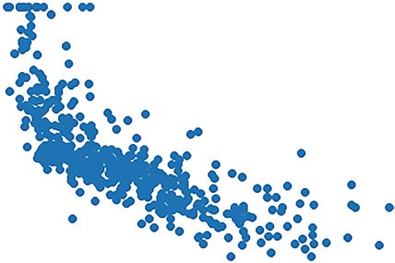

50

40

30

20

10

0

5

10

15

20

25

LSTAT

MEDV

30

35

**Figure 6.4:** Scatter plot showing the relationship between LSTAT and MEDV

Let’s also plot a scatter plot showing the relationship between the **RM** feature and the **MEDV** label:

**plt.scatter(df['RM'], df['MEDV'], marker='o') plt.xlabel('RM') plt.ylabel('MEDV')**

Figure 6.5 shows the scatter plot. Again, it appears that there is a linear correlation between the two, albeit with some outliers.

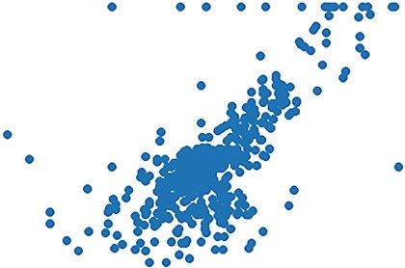

50

40

30

20

10

4

MEDV

5

6

RM

7

8

9

**Figure 6.5:** Scatter plot showing the relationship between RM and MEDV

Better still, let’s plot the two features and the label on a 3D chart:

**from mpl_toolkits.mplot3d import Axes3D**

**fig = plt.figure(figsize=(18,15)) ax = fig.add_subplot(111, projection='3d')**

**ax.scatter(df['LSTAT'], df['RM'], df['MEDV'], c='b')**

**ax.set_xlabel("LSTAT") ax.set_ylabel("RM") ax.set_zlabel("MEDV") plt.show()**

Figure 6.6 shows the 3D chart of **LSTAT** and **RM** plotted against **MEDV**.

50

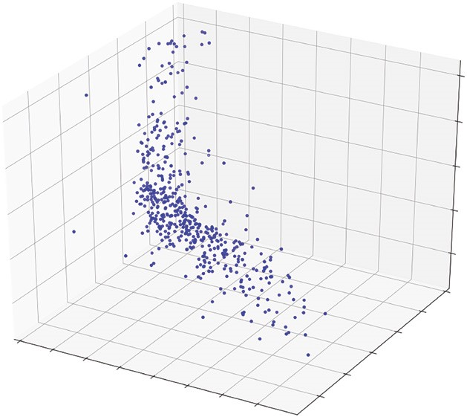

30

20

10

9

8

7

6

5

4

35

30

25

LSTA

T

20

15

10

5

0

RM

40

MEDV

**Figure 6.6:** The 3D scatter plot showing the relationship between LSTAT, RM, and MEDV

**Training the Model**

We can now train the model. First, create two DataFrames: **x** and **Y**. The **x** DataFrame will contain the combination of the **LSTAT** and **RM** features, while the **Y** DataFrame will contain the **MEDV** label:

**x = pd.DataFrame(np.c_[df['LSTAT'], df['RM']], columns = ['LSTAT','RM']) Y = df['MEDV']**

We will split the dataset into 70 percent for training and 30 percent for testing:

**from sklearn.model_selection import train_test_split x_train, x_test, Y_train, Y_test = train_test_split(x, Y, test_size = 0.3, random_state=5)**

**TIP Chapter 7, “Supervised Learning—Classification Using Logistic Regression,” will discuss more about the train_test_split() function.**

After the split, let’s print out the shape of the training sets:

**print(x_train.shape) print(Y_train.shape)** You will see the following:

**(354, 2)**

**(354,)**

This means that the **x** training set now has 354 rows and 2 columns, while the **Y** training set (which contains the label) has 354 rows and 1 column.

Let’s also print out the testing set:

**print(x_test.shape) print(Y_test.shape)**

This time, the testing set has 152 rows:

**(152, 2)**

**(152,)**

We are now ready to begin the training. As you learned from the previous chapter, you can use the **LinearRegression** class to perform linear regression. In this case, we will use it to train our model:

**from sklearn.linear_model import LinearRegression**

**model = LinearRegression() model.fit(x_train, Y_train)**

Once the model is trained, we will use the testing set to perform some predictions: **price_pred = model.predict(x_test)**

To learn how well our model performed, we use the R-Squared method that you learned in the previous chapter. The R-Squared method lets you know how close the test data fits the regression line. A value of 1.0 means a perfect fit. So, you aim for a value of R-Squared that is close to 1:

**print('R-Squared: %.4f' % model.score(x_test, Y_test))**

For our model, it returns an R-Squared value as follows:

**R-Squared: 0.6162**

We will also plot a scatter plot showing the actual price vs. the predicted price:

**from sklearn.metrics import mean_squared_error**

**mse = mean_squared_error(Y_test, price_pred) print(mse)**

**plt.scatter(Y_test, price_pred) plt.xlabel("Actual Prices") plt.ylabel("Predicted prices") plt.title("Actual prices vs Predicted prices")**

Figure 6.7 shows the plot. Ideally, it should be a straight line, but for now it is good enough.

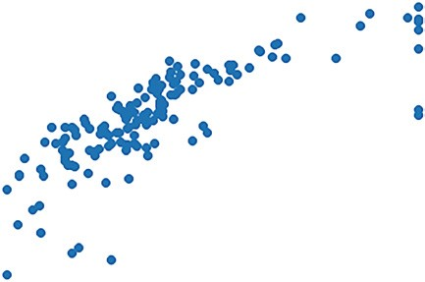

0

10

5

10

15

20

25

30

35

40

20

30

40

Actual Prices

Actual prices vs Predicted prices

Predicted prices

50

**Figure 6.7:** A scatter plot showing the predicted prices vs. the actual prices

**Supervised Learning—Linear Regression**

**Getting the Intercept and Coefficients**

The formula for multiple regression is as follows:

Y 2x2

x

0

1

1

where Y is the dependent variable, β0 is the intercept, and β1 and β2 are the coefficient of the two features x1 and x2, respectively.

With the model trained, we can obtain the intercept as well as the coefficients of the features:

**print(model.intercept_) print(model.coef_)** You should see the following:

**0.3843793678034899 [-0.65957972 4.83197581]**

We can use the model to make a prediction for the house price when **LSTAT** is 30 and **RM** is 5: **print(model.predict([[30,5]]))** You should see the following:

**[4.75686695]**

You can verify the predicted value by using the formula that was given earlier:

Y 2x2

x

0

1

1

Y = 0.3843793678034899 30 0 65957972 5 4 83197581

Y 4 7568

**Plotting the 3D Hyperplane**

Let’s plot a 3D regression hyperplane showing the predictions:

**import matplotlib.pyplot as plt import pandas as pd import numpy as np**

**from mpl_toolkits.mplot3d import Axes3D**

**from sklearn.datasets import load_boston dataset = load_boston()**

**df = pd.DataFrame(dataset.data, columns=dataset.feature_names) df['MEDV'] = dataset.target**

**x = pd.DataFrame(np.c_[df['LSTAT'], df['RM']], columns = ['LSTAT','RM'])**

**Y = df['MEDV']**

**fig = plt.figure(figsize=(18,15)) ax = fig.add_subplot(111, projection='3d')**

**ax.scatter(x['LSTAT'], x['RM'],**

**Y, c='b')**

**ax.set_xlabel("LSTAT") ax.set_ylabel("RM") ax.set_zlabel("MEDV")**

**#---create a meshgrid of all the values for LSTAT and RM--x_surf = np.arange(0, 40, 1) #---for LSTAT--y_surf = np.arange(0, 10, 1) #---for RM--x_surf, y_surf = np.meshgrid(x_surf, y_surf)**

**from sklearn.linear_model import LinearRegression model = LinearRegression() model.fit(x, Y)**

**#---calculate z(MEDC) based on the model---**

**z = lambda x,y: (model.intercept_ + model.coef_[0] * x + model.coef_[1] * y)**

**ax.plot_surface(x_surf, y_surf, z(x_surf,y_surf), rstride=1, cstride=1, color='None', alpha = 0.4)**

**plt.show()**

Here, we are training the model using the entire dataset. We then make predictions by passing a combination of values for **LSTAT** (**x_surf**) and **RM** (**y**_**surf**) and calculating the predicted values using the model’s intercept and coefficients. The hyperplane is then plotted using the **plot**_**surface()** function. The end result is shown in Figure 6.8.

As the chart shown in Jupyter Notebook is static, save the preceding code snippet in a file named **boston.py** and run it in Terminal, like this:

**$ python boston.py**

50

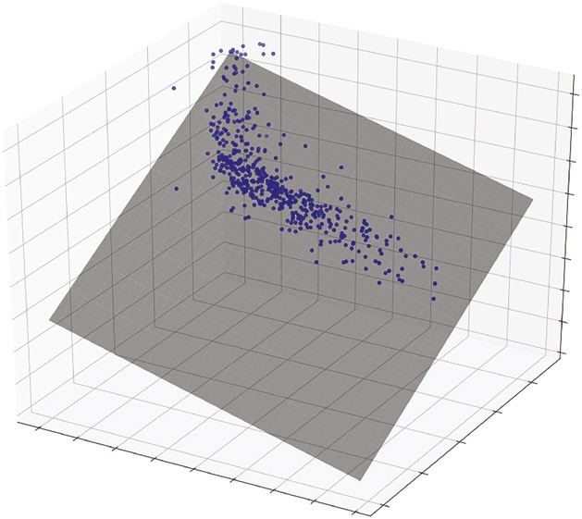

0

10

–10

–20

–30

8

6

4

2

0

35

30

25

L

STAT

20

15

10

5

0

RM

40

30

20

MEDV

40

**Figure 6.8:** The hyperplane showing the predictions for the two features—LSTAT and RM

You will now be able to rotate the chart and move it around to have a better perspective, as shown in Figure 6.9.

**Polynomial Regression**

In the previous section, you saw how to apply linear regression to predict the prices of houses in the Boston area. While the result is somewhat acceptable, it is not very accurate. This is because sometimes a linear regression line might not be the best solution to capture the relationships between the features and label accurately. In some cases, a curved line might do better.

Consider the series of points shown in Figure 6.10.

The series of points are stored in a file named **polynomial.csv**:

**x,y**

**1.5,1.5 2,2.5**

**3,4**

**4,4**

**5,4.5**

**6,5**

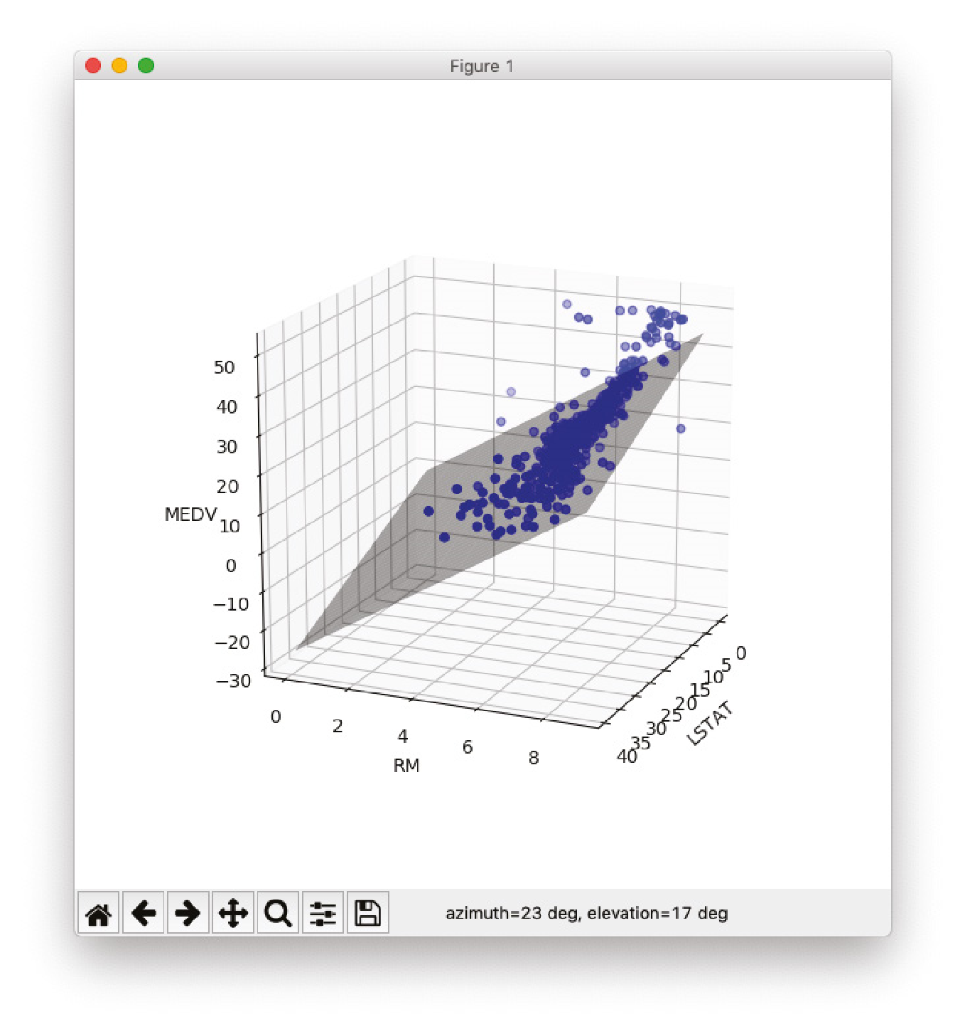

**Figure 6.9:** Rotating the chart to have a better view of the hyperplane

2.0

2

2.5

3.0

3.5

4.0

5.0

4.5

1.5

3

4

5

6

**Figure 6.10:** A scatter plot of points

And plotted using a scatter plot:

**df = pd.read_csv('polynomial.csv') plt.scatter(df.x,df.y)**

Using linear regression, you can try to plot a straight line cutting through most of the points:

**model = LinearRegression()**

**x = df.x[0:6, np.newaxis] #---convert to 2D array--y = df.y[0:6, np.newaxis] #---convert to 2D array---**

**model.fit(x,y)**

**#---perform prediction--y_pred = model.predict(x)**

**#---plot the training points--plt.scatter(x, y, s=10, color='b')**

**#---plot the straight line--plt.plot(x, y_pred, color='r') plt.show()**

**#---calculate R-Squared--print('R-Squared for training set: %.4f' % model.score(x,y))** You will see the straight regression line, as shown in Figure 6.11.

2.0

2

2.5

3.0

3.5

4.0

5.0

4.5

1.5

3

4

5

6

**Figure 6.11:** The regression line fitting the points

The R-Squared value for the training set is:

**R-Squared for training set: 0.8658**

We want to see if there is a more accurate way to fit the points. For instance, instead of a straight line, we want to investigate the possibility of a curved line. This is where *polynomial regression* comes in.

**Formula for Polynomial Regression**

*Polynomial regression* is an attempt to create a polynomial function that fits a set of data points.

A polynomial function of degree 1 has the following form:

Y 1x

0

This is the simple linear regression that we have seen in the previous chapter. *Quadratic regression* is a degree 2 polynomial:

Y 2x2

x

0

1

For a polynomial of degree 3, the formula is as follows:

Y 3x3

x

x

0

1

2

2

In general, a polynomial of degree *n* has the formula of:

Y nxn

x

x

x

1

0

2

2

3

3

The idea behind polynomial regression is simple—find the coefficients of the polynomial function that best fits the data.

**Polynomial Regression in Scikit-learn**

The Scikit-learn library contains a number of classes and functions for solving polynomial regression. The **PolynomialFeatures** class takes in a number specifying the degree of the polynomial features. In the following code snippet, we are creating a quadratic equation (polynomial function of degree 2):

**from sklearn.preprocessing import PolynomialFeatures degree = 2 polynomial_features = PolynomialFeatures(degree = degree)**

Using this **PolynomialFeatures** object, you can generate a new feature matrix consisting of all polynomial combinations of the features with a degree of less than or equal to the specified degree:

**x_poly = polynomial_features.fit_transform(x) print(x_poly)**

You should see the following:

**[[ 1. 1.5 2.25]**

**[ 1. 2. 4. ]**

**[ 1. 3. 9. ]**

**[ 1. 4. 16. ]**

**[ 1. 5. 25. ]**

**[ 1. 6. 36. ]]**

The matrix that you see is generated as follows:

**■**The first column is always 1.

**■**The second column is the value of x.

**■**The third column is the value of x2.

This can be verified using the **get**_**feature**_**names()** function: **print(polynomial_features.get_feature_names('x'))** It prints out the following:

**['1', 'x', 'x^2']**

**TIP The math behind finding the coefficients of a polynomial function is beyond the scope of this book. For those who are interested, however, check out the following link on the math behind polynomial regression: http://polynomialregression. drque.net/math.html.**

You will now use this generated matrix with the **LinearRegression** class to train your model:

**model = LinearRegression() model.fit(x_poly, y)**

**y_poly_pred = model.predict(x_poly)**

**#---plot the points--plt.scatter(x, y, s=10)**

**#---plot the regression line--plt.plot(x, y_poly_pred) plt.show()**

Figure 6.12 now shows the regression line, a nice curve trying to fit the points. You can print out the intercept and coefficients of the polynomial function:

**print(model.intercept_) print(model.coef_)**

2.0

2

2.5

3.0

3.5

4.0

5.0

4.5

1.5

3

4

5

6

**Figure 6.12:**

A curved line trying to fit the points

You should see the following:

**[-0.87153912]**

**[[ 0. 1.98293207 -0.17239897]]**

By plugging these numbers Y 0 87153912 1 98293207 x 0 17239897 x2 into the formula Y 0 1x 2x2 , you can make predictions using the preceding formula.

If you evaluate the regression by printing its R-Squared value,

**print('R-Squared for training set: %.4f' % model.score(x_poly,y))** you should get a value of 0.9474:

**R-Squared for training set: 0.9474**

Can the R-Squared value be improved? Let’s try a degree 3 polynomial. Using the same code and changing **degree** to **3**, you should get the curve shown in Figure 6.13 and a value of 0.9889 for R-Squared.

2.0

2

2.5

3.0

3.5

4.0

5.0

4.5

1.5

3

4

5

6

**Figure 6.13:** A curved line trying to fit most of the points

You now see a curve that more closely fits the points and a much-improved R-Squared value. Moreover, since raising the polynomial degree by 1 improves the R-Squared value, you might be tempted to increase it further. In fact, Figure 6.14 shows the curve when the **degree** is set to **4**. It fits all the points perfectly.

2.0

2

2.5

3.0

3.5

4.0

5.0

4.5

1.5

3

4

5

6

**Figure 6.14:** The line now fits the points perfectly

And guess what? You get an R-Squared value of 1! However, before you celebrate your success in finding the perfect algorithm in your prediction, you need to realize that while your algorithm may fit the training data perfectly, it is unlikely to perform well with new data. This is a known as *overfitting*, and the next section will discuss this topic in more detail.

**Understanding Bias and Variance**

The inability for a machine learning algorithm to capture the true relationship between the variables and the outcome is known as the *bias*. Figure 6.15 shows a straight line trying to fit all the points. Because it doesn’t cut through all of the points, it has a high bias.

The curvy line in Figure 6.16, however, is able to fit all of the points and thus has a low bias.

While the straight line can’t fit through all of the points and has high bias, when it comes to applying unseen observations, it gives a pretty good estimate. Figure 6.17 shows the testing points (in pink). The RSS (Residual Sum of Squares), which is the sum of the errors of prediction, is pretty low compared to that of the curvy line when using the same test points (see Figure 6.18).

2.0

2

2.5

3.0

3.5

4.0

5.0

4.5

1.5

3

4

5

6

**Figure 6.15:** The straight line can’t fit all of the points, so the bias is high

2.0

2

2.5

3.0

3.5

4.0

5.0

4.5

1.5

3

4

5

6

**Figure 6.16:** The curvy line fits all of the points, so the bias is low

2.0

2

2.5

3.0

3.5

4.0

5.0

4.5

1.5

3

4

Errors of prediction

Test points

5

6

**Figure 6.17:** The straight line works well with unseen data, and its result does not vary much with different datasets. Hence, it has low variance.

Errors of prediction

Test points

2.0

2

2.5

3.0

3.5

4.0

5.0

4.5

1.5

3

4

5

6

**Figure 6.18:** The curvy line does not work well with unseen data, and its result varies with different datasets. Hence, it has high variance.

In machine learning, the fit between the datasets is known as *variance*. In this example, the curvy line has *high variance* because it will result in vastly different RSS for different datasets. That is, you can’t really predict how well it will perform with future datasets—sometimes it will do well with certain datasets and at other times it may fail badly. On the other hand, the straight line has a *low variance*, as the RSS is similar for different datasets.

**TIP In machine learning, when we try to find a curve that tries to fit all of the points perfectly, it is known as *overfitting*. On the other hand, if we have a line that does not fit most points, it is known as *underfitting*.**

Ideally, we should find a line that accurately expresses the relationships between the independent variables and that of the outcome. Expressed in terms of bias and variance, the ideal algorithm should have the following:

***High bias***, with the line hugging as many points as possible

***Low variance***, with the line resulting in consistent predictions using different datasets

Figure 6.19 shows such an ideal curve—high bias and low variance.

To strike a balance between finding a simple model and a complex model, you can use techniques such as *Regularization*, *Bagging*, and *Boosting*:

**■***Regularization* is a technique that automatically penalizes the extra features you used in your modeling.

**■***Bagging* (or *bootstrap aggregation*) is a specific type of machine learning process that uses *ensemble learning* to evolve machine learning models. Bagging uses a subset of the data and each sample trains a weaker learner. The weak learners can then be combined (through averaging or max vote) to create a strong learner that can make accurate predictions.

2.0

2

2.5

3.0

3.5

4.0

5.0

4.5

1.5

3

4

5

6

**Figure 6.19:** You should aim for a line that has high bias and low variance

**■***Boosting* is also similar to Bagging, except that it uses all of the data to train each learner, but data points that were misclassified by previous learners are given more weight so that subsequent learners will give more focus to them during training.

**TIP *Ensemble learning* is a technique where you use several models working together on a single dataset and then combine its result.**

**Using Polynomial Multiple Regression on the Boston Dataset**

Earlier in this chapter, you used multiple linear regression and trained a model based on the Boston dataset. After learning about the polynomial regression in the previous section, now let’s try to apply it to the Boston dataset and see if we can improve the model.

As usual, let’s load the data and split the dataset into training and testing sets:

**import matplotlib.pyplot as plt import pandas as pd import numpy as np**

**from sklearn.preprocessing import PolynomialFeatures from sklearn.linear_model import LinearRegression from sklearn.datasets import load_boston**

**dataset = load_boston()**

**df = pd.DataFrame(dataset.data, columns=dataset.feature_names) df['MEDV'] = dataset.target**

**x = pd.DataFrame(np.c_[df['LSTAT'], df['RM']], columns = ['LSTAT','RM'])**

**Y = df['MEDV']**

**Supervised Learning—Linear Regression**

**from sklearn.model_selection import train_test_split x_train, x_test, Y_train, Y_test = train_test_split(x, Y, test_size = 0.3, random_state=5)** You then use the polynomial function with degree 2:

**#---use a polynomial function of degree 2--degree = 2**

**polynomial_features= PolynomialFeatures(degree = degree) x_train_poly = polynomial_features.fit_transform(x_train)**

When using a polynomial function of degree 2 on two independent variables x1 and x2, the formula becomes:

Y 5x22

x

x

x

x

x

1

0

2

1

3

2

1

2

41

2

where Y is the dependent variable, β0 is the intercept, and β1, β2, β3, and β4 are the coefficients of the various combinations of the two features x1 and x2, respectively.

You can verify this by printing out the feature names:

**#---print out the formula--print(polynomial_features.get_feature_names(['x','y']))** You should see the following, which coincides with the formula:

**# ['1', 'x', 'y', 'x^2', 'x y', 'y^2']**

**TIP Knowing the polynomial function formula is useful when plotting the 3D hyperplane, which you will do shortly.**

You can then train your model using the **LinearRegression** class:

**model = LinearRegression() model.fit(x_train_poly, Y_train)**

Now let’s evaluate the model using the testing set:

**x_test_poly = polynomial_features.fit_transform(x_test) print('R-Squared: %.4f' % model.score(x_test_poly, Y_test))** You will see the result as follows:

**R-Squared: 0.7340**

You can also print the intercept and coefficients:

**print(model.intercept_) print(model.coef_)**

You should see the following:

**26.9334305238 [ 0.00000000e+00 1.47424550e+00 -6.70204730e+00 7.93570743e-04**

**-3.66578385e-01 1.17188007e+00]**

With these values, the formula now becomes:

Y 0 1x1 2x2 3x12 4 1x x2 5x22

Y 26 9334305238 1 47424550e 00 x1 6 70204730e 00 x2 7 93570743e

04 x12 3 66578385e 01 x x1 2 1 17188007e 00 x22

**Plotting the 3D Hyperplane**

Since you know the intercept and coefficients of the polynomial multiple regression function, you can plot out the 3D hyperplane of function easily. Save the following code snippet as a file named **boston2.py**:

**import matplotlib.pyplot as plt import pandas as pd import numpy as np**

**from mpl_toolkits.mplot3d import Axes3D from sklearn.preprocessing import PolynomialFeatures from sklearn.linear_model import LinearRegression from sklearn.datasets import load_boston**

**dataset = load_boston()**

**df = pd.DataFrame(dataset.data, columns=dataset.feature_names) df['MEDV'] = dataset.target**

**x = pd.DataFrame(np.c_[df['LSTAT'], df['RM']], columns = ['LSTAT','RM'])**

**Y = df['MEDV']**

**fig = plt.figure(figsize=(18,15)) ax = fig.add_subplot(111, projection='3d')**

**ax.scatter(x['LSTAT'], x['RM'],**

**Y, c='b')**

**Supervised Learning—Linear Regression**

**ax.set_xlabel("LSTAT") ax.set_ylabel("RM") ax.set_zlabel("MEDV")**

**#---create a meshgrid of all the values for LSTAT and RM--x_surf = np.arange(0, 40, 1) #---for LSTAT--y_surf = np.arange(0, 10, 1) #---for RM--x_surf, y_surf = np.meshgrid(x_surf, y_surf)**

**#---use a polynomial function of degree 2--degree = 2**

**polynomial_features= PolynomialFeatures(degree = degree) x_poly = polynomial_features.fit_transform(x) print(polynomial_features.get_feature_names(['x','y']))**

**#---apply linear regression--model = LinearRegression() model.fit(x_poly, Y)**

**#---calculate z(MEDC) based on the model--z = lambda x,y: (model.intercept_ + (model.coef_[1] * x) +**

**(model.coef_[2] * y) +**

**(model.coef_[3] * x**2) +**

**(model.coef_[4] * x*y) +**

**(model.coef_[5] * y**2))**

**ax.plot_surface(x_surf, y_surf, z(x_surf,y_surf), rstride=1, cstride=1, color='None', alpha = 0.4)**

**plt.show()**

To run the code, type the following in Terminal:

**$ python boston2.py**

You will see the 3D chart, as shown in Figure 6.20.

You can drag to rotate the chart. Figure 6.21 shows the different perspectives of the hyperplane.

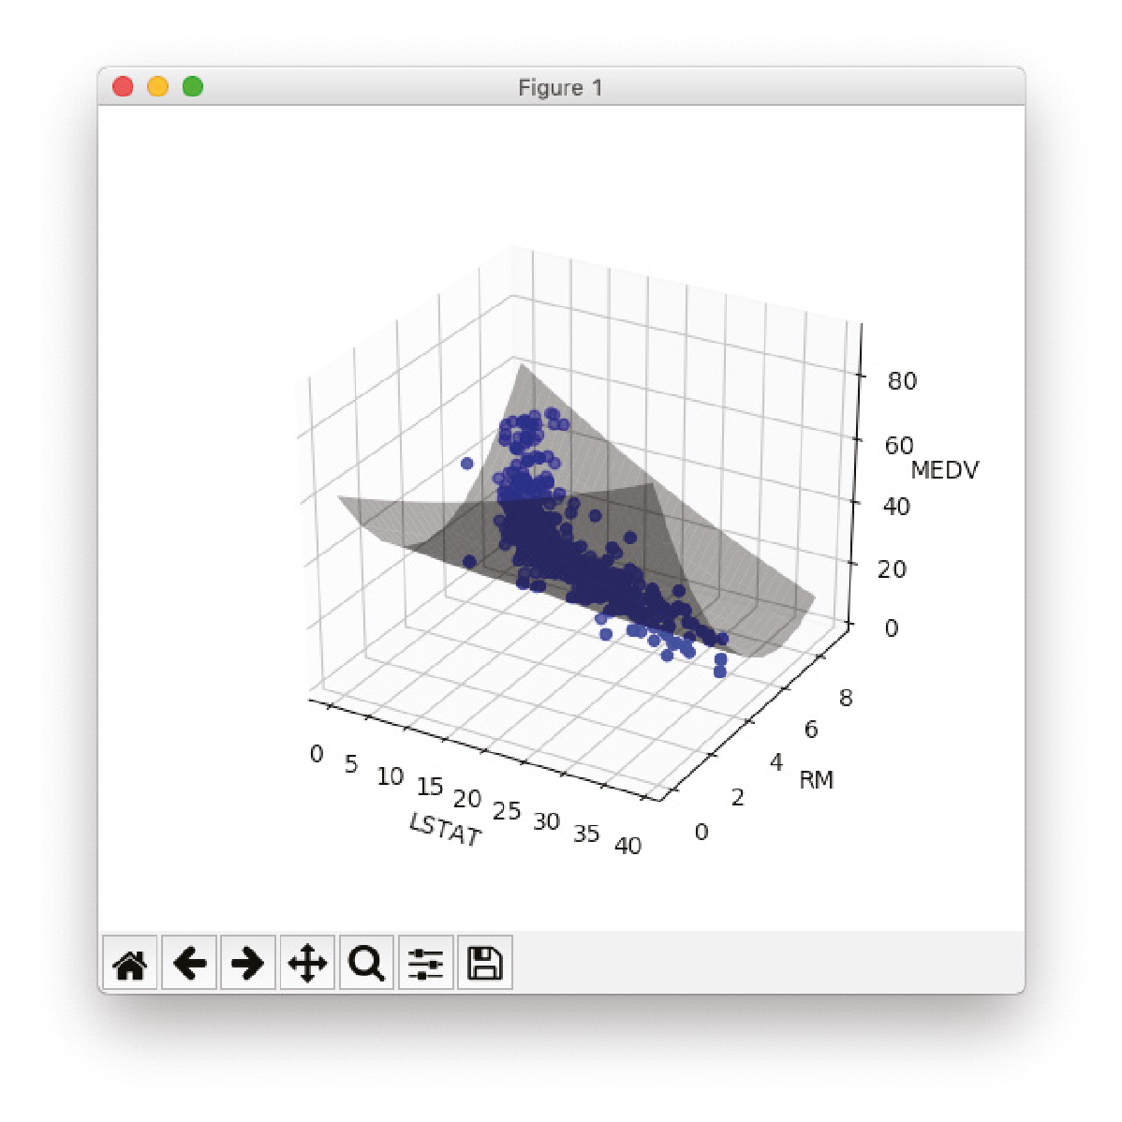

**Figure 6.20:** The hyperplane in the polynomial multiple regression

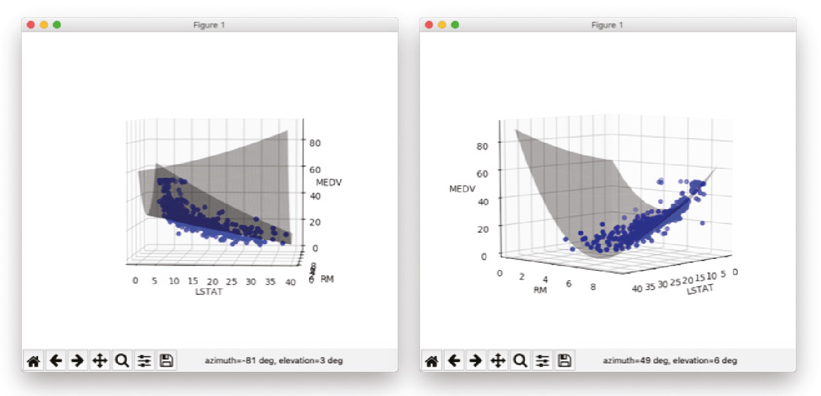

**Figure 6.21:** Rotate the chart to see the different perspectives of the hyperplane

**Supervised Learning—Linear Regression**

**Summary**

In this chapter, you learned about the various types of linear regression. In particular, you learned about the following:

**Multiple Regression** Linear relationships between two or more independent variables and one dependent variable.

**Polynomial Regression** Modeling the relationship between one independent variable and one dependent variable using an *n*th degree polynomial function.

**Polynomial Multiple Regression** Modeling the relationship between two or more independent variables and one dependent variable using an *n*th degree polynomial function.

You also learned how to plot the hyperplane showing the relationships between two independent variables and the label.

|  |
| --- |
| **CHAPTER** |
| **7**  **Regression** |

**Supervised Learning— Classification Using Logistic**

**What Is Logistic Regression?**

In the previous chapter, you learned about linear regression and how you can use it to predict future values. In this chapter, you will learn another supervised machine learning algorithm—*logistic regression*. Unlike linear regression, logistic regression does not try to predict the value of a numeric variable given a set of inputs. Instead, the output of logistic regression is the probability of a given input point belonging to a specific class. The output of logistic regression always lies in [0,1].

To understand the use of logistic regression, consider the example shown in Figure 7.1. Suppose that you have a dataset containing information about voter income and voting preferences. For this dataset, you can see that low-income voters tend to vote for candidate B, while high-income voters tend to favor candidate A.

With this dataset, you would be very interested in trying to predict which candidate future voters will vote for based on their income level. At first glance, you might be tempted to apply what you have just learned to this problem; that is, using linear regression. Figure 7.2 shows what it looks like when you apply linear regression to this problem.

Python® Machine Learning, First Edition. Wei-Meng Lee. **151**

© 2019 John Wiley & Sons, Inc. Published 2019 by John Wiley & Sons, Inc.



**Income of voters**

**XX X X X X**

**X XXX XX X**

**Candidate B**

**Candidate A**

**Figure 7.1:** Some problems have binary outcomes



**Income of voters**

*x*

*y*

**Candidate B**

**Candidate A**

**X XXX XX X**

**XX X X X X**

**Figure 7.2:** Using linear regression to solve the voting preferences problem leads to strange values

The main problem with linear regression is that the predicted value does not always fall within the expected range. Consider the case of a very low-income voter (near to 0), and you can see from the chart that the predicted result is a negative value. What you really want is a way to return the prediction as a value from 0 to 1, where this value represents the probability of an event happening.

Figure 7.3 shows how logistic regression solves this problem. Instead of drawing a straight line cutting through the points, you now use a curved line to try to fit all of the points on the chart.

Using logistic regression, the output will be a value from 0 to 1, where anything less than (or equal to) 0.5 (known as the *threshold*) will be considered as voting for candidate B, and anything greater than 0.5 will be considered as voting for candidate A.



**Income of voters**

x

y

**XX X X X X**

**X XXX X X X**

**Candidate B**

**Candidate A**

**Figure 7.3:** Logistic regression predicts the probability of an outcome, rather than a specific value

**Understanding Odds**

Before we discuss the details of the logistic regression algorithm, we first need to discuss one important term—*odds*. Odds are defined as the ratio of the probability of success to the probability of failure (see Figure 7.4).

|  |
| --- |
| Chances of something happening  Chances of something not happening |
| PProbability of success (1 – P)Probability of failure |

**Figure 7.4:** How to calculate the odds of an event happening

For example, the odds of landing a head when you flip a coin are 1. This is because you have a 0.5 probability of landing a head and a 0.5 probability of landing a tail. When you say that the odds of landing a head are 1, this means you have a 50 percent chance of landing a head.

But if the coin is rigged in such a way that the probability of landing a head is 0.8 and the probability of landing a tail is 0.2, then the odds of landing a head is 0.8/0.2 = 4. That is, you are 4 times more likely to land a head than a tail.

Likewise, the odds of getting a tail are 0.2/0.8 = 0.25.

**Logit Function**

When you apply the natural logarithm function to the odds, you get the *logit function*. The logit function is the logarithm of the odds (see Figure 7.5).

L = In(1 – PP )

**Figure 7.5:** The formula for the logit function

The logit function transfers a variable on (0, 1) into a new variable on (–∞, ∞).

To see this relationship, you can use the following code snippet:

**%matplotlib inline import pandas as pd import numpy as np**

**import matplotlib.pyplot as plt def logit(x):**

**return np.log( x / (1 - x) )**

**x = np.arange(0.001,0.999, 0.0001) y = [logit(n) for n in x] plt.plot(x,y) plt.xlabel("Probability") plt.ylabel("Logit - L")**

Figure 7.6 shows the logit curve plotted using the preceding code snippet.

Probability

6

4

2

0

Logit -

L

–2

–4

–6

0.0

0.4

0.2

0.6

0.8

1.0

**Figure 7.6:** The logit curve

**Sigmoid Curve**

For the logit curve, observe that the x-axis is the probability and the y-axis is the real-number range. For logistic regression, what you really want is a function that maps numbers on the real-number system to the probabilities, which is exactly what you get when you flip the axes of the logit curve (see Figure 7.7).



Probability

**Logit Function**

**Sigmoid curve**

6

4

2

0

–2

–4

–6

0.0

0.4

0.2

0.6

0.8

1.0

Probability

6

4

2

0

–2

–4

–6

0.0

0.4

0.2

0.6

0.8

1.0



**Figure 7.7:** Flipping the logit curve into a Sigmoid curve

When you flip the axes, the curve that you get is called the *sigmoid curve*. The sigmoid curve is obtained using the *Sigmoid function*, which is the inverse of the logit function. The Sigmoid function is used to transform values on (–∞, ∞) into numbers on (0, 1). The Sigmoid function is shown in Figure 7.8.

|  |
| --- |
| 1  P = –(L))  (1 + e |

**Figure 7.8:** The formula for the Sigmoid function

The following code snippet shows how the sigmoid curve is obtained:

**def sigmoid(x):**

**return (1 / (1 + np.exp(-x)))**

**x = np.arange(-10, 10, 0.0001) y = [sigmoid(n) for n in x] plt.plot(x,y) plt.xlabel("Logit - L") plt.ylabel("Probability")**

Figure 7.9 shows the sigmoid curve.

Just like you try to plot a straight line that fits through all of the points in linear regression (as explain in Chapter 5), in logistics regression, we would also like to plot a sigmoid curve that fits through all of the points. Mathematically, this can be expressed by the formula shown in Figure 7.10.

Logit - L

1.0

0.8

0.6

Probability

0.4

0.2

0.0

–10.0

–2.5

0.0

–7.5

–5.0

2.5

7.5

5.0

10.0

**Figure 7.9:** The sigmoid curve plotted using matplotlib



1

P =

(1

+ e

–(

**β**

**0**

**+ x**

**β**

)

)

**Figure 7.10:** Expressing the sigmoid function using the intercept and coefficient

Notice that the key difference between the formula shown in Figure 7.8 and 7.10 is that now L has been replaced by β0 and xβ. The coefficients β0 and β are unknown, and they must be estimated based on the available training data using a technique known as *Maximum Likelihood Estimation (MLE)*. In logistics regression, β0 is known as the intercept and xβ is known as the coefficient.

**Using the Breast Cancer Wisconsin (Diagnostic) Data Set**

Scikit-learn ships with the Breast Cancer Wisconsin (Diagnostic) Data Set. It is a classic dataset that is often used to illustrate binary classifications. This dataset contains 30 features, and they are computed from a digitized image of a fine needle aspirate (FNA) of a breast mass. The label of the dataset is a binary classification—M for malignant or B for benign. Interested readers can check out more information at **https://archive.ics.uci.edu/ml/datasets/Breast+ Cancer+Wisconsin+(Diagnostic)**.

**Examining the Relationship Between Features**

You can load the Breast Cancer dataset by first importing the **datasets** module from **sklearn**. Then use the **load_breast_cancer()** function as follows:

**from sklearn.datasets import load_breast_cancer cancer = load_breast_cancer()**

Now that the Breast Cancer dataset has been loaded, it is useful to examine the relationships between some of its features.

***Plotting the Features in 2D***

For a start, let’s plot the first two features of the dataset in 2D and examine their relationships. The following code snippet:

**■**Loads the Breast Cancer dataset

**■**Copies the first two features of the dataset into a two-dimensional list

**■**Plots a scatter plot showing the distribution of points for the two features

**■**Displays malignant growths in red and benign growths in blue

**%matplotlib inline**

**import matplotlib.pyplot as plt**

**from sklearn.datasets import load_breast_cancer**

**cancer = load_breast_cancer()**

**#---copy from dataset into a 2-d list---**

**X = [] for target in range(2): X.append([[], []])**

**for i in range(len(cancer.data)): # target is 0 or 1 if cancer.target[i] == target:**

**X[target][0].append(cancer.data[i][0]) # first feature - mean radius**

**X[target][1].append(cancer.data[i][1]) # second feature — mean texture**

**colours = ("r", "b") # r: malignant, b: benign fig = plt.figure(figsize=(10,8)) ax = fig.add_subplot(111) for target in range(2):**

**ax.scatter(X[target][0], X[target][1], c=colours[target])**

**ax.set_xlabel("mean radius") ax.set_ylabel("mean texture") plt.show()**

Figure 7.11 shows the scatter plot of the points.

mean texture

10

10

15

mean radius

20

25

15

20

25

30

35

40

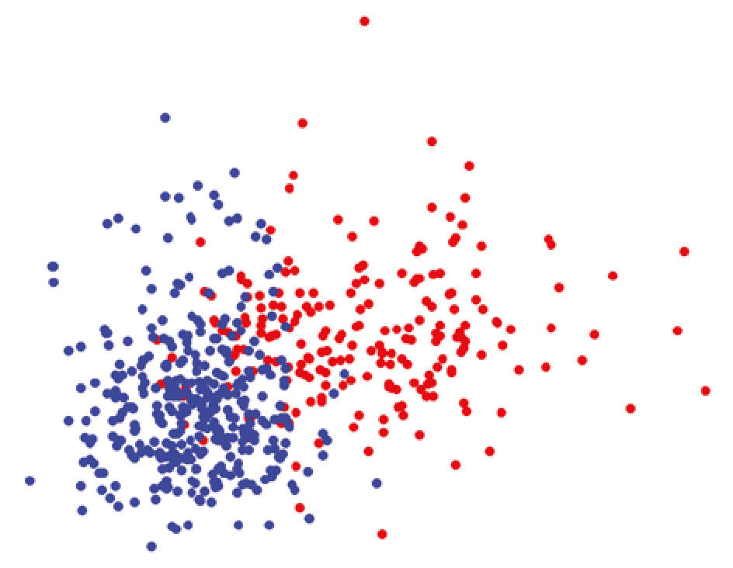

**Figure 7.11:** The scatter plot showing the relationships between the mean radius and mean texture of the tumor

From this scatter plot, you can gather that as the tumor grows in radius and increases in texture, the more likely that it would be diagnosed as malignant.

***Plotting in 3D***

In the previous section, you plotted the points based on two features using a scatter plot. It would be interesting to be able to visualize more than two features. In this case, let’s try to visualize the relationships between three features. You can use matplotlib to plot a 3D plot. The following code snippet shows how this is done. It is very similar to the code snippet in the previous section, with the additional statements in bold:

**%matplotlib inline**

**import matplotlib.pyplot as plt from mpl_toolkits.mplot3d import Axes3D from sklearn.datasets import load_breast_cancer**

**cancer = load_breast_cancer()**

**#---copy from dataset into a 2-d array---**

**X = [] for target in range(2): X.append([[], [], []])**

**for i in range(len(cancer.data)): # target is 0,1 if cancer.target[i] == target:**

**X[target][0].append(cancer.data[i][0])**

**X[target][1].append(cancer.data[i][1])**

**X[target][2].append(cancer.data[i][2])**

**colours = ("r", "b") # r: malignant, b: benign fig = plt.figure(figsize=(18,15)) ax = fig.add_subplot(111, projection='3d') for target in range(2):**

**ax.scatter(X[target][0], X[target][1], X[target][2], c=colours[target])**

**ax.set_xlabel("mean radius") ax.set_ylabel("mean texture") ax.set_zlabel("mean perimeter") plt.show()**

Instead of plotting using two features, you now have a third feature: mean perimeter. Figure 7.12 shows the 3D plot.

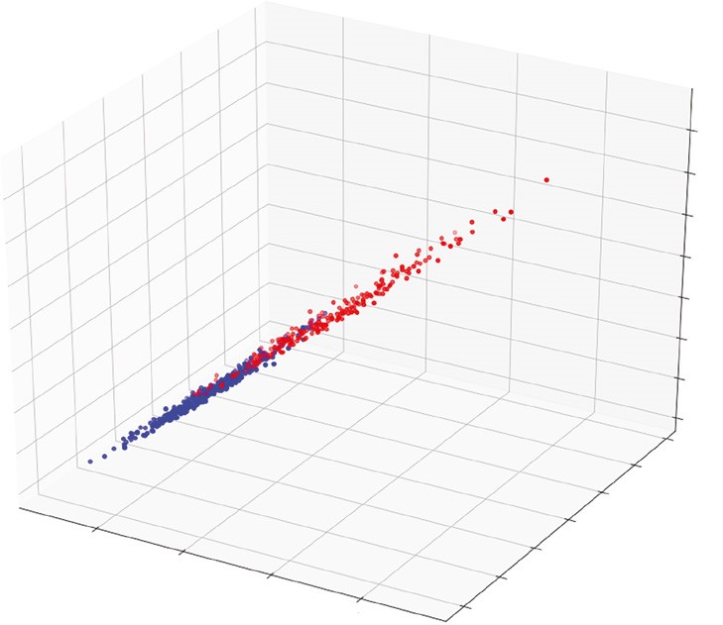

mean texture

mean perimeter

10

10

15

mean radius

20

25

15

20

25

30

35

40

40

60

80

100

120

140

160

180

**Figure 7.12:** Plotting three features using a 3D map

Jupyter Notebook displays the 3D plot statically. As you can see from Figure 7.12, you can’t really have a good look at the relationships between the three features. A much better way to display the 3D plot would be to run the preceding code snippet outside of Jupyter Notebook. To do so, save the code snippet (minus the first line containing the statement “**%matplotlib inline**”) to a file named, say, **3dplot.py**. Then run the file in Terminal using the **python** command, as follows:

**$ python 3dplot.py**

Once you do that, matplotlib will open a separate window to display the 3D plot. Best of all, you will be able to interact with it. Use your mouse to drag the plot, and you are able to visualize the relationships better between the three features. Figure 7.13 gives you a better perspective: as the mean perimeter of the tumor growth increases, the chance of the growth being malignant also increases.

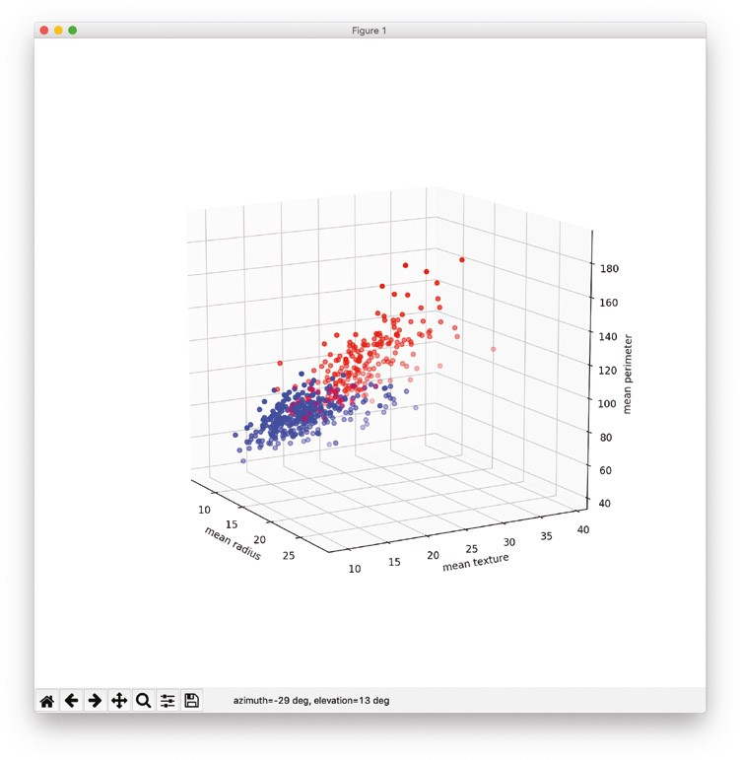

**Figure 7.13:** You can interact with the 3D plot when you run the application outside of Jupyter Notebook

**Training Using One Feature**

Let’s now use logistic regression to try to predict if a tumor is cancerous. To get started, let’s use only the first feature of the dataset: mean radius. The following code snippet plots a scatter plot showing if a tumor is malignant or benign based on the mean radius:

**%matplotlib inline import pandas as pd import matplotlib.pyplot as plt import matplotlib.patches as mpatches**

**from sklearn.datasets import load_breast_cancer**

**cancer = load_breast_cancer() # Load dataset x = cancer.data[:,0] # mean radius y = cancer.target # 0: malignant, 1: benign colors = {0:'red', 1:'blue'} # 0: malignant, 1: benign**

**plt.scatter(x,y, facecolors='none', edgecolors=pd.DataFrame(cancer.target)[0].apply(lambda x:**

**colors[x]),**

**cmap=colors)**

**plt.xlabel("mean radius") plt.ylabel("Result")**

**red = mpatches.Patch(color='red', label='malignant') blue = mpatches.Patch(color='blue', label='benign')**

**plt.legend(handles=[red, blue], loc=1)** Figure 7.14 shows the scatter plot.

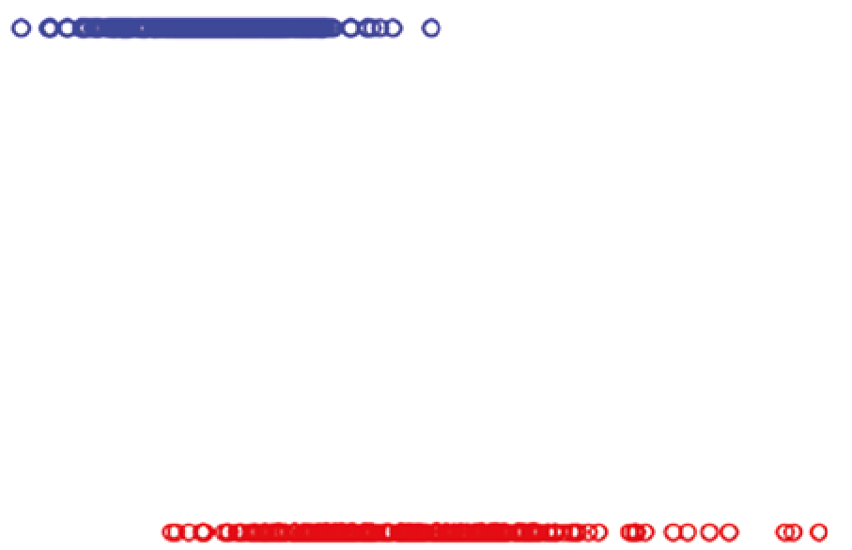

Result

0.0

10

15

mean radius

20

25

malignant

benign

0.2

0.4

0.6

0.8

1.0

**Figure 7.14:** Plotting a scatter plot based on one feature

As you can see, this is a good opportunity to use logistic regression to predict if a tumor is cancerous. You could try to plot an “s” curve (albeit flipped horizontally).

***Finding the Intercept and Coefficient***

Scikit-learn comes with the **LogisticRegression** class that allows you to apply logistic regression to train a model. Thus, in this example, you are going to train a model using the first feature of the dataset:

**from sklearn import linear_model import numpy as np**

**log_regress = linear_model.LogisticRegression()**

**#---train the model---**

**log_regress.fit(X = np.array(x).reshape(len(x),1), y = y)**

**#---print trained model intercept---**

**print(log_regress.intercept_) # [ 8.19393897]**

**#---print trained model coefficients--print(log_regress.coef_) # [[-0.54291739]]**

Once the model is trained, what we are most interested in at this point is the intercept and coefficient. If you recall from the formula in Figure 7.10, the intercept is β0 and the coefficient is xβ. Knowing these two values allows us to plot the sigmoid curve that tries to fit the points on the chart.

***Plotting the Sigmoid Curve***

With the values of β0 and xβ obtained, you can now plot the sigmoid curve using the following code snippet:

**def sigmoid(x):**

**return (1 / (1 +**

**np.exp(-(log_regress.intercept_[0] + (log_regress.coef_[0][0] * x)))))**

**x1 = np.arange(0, 30, 0.01) y1 = [sigmoid(n) for n in x1]**

**plt.scatter(x,y, facecolors='none', edgecolors=pd.DataFrame(cancer.target)[0].apply(lambda x:**

**colors[x]), cmap=colors)**

**plt.plot(x1,y1) plt.xlabel("mean radius") plt.ylabel("Probability")** Figure 7.15 shows the sigmoid curve.

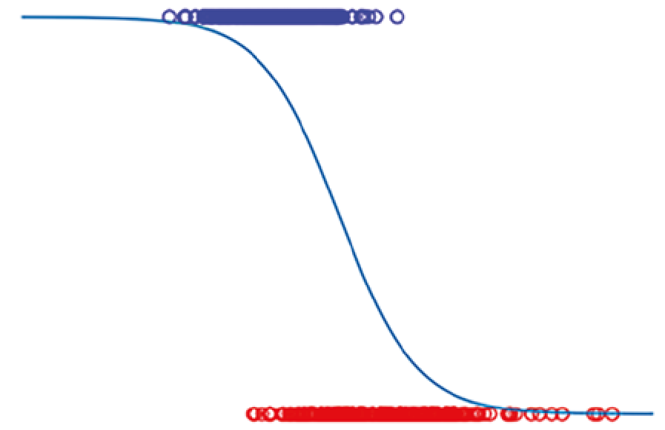

Probability

0.0

5

15

10

mean radius

20

25

30

0.2

0.4

0.6

0.8

1.0

0

**Figure 7.15:** The sigmoid curve fitting to the two sets of points

***Making Predictions***

Using the trained model, let’s try to make some predictions. Let’s try to predict the result if the mean radius is 20:

**print(log_regress.predict_proba(20)) # [[0.93489354 0.06510646]] print(log_regress.predict(20)[0]) # 0**

As you can see from the output, the **predict_proba()** function in the first statement returns a two-dimensional array. The result of 0.93489354 indicates the probability that the prediction is 0 (malignant) while the result of 0.06510646 indicates the probability that the prediction is 1. Based on the default *threshold* of 0.5, the prediction is that the tumor is malignant (value of 0), since its predicted probability (0.93489354) of 0 is more than 0.5.

The **predict()** function in the second statement returns the class that the result lies in (which in this case can be a 0 or 1). The result of 0 indicates that the prediction is that the tumor is malignant. Try another example with the mean radius of 8 this time:

**print(log_regress.predict_proba(8)) # [[0.02082411 0.97917589]] print(log_regress.predict(8)[0]) # 1**

As you can see from the result, the prediction is that the tumor is benign.

**Training the Model Using All Features**

In the previous section, you specifically trained the model using one feature. Let’s now try to train the model using all of the features and then see how well it can accurately perform the prediction.

First, load the dataset:

**from sklearn.datasets import load_breast_cancer cancer = load_breast_cancer() # Load dataset**

Instead of training the model using all of the rows in the dataset, you are going to split it into two sets, one for training and one for testing. To do so, you use the **train_test_split()** function. This function allows you to split your data into random train and test subsets. The following code snippet splits the dataset into a 75 percent training and 25 percent testing set:

**from sklearn.model_selection import train_test_split train_set, test_set, train_labels, test_labels = train_test_split( cancer.data, # features cancer.target, # labels test_size = 0.25, # split ratio random_state = 1, # set random seed**

**stratify = cancer.target) # randomize based on labels**

Figure 7.16 shows how the dataset is split. The **random_state** parameter of the **train_test_split()** function specifies the seed used by the random number generator. If this is not specified, every time you run this function you will get a different training and testing set. The **stratify** parameter allows you to specify which column (feature/label) to use so that the split is proportionate. For example, if the column specified is a categorical variable with 80 percent 0s and 20 percent 1s, then the training and test sets would each have 80 percent of 0s and 20 percent of 1s.

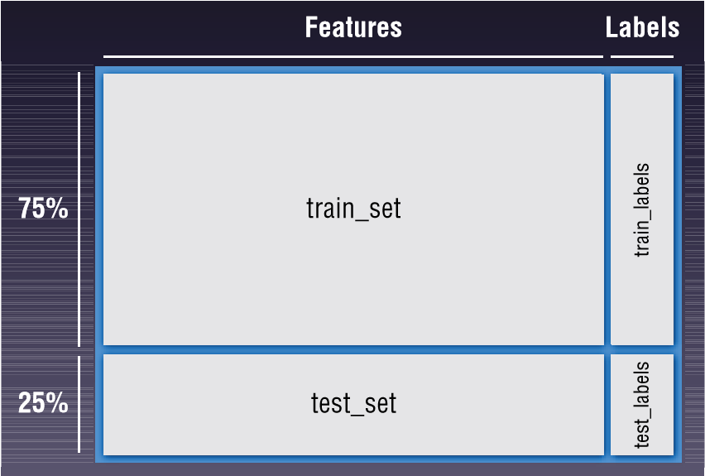

**Figure 7.16:** Splitting the dataset into training and test sets

Once the dataset is split, it is now time to train the model. The following code snippet trains the model using logistic regression:

**from sklearn import linear_model x = train_set[:,0:30] # mean radius y = train_labels # 0: malignant, 1: benign log_regress = linear_model.LogisticRegression() log_regress.fit(X = x, y = y)**

In this example, we are training it with all of the 30 features in the dataset.

When the training is done, let’s print out the intercept and model coefficients:

**print(log_regress.intercept_) # print(log_regress.coef_) #**

The following output shows the intercept and coefficients:

**[0.34525124]**

**[[ 1.80079054e+00 2.55566824e-01 -3.75898452e-02 -5.88407941e-03**

**-9.57624689e-02 -3.16671611e-01 -5.06608094e-01 -2.53148889e-01**

**-2.26083101e-01 -1.03685977e-02 4.10103139e-03 9.75976632e-01**

**2.02769521e-01 -1.22268760e-01 -8.25384020e-03 -1.41322029e-02 -5.49980366e-02 -3.32935262e-02 -3.05606774e-02 1.09660157e-04**

**1.62895414e+00 -4.34854352e-01 -1.50305237e-01 -2.32871932e-02 -1.94311394e-01 -9.91201314e-01 -1.42852648e+00 -5.40594994e-01**

**-6.28475690e-01 -9.04653541e-02]]**

Because we have trained the model using 30 features, there are 30 coefficients.

***Testing the Model***

It’s time to make a prediction. The following code snippet uses the test set and feeds it into the model to obtain the predictions:

**import pandas as pd**

**#---get the predicted probablities and convert into a dataframe--preds_prob = pd.DataFrame(log_regress.predict_proba(X=test_set))**

**#---assign column names to prediction--preds_prob.columns = ["Malignant", "Benign"]**

**#---get the predicted class labels--preds = log_regress.predict(X=test_set) preds_class = pd.DataFrame(preds) preds_class.columns = ["Prediction"]**

**#---actual diagnosis---**

**original_result = pd.DataFrame(test_labels) original_result.columns = ["Original Result"]**

**#---merge the three dataframes into one---**

**result = pd.concat([preds_prob, preds_class, original_result], axis=1) print(result.head())**

The results of the predictions are then printed out. The predictions and original diagnosis are displayed side-by-side for easy comparison:

**Malignant Benign Prediction Original Result**

1. **0.999812 1.883317e-04 0 0**
2. **0.998356 1.643777e-03 0 0**
3. **0.057992 9.420079e-01 1 1**
4. **1.000000 9.695339e-08 0 0**
5. **0.207227 7.927725e-01 1 0**

***Getting the Confusion Matrix***

While it is useful to print out the predictions together with the original diagnosis from the test set, it does not give you a clear picture of how good the model is in predicting if a tumor is cancerous. A more scientific way would be to use the *confusion matrix*. The confusion matrix shows the number of actual and predicted labels and how many of them are classified correctly. You can use Pandas’s **crosstab()** function to print out the confusion matrix:

**#---generate table of predictions vs actual--print("---Confusion Matrix---") print(pd.crosstab(preds, test_labels))**

The **crosstab()** function computes a simple cross-tabulation of two factors.

The preceding code snippet prints out the following:

**---Confusion Matrix--col_0 0 1 row_0**

1. **48 3**
2. **5 87**

The output is interpreted as shown in Figure 7.17.

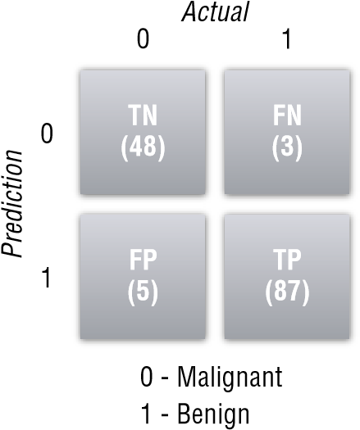

**Figure 7.17:** The confusion matrix for the prediction

The columns represent the actual diagnosis (0 for malignant and 1 for benign). The rows represent the prediction. Each individual box represents one of the following:

**■***True Positive (TP)*: The model correctly predicts the outcome as positive. In this example, the number of TP (87) indicates the number of correct predictions that a tumor is benign.

**■***True Negative (TN)*: The model correctly predicts the outcome as negative. In this example, tumors were correctly predicted to be malignant.

**■***False Positive (FP)*: The model incorrectly predicted the outcome as positive, but the actual result is negative. In this example, it means that the tumor is actually malignant, but the model predicted the tumor to be benign.

**■***False Negative (FN)*: The model incorrectly predicted the outcome as negative, but the actual result is positive. In this example, it means that the tumor is actually benign, but the model predicted the tumor to be malignant.

This set of numbers is known as the *confusion matrix*.

Besides using the **crosstab()** function, you can also use the **confusion_ matrix()** function to print out the confusion matrix:

**from sklearn import metrics**

**#---view the confusion matrix---**

**print(metrics.confusion_matrix(y_true = test_labels, # True labels y_pred = preds)) # Predicted labels** Note that the output is switched for the rows and columns.

**[[48 5]**

**[ 3 87]]**

***Computing Accuracy, Recall, Precision, and Other Metrics***

Based on the confusion matrix, you can calculate the following metrics:

**■*Accuracy*:** This is defined as the sum of all correct predictions divided by the total number of predictions, or mathematically:

TP/TN / TP TN FP FN

**■**This metric is easy to understand. After all, if the model correctly predicts 99 out of 100 samples, the accuracy is 0.99, which would be very impressive in the real world. But consider the following situation: Imagine that you’re trying to predict the failure of equipment based on the sample data. Out of 1,000 samples, only three are defective. If you use a dumb algorithm that always returns negative (meaning no failure) for all results, then the accuracy is 997/1000, which is 0.997. This is very impressive, but does this mean it’s a good algorithm? No. If there are 500 defective items in the dataset of 1,000 items, then the accuracy metric immediately indicates the flaw of the algorithm. In short, accuracy works best with evenly distributed data points, but it works really badly for a skewed dataset. Figure 7.18 summarizes the formula for accuracy.

**■*Precision*:** This metric is defined to be TP / (TP + FP). This metric is concerned with number of correct positive predictions. You can think of precision as “of those predicted to be positive, how many were actually predicted correctly?” Figure 7.19 summarizes the formula for precision.

**■*Recall* (also known as *True Positive Rate (TPR)*):** This metric is defined to be TP / (TP + FN). This metric is concerned with the number of correctly predicted positive events. You can think of recall as “of those positive events, how many were predicted correctly?” Figure 7.20 summarizes the formula for recall.

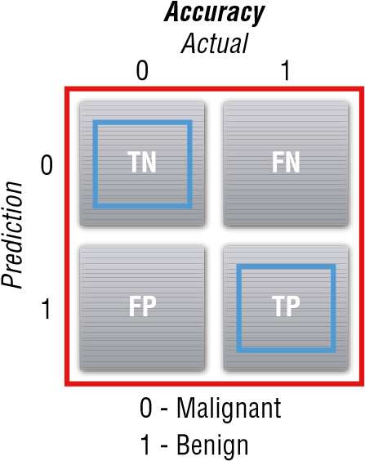

**Accuracy = (TN+TP)**

**(TN+FN+FP+TP)**

**Figure 7.18:** Formula for calculating accuracy

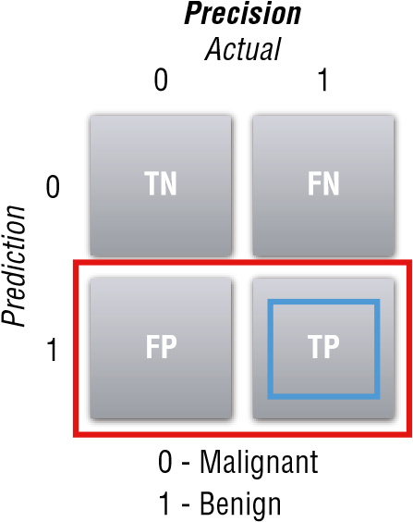

**Precision = TP**

**(FP+TP)**

**Figure 7.19:** Formula for calculating precision

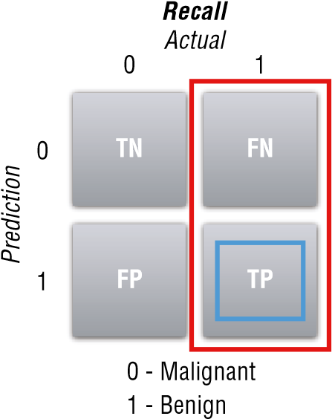

**Recall = TP**

**(FN+TP)**

**Figure 7.20:** Formula for calculating recall

**■*F1 Score*:** This metric is defined to be 2 * (precision * recall) / (precision + recall). This is known as the *harmonic mean of precision and recall*, and it is a good way to summarize the evaluation of the algorithm in a single number.

**■*False Positive Rate (FPR)*:** This metric is defined to be FP / (FP+TN). FPR corresponds to the proportion of negative data points that are mistakenly considered as positive, with respect to all negative data points. In other words, the higher FPR, the more negative data points you’ll misclassify.

The concept of precision and recall may not be apparent immediately, but if you consider the following scenario, it will be much clearer. Consider the case of breast cancer diagnosis. If a malignant tumor is represented as negative and a benign tumor is represented as positive, then:

**■**If the precision or recall is high, it means that more patients with benign tumors are diagnosed correctly, which indicates that the algorithm is good.

**■**If the precision is low, it means that more patients with malignant tumors are diagnosed as benign.

**■**If the recall is low, it means that more patients with benign tumors are diagnosed as malignant.

For the last two points, having a low precision is more serious than a low recall (although wrongfully diagnosed as having breast cancer when you do not have it will likely result in unnecessary treatment and mental anguish) because it causes the patient to miss treatment and potentially causes death. Hence, for cases like diagnosing breast cancer, it’s important to consider both the precision and recall metrics when evaluating the effectiveness of an ML algorithm. To get the accuracy of the model, you can use the **score()** function of the model:

**#---get the accuracy of the prediction--print("---Accuracy---") print(log_regress.score(X = test_set , y = test_labels))** You should see the following result:

**---Accuracy---**

**0.9440559440559441**

To get the precision, recall, and F1-score of the model, use the **classification_ report()** function of the **metrics** module:

**# View summary of common classification metrics print("---Metrices---") print(metrics.classification_report( y_true = test_labels, y_pred = preds))**

You will see the following results:

**---Metrices---**

**precision recall f1-score support**

1. **0.94 0.91 0.92 53**
2. **0.95 0.97 0.96 90**

**avg / total 0.94 0.94 0.94 143**

***Receiver Operating Characteristic (ROC) Curve***

With so many metrics available, what is an easy way to examine the effectiveness of an algorithm? One way would be to plot a curve known as the *Receiver Operating Characteristic (ROC) curve*. The ROC curve is created by plotting the TPR against the FPR at various threshold settings.

So how does it work? Let’s run through a simple example. Using the existing project that you have been working on, you have derived the confusion matrix based on the default threshold of 0.5 (meaning that all of those predicted probabilities less than or equal to 0.5 belong to one class, while those greater than 0.5 belong to another class). Using this confusion matrix, you then find the recall, precision, and subsequently FPR and TPR. Once the FPR and TPR are found, you can plot the point on the chart, as shown in Figure 7.21.

0.0

**False Positive Rate**

**True Positive Rat**

**e**

0.0

1.0

(0.97,0.09)

1.0

**Figure 7.21:** The point at threshold 0.5

Then you regenerate the confusion matrix for a threshold of 0, and recalculate the recall, precision, FPR, and TPR. Using the new FPR and TPR, you plot another point on the chart. You then repeat this process for thresholds of 0.1, 0.2, 0.3, and so on, all the way to 1.0.

At threshold 0, in order for a tumor to be classified as benign (1), the predicted probability must be greater than 0. Hence, all of the predictions would be classified as benign (1). Figure 7.22 shows how to calculate the TPR and FPR. For a threshold of 0, both the TPR and FPR are 1.

**Threshold 0** 0 - Malignant

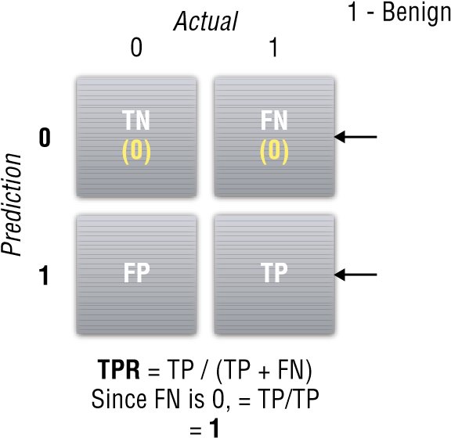**No predictions for 0**

**All predictions would be 1**

**FPR** = FP / (FP + TN)

Since TN is 0, = FP/FP

= **1**

**Figure 7.22:** The value of TPR and FPR for threshold 0

At threshold 1.0, in order for a tumor to be classified as benign (1), the predicted probability must be equal to exactly 1. Hence, all of the predictions would be classified as malignant (0). Figure 7.23 shows how to calculate the TPR and FPR when the threshold is 1.0. For a threshold of 1.0, both the TPR and FPR are 0.

**Threshold 1.0** 0 - Malignant

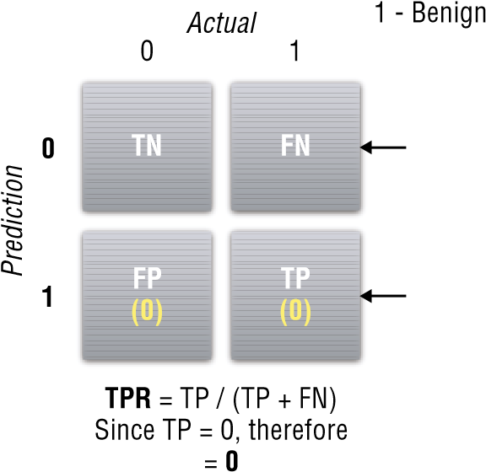**All predictions would be 0**

**No predictions for 1**

**FPR** = FP / (FP + TN)

Since FP = 0, therefore

= **0**

**Figure 7.23:** The value of TPR and FPR for threshold 1

We can now plot two more points on our chart (see Figure 7.24).

0.0

**False Positive Rate**

**True Positive Rat**

**e**

**Threshold 0.5**

**Threshold 0**

**Threshold 1.0**

0.0

1.0

1.0

(0.97,0.09)

(1

,

1)

(0

,

0)

**Figure 7.24:** Plotting the points for threshold 0, 0.5, and 1.0.

You then calculate the metrics for the other threshold values. Calculating all of the metrics based on different threshold values is a very tedious process. Fortunately, Scikit-learn has the **roc_curve()** function, which will calculate the FPR and TPR automatically for you based on the supplied test labels and predicted probabilities:

**from sklearn.metrics import roc_curve, auc**

**#---find the predicted probabilities using the test set probs = log_regress.predict_proba(test_set) preds = probs[:,1]**

**#---find the FPR, TPR, and threshold--fpr, tpr, threshold = roc_curve(test_labels, preds)**

The **roc_curve()** function returns a tuple containing the FPR, TPR, and threshold. You can print them out to see the values:

**print(fpr) print(tpr) print(threshold)**

You should see the following:

**[ 0. 0. 0.01886792 0.01886792 0.03773585 0.03773585**

**0.09433962 0.09433962 0.11320755 0.11320755 0.18867925 0.18867925**

**1. ]**

**[ 0.01111111 0.88888889 0.88888889 0.91111111 0.91111111 0.94444444 0.94444444 0.96666667 0.96666667 0.98888889 0.98888889 1.**

**1. ]**

**[ 9.99991063e-01 9.36998422e-01 9.17998921e-01 9.03158173e-01**

**8.58481867e-01 8.48217940e-01 5.43424515e-01 5.26248925e-01**

**3.72174142e-01 2.71134211e-01 1.21486104e-01 1.18614069e-01**

**1.31142589e-21]**

As you can see from the output, the threshold starts at 0.99999 (9.99e-01) and goes down to 1.311e-21.

***Plotting the ROC and Finding the Area Under the Curve (AUC)***

To plot the ROC, you can use matplotlib to plot a line chart using the values stored in the ***fpr*** and ***tpr*** variables. You can use the **auc()** function to find the area under the ROC:

**#---find the area under the curve--roc_auc = auc(fpr, tpr)**

**import matplotlib.pyplot as plt**

**plt.plot(fpr, tpr, 'b', label = 'AUC = %0.2f' % roc_auc) plt.plot([0, 1], [0, 1],'r--') plt.xlim([0, 1]) plt.ylim([0, 1])**

**plt.ylabel('True Positive Rate (TPR)') plt.xlabel('False Positive Rate (FPR)') plt.title('Receiver Operating Characteristic (ROC)') plt.legend(loc = 'lower right') plt.show()**

The area under an ROC curve is a measure of the usefulness of a test in general, where a greater area means a more useful test and the areas under ROC curves are used to compare the usefulness of tests. Generally, aim for the algorithm with the highest AUC.

Figure 7.25 shows the ROC curve as well as the AUC.

0.0

0.0

0.2

0.4

0.6

0.8

1.0

0.2

0.4

False Positive Rate (FPR)

Receiver Operating Characteristic (ROC)

True Positive Rate (TPR)

0.6

0.8

1.0

AUC = 0.99

**Figure 7.25:** Plotting the ROC curve and calculating the AUC

**Summary**

In this chapter, you learned about another supervised machine learning algorithm—logistics regression. You first learned about the logit function and how to transform it into a sigmoid function. You then applied the logistic regression to the breast cancer dataset and used it to predict if a tumor is malignant or benign. More importantly, this chapter discussed some of the metrics that are useful in determining the effectiveness of a machine learning algorithm. In addition, you learned about what an ROC curve is, how to plot it, and how to calculate the area under the curve.

|  |
| --- |
| **CHAPTER** |
| **8** |

**Supervised Learning— Classification Using Support**

**Vector Machines**

**What Is a Support Vector Machine?**

In the previous chapter, you saw how to perform classification using logistics regression. In this chapter, you will learn another supervised machine learning algorithm that is also very popular among data scientists—*Support Vector Machines (SVM)*. Like logistics regression, SVM is also a classification algorithm.

The main idea behind SVM is to draw a line between two or more classes in the best possible manner (see Figure 8.1).

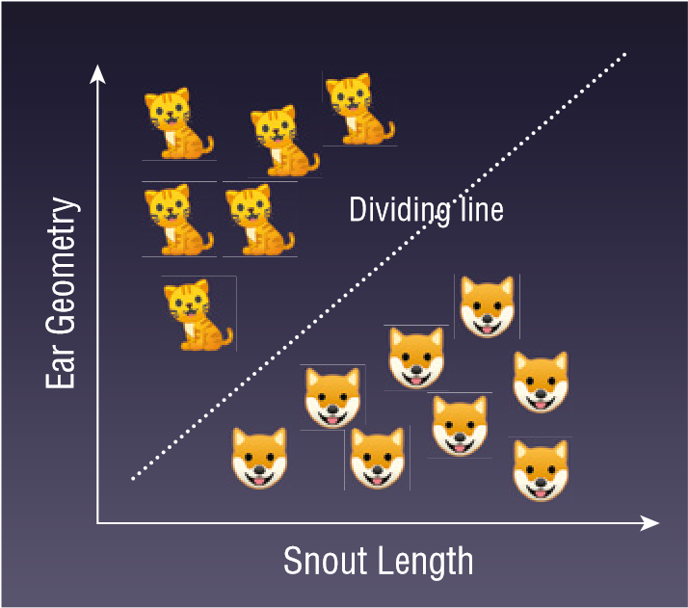

**Figure 8.1:** Using SVM to separate two classes of animals

Python® Machine Learning, First Edition. Wei-Meng Lee. **177**

© 2019 John Wiley & Sons, Inc. Published 2019 by John Wiley & Sons, Inc.

Once the line is drawn to separate the classes, you can then use it to predict future data. For example, given the snout length and ear geometry of a new unknown animal, you can now use the dividing line as a classifier to predict if the animal is a dog or a cat.

In this chapter, you will learn how SVM works and the various techniques you can use to adapt SVM for solving nonlinearly-separable datasets.

**Maximum Separability**

How does SVM separate two or more classes? Consider the set of points in Figure 8.2. Before you look at the next figure, visually think of a straight line dividing the points into two groups.

0.0

0.5

1.0

1.5

2.0

x2

2.5

3.0

3.5

4.0

A

r

B

0.0 0.5 1.0 1.5 2.0 2.5 3.0

x1

**Figure 8.2:** A set of points that can be separated using SVM

Now look at Figure 8.3, which shows two possible lines separating the two groups of points. Is this what you had in mind?

Though both lines separate the points into two distinct groups, which one is the right one? For SVM, the right line is the one that has the widest margins (with each margin touching at least a point in each class), as shown in Figure 8.4. In that figure, d1 and d2 are the width of the margins. The goal is to find the largest possible width for the margin that can separate the two groups. Hence, in this case d2 is the largest. Thus the line chosen is the one on the right.

**Supervised Learning—Classification Using Support Vector Machines 179**

0.0

0.0

0.5

1.0

1.5

2.0

x2

2.5

3.0

3.5

4.0

0.5

1.5

1.0

x1

2.0

2.5

3.0

A

r

B

0.0

0.0

0.5

1.0

1.5

2.0

x2

2.5

3.0

3.5

4.0

1.0

0.5

1.5

x1

2.5

2.0

3.0

A

r

B

**Figure 8.3:** Two possible ways to split the points into two classes

0.0

0.0

0.5

1.0

1.5

2.0

x2

2.5

3.0

3.5

4.0

0.5

1.0

1.5

x1

2.0

2.5

3.0

A

r

B

0.0

0.0

0.5

1.0

1.5

2.0

x2

2.5

3.0

3.5

4.0

0.5

1.0

1.5

x1

2.0

2.5

3.0

A

r

B

**d1**

**d2**

**d2>d1**

**Figure 8.4:** SVM seeks to split the two classes with the widest margin

Each of the two margins touches the closest point(s) to each group of points, and the center of the two margins is known as the *hyperplane*. The hyperplane is the line separating the two groups of points. We use the term “hyperplane” instead of “line” because in SVM we typically deal with more than two dimensions, and using the word “hyperplane” more accurately conveys the idea of a plane in a multidimensional space.

**Support Vectors**

A key term in SVM is *support vectors*. Support vectors are the points that lie on the two margins. Using the example from the previous section, Figure 8.5 shows the two support vectors lying on the two margins.

In this case, we say that there are two support vectors—one for each class.

0.0

0.0

0.5

1.0

1.5

2.0

x2

2.5

3.0

3.5

4.0

0.5

1.01.5

x1

2.0

2.5

3.0

A

r

B

**Support V**

**ectors**

**Figure 8.5:** Support vectors are points that lie on the margins

**Formula for the Hyperplane**

With the series of points, the next question would be to find the formula for the hyperplane, together with the two margins. Without delving too much into the math behind this, Figure 8.6 shows the formula for getting the hyperplane.

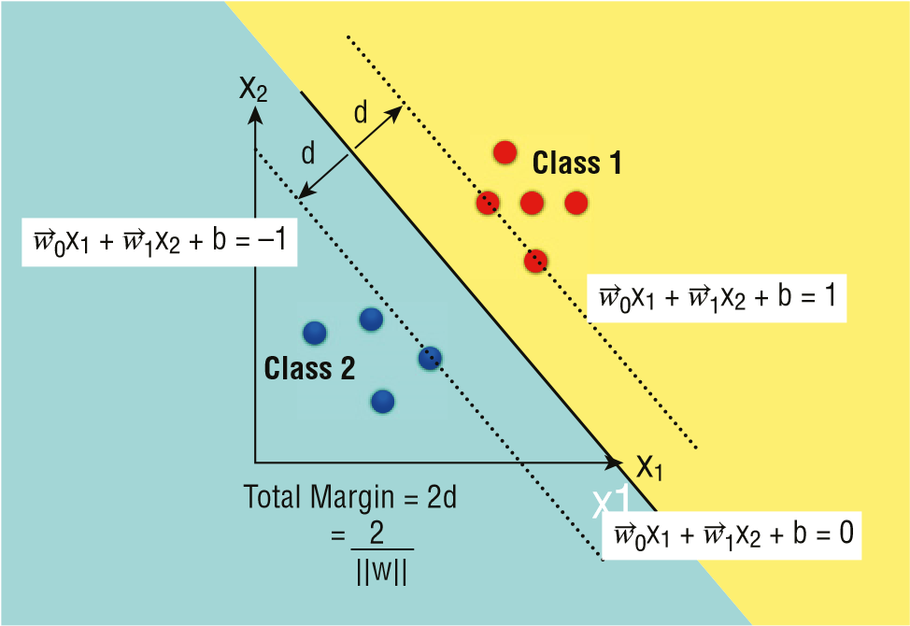

**Figure 8.6:** The formula for the hyperplane and its accompanying two margins

**Supervised Learning—Classification Using Support Vector Machines 181**

As you can see from Figure 8.6, the formula for hyperplane (g) is given as:

❒ 

g x *W*0 1x *W*1 2x b

❒ 

where x1 and x2 are the inputs, *W*0 and *W*1 are the weight vectors, and b is the bias.

If the value of g is 1, then the point specified is in Class 1, and if the value of g is 1, then the point specified is in Class 2. As mentioned, the goal of SVM is to find the widest margins that divide the classes, and the total margin (2d) is defined by:

2/ w

❒ 

where w is the normalized weight vectors (*W*0 and *W*1). Using the training set, the goal is to minimize the value of w so that you can get the maximum separability between the classes. Once this is done, you will be able to get the   values of *W*0, *W*1, and b.

Finding the margin is a *Constrained Optimization* problem, which can be solved using the *Larange Multipliers* technique. It is beyond the scope of this book to discuss how to find the margin based on the dataset, but suffice it to say that we will make use of the Scikit-learn library to find them.

**Using Scikit-learn for SVM**

Now let’s work on an example to see how SVM works and how to implement it using Scikit-learn. For this example, we have a file named **svm.csv** containing the following data:

**x1,x2,r 0,0,A**

**1,1,A**

**2,3,B**

**2,0,A**

**3,4,B**

The first thing that we will do is to plot the points using Seaborn:

**%matplotlib inline import pandas as pd import numpy as np**

**import seaborn as sns; sns.set(font_scale=1.2) import matplotlib.pyplot as plt**

**data = pd.read_csv('svm.csv') sns.lmplot('x1', 'x2', data=data, hue='r', palette='Set1', fit_reg=False, scatter_kws={"s": 50});**

Figure 8.7 shows the points plotted using Seaborn.

0.0

0.5

1.0

1.5

2.0

x2

2.5

3.0

3.5

4.0

A

r

B

0.0 0.5 1.0 1.5 2.0 2.5 3.0

x1

**Figure 8.7:** Plotting the points using Seaborn

Using the data points that we have previously loaded, now let’s use Scikitlearn’s **svm** module’s **SVC** class to help us derive the value for the various variables that we need to compute otherwise. The following code snippet uses the *linear kernel* to solve the problem. The linear kernel assumes that the dataset can be separated linearly.

**from sklearn import svm**

**#---Converting the Columns as Matrices--points = data[['x1','x2']].values result = data['r']**

**clf = svm.SVC(kernel = 'linear') clf.fit(points, result)**

**print('Vector of weights (w) = ',clf.coef_[0]) print('b = ',clf.intercept_[0])**

**print('Indices of support vectors = ', clf.support_) print('Support vectors = ', clf.support_vectors_)**

**print('Number of support vectors for each class = ', clf.n_support_) print('Coefficients of the support vector in the decision function = ', np.abs(clf.dual_coef_))**

**Supervised Learning—Classification Using Support Vector Machines 183**

The **SVC** stands for *Support Vector Classification*. The **svm** module contains a series of classes that implement SVM for different purposes:

**svm.LinearSVC**: Linear Support Vector Classification **svm.LinearSVR**: Linear Support Vector Regression **svm.NuSVC**: Nu-Support Vector Classification **svm.NuSVR**: Nu-Support Vector Regression **svm.OneClassSVM**: Unsupervised Outlier Detection **svm.SVC**: C-Support Vector Classification **svm.SVR**: Epsilon-Support Vector Regression

**TIP For this chapter, our focus is on using SVM for classification, even though SVM can also be used for regression.**

The preceding code snippet yields the following output:

**Vector of weights (w) = [0.4 0.8] b = -2.2**

**Indices of support vectors = [1 2]**

**Support vectors = [[1. 1.]**

**[2. 3.]]**

**Number of support vectors for each class = [1 1]**

**Coefficients of the support vector in the decision function = [[0.4 0.4]]** As you can see, the vector of weights has been found to be [0.4 0.8], meaning   that *W*0 is now 0.4 and *W*1 is now 0.8. The value of b is –2.2, and there are two support vectors. The index of the support vectors is 1 and 2, meaning that the points are the ones in bold:

**x1 x2 r**

1. **0 0 A**
2. **1 1 A**
3. **2 3 B**
4. **2 0 A**
5. **3 4 B**

Figure 8.8 shows the relationship between the various variables in the formula and the variables in the code snippet.

g(x) = →*w*0x1 + →*w*1x2 + b

clf.coef_[0][0] clf.coef_[0][1] clf.intercept_[0]

**Figure 8.8:** Relationships between the variables in the formula and the variables in the code snippet

**Plotting the Hyperplane and the Margins**

With the values of the variables all obtained, it is now time to plot the hyperplane and its two accompanying margins. Do you remember the formula for the hyperplane? It is as follows:

❒ 

g x W0X1 W1X2 b,

❒ 

To plot the hyperplane, set W0X1 W1X2 b to 0, like this:

❒ 

W0X1 W1X2 b 0

In order to plot the hyperplane (which is a straight line in this case), we need two points: one on the x-axis and one on the y-axis.

Using the preceding formula, when x1  0, we can solve for x2 as follows:

***W******0*(0) + *W******1X2* + b = 0**

❒

***W*x2*1*=*X2* -b/ = -b*W******1***

When x2 = 0, we can solve for x1 as follows:

***W******0X1* + *W******1*(0) + b = 0**

***W*x*****0*1 = -b/*X1* = -b*W******0***

The point **(0,-b/*W******1*)** is the *y-intercept* of the straight line. Figure 8.9 shows the two points on the two axes.

x

1

x

2



(0

, –b

/

*w*

→

1

)

(

–b

/

*w*

→

0

,0)

**Figure 8.9:** The two intercepts for the hyperplane

Once the points on each axis are found, you can now calculate the *slope* as follows:

**Slope = (-b/*W******1*) / (b/*W******0*)**

❒ 

**Slope = -(*W0*/*W1*)**

**Supervised Learning—Classification Using Support Vector Machines 185**

With the slope and y-intercept of the line found, you can now go ahead and plot the hyperplane. The following code snippet does just that:

**#---w is the vector of weights--w = clf.coef_[0]**

**#---find the slope of the hyperplane--slope = -w[0] / w[1]**

**b = clf.intercept_[0]**

**#---find the coordinates for the hyperplane--xx = np.linspace(0, 4) yy = slope * xx - (b / w[1])**

**#---plot the margins---**

**s = clf.support_vectors_[0] #---first support vector--yy_down = slope * xx + (s[1] - slope * s[0])**

**s = clf.support_vectors_[-1] #---last support vector--yy_up = slope * xx + (s[1] - slope * s[0])**

**#---plot the points---**

**sns.lmplot('x1', 'x2', data=data, hue='r', palette='Set1', fit_reg=False, scatter_kws={"s": 70})**

**#---plot the hyperplane---**

**plt.plot(xx, yy, linewidth=2, color='green');**

**#---plot the 2 margins--plt.plot(xx, yy_down, 'k--') plt.plot(xx, yy_up, 'k--')**

Figure 8.10 shows the hyperplane and the two margins.

**Making Predictions**

Remember, the goal of SVM is to separate the points into two or more classes, so that you can use it to predict the classes of future points. Having trained your model using SVM, you can now perform some predictions using the model.

The following code snippet uses the model that you have trained to perform some predictions:

**print(clf.predict([[3,3]])[0]) # 'B' print(clf.predict([[4,0]])[0]) # 'A' print(clf.predict([[2,2]])[0]) # 'B' print(clf.predict([[1,2]])[0]) # 'A'**

Check the points against the chart shown in Figure 8.10 and see if it makes sense to you.

0

0

1

2

x2

3

4

1

2

x1

3

4

A

r

B

**Figure 8.10:** The hyperplane and the two margins

**Kernel Trick**

Sometimes, the points in a dataset are not always linearly separable. Consider the points shown in Figure 8.11.

1.0

0.5

0.0

–0.5

–1.0

0.0

–1.0

–0.5

0.5

1.0

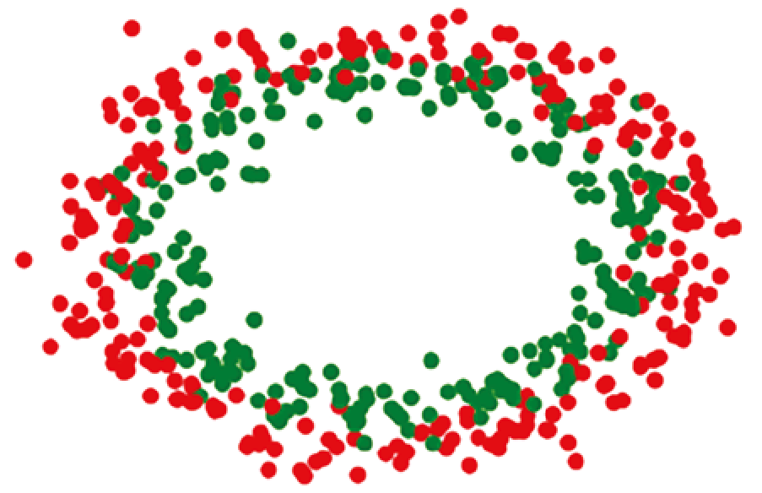

**Figure 8.11:** A scatter plot of two groups of points distributed in circular fashion

**Supervised Learning—Classification Using Support Vector Machines 187**

You can see that it is not possible to draw a straight line to separate the two sets of points. With some manipulation, however, you can make this set of points linearly separable. This technique is known as the *kernel trick*. The kernel trick is a technique in machine learning that transforms data into a higher dimension space so that, after the transformation, it has a clear dividing margin between classes of data.

**Adding a Third Dimension**

To do so, we can add a third dimension, say the z-axis, and define z to be:

z x2 y2

Once we plot the points using a 3D chart, the points are now linearly separable. It is difficult to visualize this unless you plot the points out. The following code snippet does just that:

**%matplotlib inline**

**from mpl_toolkits.mplot3d import Axes3D import matplotlib.pyplot as plt import numpy as np**

**from sklearn.datasets import make_circles**

**#---X is features and c is the class labels---**

**X, c = make_circles(n_samples=500, noise=0.09)**

**rgb = np.array(['r', 'g'])**

**plt.scatter(X[:, 0], X[:, 1], color=rgb[c]) plt.show()**

**fig = plt.figure(figsize=(18,15)) ax = fig.add_subplot(111, projection='3d') z = X[:,0]**2 + X[:,1]**2**

**ax.scatter(X[:, 0], X[:, 1], z, color=rgb[c]) plt.xlabel("x-axis") plt.ylabel("y-axis") plt.show()**

We first create two sets of random points (a total of 500 points) distributed in circular fashion using the **make**_**circles()** function. We then plot them out on a 2D chart (as what was shown in Figure 8.11). We then add the third axis, the z-axis, and plot the chart in 3D (see Figure 8.12).

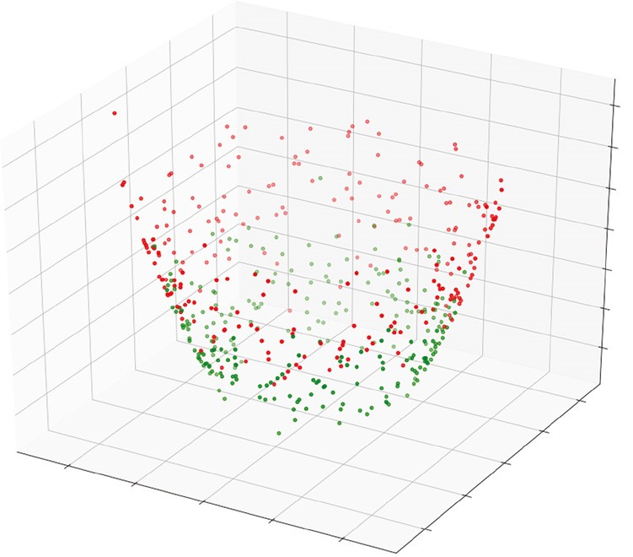

1.0

0.4

0.6

0.8

1.0

1.2

1.4

1.6

0.5

0.0

–0.5

–1.0

0.0

x-axis

y-axis

–1.0

–0.5

0.5

1.0

**Figure 8.12:** Plotting the points in the three dimensions

**TIP If you run the preceding code in Terminal (just remove the %matplotlib inline statement at the top of the code snippet) using the python command, you will be able to rotate and interact with the chart. Figure 8.13 shows the different perspectives of the 3D chart.**

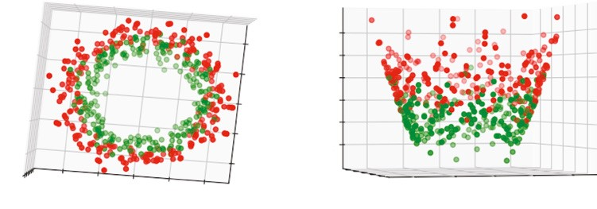

1.0

0.4

0.6

0.8

1.0

1.2

1.4

0.4

0.6

0.8

1.0

1.2

1.4

0.5

0.0

–0.5

–1.0

0.0

y-axi

s

y-axis

x-axi

s

–1.0

–0.5

0.5

1.0

0.0

–1.0

–0.5

0.5

1.0

0.0

–1.0

–0.5

0.5

1.0

x-axis

**Figure 8.13:** The various perspectives on the same dataset in 3D

**Plotting the 3D Hyperplane**

With the points plotted in a 3D chart, let’s now train the model using the third dimension:

**#---combine X (x-axis,y-axis) and z into single ndarray--features = np.concatenate((X,z.reshape(-1,1)), axis=1)**

**#---use SVM for training--from sklearn import svm**

**clf = svm.SVC(kernel = 'linear') clf.fit(features, c)**

First, we combined the three axes into a single **ndarray** using the **np.concatenate()** function. We then trained the model as usual. For a linearly-separable set of points in two dimensions, the formula for the hyperplane is as follows: **g(x) = *W******0X1* + *W******1X2* + b**

For the set of points now in three dimensions, the formula now becomes the following: **g(x) = *W******0X1* + *W******1X2* + *W******2X3* + b** 

In particular, *W*2 is now represented by **clf.coef**_**[0][2]**, as shown in Figure 8.14.

g(x) = →*w*0x1 + →*w*1x2 + →*w*2x3 + b

clf.coef_[0][0]

clf.coef_[0][1]

clf.coef_[0][2]

clf.intercept_[0]

**Figure 8.14:** The formula for the hyperplane in 3D and its corresponding variables in the code snippet

The next step is to draw the hyperplane in 3D. In order to do that, you need to find the value of **x3**, which can be derived, as shown in Figure 8.15.

→*w*0x1 + →*w*1x2 + →*w*2x3 + b = 0 *w*→2x3 = –*w*→0x1 – →*w*1x2 – b

x3 = –→*w*0x1 – →*w*1x2 – b

→*w*2

**Figure 8.15:** Formula for finding the hyperplane in 3D

This can be expressed in code as follows:

**x3 = lambda x,y: (-clf.intercept_[0] - clf.coef_[0][0] * x-clf.coef_[0][1] * y) / clf.coef_[0][2]**

To plot the hyperplane in 3D, use the **plot**_**surface()** function:

**tmp = np.linspace(-1.5,1.5,100) x,y = np.meshgrid(tmp,tmp)**

**ax.plot_surface(x, y, x3(x,y)) plt.show()**

The entire code snippet is as follows:

**from mpl_toolkits.mplot3d import Axes3D import matplotlib.pyplot as plt import numpy as np**

**from sklearn.datasets import make_circles**

**#---X is features and c is the class labels--X, c = make_circles(n_samples=500, noise=0.09) z = X[:,0]**2 + X[:,1]**2**

**rgb = np.array(['r', 'g'])**

**fig = plt.figure(figsize=(18,15)) ax = fig.add_subplot(111, projection='3d') ax.scatter(X[:, 0], X[:, 1], z, color=rgb[c]) plt.xlabel("x-axis") plt.ylabel("y-axis")**

**# plt.show()**

**#---combine X (x-axis,y-axis) and z into single ndarray--features = np.concatenate((X,z.reshape(-1,1)), axis=1)**

**#---use SVM for training--from sklearn import svm**

**clf = svm.SVC(kernel = 'linear') clf.fit(features, c) x3 = lambda x,y: (-clf.intercept_[0] - clf.coef_[0][0] * x-clf.coef_[0][1]**

**\* y) / clf.coef_[0][2] tmp = np.linspace(-1.5,1.5,100) x,y = np.meshgrid(tmp,tmp)**

**ax.plot_surface(x, y, x3(x,y)) plt.show()**

Figure 8.16 shows the hyperplane, as well as the points, plotted in 3D.

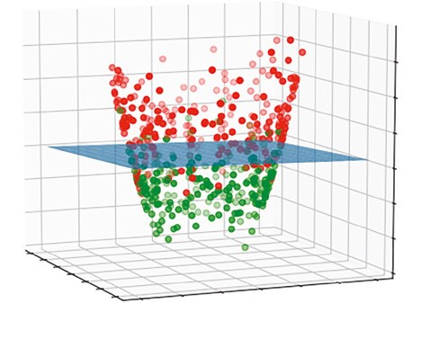

1.0

1.5

0.4

0.2

0.6

0.8

1.0

1.2

1.4

0.5

0.0

–0.5

–1.0

–1.5

0.0

x-axis

y-axis

–1.0

–1.5

–0.5

0.5

1.0

1.5

**Figure 8.16:** The hyperplane in 3D cutting through the two sets of points

**Types of Kernels**

Up to this point, we only discussed one type of SVM—linear SVM. As the name implies, linear SVM uses a straight line to separate the points. In the previous section, you also learned about the use of kernel tricks to separate two sets of data that are distributed in a circular fashion and then used linear SVM to separate them.

Sometimes, not all points can be separated linearly, nor can they be separated using the kernel tricks that you observed in the previous section. For this type of data, you need to “bend” the lines to separate them. In machine learning, *kernels* are functions that transform your data from nonlinear spaces to linear ones (see Figure 8.17).

To understand how kernels work, let’s use the Iris dataset as an example. The following code snippet loads the Iris dataset and prints out the features, target, and target names:

**%matplotlib inline import pandas as pd import numpy as np from sklearn import svm, datasets import matplotlib.pyplot as plt**

**iris = datasets.load_iris()**

**print(iris.data[0:5]) # print first 5 rows**

**print(iris.feature_names) # ['sepal length (cm)', 'sepal width (cm)', # 'petal length (cm)', 'petal width (cm)'] print(iris.target[0:5]) # print first 5 rows print(iris.target_names) # ['setosa' 'versicolor' 'virginica']** To illustrate, we will only use the first two features of the Iris dataset:

x

1

Kernel Function

**O**

**f(**

**O**

**)**

**f(**

**O**

**)**

**f(**

**O**

**)**

**f(**

**O**

**)**

**f(**

**O**

**)**

**f(**

**O**

**)**

**f(**

**x**

**)**

**f(**

**x**

**)**

**f(**

**x**

**)**

**f(**

**x**

**)**

**O**

**O**

**O**

**O**

**x**

**x**

**x**

**x**

**O**

x

2

x

1

x

2

**Figure 8.17:** A kernel function transforms your data from nonlinear spaces to linear ones

**X = iris.data[:, :2] # take the first two features y = iris.target**

We will plot the points using a scatter plot (see Figure 8.18):

**#---plot the points--colors = ['red', 'green', 'blue'] for color, i, target in zip(colors, [0, 1, 2], iris.target_names): plt.scatter(X[y==i, 0], X[y==i, 1], color=color, label=target)**

**plt.xlabel('Sepal length') plt.ylabel('Sepal width')**

**plt.legend(loc='best', shadow=False, scatterpoints=1)**

**plt.title('Scatter plot of Sepal width against Sepal length') plt.show()**

Next, we will use the SVC class with the linear kernel:

**C = 1 # SVM regularization parameter clf = svm.SVC(kernel='linear', C=C).fit(X, y) title = 'SVC with linear kernel'**

Scatter plot of Sepal width against Sepal length

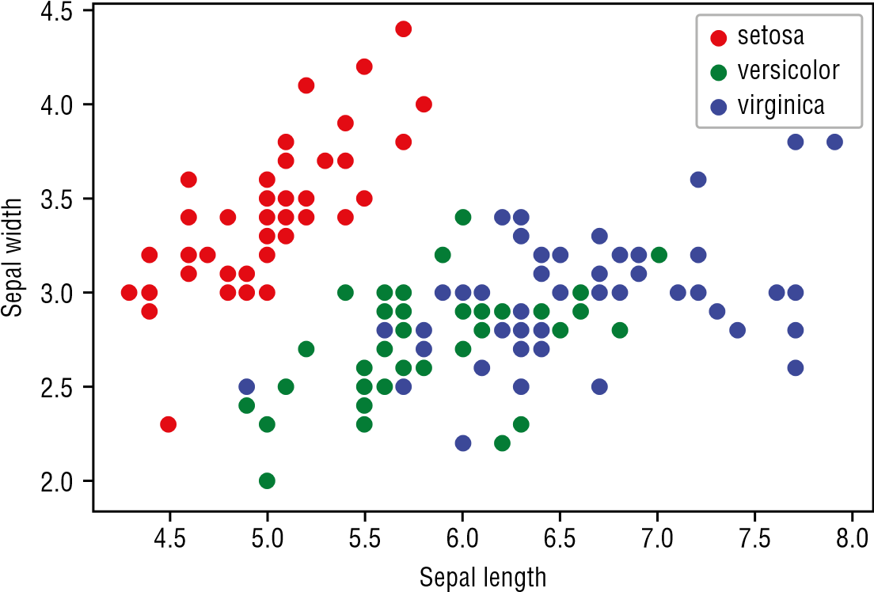

**Figure 8.18:** Scatter plot of the Iris dataset’s first two features

**TIP Notice that this time around, we have a new parameter C. We will discuss this in a moment.**

Instead of drawing lines to separate the three groups of Iris flowers, this time we will paint the groups in colors using the **contourf()** function:

**#---min and max for the first feature--x_min, x_max = X[:, 0].min() - 1, X[:, 0].max() + 1**

**#---min and max for the second feature--y_min, y_max = X[:, 1].min() - 1, X[:, 1].max() + 1**

**#---step size in the mesh--h = (x_max / x_min)/100**

**#---make predictions for each of the points in xx,yy--xx, yy = np.meshgrid(np.arange(x_min, x_max, h), np.arange(y_min, y_max, h))**

**Z = clf.predict(np.c_[xx.ravel(), yy.ravel()])**

**#---draw the result using a color plot---**

**Z = Z.reshape(xx.shape)**

**plt.contourf(xx, yy, Z, cmap=plt.cm.Accent, alpha=0.8)**

**#---plot the training points--colors = ['red', 'green', 'blue'] for color, i, target in zip(colors, [0, 1, 2], iris.target_names): plt.scatter(X[y==i, 0], X[y==i, 1], color=color, label=target) plt.xlabel('Sepal length') plt.ylabel('Sepal width') plt.title(title) plt.legend(loc='best', shadow=False, scatterpoints=1)**

Figure 8.19 shows the scatter plots as well as the groups determined by the SVM linear kernel.

SVC with linear kernel

Sepal width

5.0

4.5

4.0

3.5

3.0

2.5

2.0

1.5

1.0

4 5 6 7 8

Sepal length **Figure 8.19:** Using the SVM linear kernel

Once the training is done, we will perform some predictions:

**predictions = clf.predict(X) print(np.unique(predictions, return_counts=True))** The preceding code snippet returns the following:

**(array([0, 1, 2]), array([50, 53, 47]))**

This means that after the feeding the model with the Iris dataset, 50 are classified as “setosa,” 53 are classified as “versicolor,” and 47 are classified as “virginica.”

**C**

In the previous section, you saw the use of the C parameter:

**C = 1**

**clf = svm.SVC(kernel='linear', C=C).fit(X, y)**

C is known as the *penalty parameter of the error term*. It controls the tradeoff between the smooth decision boundary and classifying the training points correctly. For example, if the value of C is high, then the SVM algorithm will seek to ensure that all points are classified correctly. The downside to this is that it may result in a narrower margin, as shown in Figure 8.20.



More concerned about getting the points correctly classified

(

prioritizes making lesser mistakes

)

**High C**

**Figure 8.20:** A high C focuses more on getting the points correctly classified

In contrast, a lower C will aim for the widest margin possible, but it will result in some points being classified incorrectly (see Figure 8.21).



More concerned about maximizing the margin

(

prioritizes simplicity

)

**Low C**

**Figure 8.21:** A low C aims for the widest margin, but may classify some points incorrectly

Figure 8.22 shows the effects of varying the value of C when applying the SVM linear kernel algorithm. The result of the classification appears at the bottom of each chart.

**Default C C=1**

SVC with linear kernel

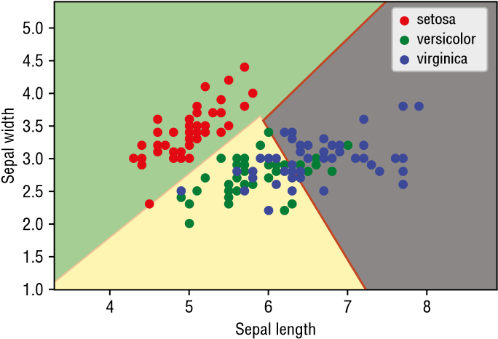

(array([0, 1, 2]), array([50, 53, 47]))

**High C Low C**

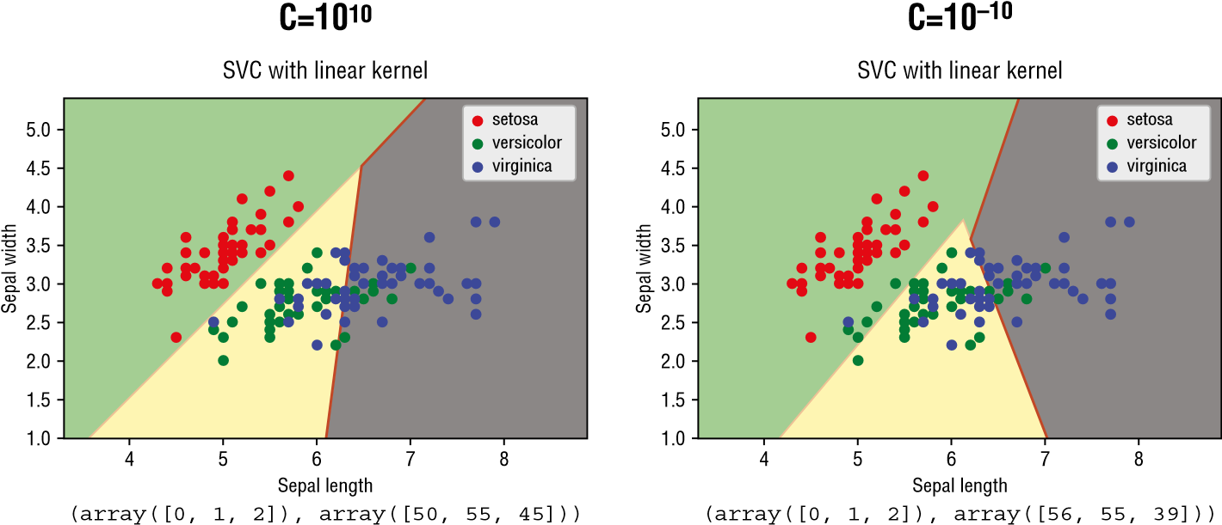

**Figure 8.22:** Using SVM with varying values of C

Note that when C is 1 or 1010, there isn’t too much difference among the classification results. However, when C is small (10–10), you can see that a number of points (belonging to “versicolor” and “virginica”) are now misclassified as “setosa.”

**TIP In short, a low C makes the decision surface smooth while trying to classify *most* points, while a high C tries to classify *all* of the points correctly.**

**Radial Basis Function (RBF) Kernel**

Besides the linear kernel that we have seen so far, there are some commonly used nonlinear kernels:

**■***Radial Basis function (RBF)*, also known as *Gaussian Kernel*

**■**Polynomial

The first, RBF, gives value to each point based on its distance from the origin or a *fixed* center, commonly on a Euclidean space. Let’s use the same example that we used in the previous section, but this time modify the kernel to use **rbf**:

**C = 1**

**clf = svm.SVC(kernel='rbf', gamma='auto', C=C).fit(X, y) title = 'SVC with RBF kernel'**

Figure 8.23 shows the same sample trained using the RBF kernel.

SVC with RBF kernel

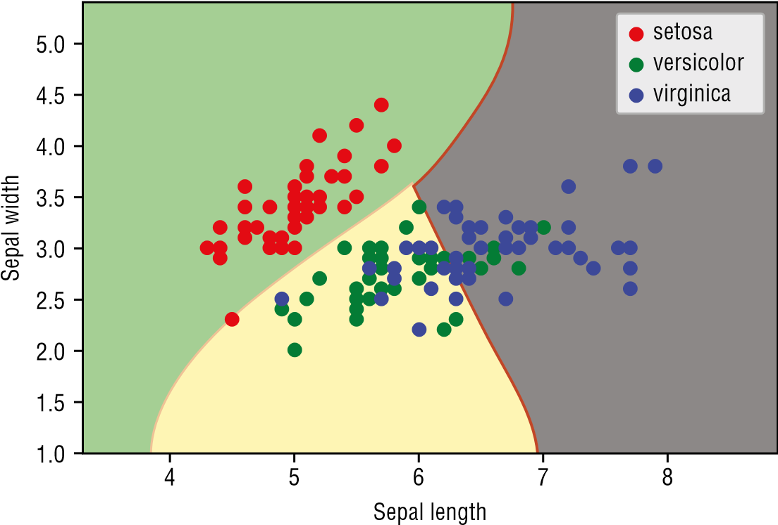

**Figure 8.23:** The Iris dataset trained using the RBF kernel

**Gamma**

If you look at the code snippet carefully, you will discover a new parameter—**gamma**. *Gamma* defines how far the influence of a single training example reaches. Consider the set of points shown in Figure 8.24. There are two classes of points—x’s and o’s.

A low Gamma value indicates that every point has a far reach (see Figure 8.25).

On the other hand, a high Gamma means that the points closest to the decision boundary have a close reach. The higher the value of Gamma, the more it will try to fit the training dataset exactly, resulting in overfitting (see Figure 8.26).

Figure 8.27 shows the classification of the points using RBF, with varying values of C and Gamma.

Note that if Gamma is high (10), overfitting occurs. You can also see from this figure that the value of C controls the smoothness of the curve.



**O**

**O**

**O**

**O**

**O**

**O**

**O**

**O**

**O**

**x**

**x**

**x**

**x**

**x**

**x**

**x**

**x**

**x**

**x**

**x**

**Figure 8.24:** A set of points belonging to two classes

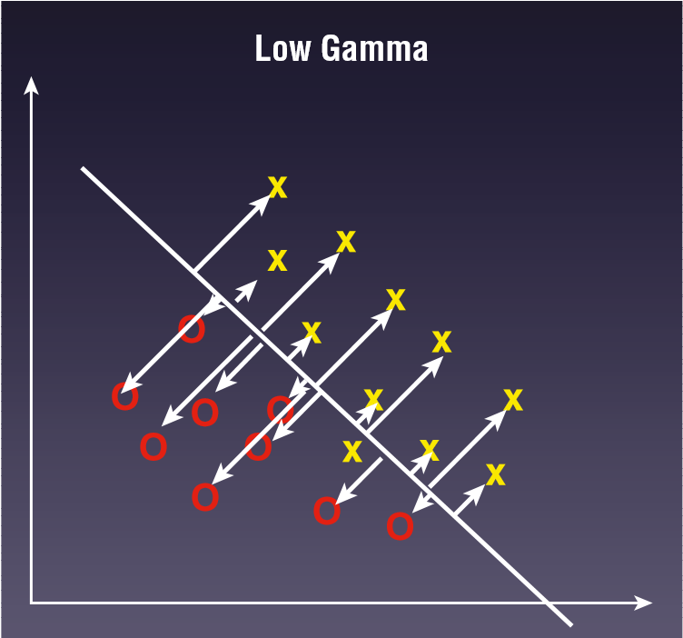

**Figure 8.25:** A low Gamma value allows every point to have equal reach

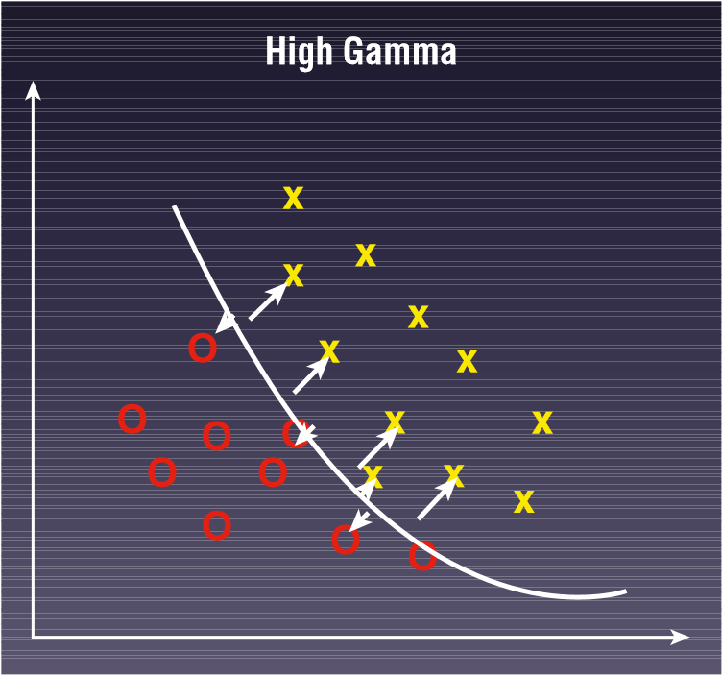

**Figure 8.26:** A high Gamma value focuses more on points close to the boundary

**Gamma = 10**

**C = 1**

SVC with RBF kernel

**Gamma = 0.1 C = 1**

SVC with RBF kernel

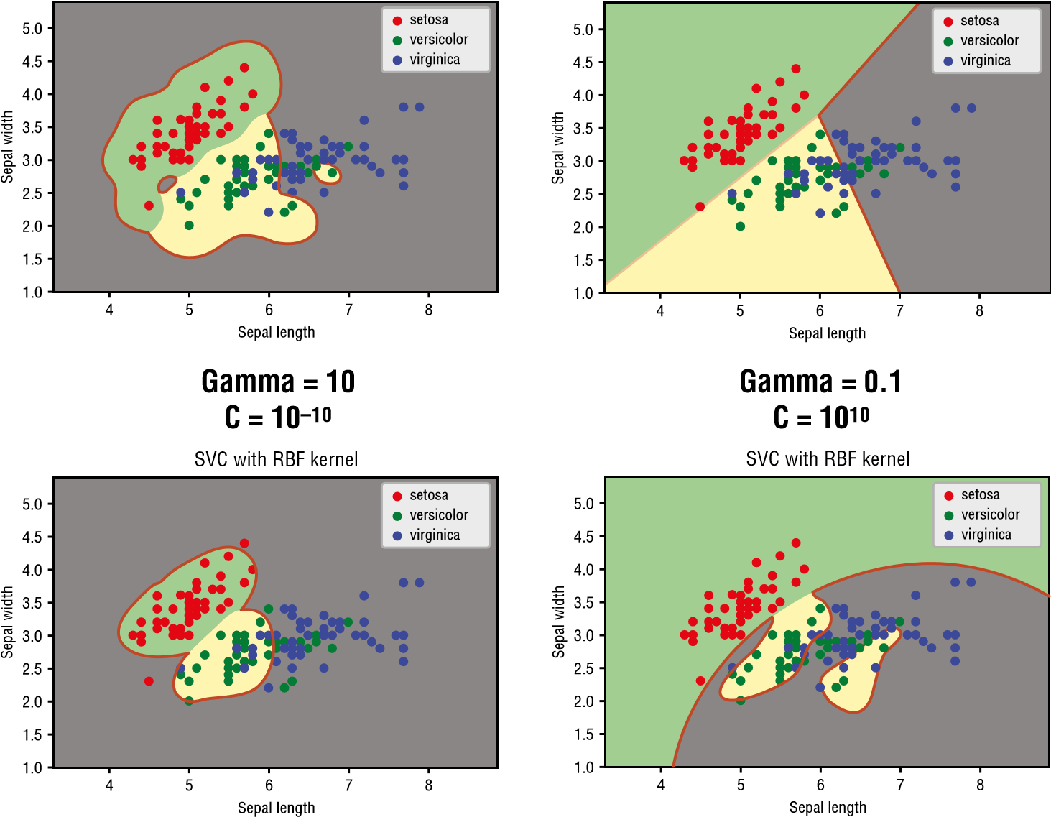

**Figure 8.27:** The effects of classifying the points using varying values of C and Gamma

**TIP To summarize, C controls the smoothness of the boundary and Gamma determines if the points are overfitted.**

**Polynomial Kernel**

Another type of kernel is called the *polynomial kernel*. A polynomial kernel of degree 1 is similar to that of the linear kernel. Higher-degree polynomial kernels afford a more flexible decision boundary. The following code snippet shows the Iris dataset trained using the polynomial kernel with degree 4:

**C = 1 # SVM regularization parameter**

**clf = svm.SVC(kernel='poly', degree=4, C=C, gamma='auto').fit(X, y) title = 'SVC with polynomial (degree 4) kernel'**

Figure 8.28 shows the dataset separated with polynomial kernels of degree 1 to 4.

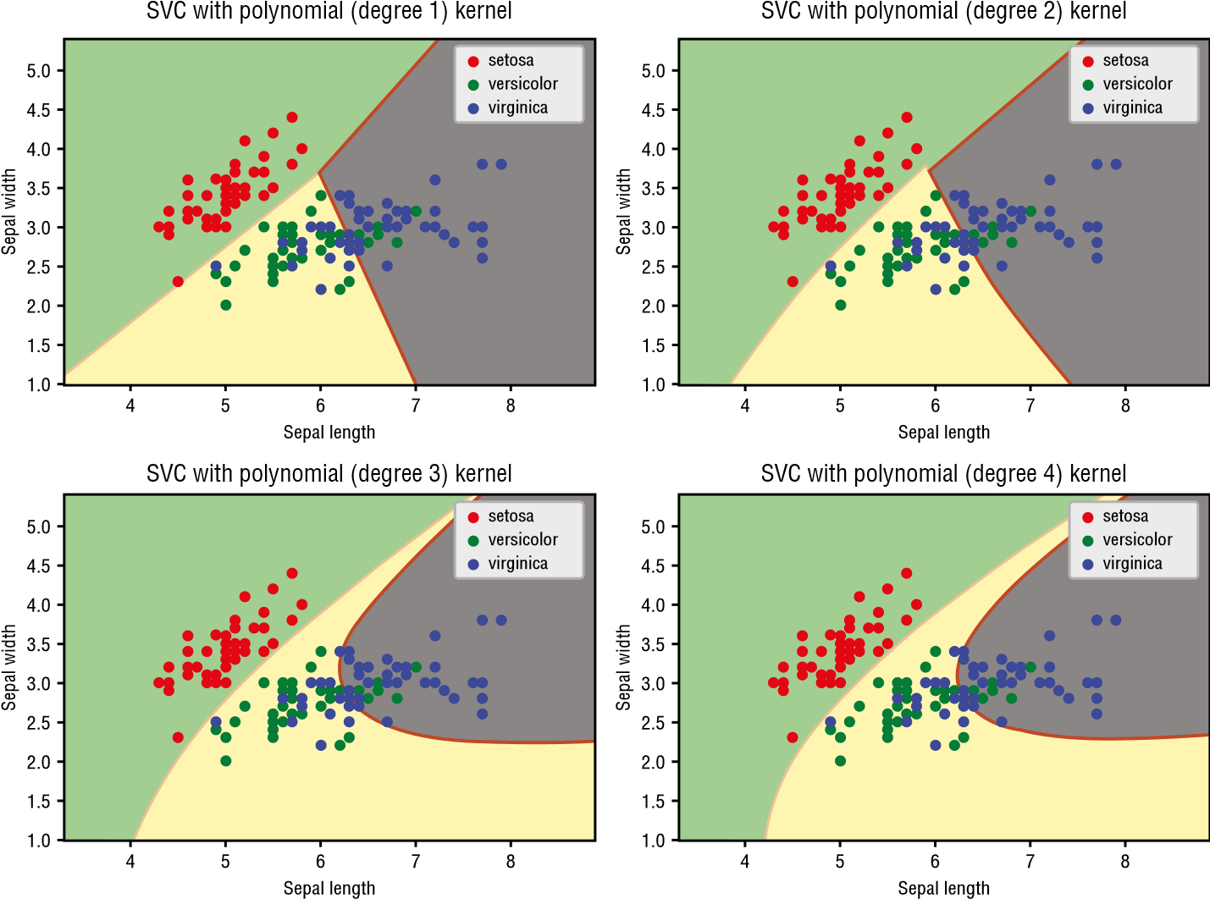

**Figure 8.28:** The classification of the Iris dataset using polynomial kernel of varying degrees

**Using SVM for Real-Life Problems**

We will end this chapter by applying SVM to a common problem in our daily lives.

Consider the following dataset (saved in a file named **house**_**sizes**_**prices**_**svm .csv**) containing the size of houses and their asking prices (in thousands) for a particular area:

**size,price,sold**

**550,50,y**

**1000,100,y**

**1200,123,y**

**1500,350,n**

**3000,200,y**

**2500,300,y**

**750, 45,y**

**1500,280,n**

**780,400,n**

**1200, 450,n**

**2750, 500,n**

The third column indicates if the house was sold. Using this dataset, you want to know if a house with a specific asking price would be able to sell.

First, let’s plot out the points:

**%matplotlib inline**

**import pandas as pd import numpy as np from sklearn import svm import matplotlib.pyplot as plt**

**import seaborn as sns; sns.set(font_scale=1.2)**

**data = pd.read_csv('house_sizes_prices_svm.csv')**

**sns.lmplot('size', 'price', data=data, hue='sold', palette='Set2', fit_reg=False, scatter_kws={"s": 50});**

Figure 8.29 shows the points plotted as a scatter plot.

100

200

300

sold

y

n

price

400

500

500 1000 1500 2000 2500 3000

size

**Figure 8.29:** Plotting the points on a scatter plot

Visually, you can see that this is a problem that can be solved with SVM’s linear kernel:

**X = data[['size','price']].values**

**y = np.where(data['sold']=='y', 1, 0) #--1 for Y and 0 for N--model = svm.SVC(kernel='linear').fit(X, y)**

With the trained model, you can now perform predictions and paint the two classes:

**#---min and max for the first feature--x_min, x_max = X[:, 0].min() - 1, X[:, 0].max() + 1**

**#---min and max for the second feature--y_min, y_max = X[:, 1].min() - 1, X[:, 1].max() + 1**

**#---step size in the mesh--h = (x_max / x_min) / 20**

**#---make predictions for each of the points in xx,yy--xx, yy = np.meshgrid(np.arange(x_min, x_max, h), np.arange(y_min, y_max, h))**

**Z = model.predict(np.c_[xx.ravel(), yy.ravel()])**

**#---draw the result using a color plot---**

**Z = Z.reshape(xx.shape)**

**plt.contourf(xx, yy, Z, cmap=plt.cm.Blues, alpha=0.3)**

**plt.xlabel('Size of house') plt.ylabel('Asking price (1000s)') plt.title("Size of Houses and Their Asking Prices")**

Figure 8.30 shows the points and the classes to which they belong.

100

200

300

sold

y

n

Asking price (1000s)

400

500

Size of Houses and Their Asking Prices

500 1000 1500 2000 2500 3000

Size of house

**Figure 8.30:** Separating the points into two classes

You can now try to predict if a house of a certain size with a specific selling price will be able to sell:

**def will_it_sell(size, price): if(model.predict([[size, price]]))==0:**

**print('Will not sell!') else:**

**print('Will sell!')**

**#---do some prediction--will_it_sell(2500, 400) # Will not sell! will_it_sell(2500, 200) # Will sell!**

**Summary**

In this chapter, you learned about how Support Vector Machines help in classification problems. You learned about the formula for finding the hyperplane, as well as the two accompanying margins. Fortunately, Scikit-learn provides the classes needed for training models using SVM, and with the parameters returned, you can plot the hyperplane and margins visually so that you can understand how SVM works. You also learned about the various kernels that you can apply to your SVM algorithms so that the dataset can be separated linearly.

|  |
| --- |
| **CHAPTER** |
| **9** |

**Supervised Learning— Classification Using K-Nearest**

**Neighbors (KNN)**

**What Is K-Nearest Neighbors?**

Up until this point, we have discussed three supervised learning algorithms: linear regression, logistics regression, and support vector machines. In this chapter, we will dive into another supervised machine learning algorithm known as *K-Nearest Neighbors (KNN)*.

KNN is a relatively simple algorithm compared to the other algorithms that we have discussed in previous chapters. It works by comparing the query instance’s distance to the other training samples and selecting the K-nearest neighbors (hence its name). It then takes the majority of these K-neighbor classes to be the prediction of the query instance.

Figure 9.1 sums this up nicely. When k = 3, the closest three neighbors of the circle are the two squares and the one triangle. Based on the simple rule of majority, the circle is classified as a square. If k = 5, then the closest five neighbors are the two squares and the three triangles. Hence, the circle is classified as a triangle.

Python® Machine Learning, First Edition. Wei-Meng Lee. **205**

© 2019 John Wiley & Sons, Inc. Published 2019 by John Wiley & Sons, Inc.

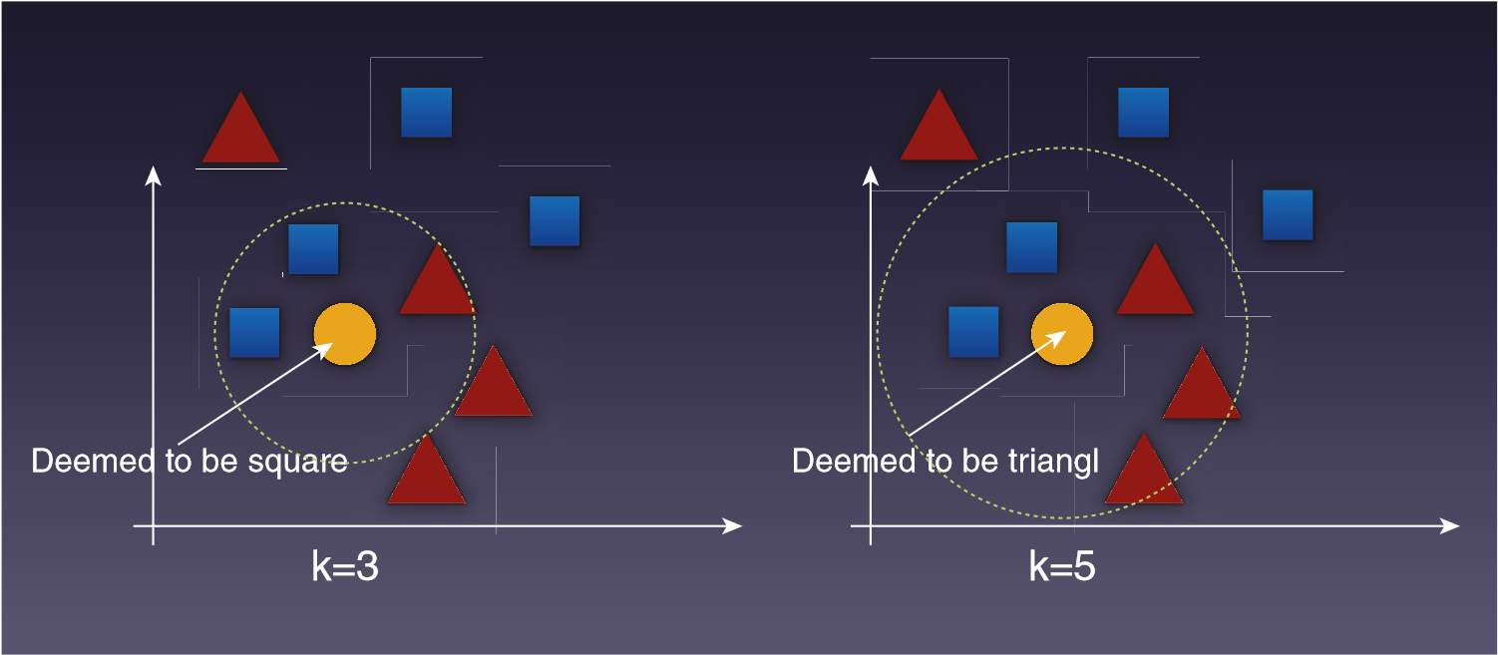

**Figure 9.1:** The classification of a point depends on the majority of its neighbors

**TIP KNN is also sometimes used for regression in addition to classification.**

**For example, it can be used to calculate the average of the numerical target of the K-nearest neighbors. For this chapter, however, we are focusing solely on its more common use as a classification algorithm.**

**Implementing KNN in Python**

Now that you have seen how KNN works, let’s try to implement KNN from scratch using Python. As usual, first let’s import the modules that we’ll need:

**import pandas as pd import numpy as np import operator import seaborn as sns import matplotlib.pyplot as plt**

***Plotting the Points***

For this example, you will use a file named **knn.csv** containing the following data:

**x,y,c 1,1,A**

**2,2,A**

**4,3,B**

**3,3,A**

**3,5,B**

**5,6,B**

**5,4,B**

**Supervised Learning—Classification Using K-Nearest Neighbors**

As we have done in the previous chapters, a good way is to plot the points using Seaborn:

**data = pd.read_csv("knn.csv") sns.lmplot('x', 'y', data=data, hue='c', palette='Set1', fit_reg=False, scatter_kws={"s": 70}) plt.show()**

Figure 9.2 shows the distribution of the various points. Points that belong to class A are displayed in red while those belonging to class B are displayed in blue.

c

A

B

1

1

2

3

4

y

5

6

2

3

x

4

5

**Figure 9.2:** Plotting the points visually

***Calculating the Distance Between the Points***

In order to find the nearest neighbor of a given point, you need to calculate the Euclidean distance between two points.

**TIP In geometry, Euclidean space encompasses the two-dimensional Euclidean plane, the three-dimensional space of Euclidean geometry, and similar spaces of higher dimension.**

Given two points, *p* p1,p2, ,pn and *q* q q1 2, ,qn , the distance between *p* and *q* is given by the following formula:

q1 p1 2 q2 p2 2 qn pn 2

Based on this formula, you can now define a function named **euclidean_ distance()** as follows:

**#---to calculate the distance between two points--def euclidean_distance(pt1, pt2, dimension):**

**distance = 0 for x in range(dimension): distance += np.square(pt1[x] - pt2[x]) return np.sqrt(distance)**

The **Euclidean_distance()** function can find the distance between two points in any dimension. For this example, the points that we are dealing with are in 2D.

***Implementing KNN***

Next, define a function named **knn()**, which takes in the training points, the test point, and the value of k:

**#---our own KNN model--def knn(training_points, test_point, k):**

**distances = {}**

**#---the number of axes we are dealing with-- dimension = test_point.shape[1]**

**#--calculating euclidean distance between each**

**# point in the training data and test data for x in range(len(training_points)): dist = euclidean_distance(test_point, training_points.iloc[x], dimension)**

**#---record the distance for each training points-- distances[x] = dist[0]**

**#---sort the distances---**

**sorted_d = sorted(distances.items(), key=operator.itemgetter(1))**

**#---to store the neighbors-- neighbors = []**

**#---extract the top k neighbors-- for x in range(k):**

**neighbors.append(sorted_d[x][0])**

**#---for each neighbor found, find out its class-- class_counter = {} for x in range(len(neighbors)):**

**#---find out the class for that particular point-- cls = training_points.iloc[neighbors[x]][-1]**

**if cls in class_counter: class_counter[cls] += 1 else:**

**class_counter[cls] = 1**

**#---sort the class_counter in descending order-- sorted_counter = sorted(class_counter.items(), key=operator.itemgetter(1), reverse=True)**

**#---return the class with the most count, as well as the**

**#neighbors found-- return(sorted_counter[0][0], neighbors)**

The function returns the class to which the test point belongs, as well as the indices of all the nearest k neighbors.

***Making Predictions***

With the **knn()** function defined, you can now make some predictions:

**#---test point--test_set = [[3,3.9]] test = pd.DataFrame(test_set) cls,neighbors = knn(data, test, 5) print("Predicted Class: " + cls)**

The preceding code snippet will print out the following output:

**Predicted Class: B**

***Visualizing Different Values of K***

It is useful to be able to visualize the effect of applying various values of k. The following code snippet draws a series of concentric circles around the test point based on the values of k, which range from 7 to 1, with intervals of –2:

**#---generate the color map for the scatter plot---**

**#---if column 'c' is A, then use Red, else use Blue--colors = ['r' if i == 'A' else 'b' for i in data['c']] ax = data.plot(kind='scatter', x='x', y='y', c = colors) plt.xlim(0,7) plt.ylim(0,7)**

**#---plot the test point---**

**plt.plot(test_set[0][0],test_set[0][1], "yo", markersize='9') for k in range(7,0,-2):**

**cls,neighbors = knn(data, test, k)**

**print("============") print("k = ", k) print("Class", cls) print("Neighbors") print(data.iloc[neighbors])**

**furthest_point = data.iloc[neighbors].tail(1)**

**#---draw a circle connecting the test point**

**# and the furthest point---**

**radius = euclidean_distance(test, furthest_point.iloc[0], 2)**

**#---display the circle in red if classification is A,**

**# else display circle in blue-- c = 'r' if cls=='A' else 'b'**

**circle = plt.Circle((test_set[0][0], test_set[0][1]), radius, color=c, alpha=0.3) ax.add_patch(circle)**

**plt.gca().set_aspect('equal', adjustable='box') plt.show()**

The preceding code snippet prints out the following output:

**============ k = 7 Class B**

**Neighbors x y c 3 3 3 A**

**4 3 5 B**

**2 4 3 B**

**6 5 4 B**

**1 2 2 A**

**5 5 6 B**

**0 1 1 A**

**============ k = 5 Class B**

**Neighbors x y c 3 3 3 A**

**4 3 5 B**

**2 4 3 B**

**6 5 4 B**

1. **2 2 A**

**============ k = 3 Class B**

**Neighbors**

**x y c 3 3 3 A**

**4 3 5 B**

1. **4 3 B**

**============ k = 1 Class A**

**Neighbors x y c 3 3 3 A**

Figure 9.3 shows the series of circles centered around the test point, with varying values of k. The innermost circle is for k = 1, with the next outer ring for k = 3, and so on. As you can see, if k = 1, the circle is red, meaning that the yellow point has been classified as class A. If the circle is blue, this means that the yellow point has been classified as class B. This is evident in the outer three circles.

1

0

2

3

4

y

5

6

7

0 1 2 3 4 5 6 7

x

**Figure 9.3:** The classification of the yellow point based on the different values of k

**Using Scikit-Learn’s KNeighborsClassifier Class for KNN**

Now that you have seen how KNN works and how it can be implemented manually in Python, let’s use the implementation provided by Scikit-learn.

The following code snippet loads the Iris dataset and plots it out using a scatter plot:

**%matplotlib inline import pandas as pd import numpy as np**

**import matplotlib.patches as mpatches from sklearn import svm, datasets import matplotlib.pyplot as plt**

**iris = datasets.load_iris()**

**X = iris.data[:, :2] # take the first two features y = iris.target**

**#---plot the points--colors = ['red', 'green', 'blue'] for color, i, target in zip(colors, [0, 1, 2], iris.target_names): plt.scatter(X[y==i, 0], X[y==i, 1], color=color, label=target)**

**plt.xlabel('Sepal length') plt.ylabel('Sepal width')**

**plt.legend(loc='best', shadow=False, scatterpoints=1)**

**plt.title('Scatter plot of Sepal width against Sepal length') plt.show()**

Scatter plot of Sepal width against Sepal length

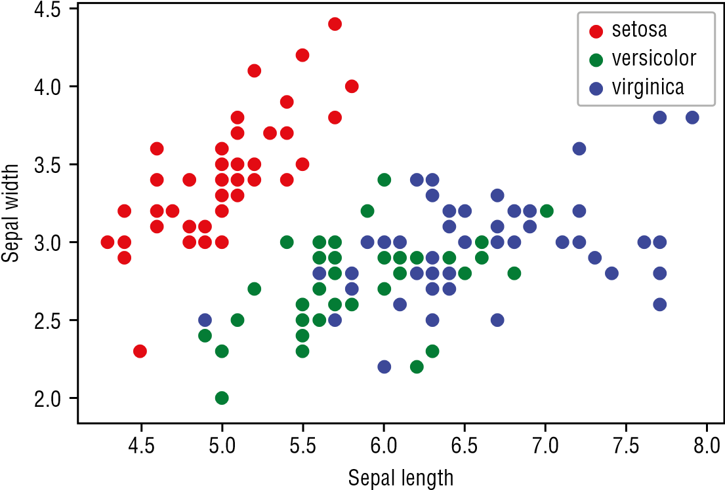

**Figure 9.4:** Plotting out the Sepal width against the Sepal length in a scatter plot

Figure 9.4 shows the scatter plot of the Sepal width against the Sepal length.

***Exploring Different Values of K***

We can now use Scikit-learn’s **KNeighborsClassifier** class to help us train a model on the Iris dataset using KNN. For a start, let’s use a k of 1:

**from sklearn.neighbors import KNeighborsClassifier**

**k = 1**

**#---instantiate learning model--knn = KNeighborsClassifier(n_neighbors=k)**

**#---fitting the model--knn.fit(X, y)**

**#---min and max for the first feature--x_min, x_max = X[:, 0].min() - 1, X[:, 0].max() + 1**

**#---min and max for the second feature--y_min, y_max = X[:, 1].min() - 1, X[:, 1].max() + 1**

**#---step size in the mesh--h = (x_max / x_min)/100**

**#---make predictions for each of the points in xx,yy--xx, yy = np.meshgrid(np.arange(x_min, x_max, h), np.arange(y_min, y_max, h))**

**Z = knn.predict(np.c_[xx.ravel(), yy.ravel()])**

**#---draw the result using a color plot---**

**Z = Z.reshape(xx.shape)**

**plt.contourf(xx, yy, Z, cmap=plt.cm.Accent, alpha=0.8)**

**#---plot the training points--colors = ['red', 'green', 'blue'] for color, i, target in zip(colors, [0, 1, 2], iris.target_names): plt.scatter(X[y==i, 0], X[y==i, 1], color=color, label=target)**

**plt.xlabel('Sepal length') plt.ylabel('Sepal width') plt.title(f'KNN (k={k})')**

**plt.legend(loc='best', shadow=False, scatterpoints=1)**

**predictions = knn.predict(X)**

**#--classifications based on predictions--print(np.unique(predictions, return_counts=True))**

The preceding code snippet creates a *meshgrid* (a rectangular grid of values) of points scattered across the x- and y-axes. Each point is then used for prediction, and the result is drawn using a color plot.

Figure 9.5 shows the classification boundary using a k of 1. Notice that for k = 1, you perform your prediction based solely on a single sample—your nearest neighbor. This makes your prediction very sensitive to all sorts of distortions, such as outliers, mislabeling, and so on. In general, setting k = 1 usually leads to *overfitting*, and as a result your prediction is usually not very accurate.

KNN (k=1)

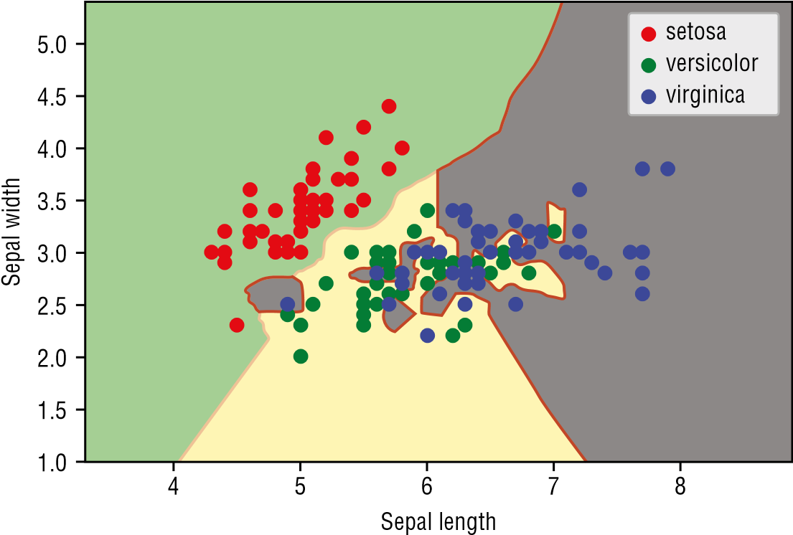

**Figure 9.5:** The classification boundary based on k = 1

**TIP *Overfitting* in machine learning means that the model you have trained fits the training data too well. This happens when all of the noises and fluctuations in your training data are picked up during the training process. In simple terms, this means that your model is trying very hard to fit all of your data perfectly. The key problem with an overfitted model is that it will not work well with new, unseen data.**

***Underfitting*, on the other hand, occurs when a machine learning model cannot accurately capture the underlying trend of the data. Specifically, the model does not fit the data well enough.**

**Figure 9.6 shows an easy way to understand overfitting, underfitting, and a generally good fit.**

y

x

Overfitting

y

x

Underfitting

y

x

Good Fit

**Figure 9.6:** Understanding the concept of overfitting, underfitting, and a good fit

For KNN, setting k to a higher value tends to make your prediction more robust against noise in your data.

Using the same code snippet, let’s vary the values of k. Figure 9.7 shows the classifications based on four different values of k.

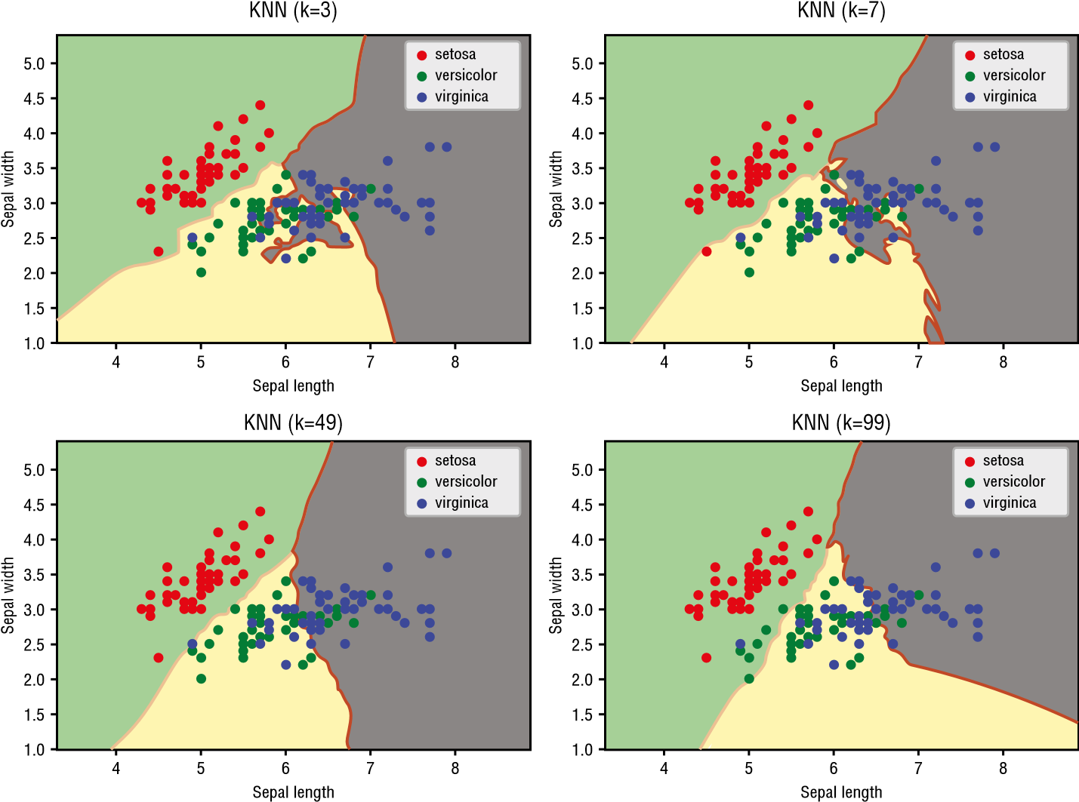

**Figure 9.7:** The effects of varying the values of k

Note that as k increases, the boundary becomes smoother. But it also means that more points will be classified incorrectly. When k increases to a large value, *underfitting* occurs.

The key issue with KNN is then how do you find out the ideal value of k to use?

***Cross-Validation***

In the previous few chapters, you have witnessed that we split our dataset into two individual sets—one for training and one for testing. However, the data in your dataset may not be distributed evenly, and as a result your test set may be too simple or too hard to predict, thereby making it very difficult to know if your model works well.

Instead of using part of the data for training and part for testing, you can split the data into *k-folds* and train the models *k* times, rotating the training and testing sets. By doing so, each data point is now being used for training and testing.

**TIP Do not confuse the** *k* **in k-folds with the** *k* **in KNN—they are not related.**

Figure 9.8 shows a dataset split into five folds (blocks). For the first run, blocks 1, 2, 3, and 4 will be used to train the model. Block 0 will be used to test the model. In the next run, blocks 0, 2, 3, and 4 will be used for training, and block 1 will be used for testing, and so on.

**Folds = 5**

|  |  |  |  |  |
| --- | --- | --- | --- | --- |
| 0 | 1 | 2 | 3 | 4 |
| 0 | 1 | 2 | 3 | 4 |
| 0 | 1 | 2 | 3 | 4 |
| 0 | 1 | 2 | 3 | 4 |
| 0 | 1 | 2 | 3 | 4 |

Run 1

Run 2

Run 3

Run 4

Run 5

|  |
| --- |
|  |
|  |

Training Set

Testing Set

**Figure 9.8:** How cross-validation works

At the end of each run, the model is scored. At the end of the k-runs, the score is averaged. This averaged score will give you a good indication of how well your algorithm performs.

**TIP The purpose of *cross-validation* is not for training your model, but rather it is for model checking. Cross-validation is useful when you need to compare different machine learning algorithms to see how they perform with the given dataset. Once the algorithm is selected, you will use all of the data for training the model.**

***Parameter-Tuning K***

Now that you understand cross-validation, let’s use it on our Iris dataset. We will train the model using all of the four features, and at the same time we shall use cross-validation on the dataset using 10 folds. We will do this for each value of k:

**from sklearn.model_selection import cross_val_score**

**#---holds the cv (cross-validates) scores--cv_scores = []**

**#---use all features---**

**X = iris.data[:, :4] y = iris.target**

**#---number of folds--folds = 10**

**#---creating odd list of K for KNN---**

**ks = list(range(1,int(len(X) * ((folds - 1)/folds))))**

**#---remove all multiples of 3--ks = [k for k in ks if k % 3 != 0]**

**#---perform k-fold cross validation--for k in ks:**

**knn = KNeighborsClassifier(n_neighbors=k)**

**#---performs cross-validation and returns the average accuracy-- scores = cross_val_score(knn, X, y, cv=folds, scoring='accuracy') mean = scores.mean() cv_scores.append(mean) print(k, mean)**

The Scikit-learn library provides the **cross_val_score()** function that performs cross-validation for you automatically, and it returns the metrics that you want (for example, accuracy).

When using cross-validation, be aware that at any one time, there will be *((folds1)/folds) * total_rows* available for training. This is because *(1/folds) * total_rows* will be used for testing.

For KNN, there are three rules to which you must adhere:

**■**The value of k cannot exceed the number of rows for training.

**■**The value of k should be an odd number (so that you can avoid situations where there is a tie between the classes) for a two-class problem.

**■**The value of k must not be a multiple of the number of classes (to avoid ties, similar to the previous point).

Hence, the ***ks*** list in the preceding code snippet will contain the following values:

**[1, 2, 4, 5, 7, 8, 10, 11, 13, 14, 16, 17, 19, 20, 22, 23, 25, 26, 28,**

**29, 31, 32, 34, 35, 37, 38, 40, 41, 43, 44, 46, 47, 49, 50, 52, 53, 55,**

**56, 58, 59, 61, 62, 64, 65, 67, 68, 70, 71, 73, 74, 76, 77, 79, 80, 82,**

**83, 85, 86, 88, 89, 91, 92, 94, 95, 97, 98, 100, 101, 103, 104, 106,**

**107, 109, 110, 112, 113, 115, 116, 118, 119, 121, 122, 124, 125, 127,**

**128, 130, 131, 133, 134]**

After the training, the ***cv_scores*** will contain a list of accuracies based on the different values of k:

1. **0.96**
2. **0.9533333333333334**
3. **0.9666666666666666**
4. **0.9666666666666668**
5. **0.9666666666666668**
6. **0.9666666666666668**
7. **0.9666666666666668**
8. **0.9666666666666668**
9. **0.9800000000000001**
10. **0.9733333333333334...**

**128 0.6199999999999999**

1. **0.6066666666666667**
2. **0.5933333333333332**
3. **0.5666666666666667**
4. **0.5533333333333333**

***Finding the Optimal K***

To find the optimal k, you simply find the value of k that gives the highest accuracy. Or, in this case, you will want to find the lowest *misclassification error (MSE)*.

The following code snippet finds the MSE for each k, and then finds the k with the lowest MSE. It then plots a line chart of MSE against k (see Figure 9.9):

**#---calculate misclassification error for each k---**

**MSE = [1 - x for x in cv_scores]**

**#---determining best k (min. MSE)--optimal_k = ks[MSE.index(min(MSE))]**

**print(f"The optimal number of neighbors is {optimal_k}")**

**#---plot misclassification error vs k--plt.plot(ks, MSE)**

**plt.xlabel('Number of Neighbors K') plt.ylabel('Misclassification Error') plt.show()**

The preceding code snippet prints out the following:

**The optimal number of neighbors is 13**

0

0.0

0.1

0.2

0.3

Misclassification Error

0.4

20

40

60

Number of Neighbors K

80

100

120

140

**Figure 9.9:** The chart of miscalculations for each k

Figure 9.10 shows the classification when k = 13.

KNN (k=13)

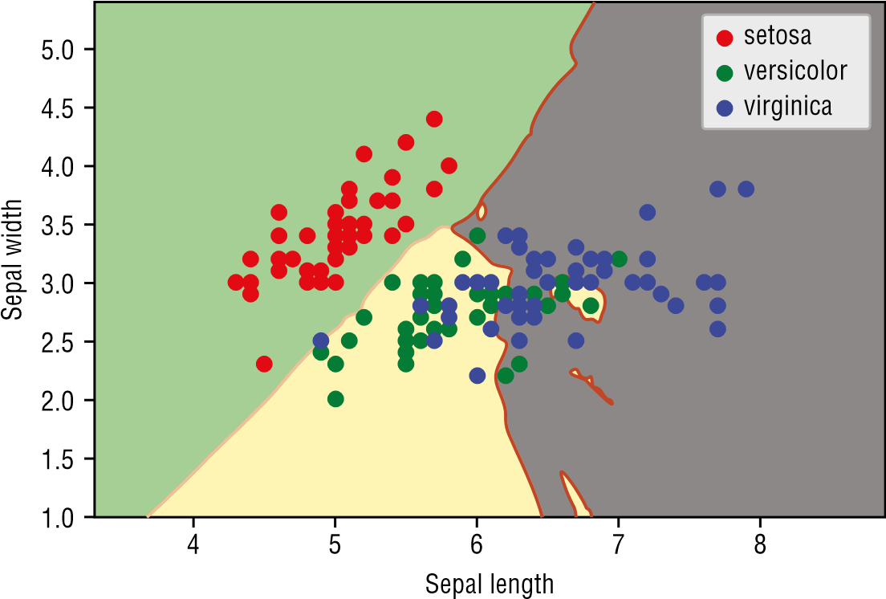

**Figure 9.10:** The optimal value of k at 13

**Summary**

Of the four algorithms that we have discussed in this book, KNN is considered one of the most straightforward. In this chapter, you learned how KNN works and how to derive the optimal k that minimizes the miscalculation of errors.

In the next chapter, you will learn a new type of algorithm—unsupervised learning. You will learn how to discover structures in your data by performing clustering using K-Means.

|  |
| --- |
| **CHAPTER** |
| **10** |

**Unsupervised Learning— Clustering Using K-Means**

**What Is Unsupervised Learning?**

So far, all of the machine learning algorithms that you have seen are supervised learning. That is, the datasets have all been labeled, classified, or categorized. Datasets that have been labeled are known as *labeled data*, while datasets that have not been labeled are known as *unlabeled data*. Figure 10.1 shows an example of labeled data.



Features

**Size of**

**House**

**Year**

**Built**

**Price**

**Sold**

*Label*

**Figure 10.1:** Labeled data

Based on the size of the house and the year in which it was built, you have the price at which the house was sold. The selling price of the house is the *label*, and your machine learning model can be trained to give the estimated worth of the house based on its size and the year in which it was built.

Python® Machine Learning, First Edition. Wei-Meng Lee. **221**

© 2019 John Wiley & Sons, Inc. Published 2019 by John Wiley & Sons, Inc.

*Unlabeled data*, on the other hand, is data without label(s). For example, Figure 10.2 shows a dataset containing a group of people’s waist circumference and corresponding leg length. Given this set of data, you can try to cluster them into groups based on the waist circumference and leg length, and from there you can figure out the average dimension in each group. This would be useful for clothing manufacturers to tailor different sizes of clothing to fit its customers.



Features

**Waist**

**Circumference**

**Leg length**

**Figure 10.2:** Unlabeled data

**Unsupervised Learning Using K-Means**

Since there is no label in unlabeled data, it is thus of interest to us that we are able to find patterns in that unlabeled data. This technique of finding patterns in unlabeled data is known as *clustering*. The main aim of clustering is to segregate groups with similar traits and assign them into groups (commonly known as *clusters*).

One of the common algorithms used for clustering is the K-Means algorithm.

K-Means clustering is a type of unsupervised learning:

**■**Used when you have unlabeled data

**■**The goal is to find groups in data, with the number of groups represented by K

The goal of K-Means clustering is to achieve the following:

**■**K centroids representing the center of the clusters

**■**Labels for the training data

In the next section, you will learn how clustering using K-Means works.

**How Clustering in K-Means Works**

Let’s walk through a simple example so that you can see how clustering using K-Means works. Suppose you have a series of unlabeled points, as shown in Figure 10.3.



**Figure 10.3:**

A set of unlabeled data points

Your job is to cluster all of these points into distinct groups so that you can discover a pattern among them. Suppose you want to separate them into two groups (that is, **K=2**). The end result would look like Figure 10.4.



2

Clusters

**Figure 10.4:** Clustering the points into two distinct clusters

First, you will randomly put K number of centroids on the graph. In Figure 10.5, since K equals 2, we will randomly put two centroids on the graph: C0 and C1. For each point on the graph, measure the distance between itself and each of the centroids. As shown in the figure, the distance (represented by **d**0) between **a** and **C**0 is shorter than the distance (represented by **d**1) between **a** and **C**1. Hence, **a** is now classified as cluster 0. Likewise, for point **b**, the distance between itself and **C**1 is shorter than the distance between itself and **C**0. Hence, point **b** is classified as cluster 1. You repeat this process for all the points in the graph.

After the first round, the points would be clustered, as shown in Figure 10.6.



**Planted centroid**

Cluster 0

Cluster 1

**Planted centroid**

**Classified as**

**cluster 0 as**

**d**

**0**

**d**

**<**

**1**

**Classified as**

**cluster 1 as**

**d**

**1**

**d**

**<**

**0**

d

0

d

0

d

1

c

0

d

1

**b**

**a**



c

1

**Figure 10.5:** Measuring the distance of each point with respect to each centroid and finding the shortest distance



**c**

**0**



**c**

**1**

**Figure 10.6:** Groupings of the points after the first round of clustering

Now take the average of all of the points in each cluster and reposition the centroids using the newly calculated average. Figure 10.7 shows the new positions of the two centroids.

You now measure the distance between each of the old centroids and the new centroids (see Figure 10.8). If the distance is 0, that means that the centroid did not change position and hence the centroid is found. You repeat the entire process until all the centroids do not change position anymore.



New centroids

Old centroids

**c**

**0**

**c**

**0**

**c**

**1**



**c**

**1**

**Figure 10.7:** Repositioning the centroids by taking the average of all the points in each cluster



**c**

**0**

**c**

**0**

**c**

**1**



**c**

**1**

**Figure 10.8:** Measuring the distance between each centroid; if the distance is 0, the centroid is found

**Implementing K-Means in Python**

Now that you have a clear picture of how K-Means works, it is useful to implement this using Python. You will first implement K-Means using Python, and then see how you can use Scikit-learn’s implementation of K-Means in the next section.

Suppose you have a file named **kmeans.csv** with the following content:

**x,y 1,1**

**2,2**

**2,3**

**1,4**

**3,3**

**6,7**

**7,8**

**6,8**

**7,6**

**6,9**

**2,5**

**7,8**

**8,9**

**6,7**

**7,8**

**3,1**

**8,4**

**8,6**

**8,9**

Let’s first import all of the necessary libraries:

**%matplotlib inline import numpy as np import pandas as pd import matplotlib.pyplot as plt**

Then load the CSV file into a Pandas dataframe, and plot a scatter plot showing the points:

**df = pd.read_csv("kmeans.csv") plt.scatter(df['x'],df['y'], c='r', s=18)** Figure 10.9 shows the scatter plot with the points.

1

2

3

4

5

6

7

8

9

1

2

3

4

5

6

7

8

**Figure 10.9:** The scatter plot showing all the points

You can now generate some random centroids. You also need to decide on the value of K. Let’s assume K to be 3 for now. You will learn how to d etermine the optimal K later in this chapter. The following code snippet generates three random centroids and marks them on the scatter plot:

**#---let k assume a value--k = 3**

**#---create a matrix containing all points---**

**X = np.array(list(zip(df['x'],df['y'])))**

**#---generate k random points (centroids)---**

**Cx = np.random.randint(np.min(X[:,0]), np.max(X[:,0]), size = k)**

**Cy = np.random.randint(np.min(X[:,1]), np.max(X[:,1]), size = k)**

**#---represent the k centroids as a matrix---**

**C = np.array(list(zip(Cx, Cy)), dtype=np.float64) print(C)**

**#---plot the orginal points as well as the k centroids--plt.scatter(df['x'], df['y'], c='r', s=8) plt.scatter(Cx, Cy, marker='*', c='g', s=160) plt.xlabel("x") plt.ylabel("y")**

Figure 10.10 shows the points, as well as the centroids on the scatter plot.

0

2

4

y

6

8

1

0

2

3

4

5

6

7

8

x

**Figure 10.10:** The scatter plot with the points and the three random centroids

Now comes the real meat of the program. The following code snippet implements the K-Means algorithm that we discussed earlier in the “How Clustering in K-Means Works” section:

**from copy import deepcopy**

**#---to calculate the distance between two points--def euclidean_distance(a, b, ax=1):**

**return np.linalg.norm(a - b, axis=ax)**

**#---create a matrix of 0 with same dimension as C (centroids)---**

**C_prev = np.zeros(C.shape)**

**#---to store the cluster each point belongs to--clusters = np.zeros(len(X))**

**#---C is the random centroids and C_prev is all 0s---**

**#---measure the distance between the centroids and C_prev--distance_differences = euclidean_distance(C, C_prev)**

**#---loop as long as there is still a difference in**

**# distance between the previous and current centroids--while distance_differences.any() != 0: #---assign each value to its closest cluster-- for i in range(len(X)):**

**distances = euclidean_distance(X[i], C)**

**#---returns the indices of the minimum values along an axis-- cluster = np.argmin(distances) clusters[i] = cluster**

**#---store the prev centroids---**

**C_prev = deepcopy(C)**

**#---find the new centroids by taking the average value-- for i in range(k): #---k is the number of clusters---**

**#---take all the points in cluster i---**

**points = [X[j] for j in range(len(X)) if clusters[j] == i] if len(points) != 0:**

**C[i] = np.mean(points, axis=0)**

**#---find the distances between the old centroids and the new centroids---**

**distance_differences = euclidean_distance(C, C_prev)**

**#---plot the scatter plot--colors = ['b','r','y','g','c','m'] for i in range(k):**

**points = np.array([X[j] for j in range(len(X)) if clusters[j] == i]) if len(points) > 0:**

**plt.scatter(points[:, 0], points[:, 1], s=10, c=colors[i]) else:**

**# this means that one of the clusters has no points print("Plesae regenerate your centroids again.")**

**plt.scatter(points[:, 0], points[:, 1], s=10, c=colors[i]) plt.scatter(C[:, 0], C[:, 1], marker='*', s=100, c='black')**

With the preceding code snippet, the centroids would now be computed and displayed on the scatter plot, as shown in Figure 10.11.

1

2

3

4

5

6

7

8

9

1

2

3

4

5

6

7

8

**Figure 10.11:** The scatter plot showing the clustering of the points as well as the new- found centroids

**TIP Due to the locations of the points, it is possible that the centroids you obtained may not be identical to the one shown in Figure 10.11.**

**Also, there may be cases where after the clustering, there are no points belonging to a particular centroid. In this case, you have to regenerate the centroid and perform the clustering again.**

You can now also print out the clusters to which each point belongs:

**for i, cluster in enumerate(clusters): print("Point " + str(X[i]), "Cluster " + str(int(cluster)))**

You should be able to see the following output:

**Point [1 1] Cluster 2**

**Point [2 2] Cluster 2**

**Point [2 3] Cluster 2**

**Point [1 4] Cluster 2**

**Point [3 3] Cluster 2**

**Point [6 7] Cluster 1**

**Point [7 8] Cluster 1**

**Point [6 8] Cluster 1**

**Point [7 6] Cluster 0**

**Point [6 9] Cluster 1**

**Point [2 5] Cluster 2**

**Point [7 8] Cluster 1**

**Point [8 9] Cluster 1**

**Point [6 7] Cluster 1**

**Point [7 8] Cluster 1**

**Point [3 1] Cluster 2**

**Point [8 4] Cluster 0**

**Point [8 6] Cluster 0**

**Point [8 9] Cluster 1**

**TIP The cluster numbers that you will see may not be the same as the ones shown in the preceding code.**

More importantly, you want to know the location of each centroid. You can do so via printing out the value of **C**:

**print(C)**

**'''**

**[[ 7.66666667 5.33333333]**

**[ 6.77777778 8.11111111]**

**[ 2. 2.71428571]]**

**'''**

**Using K-Means in Scikit-learn**

Rather than implementing your own K-Means algorithm, you can use the **KMeans** class in Scikit-learn to do clustering. Using the same dataset that you used in the previous section, the following code snippet creates an instance of the **KMeans** class with a cluster size of 3:

**#---using sci-kit-learn--from sklearn.cluster import KMeans k=3 kmeans = KMeans(n_clusters=k)**

You can now train the model using the **fit()** function: **kmeans = kmeans.fit(X)**

To assign a label to all of the points, use the **predict()** function: **labels = kmeans.predict(X)**

To get the centroids, use the **cluster**_**centers** property: **centroids = kmeans.cluster_centers_**

Let’s print the clusters label and centroids and see what you got:

**print(labels) print(centroids)**

You should see the following:

**[1 1 1 1 1 0 0 0 2 0 1 0 0 0 0 1 2 2 0]**

**[[ 6.77777778 8.11111111]**

**[ 2. 2.71428571]**

**[ 7.66666667 5.33333333]]**

**TIP Due to the locations of the points, it is possible that the centroids you obtained may not be identical to the one shown here in the text.**

Let’s now plot the points and centroids on a scatter plot:

**#---map the labels to colors--c = ['b','r','y','g','c','m'] colors = [c[i] for i in labels]**

**plt.scatter(df['x'],df['y'], c=colors, s=18) plt.scatter(centroids[:, 0], centroids[:, 1], marker='*', s=100, c='black')**

Figure 10.12 shows the result.

Using the model that you have just trained, you can use it to predict the cluster to which a point will belong using the **predict()** function:

**#---making predictions--cluster = kmeans.predict([[3,4]])[0] print(c[cluster]) # r**

**cluster = kmeans.predict([[7,5]])[0] print(c[cluster]) # y**

The preceding statements print the cluster in which a point is located using its color: **r** for red and **y** for yellow.

1

2

3

4

5

6

7

8

9

1

2

3

4

5

6

7

8

**Figure 10.12:** Using the KMeans class in Scikit-learn to do the clustering

**TIP You may get different colors for the predicted points, which is perfectly fine.**

**Evaluating Cluster Size Using the Silhouette Coefficient**

So far, we have been setting K to a fixed value of 3. How do you ensure that the value of K that you have set is the optimal number for the number of clusters? With a small dataset, it is easy to deduce the value of K by visual inspection; however, with a large dataset, it will be a more challenging task. Also, regardless of the dataset size, you will need a scientific way to prove that the value of K you have selected is the optimal one. To do that, you will use the Silhouette Coefficient.

The *Silhouette Coefficient* is a measure of the quality of clustering that you have achieved. It measures cluster cohesion, which is the space between clusters. The range of values for the Silhouette Coefficient is between –1 and 1. The Silhouette Coefficient formula is given as:

1 – a / b where:

**■*a*** is the average distance of a point to all other points in the same cluster; if ***a*** is small, cluster cohesion is good, as all of the points are close together

**■*b*** is the *lowest* average distance of a point to all other points in the closest cluster; if ***b*** is large, cluster separation is good, as the nearest cluster is far apart

If ***a*** is small and ***b*** is large, the Silhouette Coefficient is high. The value of k that yields the highest Silhouette Coefficient is known as the *optimal K*.

***Calculating the Silhouette Coefficient***

Let’s walk through an example of how to calculate the Silhouette Coefficient of a point. Consider the seven points and the clusters (**K=3**) to which they belong, as shown in Figure 10.13.



Cluster 1

Cluster 0

Cluster 2

**(12,12)**

**(10,13)**

**(10,10)**

**(25,20)**

**(25,5)**

**(25,4)**

**(26,21)**

**Figure 10.13:** The set of points and their positions

Let’s calculate the Silhouette Coefficient of a particular point and walk through the math. Consider the point (10,10) in cluster 0:

**■**Calculate its average distance to all other points in the same cluster:

**■**(10,10) – (12,12) = √8 = 2.828

**■**(10,10) – (10,13) = √9 = 3

**■**Average: (2.828 + 3.0) / 2 = 2.914

**■**Calculate its average distance to all other points in cluster 1:

**■**(10,10) – (25,20) = √325 = 18.028 **■**(10,10) – (26,21) = √377 = 19.416

**■**Average: (18.028 + 19.416) / 2 = 18.722

**■**Calculate its average distance to all other points in cluster 2:

**■**(10,10) – (25,5) = √250 = 15.811

**■**(10,10) – (25,4) = √261= 16.155

**■**Average: (15.811 + 16.156) / 2 = 15.983

**■**Minimum average distance from (10,10) to all the points in cluster 1 and 2 is **min(18.722,15.983)** = 15.983

Therefore, the Silhouette Coefficient of point (10,10) is 1 – (a/b) = 1 – (2.914/15.983) = 0.817681—and this is just for one point in the dataset. You need to calculate the Silhouette Coefficients of the other six points in the dataset. Fortunately, Scikit-learn contains the **metrics** module that automates this process.

Using the **kmean.csv** example that you used earlier in this chapter, the following code snippet calculates the Silhouette Coefficient of all of the 19 points in the dataset and prints out the average of the Silhouette Coefficient:

**from sklearn import metrics**

**silhouette_samples = metrics.silhouette_samples(X, kmeans.labels_) print(silhouette_samples)**

**print("Average of Silhouette Coefficients for k =", k) print("============================================") print("Silhouette mean:", silhouette_samples.mean())** You should see the following results:

**[ 0.67534567 0.73722797 0.73455072 0.66254937 0.6323039 0.33332111**

**0.63792468 0.58821402 0.29141777 0.59137721 0.50802377 0.63792468**

**0.52511161 0.33332111 0.63792468 0.60168807 0.51664787 0.42831295**

**0.52511161]**

**Average of Silhouette Coefficients for k = 3**

**============================================**

**Silhouette mean: 0.55780519852**

In the preceding statements, you used the **metrics.silhouette**_**samples()** function to get an array of Silhouette Coefficients for the 19 points. You then called the **mean()** function on the array to get the average Silhouette Coefficient. If you are just interested in the average Silhouette coefficient and not the Silhouette Coefficient for the individual points, you can simply call the **metrics .silhouette**_**score()** function, like this:

**print("Silhouette mean:", metrics.silhouette_score(X, kmeans.labels_)) # Silhouette mean: 0.55780519852**

***Finding the Optimal K***

Now that you have seen how to calculate the mean Silhouette Coefficient for a dataset with K clusters, what you want to do next is to find the optimal K that gives you the highest average Silhouette Coefficient. You can start with a cluster size of 2, up to the cluster size of one less than the size of the dataset. The following code snippet does just that:

**silhouette_avgs = [] min_k = 2**

**#---try k from 2 to maximum number of labels--for k in range(min_k, len(X)):**

**kmean = KMeans(n_clusters=k).fit(X) score = metrics.silhouette_score(X, kmean.labels_) print("Silhouette Coefficients for k =", k, "is", score) silhouette_avgs.append(score)**

**f, ax = plt.subplots(figsize=(7, 5)) ax.plot(range(min_k, len(X)), silhouette_avgs)**

**plt.xlabel("Number of clusters") plt.ylabel("Silhouette Coefficients")**

**#---the optimal k is the one with the highest average silhouette---**

**Optimal_K = silhouette_avgs.index(max(silhouette_avgs)) + min_k print("Optimal K is ", Optimal_K)**

The code snippet will print out something similar to the following:

**Silhouette Coefficients for k = 2 is 0.689711206994**

**Silhouette Coefficients for k = 3 is 0.55780519852**

**Silhouette Coefficients for k = 4 is 0.443038181464**

**Silhouette Coefficients for k = 5 is 0.442424857695**

**Silhouette Coefficients for k = 6 is 0.408647742839**

**Silhouette Coefficients for k = 7 is 0.393618055172**

**Silhouette Coefficients for k = 8 is 0.459039364508**

**Silhouette Coefficients for k = 9 is 0.447750636074**

**Silhouette Coefficients for k = 10 is 0.512411340842**

**Silhouette Coefficients for k = 11 is 0.469556467119**

**Silhouette Coefficients for k = 12 is 0.440983139813**

**Silhouette Coefficients for k = 13 is 0.425567707244**

**Silhouette Coefficients for k = 14 is 0.383836485201**

**Silhouette Coefficients for k = 15 is 0.368421052632**

**Silhouette Coefficients for k = 16 is 0.368421052632**

**Silhouette Coefficients for k = 17 is 0.368421052632**

**Silhouette Coefficients for k = 18 is 0.368421052632**

**Optimal K is 2**

As you can see from the output, the optimal K is 2. Figure 10.14 shows the chart of the Silhouette Coefficients plotted against the number of clusters (k).

0.40

0.45

0.50

Silhouette Coefficients

0.55

0.60

0.65

0.70

2

4

6

8

10

Number of clusters

12

14

16

18

**Figure 10.14:** The chart showing the various values of K and their corresponding Silhouette Coefficients

**Using K-Means to Solve Real-Life Problems**

Suppose you are a clothing designer, and you have been tasked with designing a new series of Bermuda shorts. One of the design problems is that you need to come up with a series of sizes so that it can fit most people. Essentially, you need to have a series of sizes of people with different:

**■**Waist Circumference

**■**Upper Leg Length

So, how do you find the right combination of sizes? This is where the K-Means algorithm comes in handy. The first thing you need to do is to get ahold of a dataset containing the measurements of a group of people (of a certain age range). Using this dataset, you can apply the K-Means algorithm to group these people into clusters based on the specific measurement of their body parts. Once the clusters are found, you would now have a very clear picture of the sizes for which you need to design.

For the dataset, you can use the Body Measurement dataset from **https:// data.world/rhoyt/body-measurements**. This dataset has 27 columns and 9338 rows. Among the 27 columns, two columns are what you need:

**BMXWAIST:** Waist Circumference (cm) **BMXLEG:** Upper Leg Length (cm)

For this example, assume that the dataset has been saved locally with the filename **BMX**_**G.csv**.

**Importing the Data**

First, import the data into a Pandas dataframe:

**%matplotlib inline import numpy as np import pandas as pd**

**df = pd.read_csv("BMX_G.csv")**

Examine its shape, and you should see 9338 rows and 27 columns:

**print(df.shape) # (9338, 27)**

**Cleaning the Data**

The dataset contains a number of missing values, so it is important to clean the data. To see how many empty fields each column contains, use the following statement: **df.isnull().sum()**

You should see the following:

**Unnamed: 0 0 seqn 0 bmdstats 0 bmxwt 95 bmiwt 8959 bmxrecum 8259 bmirecum 9307 bmxhead 9102 bmihead 9338 bmxht 723 bmiht 9070 bmxbmi 736 bmdbmic 5983 bmxleg 2383 bmileg 8984 bmxarml 512 bmiarml 8969 bmxarmc 512 bmiarmc 8965 bmxwaist 1134 bmiwaist 8882 bmxsad1 2543 bmxsad2 2543 bmxsad3 8940 bmxsad4 8940 bmdavsad 2543 bmdsadcm 8853 dtype: int64**

Observe that the column **bmxleg** has 2383 missing values and **bmxwaist** has 1134 missing values, so you would need to remove them as follows:

**df = df.dropna(subset=['bmxleg','bmxwaist']) # remove rows with NaNs print(df.shape) # (6899, 27)**

After removing the **bmxleg** and **bmxwaist** columns with missing values, there are now 6899 rows remaining.

**Plotting the Scatter Plot**

With the data cleaned, let’s plot a scatter plot showing the distribution in upper leg length and waist circumference:

**import matplotlib.pyplot as plt**

**plt.scatter(df['bmxleg'],df['bmxwaist'], c='r', s=2) plt.xlabel("Upper leg Length (cm)") plt.ylabel("Waist Circumference (cm)")** Figure 10.15 shows the scatter plot.

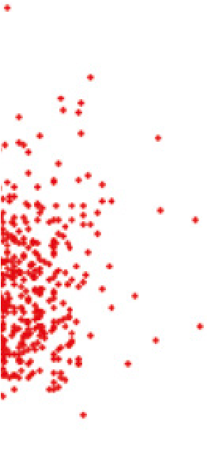

W

aist Cir

cumference (cm)

60

80

100

120

140

160

180

25

30

35

40

Upper leg Length (cm)

45

50

**Figure 10.15:** The scatter plot showing the distribution of waist circumference and upper leg length

**Clustering Using K-Means**

Assume that you want to create two sizes of Bermuda shorts. In this case, you would like to cluster the points into two clusters; that is, **K=2**. Again, we can use Scikit-learn’s **KMeans** class for this purpose:

**#---using sci-kit-learn--from sklearn.cluster import KMeans**

**k = 2**

**X = np.array(list(zip(df['bmxleg'],df['bmxwaist'])))**

**kmeans = KMeans(n_clusters=k) kmeans = kmeans.fit(X) labels = kmeans.predict(X) centroids = kmeans.cluster_centers_**

**#---map the labels to colors--c = ['b','r','y','g','c','m'] colors = [c[i] for i in labels]**

**plt.scatter(df['bmxleg'],df['bmxwaist'], c=colors, s=2) plt.scatter(centroids[:, 0], centroids[:, 1], marker='*', s=100, c='black')**

Figure 10.16 shows the points separated into two clusters, red and blue, together with the two centroids.

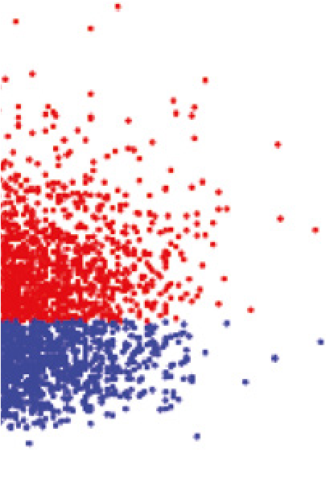

60

80

100

120

140

160

180

25

30

35

40

45

50

**Figure 10.16:** Clustering the points into two clusters

For you, the most important information is the value of the two centroids: **print(centroids)**

You should get the following:

**[[ 37.65663043 77.84326087]**

**[ 38.81870146 107.9195713 ]]**

This means that you can now design your Bermuda shorts with the following dimensions:

**■**Waist 77.8 cm, upper leg length 37.7 cm

**■**Waist 107.9 cm, upper leg length 38.8 cm

**Finding the Optimal Size Classes**

Before deciding on the actual different sizes to make, you wanted to see if the **K=2** is the optimal one, hence you try out different values of K from 2 to 10 and look for the optimal K:

**from sklearn import metrics**

**silhouette_avgs = [] min_k = 2**

**#---try k from 2 to maximum number of labels--for k in range(min_k, 10):**

**kmean = KMeans(n_clusters=k).fit(X) score = metrics.silhouette_score(X, kmean.labels_) print("Silhouette Coefficients for k =", k, "is", score) silhouette_avgs.append(score)**

**#---the optimal k is the one with the highest average silhouette---**

**Optimal_K = silhouette_avgs.index(max(silhouette_avgs)) + min_k print("Optimal K is", Optimal_K)** The results are as shown here:

**Silhouette Coefficients for k = 2 is 0.516551581494**

**Silhouette Coefficients for k = 3 is 0.472269050688**

**Silhouette Coefficients for k = 4 is 0.436102446644**

**Silhouette Coefficients for k = 5 is 0.418064636123**

**Silhouette Coefficients for k = 6 is 0.392927895139**

**Silhouette Coefficients for k = 7 is 0.378340717032**

**Silhouette Coefficients for k = 8 is 0.360716292593**

**Silhouette Coefficients for k = 9 is 0.341592231958**

**Optimal K is 2**

The result confirms that the optimal K is 2. That is, you should have two different sizes for the Bermuda shorts that you are designing.

However, the company wanted you to have more sizes so that it can accommodate a wider range of customers. In particular, the company feels that four sizes would be a better decision. To do so, you just need to run the **KMeans** code snippet that you saw in the “Clustering Using K-Means” section and set **k** **=4**.

You should now see the clusters as shown in Figure 10.17.

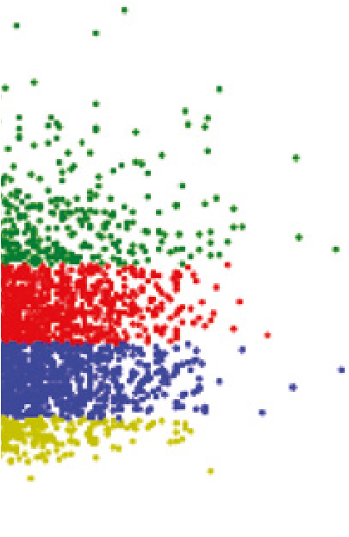

60

80

100

120

140

160

180

25

30

35

40

45

50

**Figure 10.17:** Clustering the points into four clusters

The centroids locations are as follows:

**[[ 38.73004292 85.05450644]**

**[ 38.8849217 102.17011186]**

**[ 36.04064872 67.30131125]**

**[ 38.60124294 124.07853107]]**

This means that you can now design your Bermuda shorts with the following dimensions:

**■**Waist 67.3 cm, upper leg length 36.0 cm

**■**Waist 85.1 cm, upper leg length 38.7 cm

**■**Waist 102.2 cm, upper leg length 38.9 cm

**■**Waist 124.1 cm, upper leg length 38.6 cm

**Summary**

In this chapter, you learned about unsupervised learning. Unsupervised learning is a type of machine learning technique that allows you to find patterns in data. In unsupervised learning, the data that is used by the algorithm (for example, K-Means, as discussed in this chapter) is not labeled, and your role is to discover its hidden structures and assign labels to them.

|  |
| --- |
| **CHAPTER** |
| **11**  **Studio** |

**Using Azure Machine Learning**

**What Is Microsoft Azure Machine Learning Studio?**

*Microsoft Azure Machine Learning Studio* (henceforth referred to as *MAML*) is an online collaborative, drag-and-drop tool for building machine learning models. Instead of implementing machine learning algorithms in languages like Python or R, MAML encapsulates the most-commonly used machine learning algorithms as modules, and it lets you build learning models visually using your dataset. This shields the beginning data science practitioners from the details of the algorithms, while at the same time offering the ability to fine-tune the hyperparameters of the algorithm for advanced users. Once the learning model is tested and evaluated, you can publish your learning models as web services so that your custom apps or BI tools, such as Excel, can consume it. What’s more, MAML supports embedding your Python or R scripts within your learning models, giving advanced users the opportunity to write custom machine learning algorithms.

In this chapter, you will take a break from all of the coding that you have been doing in the previous few chapters. Instead of implementing machine learning using Python and Scikit-learn, you will take a look at how to use the MAML to perform machine learning visually using drag-and-drop.

Python® Machine Learning, First Edition. Wei-Meng Lee. **243**

© 2019 John Wiley & Sons, Inc. Published 2019 by John Wiley & Sons, Inc.

**An Example Using the Titanic Experiment**

Now that you have a good sense of what machine learning is and what it can do, let’s get started with an experiment using MAML. For this experiment, you will be using a classic example in machine learning—predicting the survival of a passenger on the Titanic.

In case you are not familiar with the Titanic, on April 15, 1912, during her maiden voyage, the Titanic sank after colliding with an iceberg, killing 1,502 out of 2,224 passengers and crew. While the main reason for the deaths was due to insufficient lifeboats, of those who survived, most of them were women, children, and the upper-class. As such, this presents a very interesting experiment in machine learning. If we are given a set of data points, containing the various profiles of passengers (such as gender, cabin class, age, and so forth) and whether they survived the sinking, it would be interesting for us to use machine learning to predict the survivability of a passenger based on his/her profile.

Interestingly, you can get the Titanic data from Kaggle (**https://www.kaggle .com/c/titanic/data**). Two sets of data are provided (see Figure 11.1):

**■**Training set

**■**

Testing set



**Figure 11.1:** You can download the training and testing datasets from Kaggle

You use the training set to train your learning model so that you can use it to make predictions. Once your learning model is trained, you will make use of the testing set to predict the survivability of passengers.

Because the testing test does not contain a label specifying if a passenger survived, we will not use it for this experiment. Instead, we will only use the training set for training and testing our model.

Once the training set is downloaded, examine its contents (see Figure 11.2).

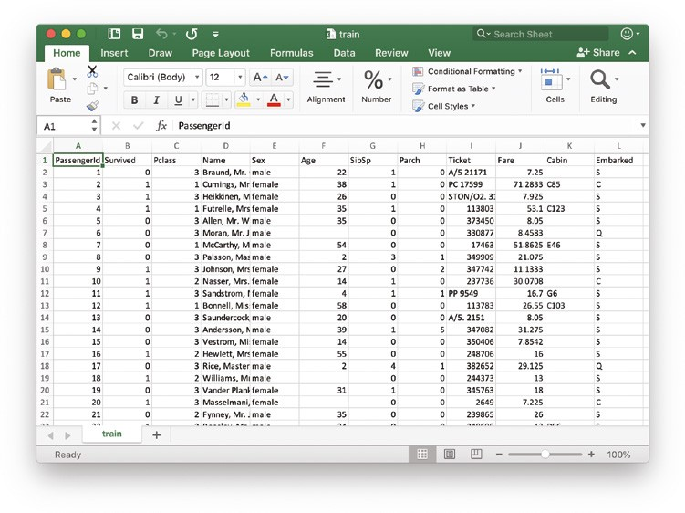

**Figure 11.2:** Examining the data in Excel

The training set should have the following fields:

**PassengerId:** A running number indicating the row of records.

**Survived:** If the particular passenger survived the sinking. This is the label of the dataset for our experiment.

**Pclass:** Ticket class that the passenger is holding.

**Name:** Name of the passenger.

**Sex:** Gender of the passenger.

**Age:** Age of the passenger.

**SibSp:** Number of siblings/spouses aboard the Titanic. **Parch:** Number of parents/children aboard the Titanic.

**Ticket:** Ticket number.

**Fare:** Fare paid by the passenger.

**Cabin:** Cabin number of the passenger.

**Embarked:** Place of embarkation. Note that C = Cherbourg, Q = Queenstown, and S = Southampton.

**Using Microsoft Azure Machine Learning Studio**

We are now ready to load the data into MAML. Using your web browser, navigate to **http://studio.azureml.net**, and click the “Sign up here” link (see Figure 11.3).



**Figure 11.3:** Click the “Sign up here” link for first-time Azure Machine Learning users

If you just want to experience MAML without any financial commitment, choose the Free Workspace option and click Sign In (see Figure 11.4).



**Figure 11.4:** You can choose from the various options available to use MAML

Once you are signed in, you should see a list of items on the left side of the page (see Figure 11.5). I will highlight some of the items on this panel as we move along.

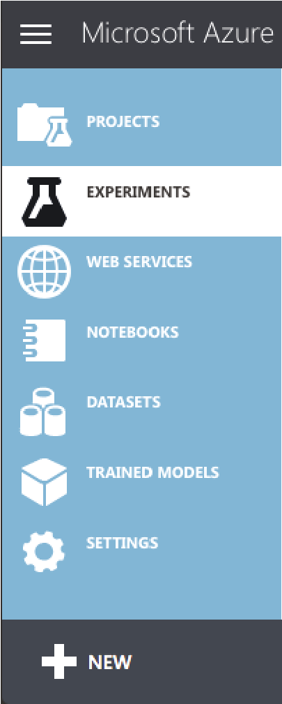

**Figure 11.5:** The left panel of MAML

***Uploading Your Dataset***

To create learning models, you need datasets. For this example, we will use the dataset that you have just downloaded.

Click the **+** NEW item located at the bottom-left of the page. Select DATASET on the left (see Figure 11.6), and then click the item on the right labeled FROM LOCAL FILE.

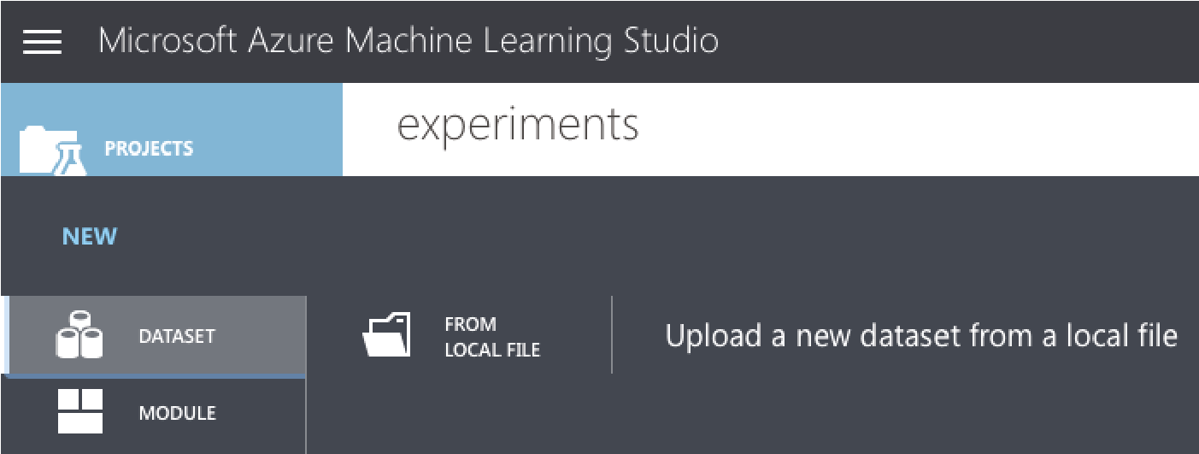

**Figure 11.6:** Uploading a dataset to the MAML

Click the Choose File button (see Figure 11.7) and locate the training set downloaded earlier. When finished, click the tick button to upload the dataset to the MAML.

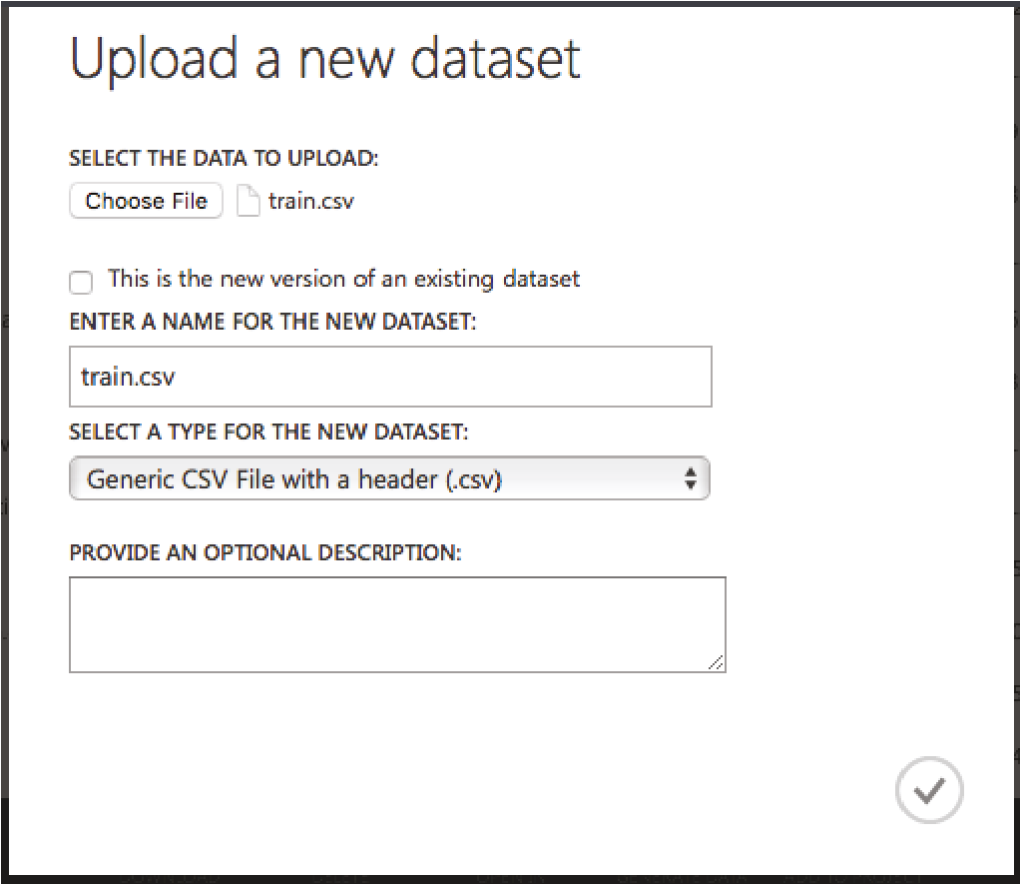

**Figure 11.7:** Choose a file to upload as a dataset

***Creating an Experiment***

You are now ready to create an experiment in MAML. Click the **+** NEW button at the bottom-left of the page and select Blank Experiment (see Figure 11.8).

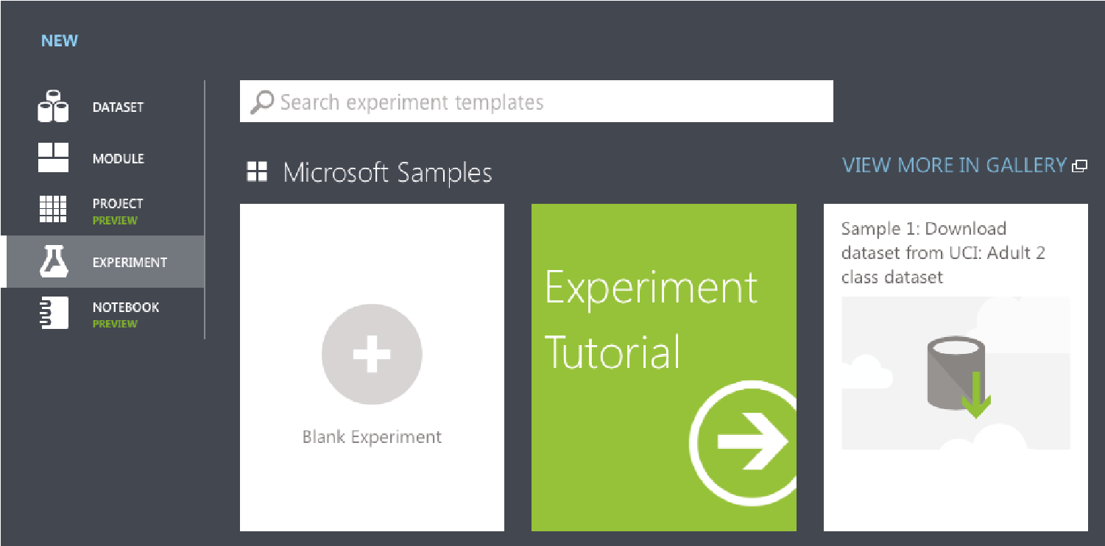

**Figure 11.8:** Creating a new blank experiment in MAML

You should now see the canvas, as shown in Figure 11.9.

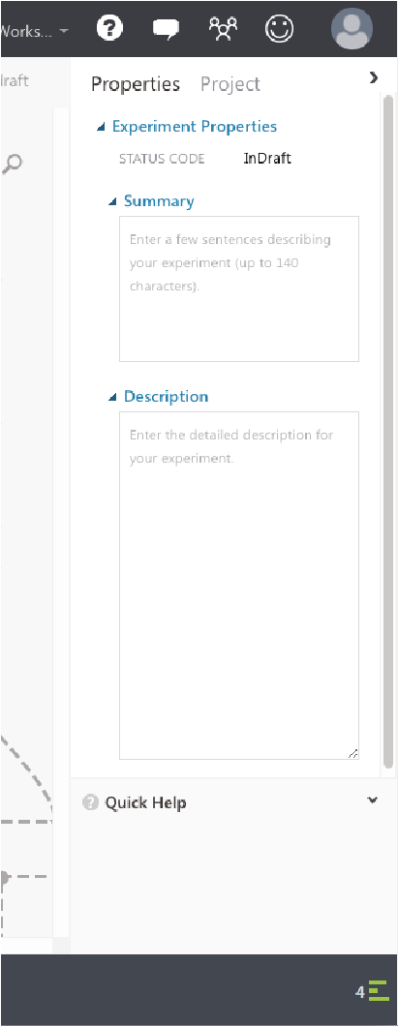

**Figure 11.9:** The canvas representing your experiment

You can give a name to your experiment by typing it over the default experiment name at the top (see Figure 11.10).

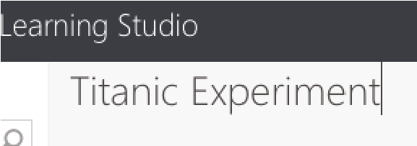

**Figure 11.10:** Naming your experiment

Once that is done, let’s add our training dataset to the canvas. You can do so by typing the name of the training set in the search box on the left, and the matching dataset will now appear (see Figure 11.11).

Drag and drop the **train.csv** dataset onto the canvas (see Figure 11.12).

The **train.csv** dataset has an output port (represented by a circle with a 1 inside). Clicking it will reveal a context menu (see Figure 11.13).

Click Visualize to view the content of the dataset. The dataset is now displayed, as shown in Figure 11.14.

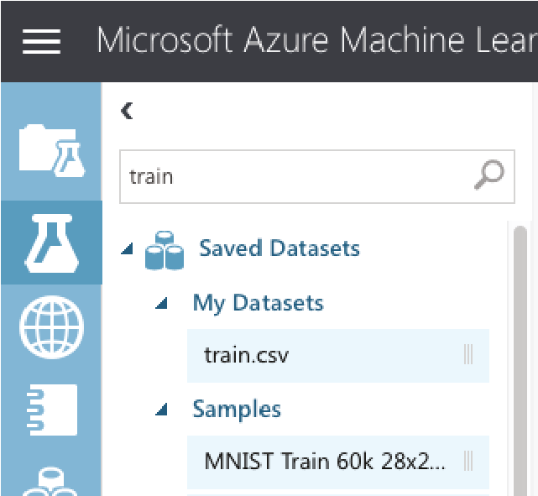

**Figure 11.11:** Using the dataset that you have uploaded

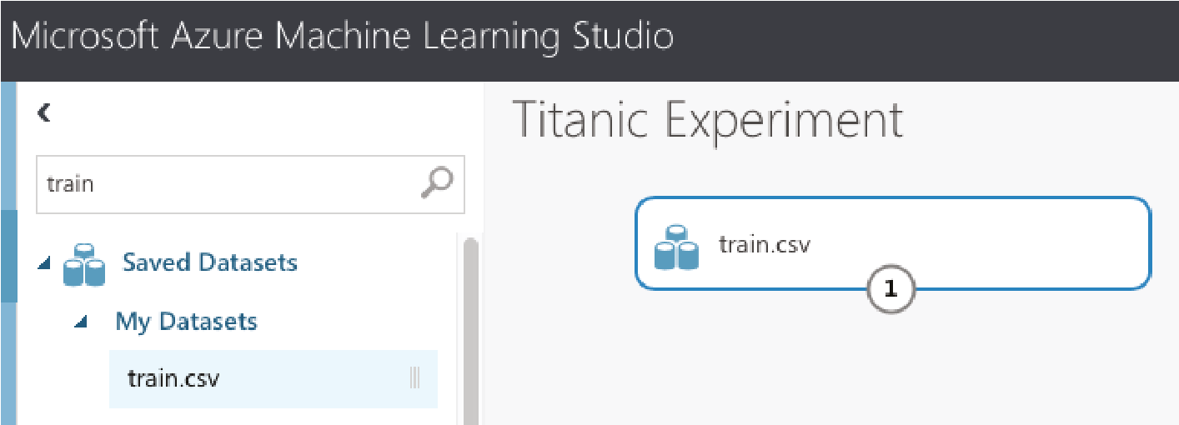

**Figure 11.12:** Dragging and dropping the dataset onto the canvas

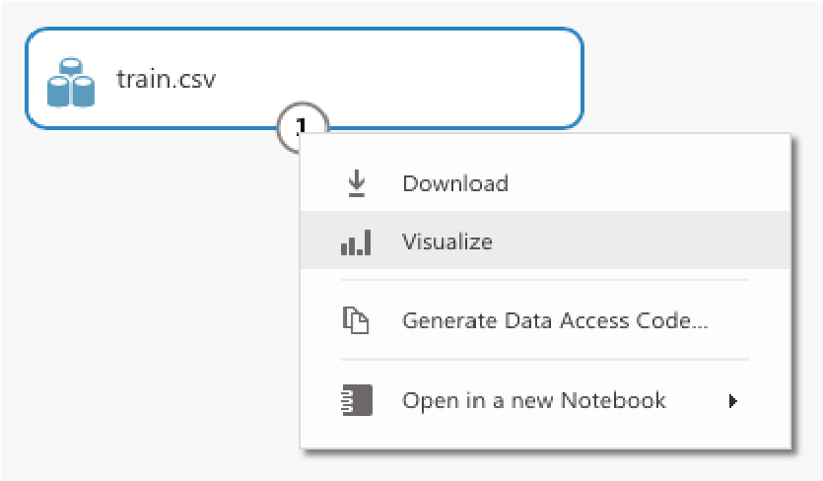

**Figure 11.13:** Visualizing the content of the dataset

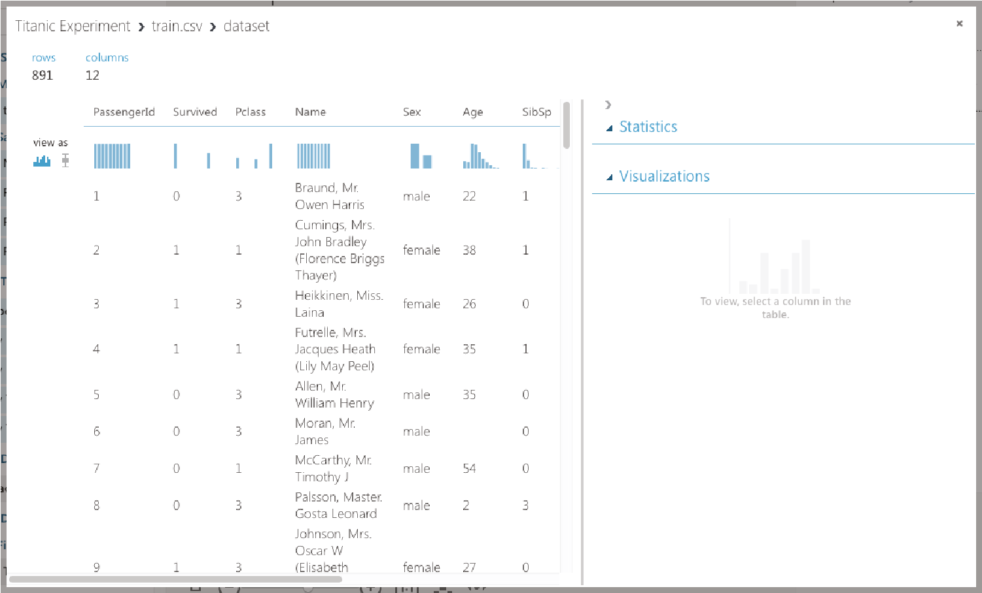

**Figure 11.14:**

Viewing the dataset

Take a minute to scroll through the data. Observe the following:

**■**The **PassengerID** field is simply a running number, and it does not provide any information with regard to the passenger. This field should be discarded when training your model.

**■**The **Ticket** field contains the ticket number of the passengers. In this case, however, a lot of these numbers seem to be randomly generated. Thus, it is not very useful in helping us to predict the survivability of a passenger and hence should be discarded.

**■**The **Cabin** field contains a lot of missing data. Fields that have a lot of missing data do not provide insights to our learning model and hence should be discarded.

**■**If you select the **Survived** field, you will see the chart displayed on the bottom right of the window (see Figure 11.15). Because a passenger can either survive (represented by a 1) or die (represented by a 0), it does not make sense to have any values in between. However, since this value is represented as a numeric value, MAML would not be able to figure this out unless you tell it. To fix this, you need to make this value a categorical value. A *categorical value* is a value that can take on one of a limited, and usually fixed, number of possible values.

**■**The **Pclass**, **SibSp**, and **Parch** fields should all be made categorical as well.

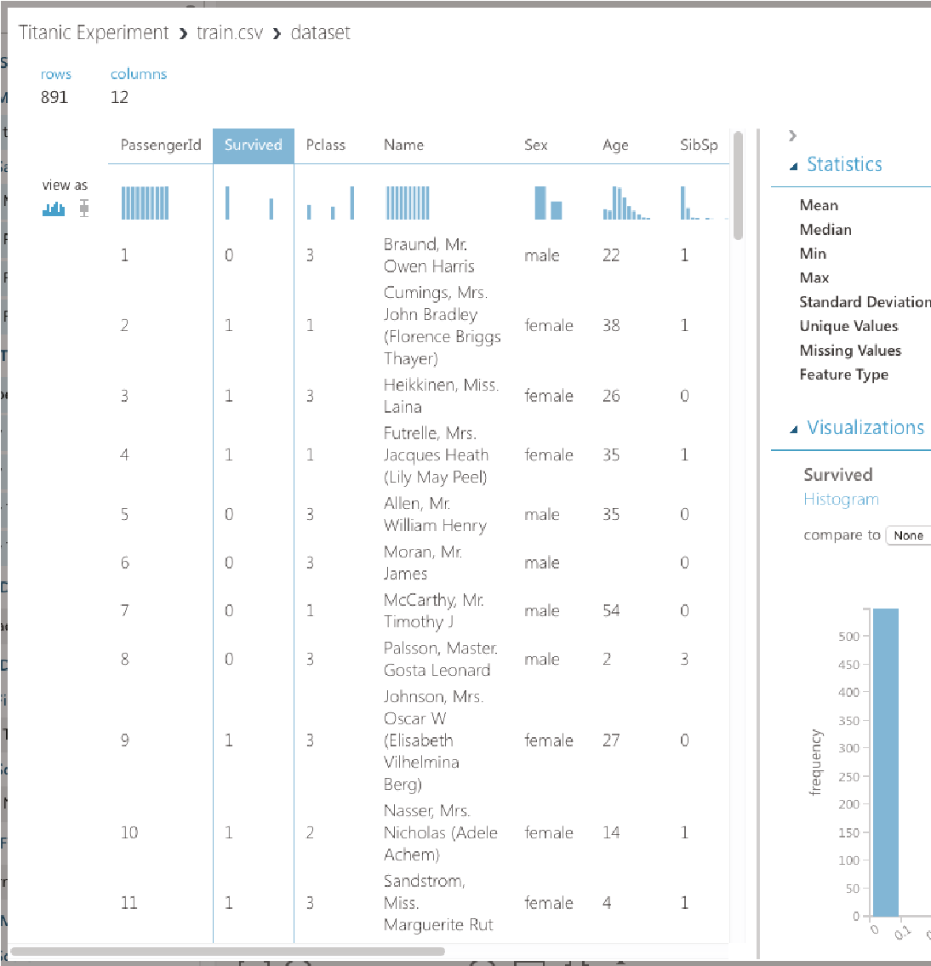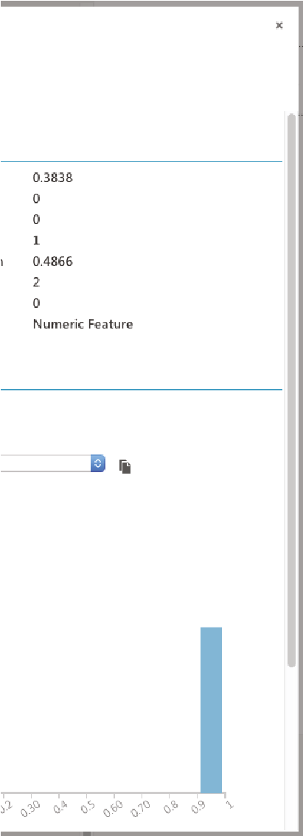

**Figure 11.15:**

Viewing the Survived column

All of the fields that are not discarded are useful in helping us to create a learning model. These fields are known as *features*.

***Filtering the Data and Making Fields Categorical***

Now that we have identified the features we want, let’s add the Select Columns in Dataset module to the canvas (see Figure 11.16).

In the Properties pane, click the Launch column selector and select the columns, as shown in Figure 11.17.

The Select Columns in Dataset module will reduce the dataset to the columns that you have specified. Next, we want to make some of the columns categorical. To do that, add the Edit Metadata module, as shown in Figure 11.18, and connect it as shown. Click the Launch column selector button, and select the **Survived**, **Pclass**, **SibSp**, and **Parch** fields. In the Categorical section of the properties pane, select “Make categorical.”

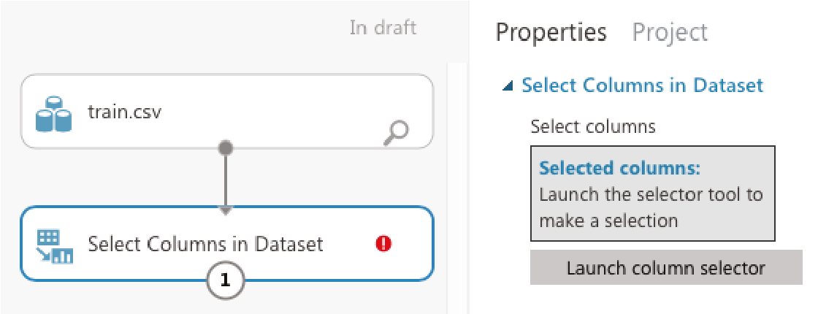

**Figure 11.16:** Use the Select Columns in Dataset module to filter columns

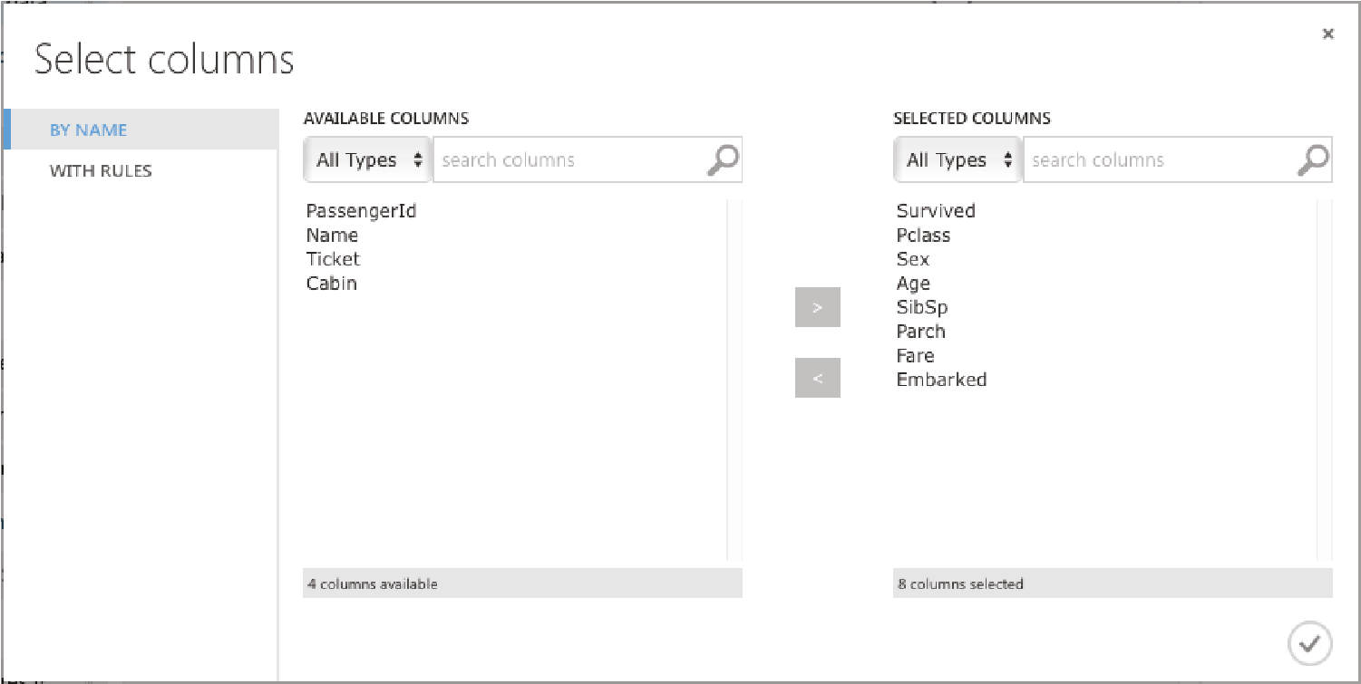

**Figure 11.17:** Selecting the fields that you want to use as features

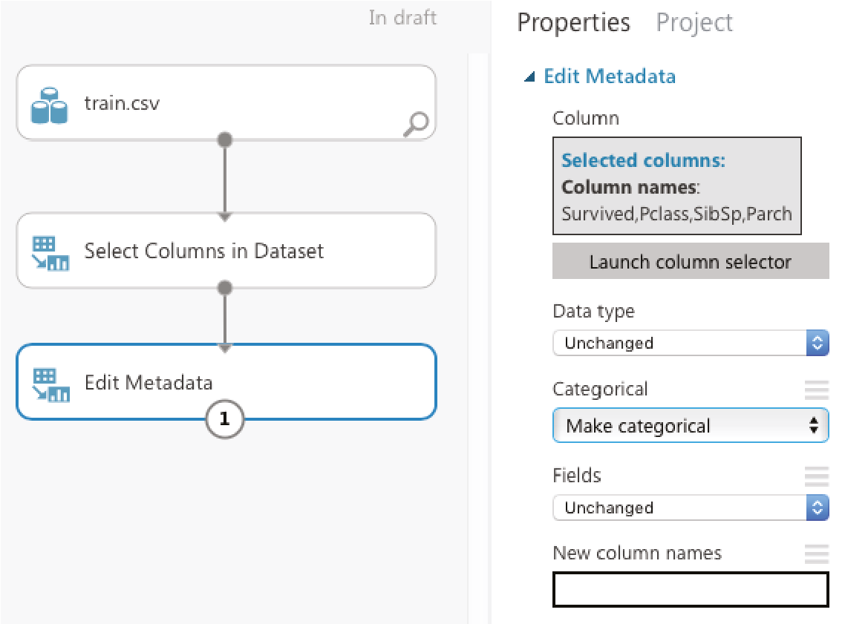

**Figure 11.18:** Making specific fields categorical

You can now run the experiment by clicking the RUN button located at the bottom of the MAML. Once the experiment is run, click the output port of the Edit Metadata module and select Visualize. Examine the dataset displayed.

***Removing the Missing Data***

If you examine the dataset returned by the Edit Metadata module carefully, you will see that the **Age** column has some missing values. It is always good to remove all those rows that have missing values so that those missing values will not affect the efficiency of the learning model. To do that, add a *Clean Missing Data* module to the canvas and connect it as shown in Figure 11.19. In the properties pane, set the “Cleaning mode” to “Remove entire row.”

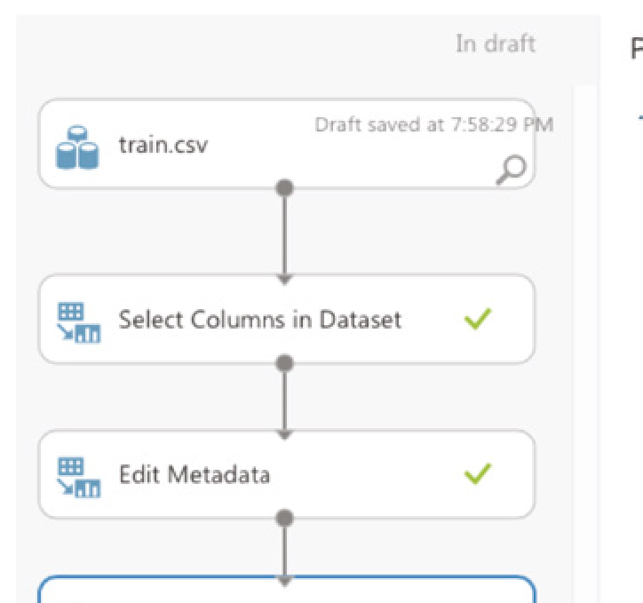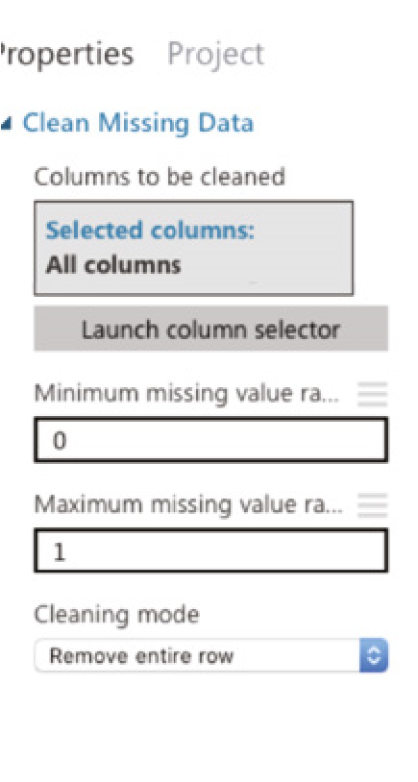

**Figure 11.19:** Removing rows that have missing values in the Age column

**TIP You can also replace the missing values with the mean of the column, if you prefer.**

Click RUN. The dataset should now have no more missing values. Also notice that the number of rows has been reduced to 712 (see Figure 11.20).

***Splitting the Data for Training and Testing***

When building your learning model, it is essential that you test it with sample data after the training is done. If you only have one single set of data, you can split it into two parts—one for training and one for testing. This is accomplished by the Split Data module (see Figure 11.21). For this example, I am splitting 80 percent of the dataset for training and the remaining 20 percent for testing.

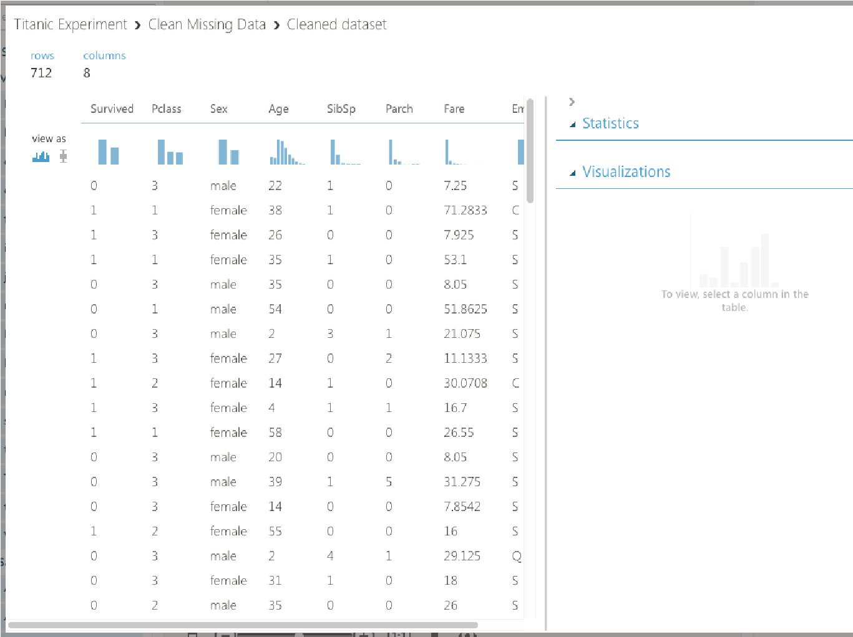

**Figure 11.20:** Viewing the cleaned and filtered dataset

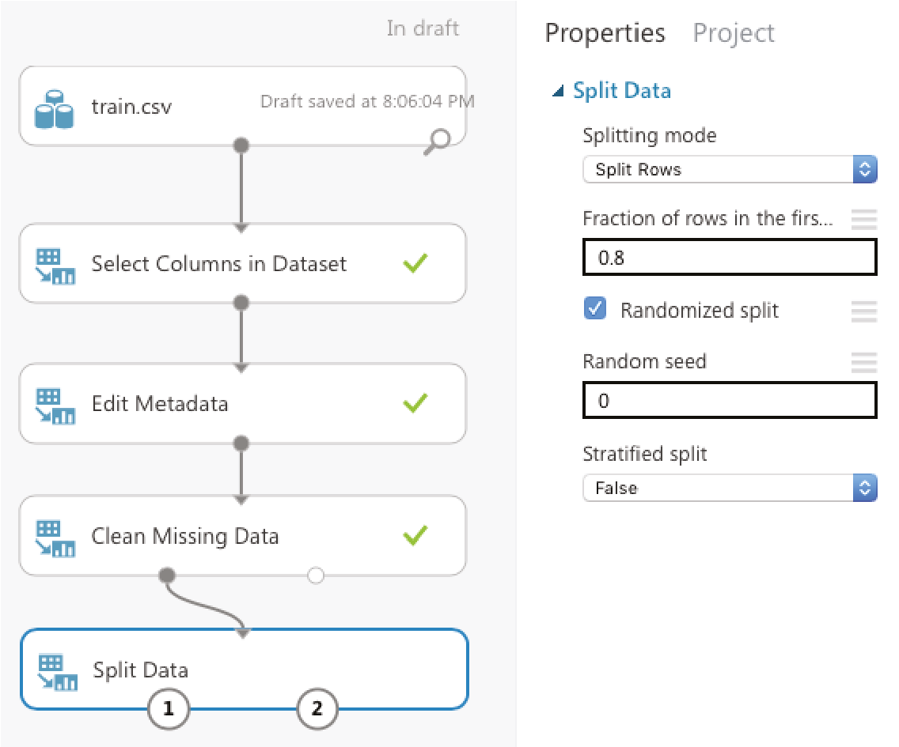

**Figure 11.21:** Splitting the data into training and testing datasets

The left output port of the Split Data module will return 80 percent of the dataset while the right output port will return the remaining 20 percent.

**Training a Model**

You are now ready to create the training model. Add the Two-Class Logistic Regression and Train Model modules to the canvas and connect them as shown in Figure 11.22. The Train Model module takes in a learning algorithm and a training dataset. You will also need to tell the Train Model module the label for which you are training it. In this case, it is the **Survived** column.

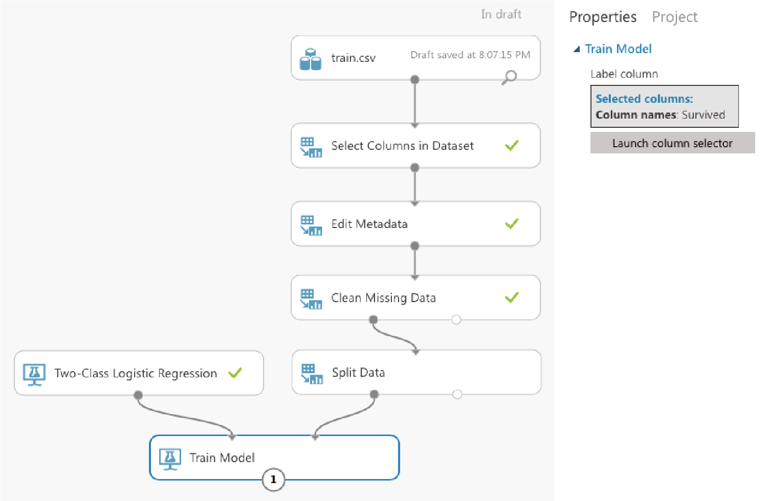

**Figure 11.22:** Training your model using the Two-Class Logistic Regression algorithm

Once you have trained the model, it is essential that you verify its effectiveness. To do so, use the Score Model module, as shown in Figure 11.23. The *Score Model* takes in a trained model (which is the output of the Train Model module) and a testing dataset.

You are now ready to run the experiment again. Click RUN. Once it is completed, select the **Scored Labels** column (see Figure 11.24). This column represents the results of applying the test dataset against the learning model. The column next to it, **Scored Probabilities**, indicates the confidence of the prediction. With the **Scored Labels** column selected, look at the right side of the screen and above the chart, select Survived for the item named “compare to.” This will plot the confusion matrix.

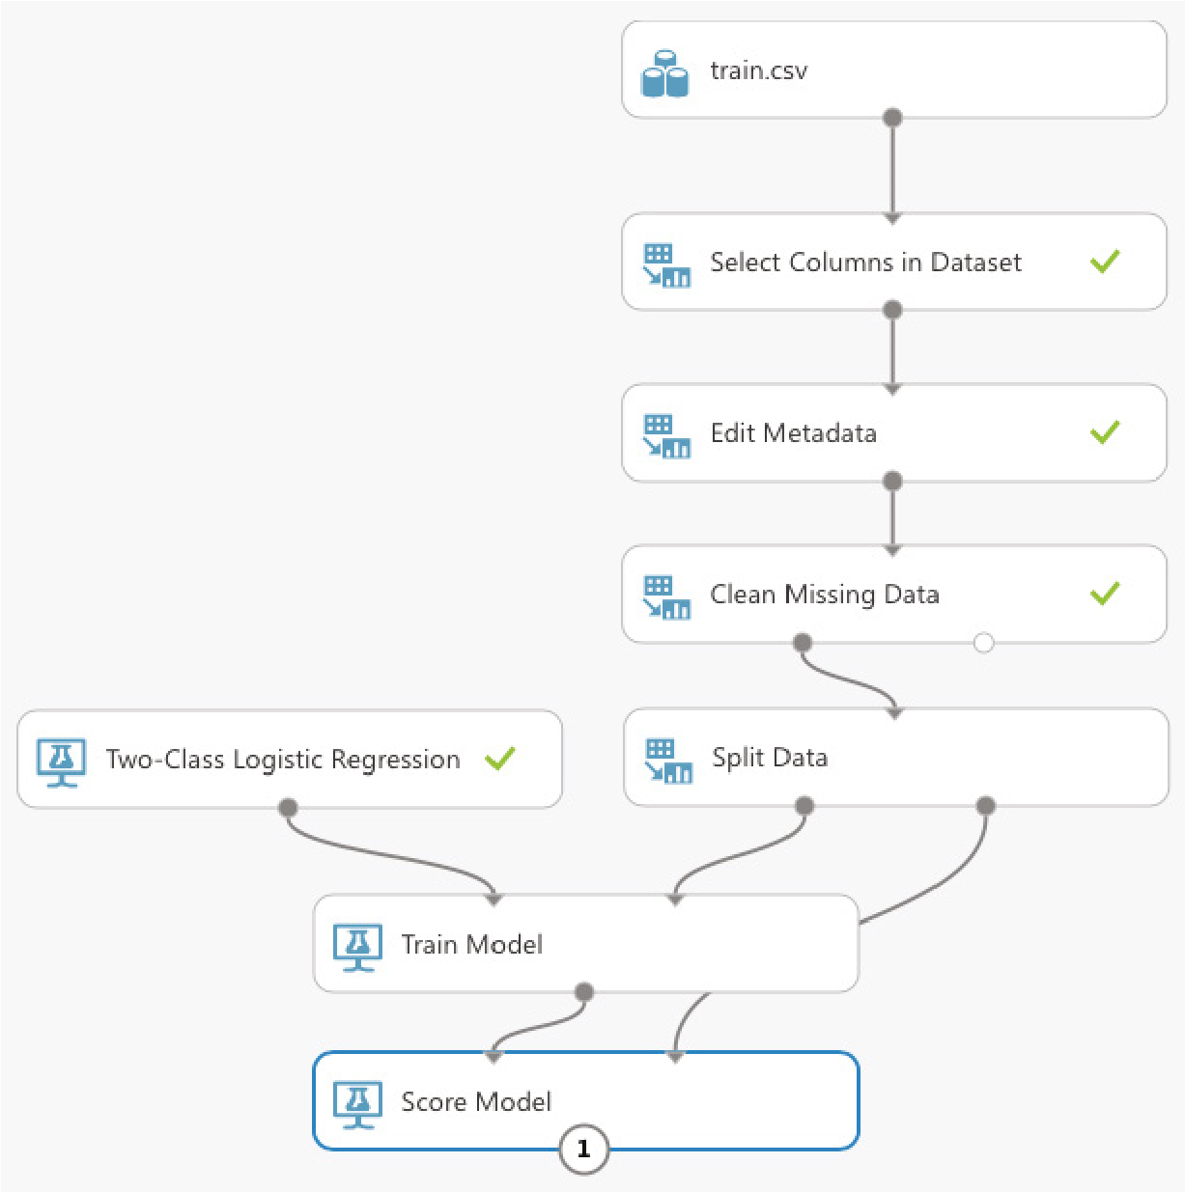

**Figure 11.23:** Scoring your model using the testing dataset and the trained model

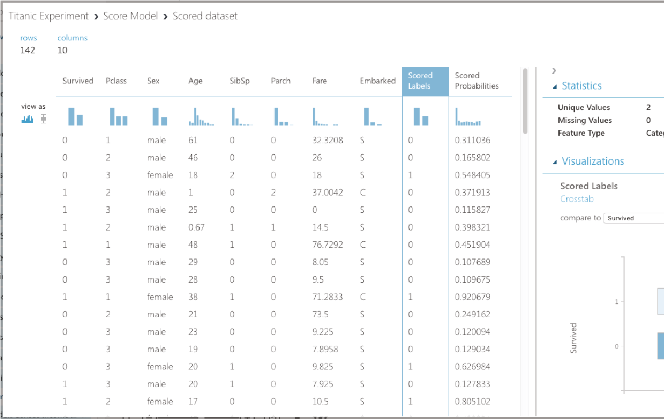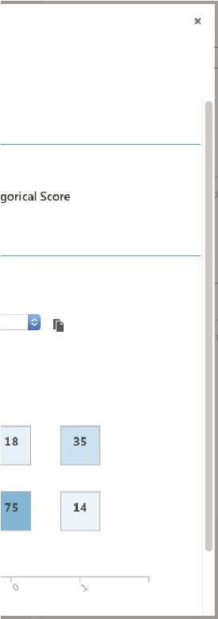

**Figure 11.24:** Viewing the confusion matrix for the learning model

The y-axis of the confusion matrix shows the actual survival information of passengers: 1 for survived and 0 for did not survive. The x-axis shows the prediction. As you can see, 75 were correctly predicted not to survive the disaster, and 35 were correctly predicted to survive the disaster. The two other boxes show the predictions that were incorrect.

***Comparing Against Other Algorithms***

While the numbers for the predictions look pretty decent, it is not sufficient to conclude at this moment that we have chosen the right algorithm for this problem. MAML comes with 25 machine learning algorithms for different types of problems. Now let’s use another algorithm provided by MAML, TwoClass Decision Jungle, to train another model. Add the modules as shown in Figure 11.25.

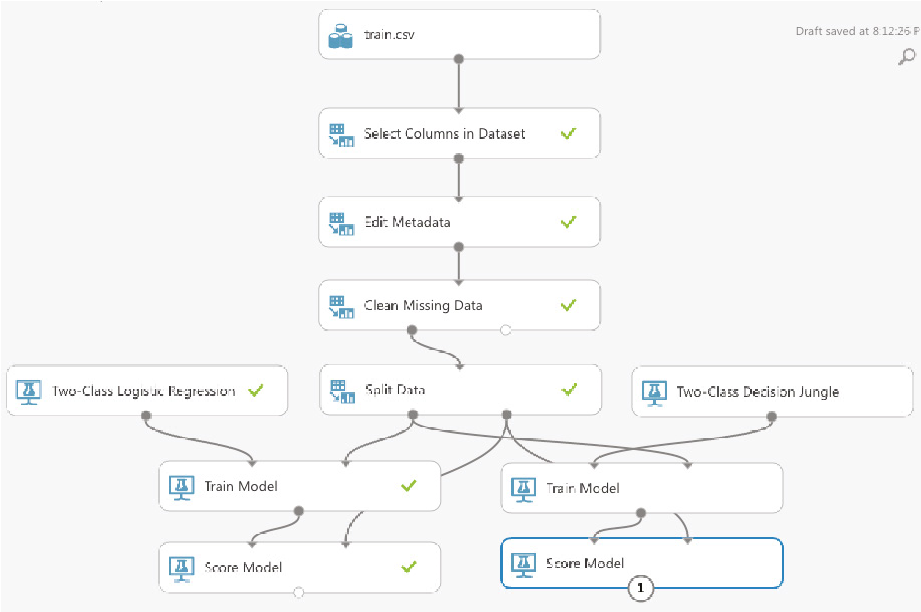

**Figure 11.25:** Using another algorithm for training the alternative model

**TIP The Two-Class Decision Jungle algorithm is another machine learning algorithm that is based on decision trees. For this experiment, you can also use other algorithms provided by MAML, such as the Two-Class Logistic Regression and TwoClass Support Vector Machine.**

Click Run. You can click the output port of the second Score Model module to view the result of the model, just like the previous learning model. However, it would be more useful to be able to compare them directly. You can accomplish this using the Evaluate Model module (see Figure 11.26).

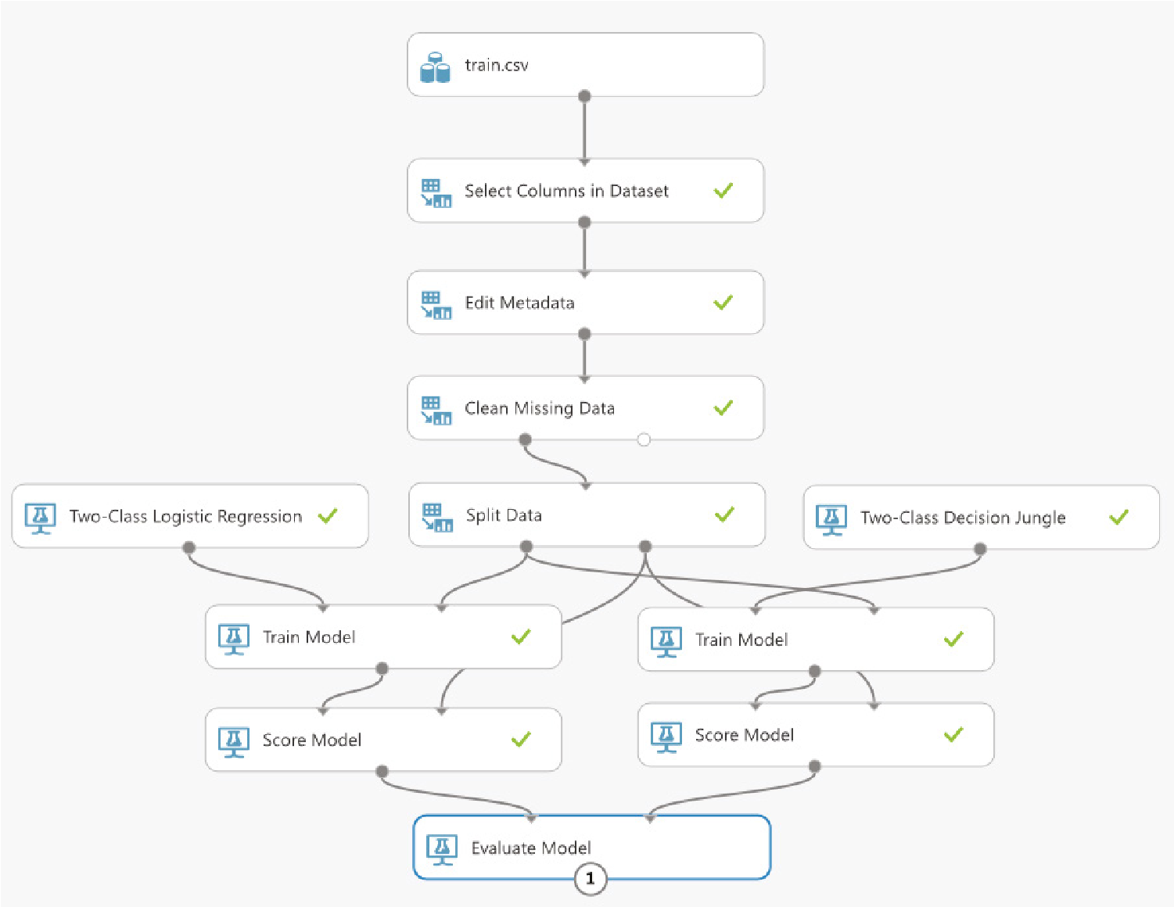

**Figure 11.26:** Evaluating the performance of the two models

Click RUN to run the experiment. When done, click the output port of the Evaluate Model module and you should see something like Figure 11.27.

The blue line represents the algorithm on the left input port of the Evaluate Model module (Two-Class Logistic Regression), while the red line represents the algorithm on the right (Two-Class Decision Jungle). When you click either the blue or red box, you will see the various metrics for each algorithm displayed below the chart.

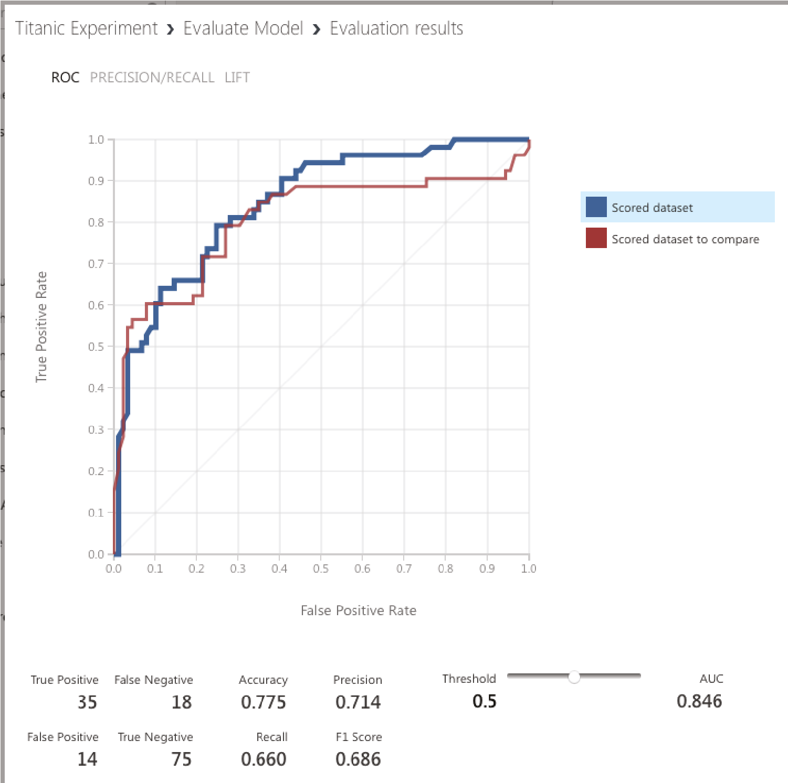

**Figure 11.27:** Viewing the metrics for the two learning algorithms

***Evaluating Machine Learning Algorithms***

Now that you have seen an experiment performed using two specific machine learning algorithms—Two-Class Logistic Regression and Two-Class Decision Jungle—let’s step back a little and examine the various metrics that were generated by the *Evaluate Model* module. Specifically, let’s define the meaning of the following terms:

**True Positive (TP)** The model correctly predicts the outcome as positive. In this case, the number of TP indicates the number of correct predictions that a passenger survived (positive) the disaster.

**True Negative (TN)** The model correctly predicts the outcome as negative (did not survive); that is, passengers were correctly predicted not to survive the disaster.

**False Positive (FP)** The model incorrectly predicted the outcome as positive, but the actual result is negative. In the Titanic example, it means that the passenger did not survive the disaster, but the model predicted the passenger to have survived.

**False Negative (FN)** The model incorrectly predicted the outcome as negative, but the actual result is positive. In this case, this means the model predicted that the passenger did not survive the disaster, but actually the passenger did.

This set of numbers is known as the *confusion matrix*. The confusion matrix is discussed in detail in Chapter 7, “Supervised Learning—Classification Using Logistic Regression.” So if you are not familiar with it, be sure to read up on Chapter 7.

**Publishing the Learning Model as a Web Service**

Once the most effective machine learning algorithm has been determined, you can publish the learning model as a web service. Doing so will allow you to build custom apps to consume the service. Imagine that you are building a learning model to help doctors diagnose breast cancer. Publishing as a web service would allow you to build apps to pass the various features to the learning model to make the prediction. Best of all, by using MAML, there is no need to handle the details of publishing the web service—MAML will host it for you on the Azure cloud.

***Publishing the Experiment***

To publish our experiment as a web service:

**■**Select the left Train Model module (since it has a better performance compared to the other).

**■**At the bottom of the page, hover your mouse over the item named SET UP WEB SERVICE, and click Predictive Web Service (Recommended).

**TIP For this experiment, the best algorithm is the one that gives the highest AUC (Area Under the Curve) score.**

This will create a new Predictive experiment, as shown in Figure 11.28.

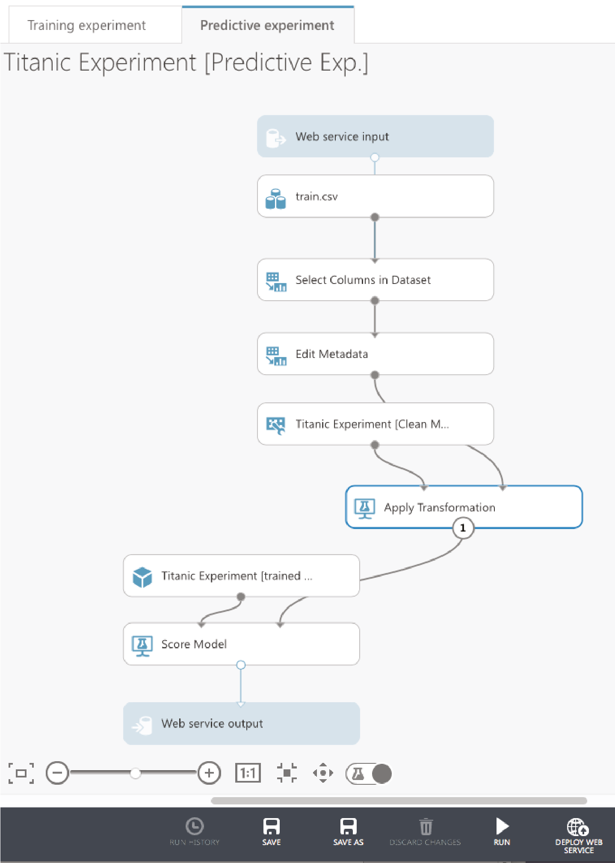

**Figure 11.28:** Publishing the learning model as a web service

Click RUN, and then DEPLOY WEB SERVICE. The page seen in Figure 11.29 will now be shown.

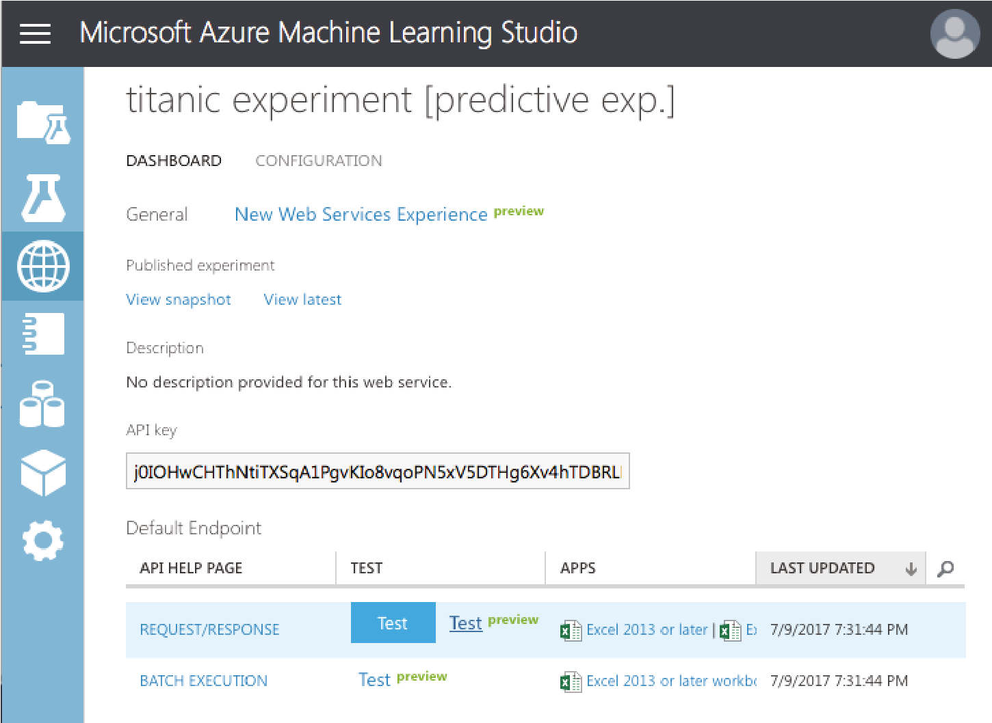

**Figure 11.29:**

The test page for the web service

***Testing the Web Service***

Click the Test hyperlink. The test page shown in Figure 11.30 is displayed. You can click the Enable button to fill the various fields from your training set. This will save you the chore of filling in the various fields.

The fields should now be filled with values from the training data. At the bottom of the page, click Test Request/Response and the prediction will be shown on the right.

***Programmatically Accessing the Web Service***

At the top of the Test page, you should see a Consume link as shown in Figure 11.31. Click it.

You will see the credentials that you need to use in order to access your web service, as well as the URLs for the web service. At the bottom of the page, you will see the sample code generated for you that you could use to access the web service programmatically (see Figure 11.32). The sample code is available in C#, Python 2, Python 3, and R.

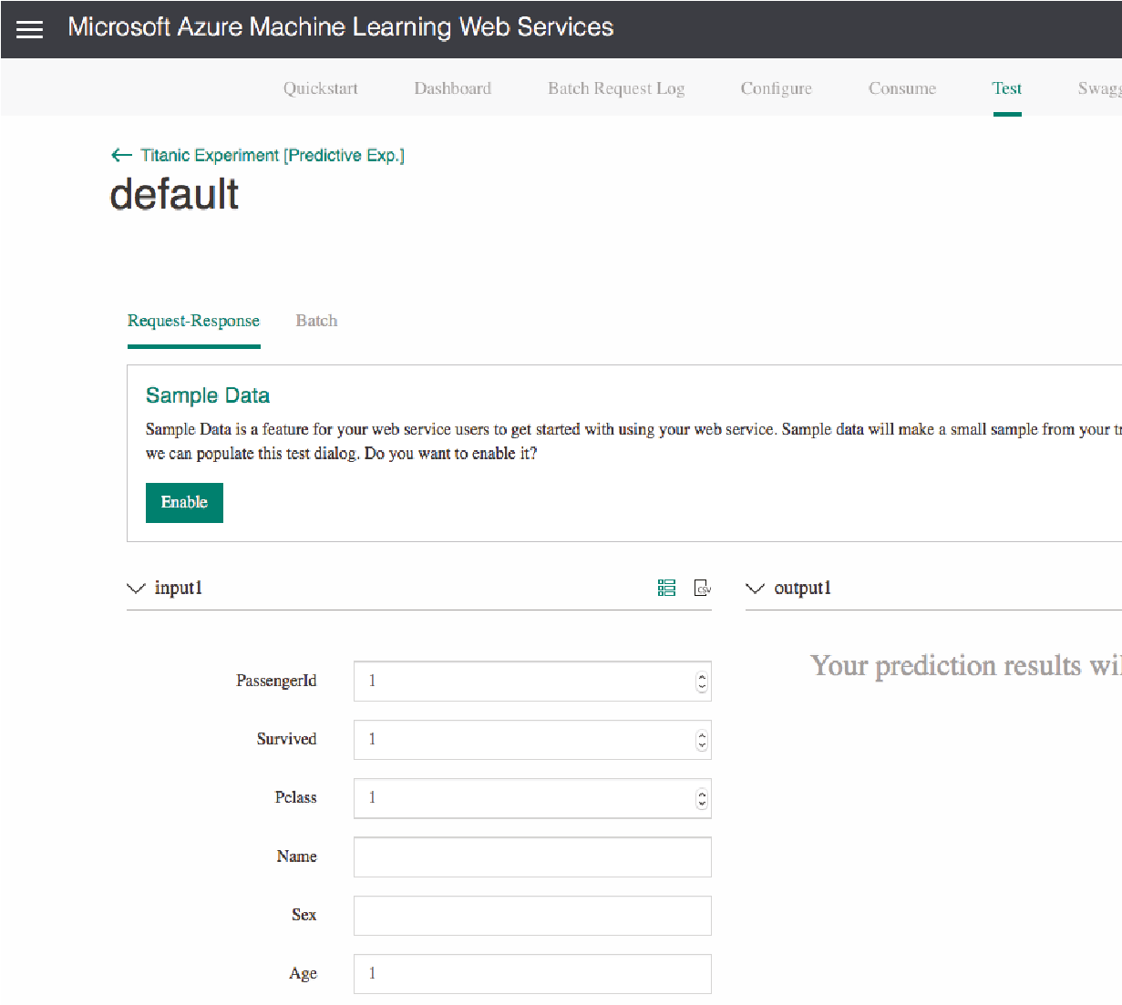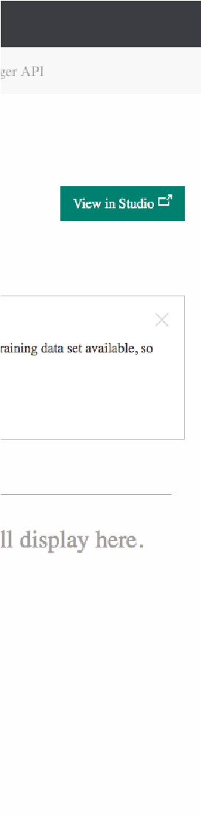

**Figure 11.30:** Testing the web service with some data

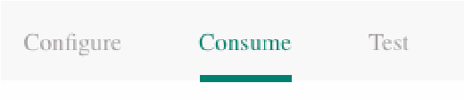

**Figure 11.31:** The Consume link at the top of the web service page

Click the Python 3+ tab, and copy the code generated. Click the View in Studio link at the top-right of the page to return to MAML. Back in MAML, click the + NEW button at the bottom of the screen. Click NOTEBOOK on the left, and you should be able to see the various notebooks, as shown in Figure 11.33.

**TIP The notebooks hosted by the MAML are the same as the Jupyter Notebook that you have installed on your local computer.**

Click Python 3, give a name to your notebook, and paste in the Python code that you copied earlier (see Figure 11.34).

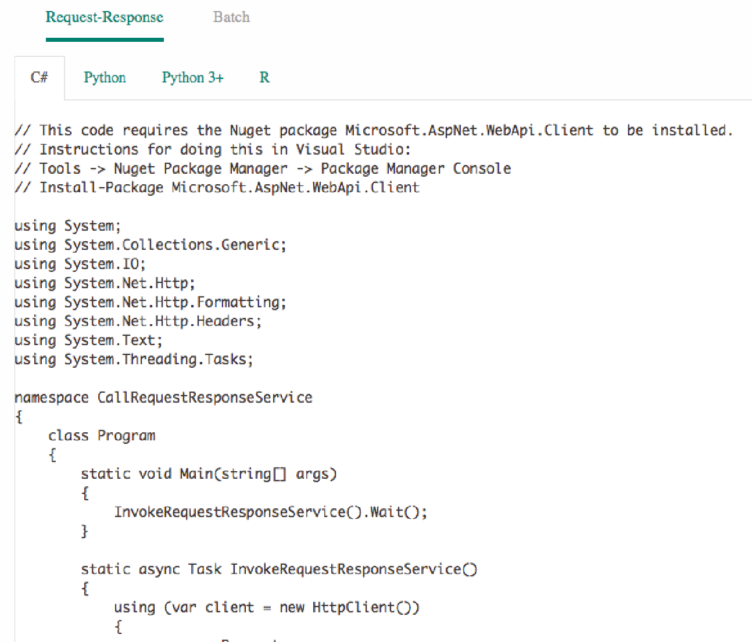

**Figure 11.32:** The sample code for accessing the web service written in the three programming languages



**Figure 11.33:** Creating a new notebook in MAML

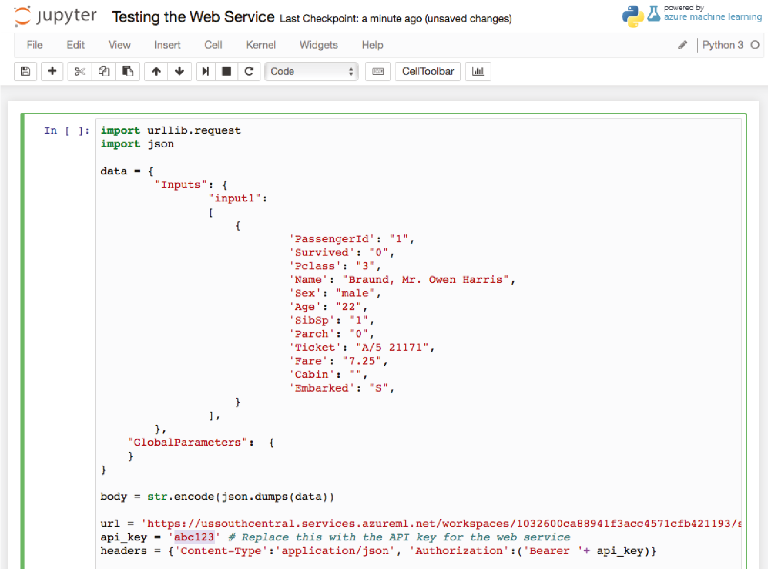

**Figure 11.34:** Testing the code in the Python notebook

Be sure to replace the value of the **api_key** variable with that of your primary key. Press Ctrl+Enter to run the Python code. If the web service is deployed correctly, you should see the result at the bottom of the screen (see Figure 11.35).

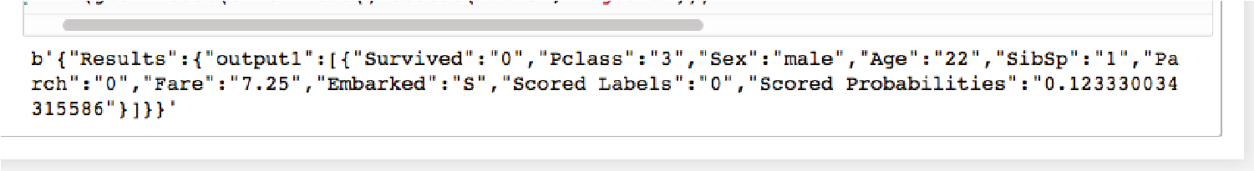

**Figure 11.35:** The result returned by the web service

**Summary**

In this chapter, you have seen how you can use the MAML to create machine learning experiments. Instead of writing your code in Python, you can use the various algorithms provided by Microsoft and build your machine learning models visually using drag and drop. This is very useful for beginners who want to get started with machine learning without diving into the details. Best of all, MAML helps you to deploy your machine learning as a web service automatically—and it even provides the code for you to consume it.

In the next chapter, you will learn how to deploy your machine learning models created in Python and Scikit-learn manually using Python and the Flask micro-framework.

|  |
| --- |
| **CHAPTER** |
| **12**  **Models** |

**Deploying Machine Learning**

**Deploying ML**

The main goal of machine learning is to create a model that you can use for making predictions. Over the past few chapters in this book, you learned about the various algorithms used to build an ideal machine learning model. At the end of the entire process, what you really want is to make your model accessible to users so that they can utilize it to do useful tasks, like making predictions (such as helping doctors with their diagnosis, and so forth).

A good way to deploy your machine learning model is to build a *REST (REpresentational State Transfer) API*, so that the model is accessible by others who may not be familiar with how machine learning works. Using REST, you can build multi-platform front-end applications (such as iOS, Android, Windows, and so forth) and pass the data to the model for processing. The result can then be returned back to the application. Figure 12.1 summarizes the architecture that we will use for deploying our machine learning model.

In this chapter, we will go through a case study, build a machine learning model, and then deploy it as a REST service. Finally, we will build a console front-end application using Python to allow users to make some predictions.

Python® Machine Learning, First Edition. Wei-Meng Lee. **269**

© 2019 John Wiley & Sons, Inc. Published 2019 by John Wiley & Sons, Inc.



**Internet**

**Frontend Clients**



**REST**

**API**

**Machine Learning Model**

**Figure 12.1:** Deploying your machine learning model as a REST API allows front-end applications to use it for predictions

**Case Study**

For this case study, we are going to help predict the likelihood of a person being diagnosed with diabetes based on several diagnostic measurements of that person.

The dataset that you will be using in this chapter is from this database:

**https://www.kaggle.com/uciml/pima-indians-diabetes-database**. This dataset contains several medical independent predictors and one target. Its features consist of the following:

**■***Pregnancies*: Number of times pregnant

**■***Glucose*: Plasma glucose concentration after 2 hours in an oral glucose tolerance test

**■***BloodPressure*: Diastolic blood pressure (mm Hg)

**■***SkinThickness*: Triceps skin fold thickness (mm)

**■***Insulin*: 2-Hour serum insulin (mu U/ml)

**■***BMI*: Body mass index (weight in kg/(height in m)^2)

**■***DiabetesPedigreeFunction*: Diabetes pedigree function

**■***Age*: Age (years)

**■***Outcome*: 0 (non-diabetic) or 1 (diabetic)

The dataset has 768 records, and all patients are females at least 21 years of age and of Pima Indian descent. **Loading the Data**

For this example, the dataset has been downloaded locally and named **diabetes.csv**.

The following code snippet loads the dataset and prints out information about the DataFrame using the **info()** function:

**import numpy as np import pandas as pd df = pd.read_csv('diabetes.csv') df.info()**

You should see the following output:

**<class 'pandas.core.frame.DataFrame'>**

**RangeIndex: 768 entries, 0 to 767 Data columns (total 9 columns):**

**Pregnancies 768 non-null int64**

**Glucose 768 non-null int64**

**BloodPressure 768 non-null int64**

**SkinThickness 768 non-null int64**

**Insulin 768 non-null int64**

**BMI 768 non-null float64**

**DiabetesPedigreeFunction 768 non-null float64**

**Age 768 non-null int64 Outcome 768 non-null int64 dtypes: float64(2), int64(7) memory usage: 54.1 KB**

**Cleaning the Data**

As with all datasets, your first job is to clean the data so that there are no missing or erroneous values. Let’s first check for nulls in the dataset:

**#---check for null values--print("Nulls") print("=====") print(df.isnull().sum())** The result is as follows:

**Nulls**

**=====**

**Pregnancies 0**

**Glucose 0**

**BloodPressure 0**

**SkinThickness 0**

**Insulin 0**

**BMI 0**

**DiabetesPedigreeFunction 0**

**Age 0 Outcome 0 dtype: int64**

There are no nulls. Next, let’s check for 0s:

**#---check for 0s--print("0s") print("==") print(df.eq(0).sum())**

For features like Pregnancies and Outcome, having values of 0 is normal. For the other features, however, a value of 0 indicates that the values are not captured in the dataset.

**0s**

**==**

**Pregnancies 111**

**Glucose 5**

**BloodPressure 35**

**SkinThickness 227**

**Insulin 374**

**BMI 11**

**DiabetesPedigreeFunction 0**

**Age 0 Outcome 500 dtype: int64**

There are many ways to deal with this case of 0 for features, but for simplicity, let’s just replace the 0 values with **NaN**:

**df[['Glucose','BloodPressure','SkinThickness',**

**'Insulin','BMI','DiabetesPedigreeFunction','Age']] = \ df[['Glucose','BloodPressure','SkinThickness',**

**'Insulin','BMI','DiabetesPedigreeFunction','Age']].replace**

**(0,np.NaN)**

Once the NaN values have replaced the 0s in the DataFrame, you can now replace them with the mean of each column as follows: **df.fillna(df.mean(), inplace = True) # replace NaN with the mean**

You can now check the DataFrame to verify that there are now no more 0s in the DataFrame: **print(df.eq(0).sum())**

You should see this output:

**Pregnancies 111**

**Glucose 0**

**BloodPressure 0**

**SkinThickness 0**

**Insulin 0**

**BMI 0**

**DiabetesPedigreeFunction 0**

**Age 0 Outcome 500 dtype: int64**

**Examining the Correlation Between the Features**

The next step is to examine how the various independent features affect the outcome (whether a patient is diabetic or not). To do that, you can call the **corr()** function on the DataFrame:

**corr = df.corr() print(corr)**

The **corr()** function computes the pairwise correlation of columns. For example, the following output shows that the glucose level of a patient after a 2-hour oral glucose tolerance test has little relationship to the number of pregnancies of a patient (0.127911), but it has a significant relationship to the outcome (0.492928):

**Pregnancies Glucose BloodPressure SkinThickness \**

**Pregnancies 1.000000 0.127911 0.208522 0.082989**

**Glucose 0.127911 1.000000 0.218367 0.192991**

**BloodPressure 0.208522 0.218367 1.000000 0.192816**

**SkinThickness 0.082989 0.192991 0.192816 1.000000**

**Insulin 0.056027 0.420157 0.072517 0.158139**

**BMI 0.021565 0.230941 0.281268 0.542398**

**DiabetesPedigree**

**Function -0.033523 0.137060 -0.002763 0.100966**

**Age 0.544341 0.266534 0.324595 0.127872**

**Outcome 0.221898 0.492928 0.166074 0.215299**

**Insulin BMI DiabetesPedigreeFunction \**

**Pregnancies 0.056027 0.021565 -0.033523**

**Glucose 0.420157 0.230941 0.137060**

**BloodPressure 0.072517 0.281268 -0.002763**

**SkinThickness 0.158139 0.542398 0.100966**

**Insulin 1.000000 0.166586 0.098634**

**BMI 0.166586 1.000000 0.153400**

**DiabetesPedigree**

**Function 0.098634 0.153400 1.000000**

**Age 0.136734 0.025519 0.033561**

**Outcome 0.214411 0.311924 0.173844**

**Age Outcome**

**Pregnancies 0.544341 0.221898**

**Glucose 0.266534 0.492928**

**BloodPressure 0.324595 0.166074**

**SkinThickness 0.127872 0.215299**

**Insulin 0.136734 0.214411**

**BMI 0.025519 0.311924**

**DiabetesPedigree**

**Function 0.033561 0.173844**

**Age 1.000000 0.238356**

**Outcome 0.238356 1.000000**

Our goal here is to find out which features significantly affect the outcome.

**Plotting the Correlation Between Features**

Rather than look at the various numbers representing the various correlations between the columns, it is useful to be able to picture it visually. The following code snippet uses the **matshow()** function to plot the results returned by the **corr()** function as a matrix. At the same time, the various correlation factors are also shown in the matrix:

**%matplotlib inline import matplotlib.pyplot as plt fig, ax = plt.subplots(figsize=(10, 10))**

**cax = ax.matshow(corr,cmap='coolwarm', vmin=-1, vmax=1) fig.colorbar(cax)**

**ticks = np.arange(0,len(df.columns),1) ax.set_xticks(ticks) ax.set_xticklabels(df.columns) plt.xticks(rotation = 90) ax.set_yticklabels(df.columns) ax.set_yticks(ticks)**

**#---print the correlation factor--for i in range(df.shape[1]): for j in range(9):**

**text = ax.text(j, i, round(corr.iloc[i][j],2), ha="center", va="center", color="w") plt.show()**

Figure 12.2 shows the matrix. The cubes that have colors closest to red represent the highest correlation factors, while those closest to blue represent the lowest correlation factors.

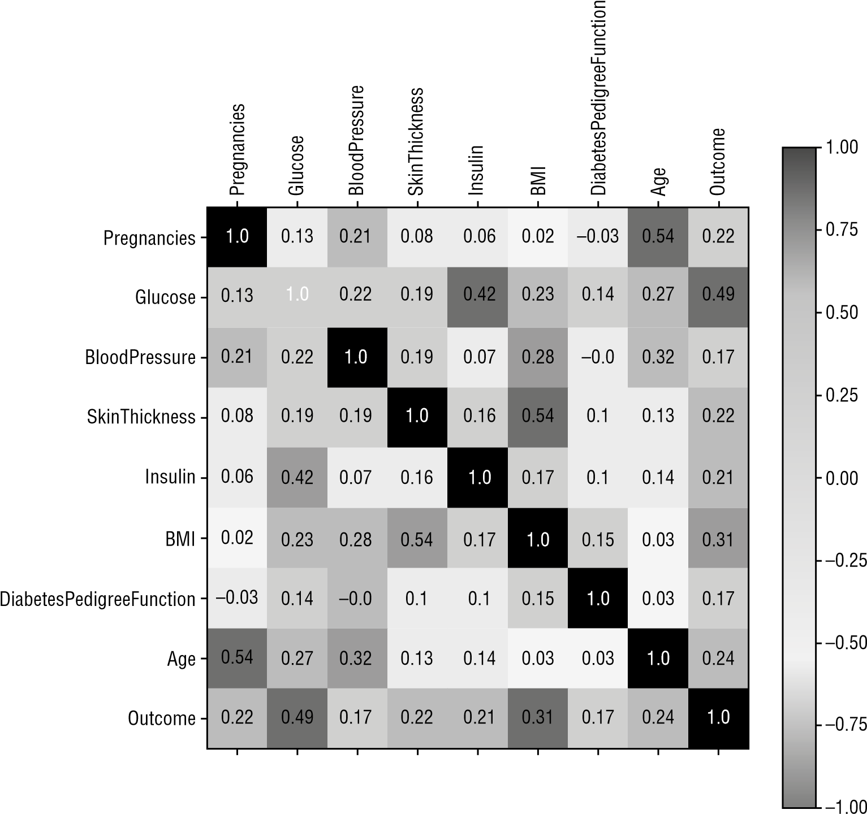

**Figure 12.2:** Matrix showing the various correlation factors

Another way to plot the correlation matrix is to use Seaborn’s **heatmap()** function as follows:

**import seaborn as sns sns.heatmap(df.corr(),annot=True)**

**#---get a reference to the current figure and set its size--fig = plt.gcf() fig.set_size_inches(8,8)**

Figure 12.3 shows the heatmap produced by Seaborn.

Now let’s print out the top four features that have the highest correlation with the *Outcome*:

**#---get the top four features that has the highest correlation--print(df.corr().nlargest(4, 'Outcome').index)**

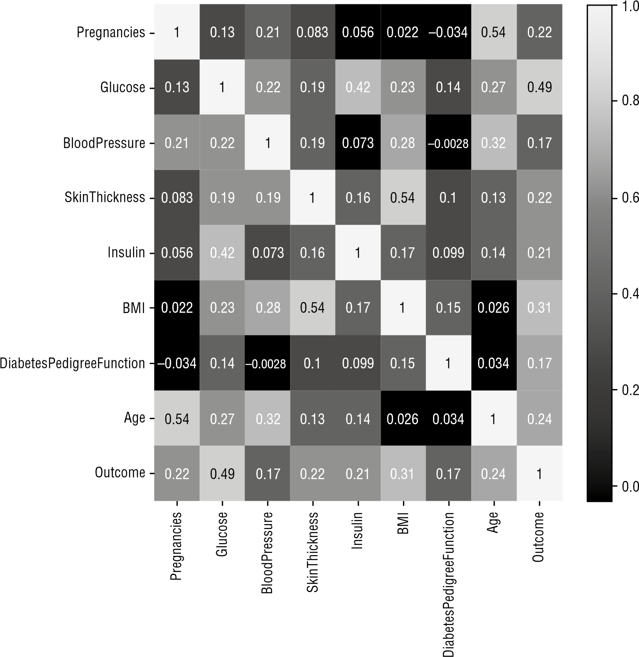

**Figure 12.3:** Heatmap produced by Seaborn showing the correlation factors

**#---print the top 4 correlation values--print(df.corr().nlargest(4, 'Outcome').values[:,8])** You should see the following output:

**Index(['Outcome', 'Glucose', 'BMI', 'Age'], dtype='object')**

**[1. 0.49292767 0.31192439 0.23835598]**

You can now see that apart from the **Outcome** feature, the three most influential features are **Glucose**, **BMI**, and **Age**. We can use these three features to train our model.

**Evaluating the Algorithms**

Before we train our model, it is always good to evaluate a few algorithms to find the one that gives the best performance. Accordingly, we will try the following algorithms:

**■**Logistic Regression

**■**K-Nearest Neighbors (KNN)

**■**Support Vector Machines (SVM)—Linear and RBF Kernels

***Logistic Regression***

For the first algorithm, we will use logistic regression. Instead of splitting the dataset into training and testing sets, we will use 10-fold cross-validation to obtain the average score of the algorithm used:

**from sklearn import linear_model**

**from sklearn.model_selection import cross_val_score**

**#---features---**

**X = df[['Glucose','BMI','Age']]**

**#---label--y = df.iloc[:,8]**

**log_regress = linear_model.LogisticRegression() log_regress_score = cross_val_score(log_regress, X, y, cv=10, scoring='accuracy').mean() print(log_regress_score)**

The result of training the model should use an average of 0.7617737525632263.

We will also save this result to a list so that we can use it to compare with the scores of other algorithms:

**result = [] result.append(log_regress_score)**

***K-Nearest Neighbors***

The next algorithm that we will use is the K-Nearest Neighbors (KNN). In addition to using the 10-fold cross-validation to obtain the average score of the algorithm, we also need to try out the various values of k to obtain the optimal k so that we can get the best accuracy:

**from sklearn.neighbors import KNeighborsClassifier**

**#---empty list that will hold cv (cross-validates) scores--cv_scores = []**

**#---number of folds--folds = 10**

**#---creating odd list of K for KNN---**

**ks = list(range(1,int(len(X) * ((folds - 1)/folds)), 2))**

**#---perform k-fold cross validation--for k in ks:**

**knn = KNeighborsClassifier(n_neighbors=k) score = cross_val_score(knn, X, y, cv=folds, scoring='accuracy').mean() cv_scores.append(score)**

**#---get the maximum score--knn_score = max(cv_scores)**

**#---find the optimal k that gives the highest score--optimal_k = ks[cv_scores.index(knn_score)] print(f"The optimal number of neighbors is {optimal_k}") print(knn_score) result.append(knn_score)**

You should get the following output:

**The optimal number of neighbors is 19**

**0.7721462747778537**

***Support Vector Machines***

The next algorithm we will use is Support Vector Machine (SVM). We will use two types of kernels for SVM: linear and RBF. The following code snippet uses the linear kernel:

**from sklearn import svm linear_svm = svm.SVC(kernel='linear') linear_svm_score = cross_val_score(linear_svm, X, y,**

**cv=10, scoring='accuracy').mean() print(linear_svm_score) result.append(linear_svm_score)** You should get an accuracy of:

**0.7656527682843473**

The next code snippet uses the RBF kernel:

**rbf = svm.SVC(kernel='rbf')**

**rbf_score = cross_val_score(rbf, X, y, cv=10, scoring='accuracy').mean() print(rbf_score) result.append(rbf_score)**

You should get an accuracy of:

**0.6353725222146275**

***Selecting the Best Performing Algorithm***

Now that we have evaluated the four different algorithms, we can choose the best performing one:

**algorithms = ["Logistic Regression", "K Nearest Neighbors", "SVM Linear**

**Kernel", "SVM RBF Kernel"]**

**cv_mean = pd.DataFrame(result,index = algorithms) cv_mean.columns=["Accuracy"] cv_mean.sort_values(by="Accuracy",ascending=False)**

**Accuracy**

|  |  |
| --- | --- |
| **K Nearest Neighbors** | 0.772146 |
| **SVM Linear Kernel** | 0.765653 |
| **Logistic Regression** | 0.761774 |

**SVM RBF Kernel** 0.635373

**Figure 12.4:** Ranking the performance of the various algorithms

Figure 12.4 shows the output of the preceding code snippet.

**Training and Saving the Model**

Since the best performing algorithm for our dataset is KNN with k = 19, we can now go ahead and train our model using the entire dataset:

**knn = KNeighborsClassifier(n_neighbors=19) knn.fit(X, y)**

Once the model is trained, you need to save it to disk so that the model can be retrieved later for prediction purposes:

**import pickle**

**#---save the model to disk--filename = 'diabetes.sav'**

**#---write to the file using write and binary mode--pickle.dump(knn, open(filename, 'wb'))**

The trained model is now saved to a file named **diabetes.sav**. Let’s load it to ensure that it was saved properly:

**#---load the model from disk---**

**loaded_model = pickle.load(open(filename, 'rb'))**

Once the model is loaded, let’s do some predictions:

**Glucose = 65**

**BMI = 70 Age = 50**

**prediction = loaded_model.predict([[Glucose, BMI, Age]]) print(prediction) if (prediction[0]==0): print("Non-diabetic") else: print("Diabetic")**

The output prints the word “Non-Diabetic” if the return value of the prediction is a 0; else it prints the word “Diabetic”. You should see the following output:

**[0]**

**Non-diabetic**

We are also interested to know the probabilities of the prediction, and so you get the probabilities and convert them into percentages:

**proba = loaded_model.predict_proba([[Glucose, BMI, Age]]) print(proba) print("Confidence: " + str(round(np.amax(proba[0]) * 100 ,2)) + "%")** You should see the following:

**[[0.94736842 0.05263158]]**

**Confidence: 94.74%**

The probabilities printed show the probability of the result being 0, and the probability of the result being 1. The prediction is based on the one with the highest probability, and we use that probability and convert it into the confidence percentage.

**Deploying the Model**

It is now time to deploy our machine learning model as a REST API. First, however, you need to install the *Flask* micro-framework.

**TIP** *Flask* **is a micro-framework for Python that allows you to build web-based applications. Micro-frameworks in Python have little to no dependencies to external libraries and are thus very lightweight. Flask is particularly useful for developing REST APIs. For more information on Flask, check out its documentation at http://flask .pocoo.org/docs/1.0/.**

Type the following in Terminal or Command Prompt to install Flask:

**$ pip install flask**

Once Flask is installed, create a text file named **REST_API.py**, and enter the following code snippet:

**import pickle**

**from flask import Flask, request, json, jsonify import numpy as np app = Flask(__name__)**

**#---the filename of the saved model--filename = 'diabetes.sav'**

**#---load the saved model---**

**loaded_model = pickle.load(open(filename, 'rb'))**

**@app.route('/diabetes/v1/predict', methods=['POST']) def predict():**

**#---get the features to predict-- features = request.json**

**#---create the features list for prediction-- features_list = [features["Glucose"], features["BMI"], features["Age"]]**

**#---get the prediction class---**

**prediction = loaded_model.predict([features_list])**

**#---get the prediction probabilities---**

**confidence = loaded_model.predict_proba([features_list])**

**#---formulate the response to return to client-- response = {}**

**response['prediction'] = int(prediction[0])**

**response['confidence'] = str(round(np.amax(confidence[0]) * 100 ,2)) return jsonify(response)**

**if __name__ == '__main__': app.run(host='0.0.0.0', port=5000)**

The preceding code snippet accomplishes the following:

**■**Creates a route **/diabetes/v1/predict** using the **route** decorator.

**■**The route is accessible through the POST verb.

**■**To make a prediction, users make a call to this route and pass in the various features using a JSON string.

**■**The result of the prediction is returned as a JSON string.

**NOTE A** *decorator* **in Python is a function that wraps and replaces another function.**

**Testing the Model**

To test the REST API, run it in Terminal by entering the following command:

**$ python REST_API.py**

You should see the following output:

* **Serving Flask app "REST_API" (lazy loading)**
* **Environment: production**

**WARNING: Do not use the development server in a production environment.**

**Use a production WSGI server instead.**

* **Debug mode: off**
* **Running on http://0.0.0.0:5000/ (Press CTRL+C to quit)**

This indicates that the service is up and listening at port 5000.

The easiest way to test the API is to use the cURL command (installed by default on macOS) from a separate Terminal or Command Prompt window:

**$ curl -H "Content-type: application/json" -X POST http://127.0.0.1:5000/diabetes/v1/predict -d '{"BMI":30, "Age":29,"Glucose":100 }'**

The preceding command sets the JSON header, and it uses the **POST** verb to connect to the REST API listening at port 5000. The features and their values to use for the prediction are sent as a JSON string.

**TIP For Windows users, single quotes are not recognized by the cURL command. You have to use double quotes and turn off the special meaning of double quotes in the JSON string: "{\"BMI\":30, \"Age\":29,\"Glucose\":100 }".**

When the REST API has received the data sent to it, it will use it to perform the prediction. You will see the prediction result returned as follows:

**{"confidence":"78.95","prediction":0}**

The result indicates that based on the data sent to it, it is not likely that the person has diabetes (78.95% confidence).

Go ahead and try some other values, like this:

**$ curl -H "Content-type: application/json" -X POST http://127.0.0.1:5000/diabetes/v1/predict -d '{"BMI":65, "Age":29,"Glucose":150 }'**

This time around, the prediction indicates that the person is likely to be diabetic with 68.42% confidence:

**{"confidence":"68.42","prediction":1}**

**Creating the Client Application to Use the Model**

Once the REST API is up and running, and it has been tested to be working correctly, you can build the client side of things. Since this book revolves around Python, it is fitting to build the client using Python. Obviously, in real life, you would most likely build your clients for the iOS, Android, macOS, and Windows platforms.

Our Python client is pretty straightforward—formulate the JSON string to send to the service, get the result back in JSON, and then retrieve the details of the result:

**import json import requests**

**def predict_diabetes(BMI, Age, Glucose):**

**url = 'http://127.0.0.1:5000/diabetes/v1/predict' data = {"BMI":BMI, "Age":Age, "Glucose":Glucose} data_json = json.dumps(data)**

**headers = {'Content-type':'application/json'}**

**response = requests.post(url, data=data_json, headers=headers) result = json.loads(response.text) return result**

**if __name__ == "__main__":**

**predictions = predict_diabetes(30,40,100)**

**print("Diabetic" if predictions["prediction"] == 1 else "Not**

**Diabetic") print("Confidence: " + predictions["confidence"] + "%")** Running this in Jupyter Notebook yields the following result:

**Not Diabetic**

**Confidence: 68.42%**

Let’s save the preceding code snippet into a file and add the code to allow users to enter the various values for BMI, Age, and Glucose. Save the following code snippet in a file named **Predict_Diabetes.py**:

**import json import requests**

**def predict_diabetes(BMI, Age, Glucose):**

**url = 'http://127.0.0.1:5000/diabetes/v1/predict'**

**data = {"BMI":BMI, "Age":Age, "Glucose":Glucose} data_json = json.dumps(data)**

**headers = {'Content-type':'application/json'}**

**response = requests.post(url, data=data_json, headers=headers) result = json.loads(response.text) return result**

**if __name__ == "__main__": BMI = input('BMI?')**

**Age = input('Age?')**

**Glucose = input('Glucose?')**

**predictions = predict_diabetes(BMI,Age,Glucose)**

**print("Diabetic" if predictions["prediction"] == 1 else "Not**

**Diabetic") print("Confidence: " + predictions["confidence"] + "%")** You can now run the application in Terminal:

**$ python Predict_Diabetes.py** You can now enter the values:

**BMI?55**

**Age?29**

**Glucose?120**

The result will now be shown:

**Not Diabetic**

**Confidence: 52.63%**

**Summary**

In this final chapter, you saw how to deploy your machine learning model using the Flask micro-framework. You also saw how you can view the correlations between the various features and then only use those most useful features for training your model. It is always useful to evaluate several machine learning algorithms and choose the best performing one so that you can choose the correct algorithm for your specific dataset.

I hope that this book has given you a good overview of machine learning, and that it has jumpstarted and inspired you to continue learning. As I have mentioned, this book is a gentle introduction to machine learning, and there are some details that were purposely omitted to make it easy to follow along. Nevertheless, if you have tried all of the exercises in each chapter, you should now have a pretty good understanding of the fundamentals of machine learning!

**A**

accuracy, computing of, 168–171 algorithms

categories of in ML, 5 comparing ML algorithms, 258–260 evaluating ML algorithms, 260–261,

277–279

supervised learning algorithms, 5

Two-Class Decision Jungle

algorithm, 258, 259, 260

Two-Class Logistic Regression algorithm, 258, 259, 260

Two-Class Support Vector Machine algorithm, 258

unsupervised learning algorithms, 5,

7

Anaconda, 8–18 **apply()** function, 57, 58, 59 area under the curve (AUC), 174

**argsort()** function, 33 **arrange()** function, 20 array assignment, 34–38 array indexing, 22–26 array math, 27–34 arrays copying by reference, 34–35

Python® Machine Learning, First Edition. Wei-Meng Lee.

**Index**

copying by value (deep copy), 37 copying by view (shallow copy),

36–37

creating NumPy arrays, 20–21 reshaping of, 26–27

slicing of, 23–25

**asmatrix()** function, 30 **auc()** function, 174

Auto MPG Data Set, 98

Azure Machine Learning Studio

(MAML)

comparing against other algorithms,

258–260 creating experiment, 248–252 evaluating machine learning

algorithms, 260–261

example using Titanic experiment,

244–246

filtering data and making fields

categorical, 252–254

introduction, 243 programmatically accessing web service, 263–266

publishing experiment, 261–263 publishing learning model as web

service, 261–262

|  |
| --- |
| © 2019 John Wiley & Sons, Inc. Published 2019 by John Wiley & Sons, Inc. |

**285**

**B–C**

removing missing data, 254 splitting data for training and

testing, 254–256

testing web service, 263 training a model, 256–258 uploading dataset, 247–248 use of, 246–266

**B**

Bagging, 143 bar chart

defined, 73 plotting of, 73–77

**bar()** function, 73 bias, 141–144

Boolean indexing, 22–23 Boosting, 143, 144 bootstrap aggregation, 143 Boston dataset, 120–124, 144–146

Breast Cancer Wisconsin (Diagnostic) Data Set, 156–174

**C**

C parameter, 194–196 case study in machine learning (ML) cleaning data, 271–273 evaluating algorithms, 277–279 examining correlation between

features, 273–274

introduction, 270–271 loading data, 271 plotting correlation between

features, 274–276

selecting best performing algorithm,

279 training and saving the model,

279–282

**catplot()** function, 87

Census Income Data Set, 98

charts

bar chart, 73–77 line chart, 68–73 pie chart, 77–82

classes

**DataFrame()** class, 45

**KMeans** class, 230, 232, 239

**KNeighborsClassifier** class, 213

**LinearRegression** class, 101–102,

131, 139, 145

**LogisticRegression** class, 162

**MinMaxScaler** class, 112

**PolynomialFeatures** class, 138

**Series** class, 41

**SVC** class, 182, 192

classification problems, described, 4

**classification_report()** function,

170 clustering

defined/described, 4, 5, 222 using K-Means. *See* K-Means,

clustering using

clusters, defined, 222

coefficient of determination, 105

coefficient of multiple determinations

for multiple regressions, 105

conda, 8 confusion matrix, 166–168, 261

**confusion_matrix()** function, 168

Constrained Optimization, 181

**contourf()** function, 193

**copy()** function, 37 **corr()** function, 126, 273, 274 correlation

examining correlation between

features in ML case study,

273–274

negative correlation, 127

plotting correlation between features

in ML case study, 274–276

positive correlation, 127

**cross_val_score()** function, 217

crosstab, 63–64 **crosstab()** function, 64, 166, 167 cross-validation, 216

**cumsum()** function, 31 cumulative sum, 31–32

**D**

data

cleaning data in clustering using

K-Means, 237–238 cleaning data in ML case study,

271–273

data cleansing in linear regression,

125–126 data cleansing in Scikit-learn,

106–117 filtering data and making fields categorical in MAML, 252–254

importing data in clustering using

K-Means, 237

labeled data, 221

loading data in ML case study, 271

manipulation of tabular data using

Pandas, 39–65 removing missing data in MAML,

254 sorting of in Pandas DataFrame,

55–57 splitting data for training and testing

in MAML, 254–256

unlabeled data, 221, 222

data cleansing, 107–117, 125 data visualization, using matplotlib, 67–91

DataFrame, Pandas. *See* Pandas DataFrame

**DataFrame()** class, 45 datasets

Boston dataset, 120–124, 144–146

getting datasets in Scikit-learn, 94–100

Iris dataset. *See* Iris dataset

Kaggle dataset, 97, 244, 270

labeled dataset, 5 uploading of in MAML, 247–248

**date_range()** function, 42, 43

decorator, defined, 282

dependent variable, 119

**describe()** function, 48

**Index ■ D–F**

**dot()** function, 29 dot product, 29–30 **drop()** function, 61, 62 **drop_duplicates()** function, 111

**dropna()** function, 109 **dump()** function, 107

**duplicated()** function, 110, 111

**E**

ensemble learning, 143, 144 **euclidean_distance()** function, 208 Evaluate Model, 260

explanatory variable, 120

explode parameter, 78–79 **eye()** function, 21

**F**

F1 Score, 170

False Negative (FN), 167, 261

False Positive (FP), 167, 261

False Positive Rate (FPR), 170, 171–172,

173 features

in case study, 273–276 independent variables as, 119 in linear regression, 126–128 in logistic regression, 156–174

in Titanic experiment with MAML,

252

Fisher, Ronald (biologist), 94 **fit()** function, 102, 230 Flask micro-framework, 280

**flatten()** function, 27 **full()** function, 21

functions

**apply()** function, 57, 58, 59

applying of to DataFrame, 57–60

**argsort()** function, 33 **arrange()** function, 20 **asmatrix()** function, 30 **auc()** function, 174

**bar()** function, 73 **catplot()** function, 87

**F–F**

**classification_report()**

function, 170

**confusion_matrix()** function, 168 **contourf()** function, 193

**copy()** function, 37

**corr()** function, 126, 273, 274

**cross_val_score()** function, 217 **crosstab()** function, 64, 166, 167 **cumsum()** function, 31 **date_range()** function, 42, 43 **describe()** function, 48

**dot()** function, 29 **drop()** function, 61, 62 **drop_duplicates()** function, 111

**dropna()** function, 109 **dump()** function, 107 **duplicated()** function, 110, 111

**euclidean_distance()** function,

208 **eye()** function, 21 **fit()** function, 102, 230

**flatten()** function, 27

**full()** function, 21

**get_feature_names()** function,

139 **head()** function, 49 **heatmap()** function, 275

**info()** function, 125, 271 **isnull()** function, 108, 125 kernel function, 192

**knn()** function, 208, 209

**legend()** function, 72, 81

**lmplot()** function, 89

**load()** function, 107

**load_boston()** function, 121

**load_breast_cancer()** function,

156 **load_dataset()** function, 88 logit function, 153–154

**make_blobs()** function, 98

**make_circles()** function, 100, 187

**make_regression()** function, 98

**matshow()** function, 274

**mean()** function, 48, 234

**metrics.silhouette_samples()** function, 234

**metrics.silhouette_score()**

function, 234

**np.add()** function, 28

**np.concatenate()** function, 189

**np.dot()** function, 31

**np.where()** function, 114

**outliers_iqr()** function, 114, 115

**outliers_z_score()** function, 116

**pie()** function, 81, 82

**plot()** function, 68, 71, 85

**plot_surface()** function, 134, 190

polynomial function, 120, 138, 139,

145, 149

**predict()** function, 102, 163, 231

**predict_proba()** function, 163

Radial Basis function (RBF), 196–197,

277, 278–279 **randn()** function, 45 **random()** function, 21 **ravel()** function, 27, 106

**read_csv()** function, 46

**reset_index()** function, 109

**reshape()** function, 26–27, 35

**roc_curve()** function, 173

**savefig()** function, 82 **scatter()** function, 85

**score()** function, 106, 170

Sigmoid function, 155, 156

**sns.get_dataset_names()** function, 88

**sort()** function, 33

**sort_index()** function, 55, 56, 61

**sort_values()** function, 55, 56

**sq()** function, 57, 58

**sq_root()** function, 57, 58, 59

**subplot()** function, 85

**sum()** function, 59 **tail()** function, 49 **title()** function, 69

**train_test_split()** function,

131, 164

**transpose()** function, 54 **view()** function, 36 **xlabel()** function, 69 **xticks()** function, 76–77

**ylabel()** function, 69 **zeros()** function, 20

**G**

Gamma, 197–199

Gaussian Kernel, 196–197 **get_feature_names()** function, 139

*The Grammar of Graphics: Statistics and Computing* (Wilkinson), 70

**H**

harmonic mean of precision and

recall, 170

**head()** function, 49

**heatmap()** function, 275

high bias, 143

high variance, 143

hyperplane

defined, 179 formula for in SVM, 180–181 plotting of, 184–185, 189–191 3D hyperplane, 133–135, 136, 146–147,

189–191

**I**

independent variable, 119

**info()** function, 125, 271

Interquartile Range (IQR), 113

Iris dataset, 89, 94, 96, 119, 191–194, 197,

199, 200, 212, 213, 217

**isnull()** function, 108, 125

**J**

Jupyter Notebook (formerly known as *iPython Notebook*), 8, 9–18, 67, 68, 69,

134, 160, 264, 283

**K**

k

exploring different values of, 212–215

finding optimal k, 218–219, 234–236 **Index ■ G–K**

visualizing different values of,

209–211

Kaggle dataset, 97, 244, 270

kernel function, 192

kernel trick, 186–191 kernels

defined, 191 Gaussian Kernel, 196–197 linear kernel, 182, 192, 194, 195, 196,

199, 201, 278, 279 polynomial kernel, 199–200 types of, 191–200

k-folds, 216

K-Means

calculating Silhouette Coefficient,

233–234 cleaning data, 237–238 clustering using, 239–240 evaluating cluster size using

Silhouette Coefficient, 232–236 finding optimal k, 234–236 finding optimal size classes, 240–241

how it works, 222–225 implementing of in Python, 225–230 importing data, 237 plotting scatter plot, 238

unsupervised learning using, 222 using of in Scikit-learn, 230–232

using of to solve real-life problems,

236–241

what is unsupervised learning?

221–226

**KMeans** class, 230, 232, 239

K-Nearest Neighbors (KNN)

calculating distance between points,

207–208 cross-validation, 216 described, 205–219 evaluation of in ML case study,

277–278

exploring different values of k,

212–215 finding optimal k, 218–219

implementing of in Python, 206–211  **L–M**

making predictions, 209 parameter-tuning k, 217–218 using Scikit-learn’s **KNeighborsClassifier** class for,

211–219

visualizing different values of k,

209–211

**KNeighborsClassifier** class, 213

**knn()** function, 208, 209

**L**

label (dependent variable), 119 labeled data, 221

labeled dataset, 5

Larange Multipliers, 181

**legend()** function, 72, 81 line chart, plotting of, 68–73 linear kernel, 182, 192, 194, 195, 196,

199, 201, 278, 279 linear regression data cleansing, 125–126

defined, 100, 120 feature selection, 126–128 formula for polynomial regression,

138 getting gradient and intercept of linear regression line, 103–104

getting intercept and coefficients, 133 multiple regression, 128–130 plotting 3D hyperplane, 133–135,

146–147

plotting linear regression line,

102–103 polynomial regression, 135–147

training the model, 131–132 types of, 119–120 understanding bias and variance,

141–144 using polynomial multiple

regression on Boston dataset,

144–146

**LinearRegression** class, 101–102, 131,

139, 145 **list** data type, 19–20 lmplot, 88–89 **lmplot()** function, 89 **load()** function, 107 **load_boston()** function, 121

**load_breast_cancer()** function,

156 **load_dataset()** function, 88 logistic regression

computing accuracy, recall,

precision, and other metrics,

168–171

defined, 151–153 evaluation of in ML case study, 277 examining relationship between features, 156–161

finding intercept and coefficient, 162 getting the confusion matrix,

166–168

logit function, 153–154 making predictions, 163–164

plotting features in 2D, 157–158 plotting in 3D, 158–160

plotting ROC and finding area under

the curve (AUC), 174

plotting sigmoid curve, 162–163 Receiver Operating Characteristic

(ROC) curve, 171–174 sigmoid curve, 154–156 testing the model, 166 training the model using all features,

164–174

training using one feature, 161–164

Two-Class Logistic Regression

algorithm, 258, 259, 260

understanding odds, 153 using Breast Cancer Wisconsin

(Diagnostic) Data Set, 156–174 **LogisticRegression** class, 162

logit function, 153–154

low variance, 143

**M**

machine learning (ML) case study

cleaning data, 271–273 evaluating algorithms, 277–279 examining correlation between

features, 273–274

introduction, 270–271 loading data, 271 plotting correlation between features, 274–276

selecting best performing

algorithm, 279

training and saving the model,

279–280

categories of algorithms in, 5

creating client application to use the

model, 283–284

defined, 1, 3 deployment of, 269–270 deployment of model of introduction, 280–282 testing model, 282–283

described, 3 disciplines of, 3 main goal of, 269

**make_blobs()** function, 98 **make_circles()** function, 100, 187

**make_regression()** function, 98 mathematics, as discipline of machine

learning, 3

matplotlib

defined, 67 plotting bar charts

adding another bar to chart,

74–75

changing tick marks, 75–77 introduction, 73–74

plotting line charts

adding legend, 72–73 adding title and labels, 69 introduction, 68–69 plotting multiple lines in same

chart, 71–72

styling, 69–71

plotting pie charts displaying custom colors, 79–80 displaying legend, 81

exploding slices, 78–79 introduction, 77–78

**Index ■ M–M**

location strings and corresponding

location codes, 82

rotating pie charts, 80 saving chart, 82

plotting scatter plots combining plots, 83–84 introduction, 83 subplots, 84–85

plotting using Seaborn

displaying categorical plots,

86–88 displaying lmplots, 88–89 displaying swarmplots, 90–91

introduction, 85–86

matrix class, 30–31 matrix multiplication, 30 **matshow()** function, 274

**mean()** function, 48, 234 meshgrid, 214 **metrics.silhouette_samples()** function, 234

**metrics.silhouette_score()** function, 234

Microsoft Azure Machine Learning

Studio (MAML) comparing against other algorithms,

258–260 creating experiment, 248–252 evaluating machine learning

algorithms, 260–261

example using Titanic experiment,

244–246 filtering data and making fields

categorical, 252–254

introduction, 243 programmatically accessing web service, 263–266

publishing experiment, 261–263 publishing learning model as web

service, 261–262

removing missing data, 254 splitting data for training and

testing, 254–256

testing web service, 263

training a model, 256–258  **N–P**

uploading dataset, 247–248 use of, 246–266

**MinMaxScaler** class, 112

misclassification error (MSE), 218

model, a.k.a. program, 3

multi-class classification problem, 4

multiple linear regression, 120

multiple regression, 120, 128–130

**N**

**ndarray** (n-dimensional array), 20, 31 negative correlation, 127

normalization, 112–113 **np.add()** function, 28 **np.concatenate()** function, 189 **np.dot()** function, 31 **np.where()** function, 114

NumPy

array assignment, 34–38 array indexing, 22–26 array math, 27–34 creating NumPy arrays, 20–21 described, 19–20 NumPy slice as reference, 25 reshaping arrays, 26–267 slicing arrays, 23–25 sorting in, 32–34

**O**

odds, understanding of, 153

optimal k, 218–219, 232, 234–236 outliers, 113–117 **outliers_iqr()** function, 114, 115 **outliers_z_score()** function, 116 overfitting, 143, 214–215

**P**

Pandas, described, 39–40

Pandas DataFrame adding/removing rows/columns in,

60–63 applying functions to, 57–60 checking to see if result is

DataFrame or Series, 55 common DataFrame operations, 65

creation of, 45–46 defined, 45 examples of, 124 extracting from, 49–54 generating crosstab, 63–64 selecting based on cell value, 54 selecting single cell in, 54 sorting data in, 55–57

specifying index in, 46–47 transformation of, 54–55

Pandas Series

accessing elements in, 41–42 creation of using specified index, 41 date ranges, 43–44 defined, 40

generating descriptive statistics on,

47–48 specifying datetime range as index of, 42–43

penalty parameter of the error term,

195 pie chart

defined, 77 plotting of, 77–82

**pie()** function, 81, 82 **plot()** function, 68, 71, 85 **plot_surface()** function, 134, 190

plotting

of bar charts, 73–77 of correlation between features in

ML case study, 274–276 of hyperplane, 184–185, 189–191

of line charts, 68–73 of linear regression line, 102–103

of pie charts, 77–82 plotting features in 2D (logistic regression), 157–158

of ROC and finding area under the

curve (AUC) (logistic regression),

174 of scatter plots, 83–85, 238 of sigmoid curve (logistic

regression), 162–163

of 3D hyperplane (linear regression),

133–135, 146–147

in 3D (logistic regression), 158–160 using Seaborn, 85–91, 182

polynomial function, 120, 138, 139, 145,

149 polynomial kernel, 199–200

polynomial multiple regression, 120,

144–146 polynomial regression, 120, 135–147

**PolynomialFeatures** class, 138

positive correlation, 127

precision, computing of, 168–171

**predict()** function, 102, 163, 231

**predict_proba()** function, 163 predictions

making of in KNN, 209

making of in logistic regression,

163–164 making of in Scikit-learn, 102 making of in SVM, 185–186

**Q**

quadratic regression, 138

**R**

Radial Basis function (RBF), 196–197,

277, 278–279 **randn()** function, 45 **random()** function, 21 **ravel()** function, 27, 106

**read_csv()** function, 46 recall, computing of, 168–171 Receiver Operating Characteristic

(ROC) curve, 171–174 regression

linear regression. *See* linear regression

logistic regression. *See* logistic regression

multiple linear regression, 120 multiple regression, 120, 128–130 polynomial multiple regression, 120,

144–146 polynomial regression, 120, 135–147

problems with, 4 quadratic regression, 138

**Index ■ Q–S**

Two-Class Logistic Regression algorithm, 258, 259, 260

Regularization, 143 **reset_index()** function, 109 **reshape()** function, 26–27, 35 Residual Sum of Squares (RSS),

104–105, 141, 143

REST (REpresentational State

Transfer) API, 269–270, 280, 283

ROC (Receiver Operating

Characteristic) curve, 171–174 **roc_curve()** function, 173

R-squared method, 105, 132

**S**

**savefig()** function, 82 **scatter()** function, 85 scatter plot

defined, 83 examples of, 99, 129, 130, 132, 136, 158,

186, 193, 194, 201, 212, 226, 227,

229, 238 plotting of, 83–85, 238

scientific computing, as discipline of

machine learning, 3

Scikit-learn data cleansing

cleaning rows with NaNs, 108 introduction, 106–107 normalizing columns, 112–113

removing duplicate rows,

110–112 removing outliers, 113–117 removing rows, 109 replacing NaN with mean of

column, 109

getting datasets

clustered dataset, 98–99 clustered dataset distributed in

circular fashion, 100

generating your own, 98 introduction, 94 linearly distributed dataset, 98

using Kaggle dataset, 97 using Scikit-learn dataset, 94–97

**S–S**

using UCI (University of California,

Irvine) Machine Learning

Repository, 97–98 getting started with

evaluating model using test dataset,

105–106

examining performance of model

by calculating Residual Sum of

Squares (RSS), 104–105 getting gradient and intercept of

linear regression line, 103–104

introduction, 100–101 making predictions, 102 persisting the model, 106–107

plotting linear regression line,

102–103 using **LinearRegression** class for

fitting model, 101–102

introduction to, 93–100 polynomial regression in, 138–141 use of for SVM, 181–183 use of **KNeighborsClassified** class

for KNN, 211–219

using K-Means in, 230–232

**score()** function, 106, 170 Score Model, 256

Seaborn

defined, 85 plotting points using, 182 plotting using, 85–91

Series, Pandas. *See* Pandas Series **Series** class, 41 shallow copy, 36 sigmoid curve, 154–156, 162–163

Sigmoid function, 155, 156 Silhouette Coefficient, 232–236

slope, 184

**sns.get_dataset_names()** function, 88

**sort()** function, 33

**sort_index()** function, 55, 56, 61

**sort_values()** function, 55, 56 **sq()** function, 57, 58 **sq_root()** function, 57, 58, 59

statistics, as discipline of machine

learning, 3

StatLib library, 120

Student Performance Data Set, 98 **subplot()** function, 85 **sum()** function, 59 supervised learning classification using K-Nearest

Neighbors (KNN) calculating distance between

points, 207–208

cross-validation, 216

described, 205–219 exploring different values of k,

212–215 finding optimal k, 218–219

implementation of, 208–209 implementing KNN in Python,

206–211 making predictions, 209 parameter-tuning k, 217–218

using Scikit-learn’s **KNeighborsClassifier** class for, 211–219

visualizing different values of k,

209–211 classification using Support Vector

Machines (SVM) adding third dimension, 187–188 C parameter, 194–196

formula for hyperplane, 180–181 Gamma, 197–199

introduction, 177–186 kernel trick, 186–191 making predictions, 185–186 maximum separability, 178–179 plotting 3D hyperplane, 189–191

plotting hyperplane and margins,

184–185 polynomial kernel, 199–200

Radial Basis function (RBF),

196–197 support vectors, 179–180 types of kernels, 191–200

using Scikit-learn for, 181–183 using SVM for real-life problems,

200–203

linear regression data cleansing, 125–126 defined, 120 feature selection, 126–128 formula for polynomial regression,

138 getting intercept and coefficients,

133 multiple regression, 128–130 plotting 3D hyperplane, 133–135,

146–147 polynomial regression, 135–147

polynomial regression in Scikitlearn, 138–141

training the model, 131–132 types of, 119–120 understanding bias and variance,

141–144 using Boston dataset, 120–124 using polynomial multiple

regression on Boston dataset,

144–146 logistic regression

defined, 151–153 examining relationship between features, 156–161

finding intercept and coefficient,

162 getting the confusion matrix,

166–168

logit function, 153–154 making predictions, 163–164

plotting features in 2D, 157–158 plotting in 3D, 158–160 plotting ROC and finding area

under the curve (AUC), 174

plotting sigmoid curve, 162–163 Receiver Operating Characteristic

(ROC) curve, 171–174 sigmoid curve, 154–156 testing the model, 166

**Index ■ T–T**

training the model using all

features, 164–174

training using one feature, 161–164 understanding odds, 153 using Breast Cancer Wisconsin

(Diagnostic) Data Set, 156–174 supervised learning algorithms, 5–6

Support Vector Classification (SVC),

183

Support Vector Machines (SVM) adding third dimension, 187–188 C parameter, 194–196

formula for hyperplane, 180–181 Gamma, 197–199

introduction, 177–186 kernel trick, 186–191 making predictions, 185–186 maximum separability, 178–179 plotting 3D hyperplane, 189–191

plotting hyperplane and margins,

184–185 polynomial kernel, 199–200

Radial Basis function (RBF), 196–197,

277, 278–279 support vectors, 179–180 types of kernels, 191–200

use of for real-life problems, 200–203 using Scikit-learn for, 181–183

support vectors, 179–180

**SVC** class, 182, 192

swarmplots, 90–91

**T**

tabular data, manipulation of using

Pandas, 39–65 **tail()** function, 49 targets, 120

3D hyperplane, 133–135, 136, 146–147,

189–191

threshold, 152, 163

Titanic, use of as experiment,

244–246

**title()** function, 69 traditional programming, described, 2  **U–Z**

**train_test_split()** function, 131,

164 **transpose()** function, 54 True Negative (TN), 167, 261

True Positive Rate (TPR), 168, 171–172,

173

True Positive (TP), 167, 260 Tukey Fences, 113–115 two-class classification problem, 4 Two-Class Decision Jungle algorithm,

258, 259, 260

Two-Class Logistic Regression algorithm, 258, 259, 260

Two-Class Support Vector Machine

algorithm, 258

**U**

UCI Machine Learning Repository,

97–98 underfitting, 143, 214–215 unlabeled data, 221, 222 unsupervised learning

clustering using K-Means

calculating Silhouette Coefficient,

233–234 cleaning data, 237–238 clustering using K-Means, 239–240 evaluating cluster size using

Silhouette Coefficient, 232–236 finding optimal k, 234–236 finding optimal size classes,

240–241

how it works, 222–225 implementing K-Means in Python,

225–230 importing data, 237 plotting scatter plot, 238

unsupervised learning using

K-Means, 222 using K-Means in Scikit-learn,

230–232

using K-Means to solve real-life problems, 236–241

what is unsupervised learning?

221–226 unsupervised learning algorithms,

5, 7

**V**

variables

dependent variable, 119 explanatory variable, 120

independent variable, 119

variance, 141–144

**view()** function, 36

**W**

Wilkinson, Leland (author)

*The Grammar of Graphics: Statistics and Computing*, 70

**X**

**xlabel()** function, 69 **xticks()** function, 76–77

**Y**

y-intercept, 184

**ylabel()** function, 69

**Z**

**zeros()** function, 20 Z-score, 116–117